BIRTH DEFECTS IN MASSACHUSETTS 2011-2012
Massachusetts Department of Public Health
Center for Birth Defects Research and Prevention
May 2016

INTRODUCTION

One of every 33 infants in the United States is born with a birth defect. Birth defects are defined as serious conditions affecting the structure of one or more parts of the body that develop before birth.^{1,2} Although birth defects are rare when compared to other adverse birth outcomes like low birth weight or prematurity, birth defects are the leading cause of death in the first year of life. Nationally, about 20% of all infant deaths are attributable to birth defects. Birth defects may also result in mental or physical disability, may require costly medical care, and may result in economic, emotional, and social distress for families.

The causes of many birth defects are still not well understood. Genetic and environmental factors have been implicated in certain birth defects. These include prenatal environmental factors, such as infections, exposures to medications or other chemicals, drug or alcohol abuse, and nutritional deficiencies. Some birth defects can be caused by a single abnormal gene, while others arise due to a complex interplay between various genetic and environmental factors.

Studies have shown that the presence of adequate amounts of folic acid (vitamin B9) in the mother’s system before conception and during the first trimester may help prevent birth defects of the brain and spinal cord known as neural tube defects.³ Folate supplementation may also reduce the risk of other birth defects.

However, for more than 70% of all birth defects, no known cause has been identified.⁴ Researchers are investigating a wide variety of risk factors as possible causes.

BIRTH DEFECTS IN MASSACHUSETTS

In Massachusetts, birth defects are the leading cause of infant death and substantially contribute to prematurity. Among Massachusetts residents who delivered in 2011 or 2012, there were 2,731 cases (2,663 live births and 68 stillbirths) with one or more structural birth defects. This results in a prevalence rate of 187.5 birth defects per 10,000 live births.

Cardiovascular defects are the most commonly occurring birth defects in Massachusetts, followed by musculoskeletal, genitourinary and chromosomal defects (Figure 1). Of the ten most common specific birth defects, three are cardiovascular—atrial septal defects, ventricular septal defects, and pulmonary valve stenosis. The most common non-cardiovascular defects are polydactyly/syndactyly, clubfoot, obstructive genitourinary defect, Trisomy 21 (Down syndrome), hypospadias, and orofacial clefts (data not shown).

Figure 1. Birth Defects by Body System, Massachusetts: 2011-2012
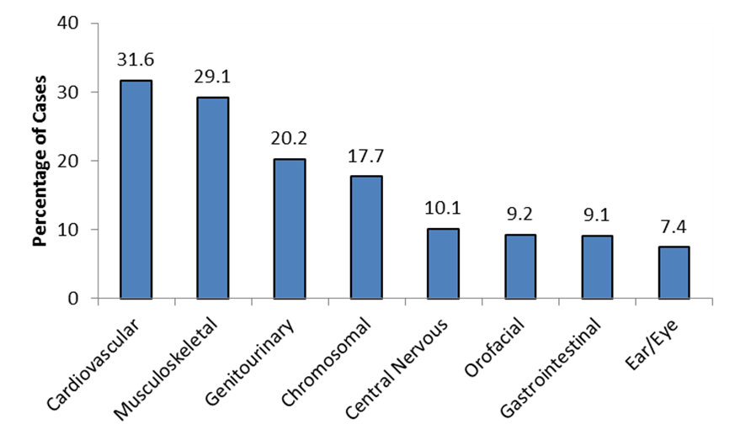
Live births and stillbirths, N=3809 defects among 2731 cases

Selected Pregnancy Outcomes

Adverse pregnancy outcomes such as low birth weight (LBW), prematurity, and small for gestational age (SGA) are more frequent among infants born with birth defects than among unaffected infants (Figure 2).

Figure 2. Pregnancy Outcomes,
Massachusetts: 2011-2012
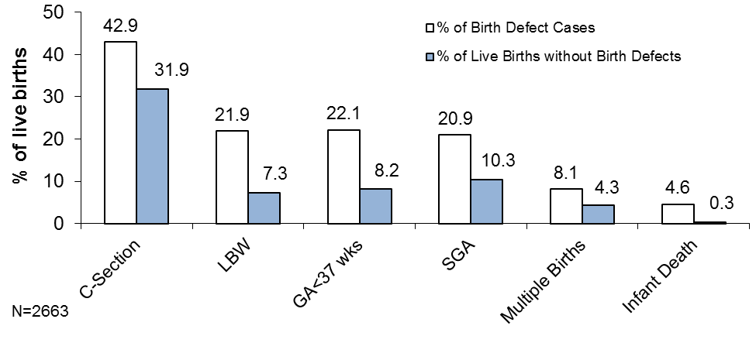
Infants with a birth defect are 3 times more likely to have low birth weight (less than 2500 grams) and 2.7 times more likely to be born premature (before 37 weeks) compared to those without birth defects. Caesarean (C-section) deliveries are more common among live born infants with birth defects (43%) compared to unaffected infants (32%). In addition, infants with birth defects are 15 times more likely to die in their first year of life (Figure 2).

Infant Sex

Among males, the prevalence of birth defects in Massachusetts in 2011-2012 is 216.9 per 10,000 live births, and among females the prevalence of birth defects is 156.4 per 10,000 live births. While the prevalence of most types of birth defects does not significantly differ by sex, males are significantly more likely than females to have obstructive genitourinary defects, clubfoot, and cleft lip (data not shown).

Birth Defects in Massachusetts vs. the US

Massachusetts is one of 11 states with active population-based monitoring programs that contribute birth defects data to published national prevalence estimates for selected major birth defects. For most defects, Massachusetts rates are similar to national rates. However, Massachusetts rates for 2011-2012 are significantly lower than the most recent US rates⁵ for anencephaly, spina bifida, cleft lip, and gastroschisis (Figure 3).

Figure 3. Prevalence Rates for Selected Defects, Massachusetts and United States
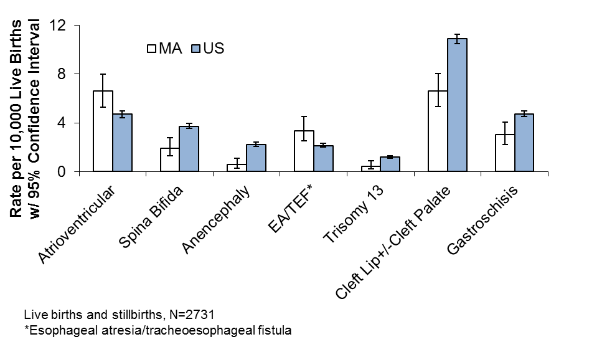
Massachusetts rates are significantly higher for atrioventricular septal defects and for esophageal
atresia/tracheoesophageal fistula. Differences in
surveillance system methodology, types of
pregnancy outcomes included, and demographic variation may account for the differences in rates for certain defects.

Until 2011, Massachusetts only collected information on live born and stillborn cases. Limiting the data to live births and stillbirths can result in under-counting of certain birth defects—especially those not compatible with life. Beginning in early 2011, Massachusetts began ascertaining prenatally-diagnosed birth defects in pregnancies that ended in other types of pregnancy losses. The first full year of data including other pregnancy losses is 2012, and preliminary 2012 data show that Massachusetts rates for spina bifida and anencephaly are similar to national rates when these other pregnancy outcomes are included.

Maternal Age

The number of births to older mothers has been increasing over time in Massachusetts.⁶ Mothers older than 35 have a higher prevalence of birth defects compared to younger mothers (Figure 4).

Figure 4. Birth Defect Prevalence Rate by Maternal Age, Massachusetts: 2011-2012
Maternal  Age | Cases | Rate | 95% CI
<20 | 129 | 190.7 | 159.2 – 226.6
20-24 | 385 | 174.9 | 158.0 – 193.1
25-29 | 643 | 177.7 | 164.3 – 191.8
30-34 | 854 | 177.8 | 166.2 – 190.0
35+ | 720 | 220.7 | 205.0 – 237.2

Live births and stillbirths, N=2731
Rate per 10,000 live births

Down Syndrome

There is a strong association between the rate of Down syndrome and advanced maternal age. In Massachusetts, the rate of Down syndrome in mothers 35 and older is 33.7 per 10,000 live births. Even though there are more cases of Down syndrome among younger mothers because there are more births in this age group⁶, the Down syndrome prevalence rate in mothers 35 and older is 4 times greater than the rate in mothers younger than 35 (Figure 5).

Figure 5. Prevalence Rate for Down Syndrome by Maternal Age, Massachusetts: 2011-2012
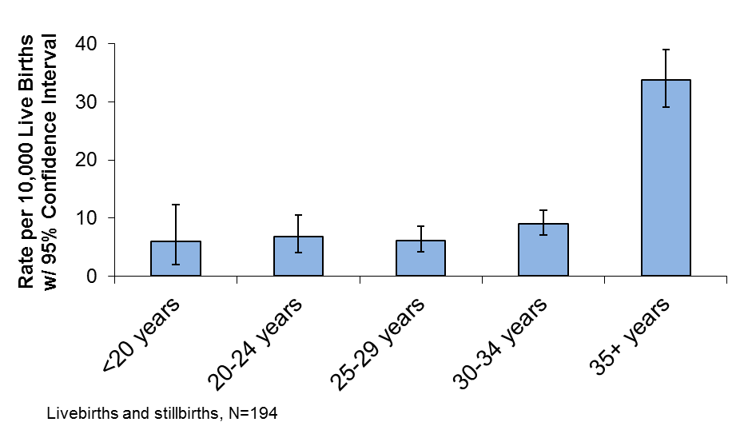
Gastroschisis

Gastroschisis, a condition in which a child is born with the intestines—and sometimes other organs—protruding through a defect in the abdominal wall, occurs more often among younger mothers. In 2011-2012, mothers less than 20 years old had the highest rate of gastroschisis (13.3 per 10,000 live births) among all age groups (Figure 6).

Figure 6. Prevalence Rate for Gastroschisis
by Maternal Age, Massachusetts: 2011-2012
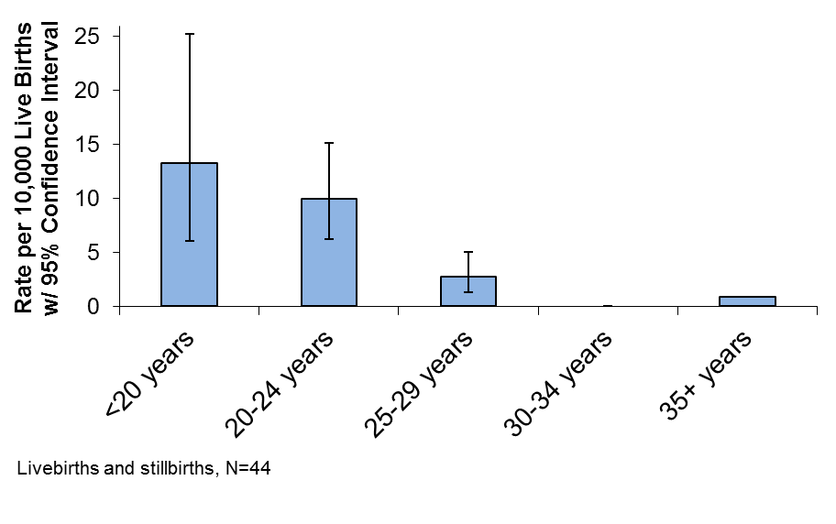
Assisted Reproductive Technology

It is estimated that 1.5 percent of US infants today are conceived through the use of assisted reproductive technology, also called ART.⁷ In 2011, Massachusetts had the highest rate of ART use in the nation. This may be partly due to high rates of insurance coverage for ART in Massachusetts and a higher proportion of older women of reproductive age trying to conceive.

Infants conceived by ART have been shown to have an increased risk for certain birth defects compared to those conceived spontaneously.⁸

Multiple Births

Birth defects are more common among multiple births (e.g. twins and triplets) than in singleton births. About 4.5% of Massachusetts live births are multiple births.⁶ The birth defect prevalence rate in 2011-2012 was 181.8 per 10,000 live births for singletons and 311.6 per 10,000 live births for multiples.

Maternal Race/Ethnicity

In Massachusetts and nationally, birth defect rates vary by maternal race and ethnicity. In 2011-2012 in Massachusetts, the rate of birth defects among Hispanic mothers is significantly higher than for white and Asian mothers (Figure 7). Possible explanations for racial/ethnic differences include genetic variation, diet and lifestyle differences, and varying access to prenatal screening and health care services.

Figure 7. Birth Defect Prevalence Rate by Race/Ethnicity, Massachusetts: 2011-2012

Maternal  Race | Cases | Age-Adjusted  Rate | 95% CI
White, Non-Hispanic | 1690 | 185.5 | 176.6 – 194.3
Black, Non-Hispanic | 285 | 207.8 | 183.7 – 232.0
Asian, Non-Hispanic | 190 | 154.8 | 132.8 – 176.8
Hispanic | 529 | 219.8 | 201.1 – 238.6
Other | 30 | 213.6 | 138.2 – 290.0

Live births and stillbirths, N=2724
Rate per 10,000 live births, standardized to statewide age distribution

Birth Defects by Region

The Massachusetts Executive Office of Health and Human Services divides the state into 6 regions, which are used for statistical, care coordination, and administrative purposes. There are no statistically significant differences between the birth defect prevalence rates observed in each region during the time period (Figure 8).

Figure 8. Birth Defect Prevalence Rate by Residence Region, Massachusetts: 2011-2012

Region | Cases | Age-Adjusted  Rate | 95% CI
Western | 348 | 211.6 | 189.4 – 233.8
Central | 341 | 186.6 | 166.8 – 206.4
Northeast | 558 | 183.7 | 168.5 – 199.0
Metro West | 620 | 182.2 | 167.9 – 196.6
Southeast | 482 | 190.8 | 173.8 – 207.9
Boston | 382 | 185.1 | 166.5 – 203.6

Live births and stillbirths, N=2731
Rate per 10,000 live births, standardized to statewide age distribution

The Financial Burden of Birth Defects

The combined lifetime cost for babies born with 12 major structural birth defects in Massachusetts has been estimated at over $200 million.⁹ Nationally, the lifetime cost of 17 common birth defects has been been estimated to be over 9 billion dollars.¹⁰ This includes direct costs of medical treatment, developmental services and special education, as well as indirect costs related to loss of work and productivity.

THE MASSACHUSETTS CENTER FOR BIRTH DEFECTS RESEARCH AND PREVENTION

The Massachusetts Center for Birth Defects Research and Prevention is a collaboration between the Massachusetts Department of Public Health and experienced staff from Boston University’s Slone Epidemiology Center and MassGeneral Hospital for Children. The Center also draws on the expertise of other local clinicians and researchers and fosters communication among them.

The Massachusetts Center for Birth Defects Research and Prevention collects data on birth defects and identifies related trends, searches for potential causative factors associated with birth defects, addresses community concerns about birth defects, provides information and referral to families of children with birth defects, and collects information on screening and prevention efforts.

FOR MORE INFORMATION

Ron Benham, Acting Director
Center for Birth Defects Research and Prevention
Massachusetts Department of Public Health
Phone: 1-888-302-2101 (toll free)
Email: ron.benham@state.ma.us

ON THE WEB
www.mass.gov/dph/birthdefects

REFERENCES

- Centers for Disease Control and Prevention (CDC). Birth Defects. http://www.cdc.gov/ncbddd/birthdefects/index.html
^{Accessed May 4, 2016.}
- Centers for Disease Control and Prevention (CDC). Facts about Birth Defects. http://www.cdc.gov/ncbddd/birthdefects/facts.html
^{Accessed May 4, 2016.}
- Wolff T, Witkop CT, et al. (2009). "Folic Acid Supplementation for the Prevention of Neural Tube Defects: An Update of the Evidence for the U.S. Preventive Services Task Force." Ann Intern Med 150(9): 632-639.
- Yoon PW, Rassmussen SA, et al. (2001). “The National Birth Defects Prevention Study.” Public Health Reports 116: 32-40.
- Parker SE, Mai CT, Canfield MA (2010). “Updated National Birth Defects Prevalence Estimates for Selected Birth Defects in the US, 2004-2006.” Birth Defects Research (Part A) 88: 1008-1016.
- Division of Research and Epidemiology, Bureau of Health Information, Statistics, Research, and Evaluation, Massachusetts Department of Public Health (2014) “Massachusetts Births 2011-2012”.
- Sunderam S, Kissen DM, et al (2014). "Assisted reproductive technology surveillance—United States, 2011." MMWR Surveillance Summaries 63(SS10): 1-28.
- Reefhuis J, Honein MA, et al. (2009). "Assisted reproductive technology and major structural birth defects in the United States." Hum Reprod 24(2): 360-10.
- Harris JA and James L. (1997) “State-by-state cost of birth defects—1992.” Teratology 56(1-2): 11-16. Adjusted for inflation to 2012 dollars using US Bureau of Labor Statistics Inflation calculator.
- Waitzman NJ, et al. (1995) “Economic costs of birth defects and cerebral palsy—United States 1992.” MMWR 44(37):694-9. Adjusted for inflation to 2012 dollars using US Bureau of Labor Statistics Inflation calculator.
Photos courtesy of the Centers for Disease Control and Prevention.

