Data Brief:
Occupational Lung Disease Bulletin
Asthma in Massachusetts Home Care Aides

Massachusetts Department of Public Health Fall 2016

Dear Healthcare Provider,
In recent years, questions about occupation and industry have been included in the Massachusetts Behavioral Risk Factor Surveillance System (BRFSS), a population-based survey of residents. The BRFSS can now be used to examine a variety of health indicators among occupation groups. This Bulletin presents data on asthma in home care aides — a group of workers that is projected to grow considerably in the coming years.
Please continue to report suspected cases of work-related lung disease using the enclosed form. To receive your Bulletin by e-mail, to provide comments, or to contribute an article to the Bulletin, contact us at MDPH.OHSP@state.ma.us

Kathleen Fitzsimmons, MPH
Epidemiologist

Introduction
Due in part to the aging population in the United States, the demand for workers who provide home care is increasing.¹⁻³ Home care aides perform a variety of tasks to assist clients – primarily older adults and persons with disabilities – with everyday activities, like cleaning house, bathing, dressing, laundry, preparing meals, and grocery shopping.^{4,5} Some home care aides also perform health care-related tasks such as checking vital signs, monitoring medications, and documenting changes in health status.⁵
In the US, home care aide occupations (home health aides and personal care aides) are projected to experience substantial growth over the coming decade, adding an estimated 800,000 new jobs by 2024.³ These occupations are expected to grow much faster than average between 2014 and 2024 (Figure 1).

Figure 1. Projected employment growth, US, 2014-2024 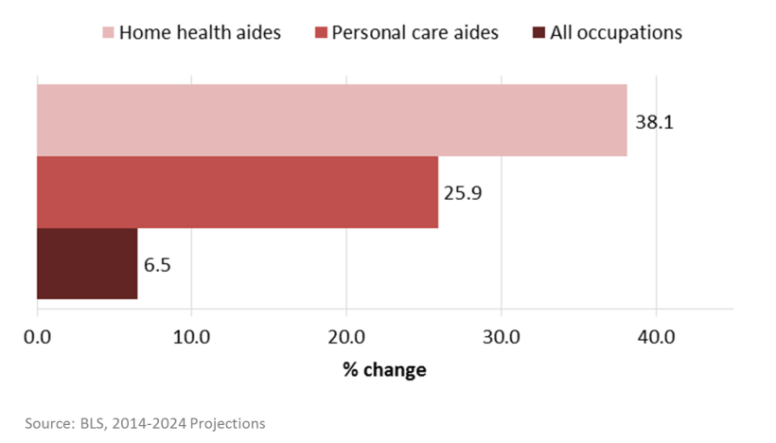
Source: US BLS, 2014-2024 Projections

According to the US Bureau of Labor Statistics, an estimated 48,000 workers are employed as home care aides in Massachusetts. These workers, on average, make just over $26,000 per year, which is equivalent to $12.72 per hour. While slightly higher than the national average income for workers in home care occupations, this is less than half the average annual income of all Massachusetts workers ($57,000/year, $27.70/hour).⁶
In their profession, home care aides may come into contact with a variety of hazards, including those that impact respiratory health. One recent study in Massachusetts found that 17.0% of home care visits involved exposure to cluttered conditions, 9.9% to a client who smoked indoors, 3.6% to pets, and 10.2% to pet waste.² Perhaps most notable, the vast majority of visits (80.3%) involved cleaning of a bathroom or kitchen. Bleach, a known asthma-causing agent, was the most frequently used disinfectant (23.8% of visits); use of other strong cleaning chemicals was also noted.^{2,7,8}
The burden of asthma among home care aides in Massachusetts has not been previously reported. This Data Brief presents estimates of the prevalence of asthma among this group of workers compared to asthma prevalence among all other workers in the state.

Methods
Data were obtained from the Massachusetts Behavioral Risk Factor Surveillance System (BRFSS) for the years 2011-2014. The BRFSS is a continuous multimode telephone survey of adults ages 18 and older, and is conducted in all states as a collaboration between the federal Centers for Disease Control and Prevention (CDC) and state health departments. Massachusetts BRFSS data are weighted to represent the state’s adult population. Additional information is available at www.mass.gov/dph/hsp.
Workers were identified as respondents who reported being employed for wages, self-employed, or out of work for less than one year. Open-ended questions about occupation and industry were asked of workers and the responses were assigned 2002 Census occupation (COC) and industry (CIC) codes by the National Institute for Occupational Safety and Health (NIOSH) at CDC using computer-assisted methods.
For this analysis, only those workers with both industry and occupation codes were included (n=32,875; 94% of those eligible). A combination of CIC and COC codes was used to define home care aides. A worker was classified as a home care aide (n=368) if his/her response to the industry question coded to Home Health Care Services (CIC 8170) or Individual and Family Services (CIC 8370) or Private Households (CIC 9290), and the occupation response coded to Nursing, Psychiatric, and Home Health Aides (COC 3600) or Personal Care Aides (COC 4610). Respondents who had ever been diagnosed with asthma were asked if they still have asthma; those answering ‘yes’ were considered to have current asthma. Estimates of current asthma prevalence and corresponding 95% confidence intervals for home care aides and all other workers were calculated.

Results
As shown in Table 1, compared to all other workers, those in home care were significantly more likely to be female (92.5 vs. 48.3%), age 45 years or older (57.0 vs. 49.0%), Hispanic (15.1 vs. 8.2%), have an education level of high school or lower (51.5 vs. 30.4%) and be current smokers (26.4 vs. 15.9%). They were no more likely to report having received the influenza vaccination in the prior 12 months (41.6 vs. 41.7%).
One in five (20.0%) home care aides reported current asthma compared to just one in ten (10.0%) of all other workers, demonstrating that asthma prevalence was twice as high among home care aides (Figure 2).
Figure 2. Current asthma prevalence among home care aides vs. all other workers, MA, 2011-2014
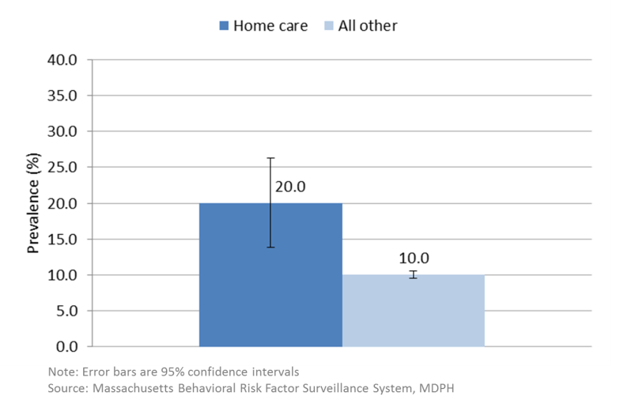
Note: Error bars are 95% confidence intervals
Source: Massachusetts Behavioral Risk Factor Surveillance System, MDPH

Table 1. Characteristics of home care aides vs. all other workers, MA, 2011-2014
 | Homecare aides |  |  |  |  | All other workers
Characteristic | Sample N | Weighted % | 95% CI |  |  | Sample N | Weighted % | 95% CI
Sex | 368 |  |  |  |  | 32507
Female* |  | 92.5 | 88.8 | 96.2 |  |  | 48.3 | 47.5 | 49.2
Age | 361 |  |  |  |  | 32143
18-44* |  | 43.0 | 35.2 | 50.8 |  |  | 51.0 | 50.1 | 51.8 | (p<0.05)
45+* |  | 57.0 | 49.2 | 64.8 |  |  | 49.0 | 48.2 | 49.9
Race/Ethnicity | 364 |  |  |  |  | 32126
White, non-Hisp* |  | 70.0 | 63.1 | 76.9 |  |  | 79.8 | 79.0 | 80.5
Hispanic* |  | 15.1 | 9.8 | 20.4 |  |  | 8.2 | 7.7 | 8.7
Other, non-Hisp |  | 14.9 | 9.6 | 20.2 |  |  | 12.1 | 11.4 | 12.7
Education Level | 368 |  |  |  |  | 32458
<=HS* |  | 51.5 | 43.8 | 59.2 |  |  | 30.4 | 29.5 | 31.3
>HS* |  | 48.5 | 40.8 | 56.2 |  |  | 69.6 | 68.7 | 70.5
Smoking status | 368 |  |  |  |  | 32313
Current* |  | 26.4 | 19.4 | 33.5 |  |  | 15.9 | 15.2 | 16.6
Former |  | 24.2 | 17.6 | 30.8 |  |  | 25.3 | 24.6 | 26.0
Never* |  | 49.3 | 41.6 | 57.1 |  |  | 58.8 | 58.0 | 59.7
Flu vaccination, past 12 mos. | 367 | 41.6 | 34.0 | 49.2 |  | 32413 | 41.7 | 40.9 | 42.6

¹ The number (unweighted) of individuals who responded to the specific BRFSS question.
² Weighted percent.
³ 95% confidence interval for the weighted percent.
Source: Massachusetts Behavioral Risk Factor Surveillance System, MDPH

Stratified analyses were used to examine factors that are more common among home care aides and are also associated with asthma (Figures 3a-e). For instance, women have been shown to consistently have higher asthma prevalence than men, both nationally and in Massachusetts.^{9,10} Additionally, in Massachusetts, women have higher age-adjusted rates of emergency department visits, hospitalizations, and deaths due to asthma.¹⁰ Current asthma prevalence among home care aides was compared to the prevalence among all other workers, stratified by sex, age, race/ethnicity, education level and smoking status. Findings are presented below.

Figure 3a. Current asthma prevalence among home care aides vs. all other workers by sex, MA, 2011-2014
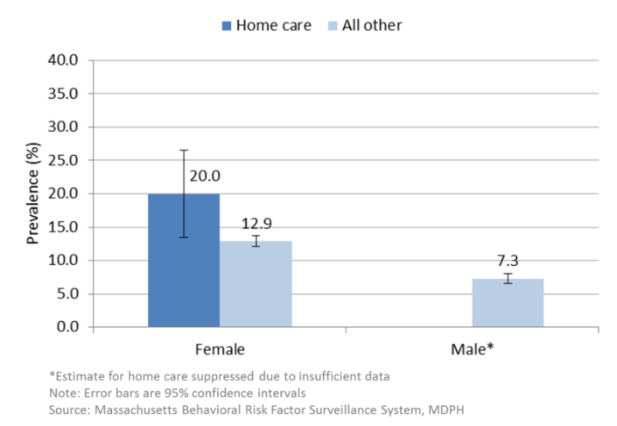
Estimate for home care suppressed due to insufficient data
Note: Error bars are 95% confidence intervals
Source: Massachusetts Behavioral Risk Factor Surveillance System, MDPH

• Among females, home care aides had significantly higher current asthma prevalence compared to all other workers (20.0 vs. 12.9%). The estimate among male home care aides was suppressed due to insufficient data (Figure 3a).

Figure 3b. Current asthma prevalence among home care aides vs. all other workers by age, MA, 2011-2014
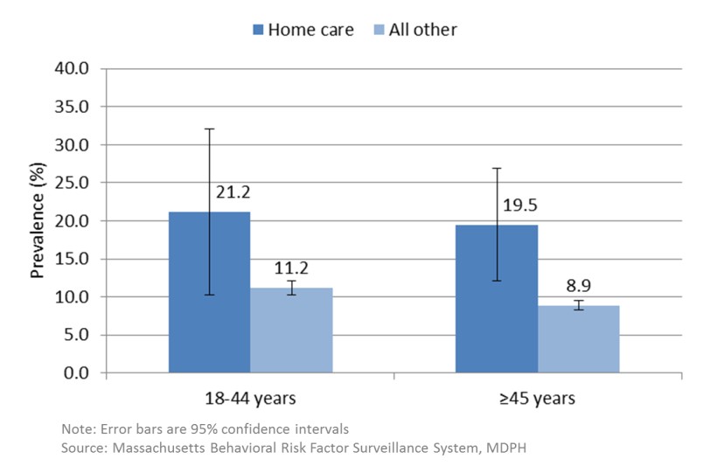
Note: Error bars are 95% confidence intervals
Source: Massachusetts Behavioral Risk Factor Surveillance System, MDPH

• In the two age groups examined, current asthma prevalence was higher among home care aides, although the difference was not statistically significant among the younger age group (Figure 3b).

Figure 3c. Current asthma prevalence among home care aides vs. all other workers by race/ethnicity, MA, 2011-2014
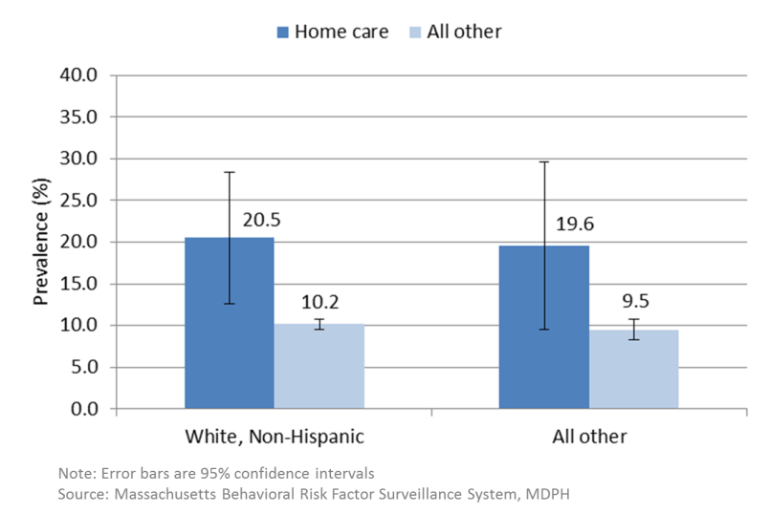
Note: Error bars are 95% confidence intervals
Source: Massachusetts Behavioral Risk Factor Surveillance System, MDPH

• The pattern looked similar when we stratified by race/ethnicity, with home care aides in both groups having higher asthma prevalence. However, among the ‘all other’ race/ethnicity group, the difference was not statistically significant (Figure 3c).

Figure 3d. Current asthma prevalence among home care aides vs. all other workers by education level, MA, 2011-2014
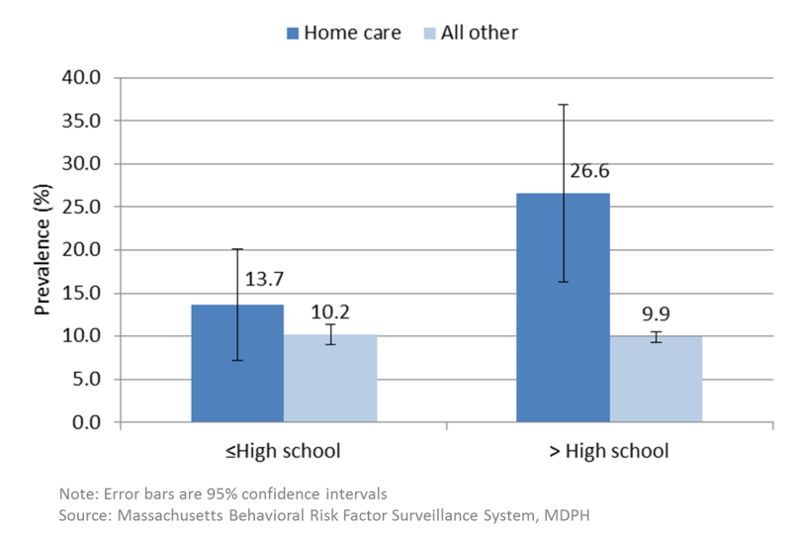
Note: Error bars are 95% confidence intervals
Source: Massachusetts Behavioral Risk Factor Surveillance System, MDPH

• There were differences by education level. Among those with more than a high school education, home care aides had significantly higher asthma prevalence compared with all other workers, whereas the prevalence was similar for both groups of workers with a high school education or lower (Figure 3d).

Figure 3e. Current asthma prevalence among home care aides vs. all other workers by smoking status, MA, 2011-2014
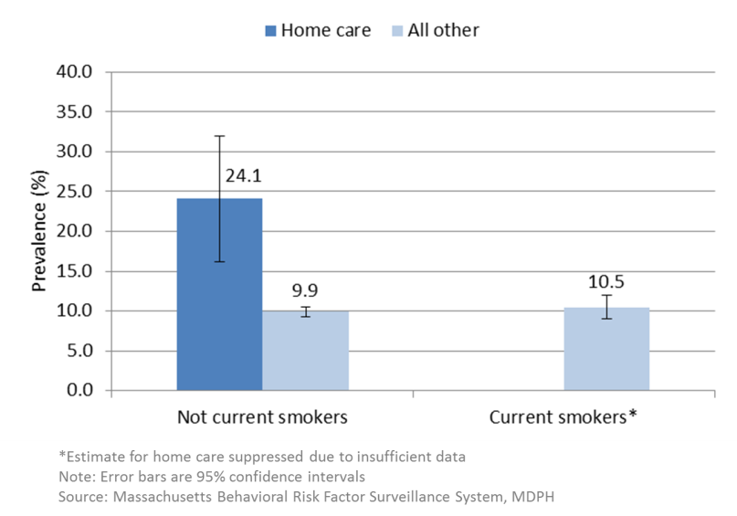
*Estimate for home care suppressed due to insufficient data
Note: Error bars are 95% confidence intervals
Source: Massachusetts Behavioral Risk Factor Surveillance System, MDPH

• Among non-smokers, current asthma prevalence was significantly higher among home care aides compared to all other workers (24.1 vs. 9.9%). The estimate among home care aides who were current smokers was suppressed due to insufficient data (Figure 3e).

Conclusion
Home care aides have higher asthma prevalence compared to other workers in Massachusetts, even after considering additional factors known to be associated with asthma. While it is impossible to assess the proportion of asthma that may be attributed to work, occupational exposures could contribute to the excess of asthma in this group. Harmful environmental exposures at home or in the community might also play a role. More research is needed to identify factors that cause or exacerbate asthma among home care aides. In the meantime, steps can be taken now to reduce exposures to known respiratory hazards in clients’ homes that could protect workers and clients alike.

Resources
• CDC-NIOSH’s Caring for Yourself While Caring for Others provides recommendations on keeping the home environment safe for both home care aides and their clients.
◊ Handbook: www.cdc.gov/niosh/docs/2015-103/pdf/2015-103.pdf
◊ 7-module training curriculum: www.cdc.gov/niosh/docs/2015-102/default.html

• University of Massachusetts Lowell’s NIOSH-funded Safe Home Care Project conducts research promoting health, safety and well-being of home care aides. They developed a module on cleaning for clients with asthma for the Massachusetts Personal and Home Care Aide State Training (PHCAST) Program and wrote an article for the Massachusetts Rehabilitation Commission’s Resource newsletter.
◊ Project website: www.uml.edu/safeHC
◊ Cleaning module: http://madirectcare.com/online-learning/cleaning-for-consumers-with-asthma
◊ Newsletter: www.uml.edu/docs/Safe-HC-Resources-Cleaning-for-home_tcm18-187363.pdf

References
1. Ortman et al. An Aging Nation: The Older Population in the United States, Current Population Reports, P25-1140. US Census Bureau, Washington, DC. 2014.
2. Quinn et al. Occupational health of home care aides: results of the safe home care survey. Occup Environ Med. 2015;0:1-9.
3. U.S. Bureau of Labor Statistics [2015]. Table 6. www.bls.gov/news.release/ecopro.toc.htm
4. Paraprofessional Healthcare Institute. [2014]. Facts 5: Home Care Aides at a Glance. www.phinational.org
5. O*NET. www.onetonline.org/find/
6. U.S. Bureau of Labor Statistics [2014]. Occupational Employment Statistics. http://data.bls.gov/cgi-bin/print.pl/oes/current/oes_ma.htm
7. Association of Occupational and Environmental Clinics. www.aoecdata.org/ExpCodeLookup.aspx
8. Sastre et al. Airway response to chlorine inhalation (bleach) among cleaning workers with and without bronchial hyperresponsiveness. Am J Ind Med. 2011;54(4):293-9.
9. Moorman et al. National Surveillance of Asthma: United
States, 2001–2010. National Center for Health Statistics. Vital Health Stat 3(35). 2012.
10. Massachusetts Department of Public Health. [2009]. Burden of Asthma in Massachusetts. www.mass.gov/dph/asthma

This work was supported by CDC Cooperative Agreement 5U60/OH008490. Contents are solely the responsibility of the authors and do not necessarily represent the official views of CDC.

Occupational Health Surveillance Program, 250 Washington St, 4th Floor, Boston, MA 02108
Tel: (617) 624-5632 | Fax: (617) 624-5696 | www.mass.gov/dph/ohsp

