CHARLES D. BAKER
Governor

KARYN E. POLITO
The Commonwealth of Massachusetts Executive Office of Health and Human Services Department of Public Health

Division of Health Professions Licensure
239 Causeway Street, Suite 500, Boston, MA 02114

MARYLOU SUDDERS
Secretary

MONICA BHAREL, MD, MPH

Lieutenant Governor Tel: 617-973-0800
ITY: 617-973-0988
Fax: 617-973-0986
www.mass.gov/dph/boards
Commissioner

by First Class and Certified Mail No. 7012 3460 0002 3702 7491

Judith Feinberg Albright, Esq. Nelson Kinder+ Mosseau PC 99 Middle Street
Manchester, NH 03101
June 17, 2015

RE: In the Matter of Brett Denhart, DN License No. 19504
. Board of Registration in Nursing, Docket Nos. DEN-2012-0031; DEN-2012-0090; &
DEN-2012-0120

Dear Attorney Albright:

Thank you for recently returning a copy of the Consent Agreement for Probation signed by your client -Dr. Brett Denhart. The Board of Registration in Dentistry has now signed the Consent Agreement for Probation ("Agreement") with respect to Dr. Denhart and his license to practice as a dentist. A copy of the executed Agreement is enclosed for your records and for presentation to your client. Please ensure that your client notes that the effective date of the Agreement is June 17, 2015, as is stated on the signature page of the Agreement.

Dr. Denhart is required to comply with the terms of the Agreement as of the effective date. It is his responsibility to ensure that the Board receives any required documentation and information by the due dates specified in the Agreement. The Agreement will remain in effect until your client receives written confirmation of final resolution of the cases from the Board.

Please note that Karen Fishman is responsible for monitoring compliance with the requirements of the Agreement. All correspondence and questions in connection with the Agreement should be directed to Ms. Fishman, Probation Monitor, Dept. of Public Health, Division of Health Professions Licensure at 239 Causeway St., Boston, MA 02114. You may also reach Ms. Fishman by telephone at (617) 973-0951.

Agreement for Probation Matter of Brett Denhart
Pg. 2

A copy of this letter and the Agreement will be placed in the complaint file of the above­ referenced docket numbers. The file will be retained for no fewer than three (3) years in accordance with state public record laws.

Thank you for your cooperation in resolving this matter.

Prosecuting Counsel
Department of Public Health Office of the General Counsel (617) 9_73-0835

Encl: Consent Agreement cc: Karen Fishman
file

COMMONWEALTH OF MASSACHUSETTS

SUFFOLK COUNTY BOARD OF REGISTRATION IN DENTISTRY

In the Matter of Brett Denhart

DNLic. No.19504
)

) Docket Nos. DEN-2012-0031
) DEN-2012-0090
) DEN-2012-0120
)

CONSENT AGREEMENT FOR PROBATION

The Massachusetts Board of Registration in Dentistry ("Board") and Brett Denhart ("Licensee''), License No. 19504, do hereby stipulate and agree that the following information shall be entered into and become a permanent part of the Licensee's record maintained by the Board.

- The Licensee hereby states that he voluntarily enters into this Consent Agreement for Probation ("Consent Agreement'') in order to resolve disputed Complaints pending against the Licensee before the Board as Docket Nos. DEN-2012-0031, DEN-2012-0090 and DEN-2012-0120 (''the Complaints").

- Licensee and the Board stipulate and agree to resolve the Complaints without making any findings and without proceeding to a formal adjudicatory hearing on the Complaints based on the allegations as follows:

(a) DEN-2012-0031

  - Licensee violated 234 CMR 9.05 (14) by failing to inform and obtain consent from the parents of a minor child prior to attempting to place an IV multiple times without success in advance of a planned extraction in violation of recognized standards of care.

(b) DEN-2012-0090

Licensee violated 234 CMR 5.05 (1) 234 CMR 9.05 (3) by failing to provide services and maintain a dental office in compliance with the CDC Guidelines. Said deficiencies included the failure to maintain sterility of surgical hand pieces, failure to have sterile gloves for surgical procedures, and failure to sterilize nasal hood prior to patient use;

- Licensee violated 234 CMR 6.04 (3) by having expired emergency

Probation CA 1

medications including, but not limited to, Brevital, Demerol and succinylcholine;

- Licensee violated 234 CMR. 6.04 (l)(c)by failing to maintain documentation of maintenance of equipment and medication;

- Licensee violated 234 CMR. 6.11 (5)(c) by failing to maintain a proper anesthesia chart documenting pre-, intra-, and post-operative vital signs, the end of procedure, and patient condition upon discharge; ·

- Licensee violated 234 CMR. 5.15 by failing to have written protocols for managing medical and dental emergencies; ·

(c) DEN-2012-0120

- Licensee violated 234 CMR. 5.05 (1) by failing to provide services in compliance with the CDC Guidelines and by failing to maintain the dental office in compliance with the CDC Guidelines.

- Maintain sterility of surgical hand pieces, have sterile gloves for surgical procedures, and failure to sterilize nasal hood prior to patient use;

- Licensee violated 234 CMR 6.04 (3) by having expired medications including, but not limited to, succinylcholine and pre-loaded adult epinephrine;

- Licensee violated 2 4 CMR 6.04 (l)(c) by failing to maintain documentation of maintenance of equipment and medication;

- Licensee violated 234 C:MR. 5.11 (2) by delegating a procedure to a dental auxiliary who did not meet the requirements necessary to perform that procedure;

- Licensee violated 234 CMR 6.11 (S)(c) by failing to maintain a proper anesthesia chart or record;

- Licensee violated 234 CMR. 5.14 (1) by failing to review and/or document the patient's dental and medical history in the patient record;

- Licensee violated 234 CMR. 6.11 (4)&(5) and 5.15 (3)(g) by failing to maintain a proper anesthesia chart documenting pre-, intra-, and post­ operative vital signs, the patient's condition upon discharge and the difficulty experienced in placing an intravenous line in the patient;

- In order to resolve this matter without further proceedings before the Board, the

Probation CA 2

Licensee and the Board agree that on the date of the execution of this Consent Agreement by the Board ("Effective Date") the Board will order that the Licensee be placed on Probation for a Period of two (2) years from the Effective Date of this Consent Agreement (Probation Period).

- Within 6 months from the Effective Date of this Consent Agreement, the Licensee shall provide written proof satisfactory to the Board that he has taken and successfully completed Board approved continuing education courses in the following areas:

6 hours: Risk Management 6 hours: Record-keeping
6 hours: CDC Guidelines for Infection Control

6 hours: Managing Medical Emergencies in Dental Settings

- The course description(s) shall be submitted to the Board for pre-approval prior to taking the course. ·

- All courses must be attended and shall not be self-study and/or taken through a computer based on-line program.

- The Board approved continuing education courses shall be taken in addition to the continuing education courses required to maintain his/her license to practice dentistry pursuant to 234 CMR 8.00. ·

- Within thirty days of the Effective Date, Licensee shall provide a copy of this Consent Agreement to all jurisdictions in which he holds a license to practice dentistry.

  - Licensee shall provide written documentation to the Board demonstrating his compliance with paragraph (4) (d).

  - If licensee is not licensed to practice dentistry or another profession in any other jurisdiction, he/she shall submit an attestation to the Board stating such.

- The burden of proof of compliance with the requirements of the Probation is on the Licensee.

5. If the Licensee fails to successfully complete the requirements of paragraph(s) 3 and/or 4, the Board may take further disciplinary action without a hearing. Such action may include, but not e limited to, extension of the period of probation, suspension of the Licensee's license to practice, or other disciplinary action as is deemed appropriate by the Board.

Probation CA 3

During the Probationary Period, the Licensee further agrees that he/she shall not:

  - Violate any law or regulation (state or federal) relating to the practice of dentistry;

(b) Commit any act that constitute deceit, malpractice, gross misconduct in the practice of dentistry, offenses against laws or regulations relating to the· practice of dentistry, unprofessional conduct, or conduct which undermines public confidence in the integrity of the profession;

- Violate any regulations promulgated by the Board set forth in 234 CMR.
1.00 et. seq.;

- The Licensee agrees to fully cooperate and respond to any inquiry or request made by the Board during the Probation Period.

- The Licensee agrees that his failure to satisfy any of the terms of Probation set forth in paragraph (6) shall result in further disciplinary action by the Board pursuant to subparagraph 7 (a) and (b).

  - The Licensee shall be entitled to a hearing as to whether he violated the terms and conditions of Probation as set forth in paragraph 7. This hearing shall be conducted in accordance with the State Administrative Procedure Act, M.G.L. Ch. 30A §§ 10 and II, and the Standard Adjudicatory Rules of Practice and Procedure, 801 CMR 1.01 and 1.03.

(b) After a hearing; if the Board determines that a violation did occur during the Probation Period, it will impose a further sanction deemed appropriate in its discretion.

(c) The Licensee agrees that the Licensee will not be entitled to a hearing to dispute the underlying allegations contained in the Complaints included in Docket No. DEN-2012-0031, DEN-2012-0090andDEN-2012-0120. The
Licensee acknowledges and agrees that by entering into this Consent Agreement, he is relinquishing important procedural rights.

- The Licensee understands that his action in entering into this Consent Agreement is a final act and not subject to reconsideration, collateral attack or judicial review in any form or forum.

- The Licensee acknowledges and understands that this Consent Agreement is subject to the Commonwealth of Massachusetts' Public Records Law, M.G. L. c. 4,
§ 7.

The Board agrees that as consideration for the Licensee's entering into this Consent Agreement, the Board will not conduct any further prosecution of

Probation CA 4

allegations contained in the Complaint(s) included Docket No. DEN-2012-0031, DEN-2012-0090 and DEN-2012-0120. Any further prosecution on the above docket number(s) will relate only to a determination as to any violations of the terms and conditions of this Consent Agreement.

- The Licensee states that he enters into this Consent Agreement of his own free will The Licensee further states that he is aware that he has a right to counsel in this matter and has either conferred with counsel prior to signing this Consent Agreement, or waived his right to have counsel.
'

A waiver by the Board of any provision of this Consent Agreement at any time shall not constitute a waiver of any other provision of this Consent Agreement, nor shall it constitute a waiver by the Board of its right to enforce such provision at any future time.

- The Licensee certifies that he/she has read this document entitled "Consent Agreement for Probation." The Licensee understands that he/she has the right to a formal adjudicatory hearing concerning the Complaint(s) included in Docket Nos.
DEN-2012-0031, DEN-2012-0090 and DEN-2012-0120 and that at said hearing
he would have the right to confront and cross-examine witnesses, to call witnesses, to present evidence; to testify on his own behalf to contest the allegations, to present oral argument, to appeal to the courts, and to all other rights set forth in the State Administrative Procedure Act (M.G.L. c. 30A), and 801 CMR 1.00 et seq.

- By executing this Consent Agreement, Licensee knowingly and voluntarily waives his right to a formal adjudicatory hearing and to all of the above-enumerated rights set forth in the State Administrative Procedures Act M.G.L. c.30A and 801 CMR
1.00 et seq., except as provided in subparagraph 7(a) & (b).

Date Signed: 06/03/2015

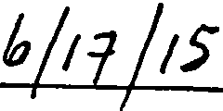Board of Registration in Dentistry:

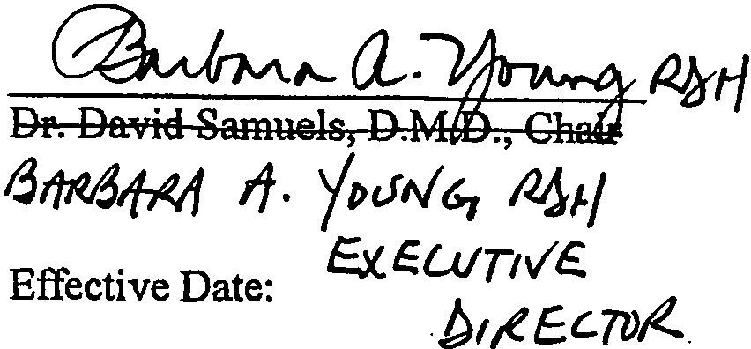

Probation CA

Date Signed: 06/17/2015
I

5

