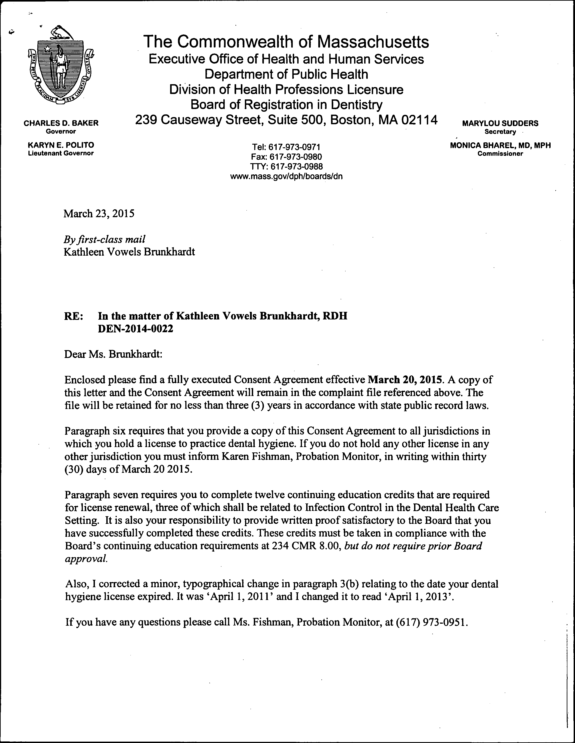

redacted

Kathleen Vowels Brunkhardt March 23, 2015

21Page

Thank you for your cooperation in this matter.

Sincerely,

Samuel Leadholm, Board Counsel Board of Registration in Dentistry

Encl.

COMMONWEALTH OF MASSACHUSETTS

SUFFOLK COUNTY BOARD OF REGISTRATION IN DENTISTRY

In the Matter of
Kathleen Vowels Brunkhardt, RDH
)
) Docket No. DEN-2014-0022
)

CONSENT AGREEMENT FOR REPRIMAND

The Massachusetts Board of Registration in Dentistry ("Board") and Kathleen Vowels Brunkhardt, RDH ("Licensee"), License 1 No. DH7893 ("License"), do hereby stipulate and agree that the following information shall be entered into and become a permanent
part of the Licensee's record maintained by the Board.

- The Licensee hereby states that she voluntarily enters into this Consent Agreement for Reprimand ("Consent Agreement") to resolve the allegations set forth in Docket No. DEN-2014-0022 ("Complaint").

- The Licensee acknowledges there are sufficient facts in the Complaint from which the Board could reasonably find grounds for discipline under M.G.L. c. 112, § 61 and Board regulations.

- The Licensee and the Board stipulate and agree to resolve the Complaint without making any findings and without proceeding to a formal adjudicatory hearing on the Complaint based on the following allegations:

  - On August 2, 1985, Licensee was issued a license to practice dental hygiene in the Commonwealth. Licensee renewed her License biennially from August 2, 1985, until on or about March 31,2013, when Licensee failed to renew her License in violation of M.G.L. c. 112, §51 and 234 CMR 4.10(2) and (4).2 Thus, her License expired onAprill, 2013.

  - Licensee practiced in the Commonwealth without a license from April 1, 2013, until on or about March 3, 2014 when she discovered her License had expired. Thus, Licensee practiced without a dental hygiene license from April I, 2013 until on or about March 1, 2014 in violation of M.G L. c. 112,
§52 and 234 CMR 9.05(6).

1The term "license" or "License" applies to both a current and expired license as well as the right to renew an expired license.

2 The regulation section and subsections cited to were in effect between April2013 and March 2014.

Kathleen Vowels Brunkhardt, RDH DH7893
DEN-20 14-0022

  - Licensee submitted her license renewal application to the Board and her License was renewed on March 6, 2014.

  - Licensee violated 234 CMR 8.03(a), by failing to take mandatory continuing education in Infection Control in Dental Health Care Setting before renewing her License.

  - Licensee violated 234 CMR 8.02(3), by failing to take 12 of20 CEUs required for the license renewal period ending March 31, 2013.

- To resolve this matter without further proceedings before the Board, the Licensee agrees and the Board hereby imposes a Reprimand on her License pursuant to 234 CMR 9.03(2)(a) to become effective the date on which this Consent Agreement is signed by the Board ("Effective Date").

- The Licensee understands her action in entering into the Consent Agreement is a final act and not subject to reconsideration, collateral attack or judicial review in any form or forum.

- Within thirty (30) days of the Effective Date, Licensee shall provide a copy of the Consent Agreement to all jurisdictions where she holds or has held any professional license.

  - Licensee shall provide written documentation to the Board demonstrating her compliance with paragraph 6.

  - If Licensee is not licensed to practice dental hygiene or another profession in any other jurisdiction, she shall submit a signed attestation to the Board stating such.

- Within six (6) months of the Effective Date, the Licensee shall provide written proof satisfactory to the Board she has taken and successfully passed twelve (12) CEUs which shall include three (3) CEUs related to Infection Control in the Dental Health Care Setting.

- The Licensee acknowledges and understands the Consent Agreement is a public record within the meaning of M.G.L. c. 4, § 7(26) and as such maybe disseminated to the public.

- The Board agrees that by Licensee entering into the Consent Agreement, the Board will forgo further prosecution of the Complaint unless the Licensee does not fulfill the stipulations as stated in Paragraphs 6 and 7 above.

- The Licensee states that she enters the Consent Agreement of her own free will.
The Licensee further states that she is aware that she has a right to counsel in this

2

Kathleen Vowels Brunkhardt, RDH DH7893
DEN-2014-0022

Agreement or waives her right to have counsel.

- A waiver by the Board of any provisions of the Consent Agreement at any time . shall not constitute a waiver of any other provision of the Consent Agreement, nor shall it constitute waiver. by the Board of its rights to enforce such provision at any future time.

12. The Licensee has read Consent Agreement. The Licensee understands she has the right to a formal adjudicatory hearing concerning the allegations set forth in the Complaint and that at a hearing she would have the right to confront and cross-. examine witnesses, call witnesses, present evidence, testify on her own behalf, contest the allegations, present oral argument, seek judicial review and to all other rights set forth in the State Administrative Procedure Act, M.GL. c. 30A and 801 CMR 1.00 et seq. By executing the Consent Agreement, Licensee knowingly and voluntarily waives her right to a formal adjudicatory hearing and to all of the above-enumerated rights set forth in the State Administrative Procedure Act, M.GL. c. 30A and 801 CMR 1.00 et seq.

Licensee

Board of Registration in Dentistry

Barbara A. Young, Executive Director

Date Signed

Effective ate

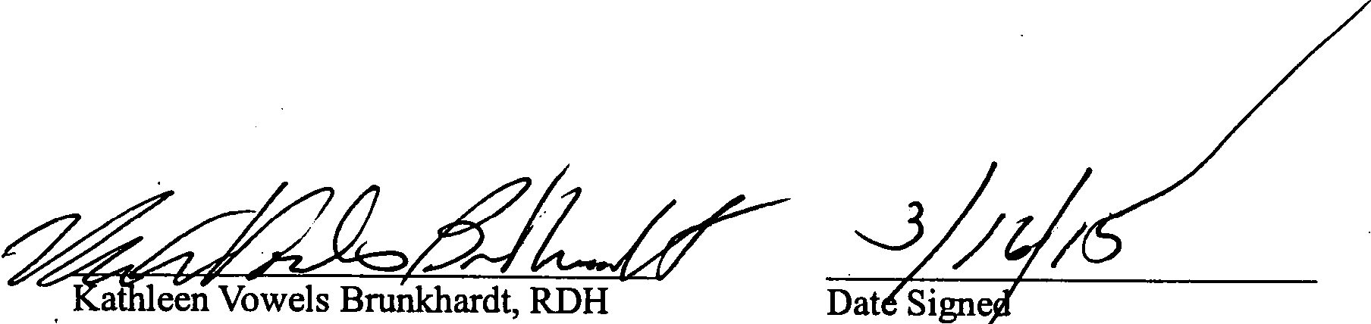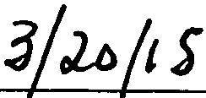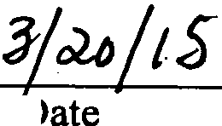

3

