Executive Office of Health and Human Services
Massachusetts Department of Public Health

Health Professions Data Series
Dentist 2012
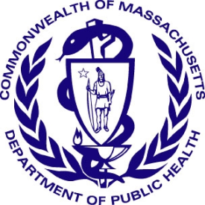

Deval L. Patrick, Governor
John W. Polanowicz, Secretary
Cheryl Bartlett, Commissioner

November 2014

Massachusetts Health Professions Data Series:
Dentist 2012
OVERVIEW
The Massachusetts Health Professions Data Series: Dentist 2012 Report provides data on the workforce demographics of dentists licensed to practice in Massachusetts. This report is part of the Department of Public Health’s Health Professions Data Series, which currently reports on seven licensed health professions: dentists, dental hygienists, pharmacists, physicians, physician assistants, registered nurses, and licensed practical nurses.
The Massachusetts Health Professions Data Series: Dentist 2012 Report represents data from the second cycle of Massachusetts’ health professional workforce data collection. This data series was launched during the 2010 clinician license renewal cycle in coordination with the Division of Health Professions Licensure and its biennial clinician renewal cycle.
The data series responds to the need for quality and timely data on demographics and employment characteristics of the Commonwealth’s healthcare workforce. With a response rate of 91%, the 2012 report is a timely source of robust data.
Chapter 224 of the Acts of 2012: An Act Improving the Quality of Health Care and Reducing Costs Through Increased Transparency, Efficiency and Innovation continues and expands the work of the Health Care Workforce Center established initially in the Acts of 2008. The publication of this data series is a significant step toward fulfilling the mandates of Chapter 224. It complements and contributes to ongoing health care access and payment reform initiatives in the Commonwealth, and federal efforts including the National Center for Health Workforce Analysis Assessment.
The data series characterizes the workforce from a supply perspective. It enhances the Commonwealth’s ability to identify trends and patterns in the Commonwealth’s healthcare workforce that will impact access to health care professionals and the services they provide. The data is integral to current and future decisions about healthcare workforce development, education, training, recruitment, and retention. It will also help to ensure the availability of a highly qualified, diverse, and culturally and linguistically competent workforce to meet the current and future needs of all Massachusetts residents.

¹ Chapter 224 of the Acts of 2012: An Act Improving Quality of Health Care and Reducing Costs Through Increased Transparency, Efficiency and Innovation: http://malegislature.gov/Laws/SessionLaws/Acts/2012/Chapter224

Background
During the 2012 license renewal cycle a total of 7,267 dentists were sent a renewal notice with the option to renew online or by mail. Dentists who renewed their license online completed 33 workforce survey questions. The survey included questions related to demographics, education, and employment characteristics and future work plans. A total of 6,592 dentists renewed their license. 5,980 (91%) dentists completed the online survey, of which 4,803 (80%) reported Massachusetts as their primary practice setting.
The following data represents the responses of 5,980 Dentists who completed an online renewal between January 1, 2012 and June 30, 2012.
Demographics n=5,980
Gender:

Race:
White, Non-Hispanic (NH) | 67%
Asian, NH | 16%
Black, NH | 2%
American Indian / Alaska Native, NH | <1%
Native Hawaiian / Pacific Islander, NH | <1%
Hispanic/Latino/Spanish | 3%
Other | 1%
Decline to Answer | 11%

Patient Language Barriers and Access to Care:
Oral health is an integral component to overall health and well-being. Preventive dental care and good oral hygiene are the foundation of positive oral health outcomes.
Research indicates that patients who experience language barriers when receiving health care are at increased risk for adverse health outcomes.
Patients who receive health services from providers who do not speak the patients’ primary language:
² Language fluency defined as ability to communicate with and provide adequate care to patients without the use of a translator (n=5,980).
³ Source: US Census Bureau, 2008-2012 American Community Survey. These are the 4 most common non-English languages spoken at home in Massachusetts
- Are less likely to access primary care
- Are less likely to access preventive care
- Have decreased patient compliance
Education n=5,980
Location of initial dentist degree / credential: 60% of respondents reported completing their DMD/DDS degree in Massachusetts. 39% completed their first degree in another US state or territory and 1% in a foreign country.
American Dental Association (ADA) Specialties: 1,931 Dentists (32%) reported having an ADA specialty for which they are board certified or eligible. 757 dentists reported having more than one specialty.
Of those dentists that have a specialty, 80% reported that their practice is limited to those specialties.

Loan repayment program: Loan repayment programs (LRP) partially repay school loans for certain health professionals in return for working for an organization that serves disadvantaged patients or is located in an underserved community. 12% reported that they participated in a Federal LRP and 3% in a State LRP. Of the dentists that did not participate in a LRP, 58% indicated that they would be interested in such a program.

Future Plans n=5,980
Plans Regarding Dental Practice within the Next Five Years
No Change in Work Status | 60% |  | Return to Dentistry | 1%
Increase Hours | 10% |  | Leave Dentistry | <1%
Reduce Hours | 14% |  | Plan to Retire | 6%
Seek Additional Education | 2% |  | Other | 7%

Of the 966 dentists that are 65 years and older, 25% are planning to retire and 24% are planning to reduce their hours of work within the next 5 years.
Employment Characteristics
Figure 5. Dentist Employment Status
⁴
4,418 - Primary Employment in MA
5,980 Total Respondents
951 Employed in Other US State

611 Employed in non-Dentistry field, Unemployed, or Did Not Report an Employment Location
Full-time: 85%
Part-time: 15%
Per Diem: 1%
Volunteer: <1%

⁴ Percentages do not add up to 100% due to respondents’ ability to report more than one employment status.
The following data represent responses from the 4,418 Dentists who reported working full-time, part-time, per diem, or volunteering in the dentistry field in Massachusetts.
Practice Setting: Respondents were asked to identify their primary practice setting. Figure 6 shows the most commonly reported primary practice settings. Work settings that represent less than 2% of the responses are not included in the figure. These settings include: Correctional Facilities, Hospitals, Long-term Care Facilities, Military/VA, and Mobile Dental Facilities.
General Dentistry and Specialty Care: Across medical disciplines there is growing concern that recent graduates are more likely to specialize than go into primary practice. 70% of the dentists currently working in Massachusetts reported working primarily in general dentistry. Figure 7 breaks down the dentists that are practicing general dentistry by age group. The consistency across age categories would suggest that there is not a trend toward specialization in dentistry.

(n= 569) (n=1,090) (n=1,057) (n=1,023) (n=679)
Dental Public Health
MassHealth: The respondents were asked to approximate the percentage of their patients that receive dental benefits from MassHealth. Only 1,844 (42%) of dentists practicing in Massachusetts reported being a MassHealth provider. Furthermore, the majority of MassHealth providers reported that patients with MassHealth make up a relatively small percentage of their patient population. As figure 8 shows, 779 dentists (42% of all MassHealth providers) reported that patients with MassHealth make up 10% or less of their entire patient population.
MassHealth providers are not evenly distributed among work settings. Nearly all dentists who reported their primary practice setting as a community health center reported being a MassHealth provider (Figure 9). Dentists working in a solo or group practice are much less likely to accept MassHealth.
MassHealth providers are also unevenly distributed by age. 54% of dentists under 45 reported accepting MassHealth, compared to only 34% of dentists 45 years or older.
Out of the 2,543 dentists practicing in Massachusetts that reported not accepting MassHealth, 85% reported no interest in becoming a MassHealth Provider.
⁵ 726 dentists reported their primary work setting as solo practice, 823 as group practice, and 101 as a community health center.

Other Public Health Implications (n=4,418):
- A public health dental hygienist (PHDH) is a practicing registered dental hygienist who enters into a collaborative agreement with a licensed dentist and may perform dental hygiene procedures in a public health setting without the supervision or direction of a dentist.
  - 32 Dentists reported having a PHDH collaborative agreement.
  - 28 reported having a PHDH agreement in the past, but not currently.
  - 8% reported that they are willing to enter into a PHDH agreement, 24% reported they may be willing, and 65% reported no interest.
- The American Dental Association recommends that children have their first dental exam no later than 12 months of age. Respondents were asked at what age they routinely see children for their first dental exam:
General Age of First Dental Exam | %
Under 12 Months | 4%
12-23 Months | 18%
24-35 Months | 25%
36 Months or Older | 36%
Do Not Treat Children | 17%
- 15% of dental providers offer patients a sliding fee scale.
- 23% reported volunteering at least 1 hour per month.
- Dentists were asked to approximate the percentage of their patients with special needs ⁶ :
  - 49% reported less than 1% of their patients were special needs patients
  - 42% reported 1-5% were special needs patients
  - 9% reported 6% or more were special needs patients
⁶ Special needs were defined as “people who have mental, physical, or developmental disabilities, sensory or behavior disorders, etc.”
Geographic Distribution n=4,418
Figure 10. Population Density⁷ and Number of Dentist Primary Practices⁸ at the City/Town Level
Population Density
Persons per Square Mile
6 - 104
105 - 325
326 - 713
714 - 1530
1531 - 18343
1 Dot = 1 Primary Practice Located Within that City/Town⁹
Dentist Primary Practice
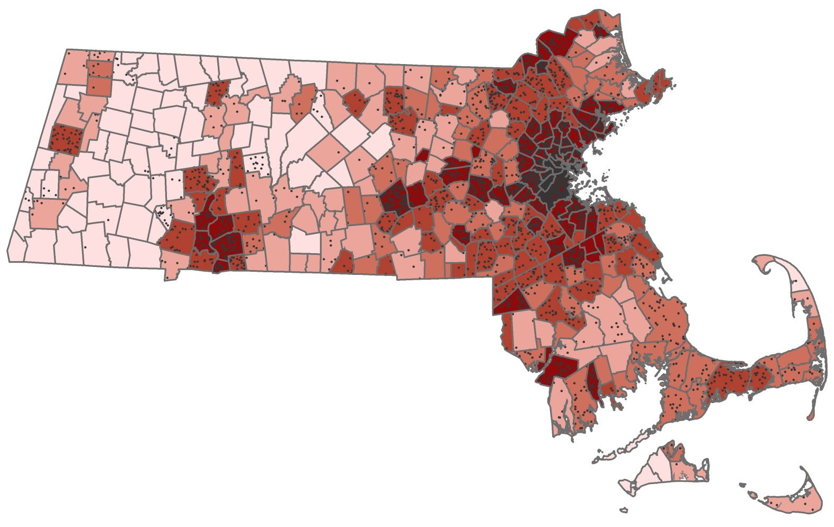

⁷ Population densities at the city/town level were obtained from 2010 census data. The data is displayed in quintiles, with an equal number
of cities and towns in each class.
⁸ Locations of primary practice were reported by zip code, which were generalized to the city/town level. With zip codes that are shared by
more than one city/town, the dentists in that particular zip code were included in the overall count for each one of those cities/towns.
⁹ Each dot in the map represents a reported location of primary practice at the city and town level. The dots are randomly distributed within
the city and town borders and not the actual location of practice within that city/town. Figure 10 does not include the 612 dentists that
renewed their license but did not complete a survey or the small number of respondents that did not report a zip code of primary practice.
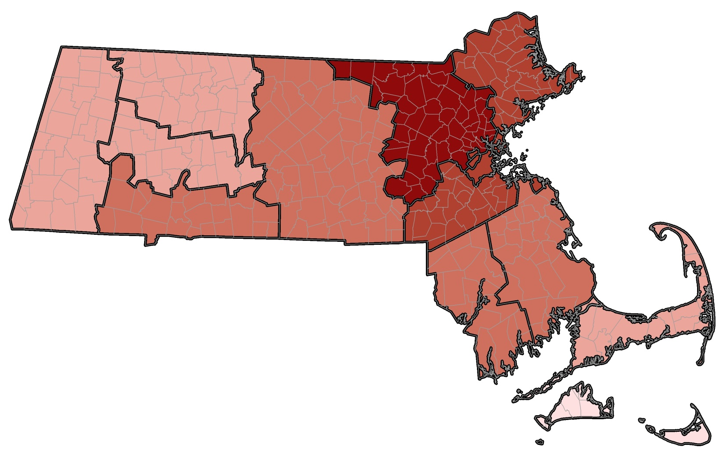
Figure 11. Dentist Primary Practice Distribution by County
Berkshire
1.6%
Hampshire
1.8%
Essex
11.1%
Suffolk
17.3%
Norfolk
14.0%

Hampden
5.9%
Franklin
0.8%
Worcester
9.4%
Middlesex
25.0%
Plymouth
6.0%
Bristol
6.1%

Barnstable
3.7%
Dukes
0.3%

Nantucket
0.2%

<1%
1 - 5%
6 - 10%
11 - 15%
16 - 25%
Percent of All Primary Practices Located in County

This report was developed by the
Massachusetts Department of Public Health

Bureau of Community Health and Prevention
Health Care Workforce Center

Bureau of Health Care Safety and Quality
Division Health Professions Licensure
Board of Registration in Dentistry

For additional information about the Health Professions
Data Series or this Dentist Report
Please contact the
Massachusetts Health Care Workforce Center
at the
Massachusetts Department of Public Health

Website: mass.gov/dph/hcworkforcecenter
Email: HCWorkforceCenter@state.ma.us

