Commonwealth of Massachusetts

Department of Housing &

Community Development

# Charles D. Baker, Governor ◆ Karyn E. Polito, Lt. Governor ◆ Chrystal Kornegay, Undersecretary

Massachusetts Seal.

DHCD logo.100 Cambridge Street, Suite 300 www.mass.gov/dhcd

Boston, Massachusetts 02114 617.573.1100xxx

**MASSACHUSETTS COMMUNITY DEVELOPMENT BLOCK GRANT (CDBG)**

**PROGRAM**

**FY 2017 Application Training**

The Department anticipates the availability of funding for the following Federal Fiscal Year 2017 Massachusetts Community Development Block Grant (MA CDBG) program components:

**Community Development Fund / Mini-Entitlement Program**

The MA CDBG program provides federal funds on a competitive basis to municipalities with a population of less than 50,000 that are not designated by HUD as entitlement areas. Communities may apply to the Community Development Fund or the Mini-Entitlement Program for a variety of projects including rehabilitation of housing stock, improvements to infrastructure, stabilization of neighborhoods, planning, public social services and downtown related projects.

Information sessions providing application guidance will be held at the following times and locations. Application guidance materials will be available online at [www.mass.gov/dhcd](http://www.mass.gov/dhcd) and will also be available at these sessions. Comments on the draft One Year Plan will also be accepted. An additional formal hearing on the Plan is anticipated in December 2016.

**Wednesday, November 30, 2016 10:30 am to 1:30 pm** at DHCD

100 Cambridge Street

Conference Room B, 2nd Floor

Boston, MA

**Wednesday, December 7, 2016 10:00 am to 1:00 pm** at West Springfield Municipal Office Building

26 Central Street

West Springfield, MA

**Thursday, December 8, 2016 10:00 am to 1:00 pm** at Worcester Union Station

2 Washington Square  
 Union Hall 2nd Floor

Worcester, MA 01604

We will need to provide you with a security ID badge in order for you to access **Conference Room B on the 2nd Floor** of 100 Cambridge Street. Please RSVP by November 25, 2016, via e-mail to [Community_Services@hotmail.com](mailto:Community_Services@hotmail.com) or call (617) 573-1409 if you plan to attend this session.

***If you require an accommodation (materials in Braille/large print, sign language interpreters, etc.), please contact DHCD by November 25, 2016***

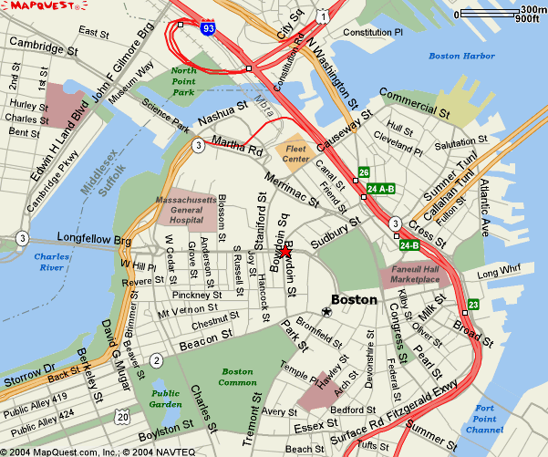**Directions to DHCD – 100 Cambridge St., Boston**

**Driving from the North**

From 93S take the Storrow Drive exit, at the bottom of the bridge turn off at Nashua Street. DO NOT GO

INTO THE TUNNEL. Turn right at end of ramp onto Nashua Street going towards the Fleet Center. Follow

Nashua Street around the Jail and past Spaulding Hospital. The street will make a right turn and come to a traffic light where you have to turn left. Turn left. Go to the next traffic light and go straight. This is Merrimac Street. Follow Merrimac to the next traffic light and turn as if going right. The entrance to the Government Center garage will be in front of you. If you are going to 100 Cambridge Street continue turning right (New Chardon Street). Follow New Chardon up the hill thru the pedestrian light and to the working traffic light at Cambridge Street. **100 Cambridge Street** is diagonally across on your left (a large **100** is in the window over the front entrance).

**Driving from the South**

Take Interstate 95N to Interstate 93N to Boston, enter new 93N Tunnel. Take Exit 26/Storrow Drive. After exiting you are on Martha Way, bear left on Merrimac Street. Government Center Parking Garage is straight

ahead at the end of Merrimac (across New Chardon).

**Driving from the West**

Take 90E (Mass Pike) to 93N to Boston, enter new 93N Tunnel. Take Exit 26/Storrow Drive. After exiting you are on Martha Way, bear left on Merrimac Street. Government Center Parking Garage is straight ahead at the end of Merrimac (across New Chardon).

**Directions to West Springfield Municipal 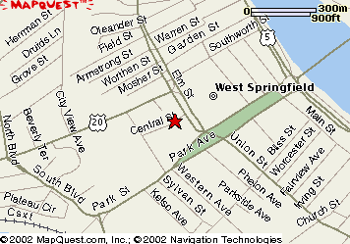Building**

Take Massachusetts Turnpike to Exit 4, West Springfield. At Exit 4, follow I-91 South signs towards Springfield. Take exit 13B (Route 5 South) off of I-91 South. This will be Riverdale Street. You will see plazas on your left; at traffic signals there will be Cinemas on your right. Go thru these traffic lights past the Cinemas, and take your first right onto Elm Street. Stay on Elm Street and proceed thru two sets of lights, (the first set is at the intersection of Elm Street and Kings Highway; continue straight through those lights, the second set of lights will be at the intersection of Elm Street and Westfield St. (Route 20) go straight through those lights). Central Street will be on the right. Take a right onto Central Street. The Municipal Office building is the brick building on the right – there are park lots on the left.

