.J

•. !-

COMMONWEALTH OF MASSACHUSETTS

SUFFOLK COUNTY BOARD OF REGISTRATION IN DENTISTRY

)
In the Matter of )
Deborah A. Grassey, RDH )

Docket No. DEN-2013-0085

CONSENT AGREEMENT FOR REPRIMAND

The Massachusetts Board of Registration in Dentistry ("Board") and Deborah A.
Grassey, RDH ("Licensee"), License 1 No. DH4134 ("License"), do hereby stipulate and agree that the following information shall be entered into and become a permanent part of
the Licensee's record maintained by the Board.

- The Licensee hereby states that she voluntarily enters into this Consent Agreement ("Consent Agreement") to resolve the matters set forth in Docket No. DEN-2013- 0085 ("Complaint").

- The Licensee acknowledges there are sufficient facts in the Complaint from which the Board could reasonably find grounds for discipline under M.G.L. c. 112, § 61 and Board regulations.

- The Licensee and the Board stipulate and agree to resolve this matter without making any findings and without having to proceed to a formal adjudicatory hearing on the Complaint as follow:

  - On July 26, 1971, Licensee was issued a license to practice dental hygiene in the Commonwealth. Licensee renewed her License biennially from July 26, 1971, until on or about March 31, 2011 when License failed to renew her License in violation of M.G. L. c. 112, §51 and 234 CMR 4.10(2) and (4). Thus, her license to practice dental hygiene expired on April 1, 2011.

- Licensee practiced in the Commonwealth without a license from March 31, 2011, until on or about March 21, 2013 when she was informed her License was expired. Thus, Licensee practiced without a dental hygiene license from April1, 2011 until on or about March 21,2013 in violation of M.G. L. c. 112,
§52 and 234 CMR 9.05(6).

- Licensee submitted her license renewal application to the Board and her

1 The term "license" or "License" applies to both a current and expired license as well as the right to renew an expired license.

..·

Grassey, Deborah DEN-20 13-0085 DH4134

License was renewed on April 4, 2013.

- Licensee failed to notify the Board of address change within 30 calendar days of such change in violation of 234 CMR 4.11(1).

- To resolve this matter without further proceedings before the Board, the Licensee agrees and the Board hereby imposes a Reprimand on her license pursuant to 234 CMR 9.03(2)(a) to become effective the date on which this Consent Agreement is signed by the Board ("Effective Date").

- The Licensee understands her action in entering into this Consent Agreement is a final act and not subject to reconsideration, collateral attack or judicial review in any form or forum.

- Within thirty (30) days of the Effective Date, Licensee shall provide a copy of the Consent Agreement to all jurisdictions where she holds or has held any professional license.

  - Licensee shall provide written documentation to the Board demonstrating her compliance with paragraph 6.

  - If Licensee is not licensed to practice dental hygiene or another profession in any other jurisdiction, she shall submit a signed attestation to the Board stating such.

- Within 6 months of the Effective Date, the Licensee shall provide written proof satisfactory to the Board that she has taken and successfully passed three hours of course work in Infection Control.

- The Licensee acknowledges and understands the Consent Agreement is a public record within the meaning of M.G.L. c. 4, § 7 and as such may be disseminated to the public.

- The Board agrees that by Licensee entering into the Consent Agreement, the Board will forgo further prosecution of the Complaint unless the Licensee does not fulfill the stipulations as stated in Paragraphs 6 and 7 above.

- . The Licensee states that she enters the Consent Agreement of her own free will.
The Licensee further states that she is aware that she has a right to counsel in this matter and either has conferred with counsel prior to signing the Consent Agreement or waives her right to have counsel.

- A waiver by the Board of any provisions of the Consent Agreement at any time shall not constitute a waiver of any other provision of the Consent Agreement, nor shall it constitute waiver by the Board of its rights to enforce such provision at any future time.

2

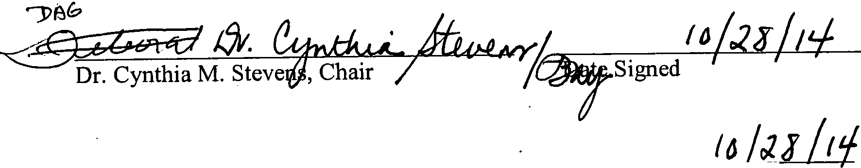..

Grassey, Deborah DEN-20 13-0085 DH4134

- The Licensee has read Consent Agreement. The Licensee understands she has the right to a formal adjudicatory hearing concerning the allegations set forth in the Complaint and that at a hearing she would have the right to confront and cross­ examine witnesses, call witnesses, present evidence, testify on her own behalf,
    - contest the allegations, present oral argument, seek judicial review and to all other
rights set forth in the State Administrative Procedure Act, M.GL. c. 30A and 801 CMR 1.00 et seq. By executing this Consent Agreement, Licensee knowingly and voluntarily waives her right to a formal adjudicatory hearing and to all of the above-enumerated rights set forth in the State Administrative Procedure Act, M.GL. c. 30A and 801 CMR 1.00 et seq.

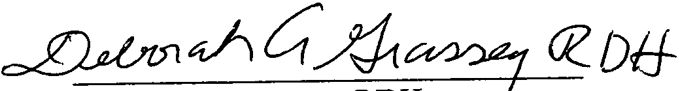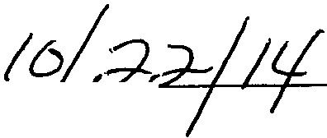Licensee

Date Signed/ Board of Registration in Dentistry

Effective Date I I

3

