i-FamilyNet User Management:
System Administration Tutorial

Department of Children & Families

Update date: 01/18/2017

Function of Administrators in i-FamilyNet:

Following are two aspects of System Administration in i-FamilyNet

Organization: Create divisions at Corporate / Lead Agency or Service Delivery Sites. Consumers or Cases could be assigned to these divisions for provision of services.

Users: Associate staff to agency or sites or divisions. Provision roles to staff at the associated organizations. This allows the system administrators to control which consumers/cases/homes i-FamilyNet user is able to access within their agency.

Administration roles in i-FamilyNet:

System Administrator: Has the ability to create and manage divisions, attach users to divisions and provision i-FamilyNet roles to users. This role cannot provision other System Administrator roles. The role can be assigned to more the one staff person in a provider agency.

Access Administrator: Has the ability to create and manage divisions, attach users to divisions and provision i-FamilyNet roles to users. This role can provision other System Administrators . The role can be assigned only to one person per agency. Please contact the DCF Help Desk once a staff person has been identified to get this role.

Administration Setup rules

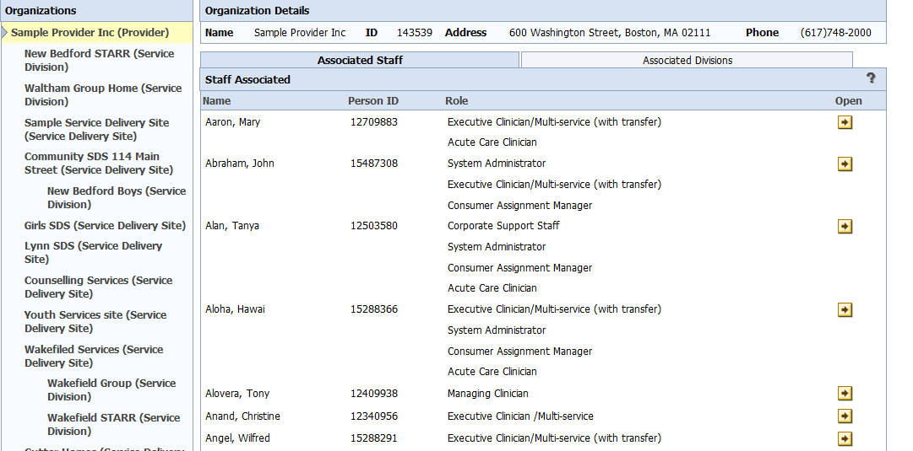
b.
#3
a.
d.
c.
#1
#2
- If a user is associated to the main organization (provider Level) (#1) they will have access to the consumers/cases/homes in all Service Delivery Sites (#2, #3) and all Divisions (a, b, c , d) within those organizations.
- If a user is associated to a Service Delivery Site (#3) they will have access to the consumers/cases/homes in that SDS and any divisions (c, d) that have been created under that SDS.
- If a user is associated to a specific division (a, b, c , d) they will only have access to the consumers/cases/homes in that Division.

Associate Staff to a Work Location

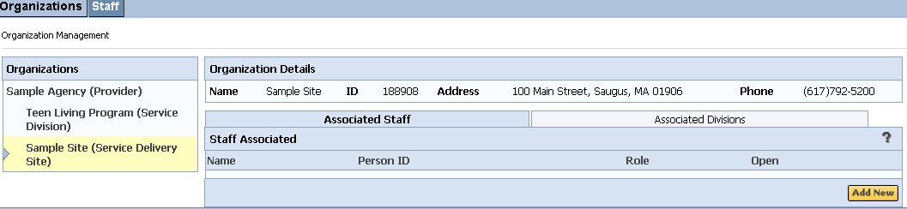
a

Select the Service Delivery Site/Service Division/Family Resource Division to which you wish to grant the user access. You will see a list of staff members who are currently associated to the site on the Associated Staff tab.

Click the Add New button to add a user to the highlighted Service Delivery Site/Service Division/Family Resource Division (a).

Associate Staff to a Work Location.. Continued

- You will see a list of all staff in your agency that have active Virtual Gateway accounts. If you do not find a specific name in this list it is because that person’s Virtual Gateway account has not been created.
- Click the Action button across from the user whom you would like to associate to this site.
Joe Worker
Neal Worker
Joan Worker

Associate Staff to a Work Location.. Continued

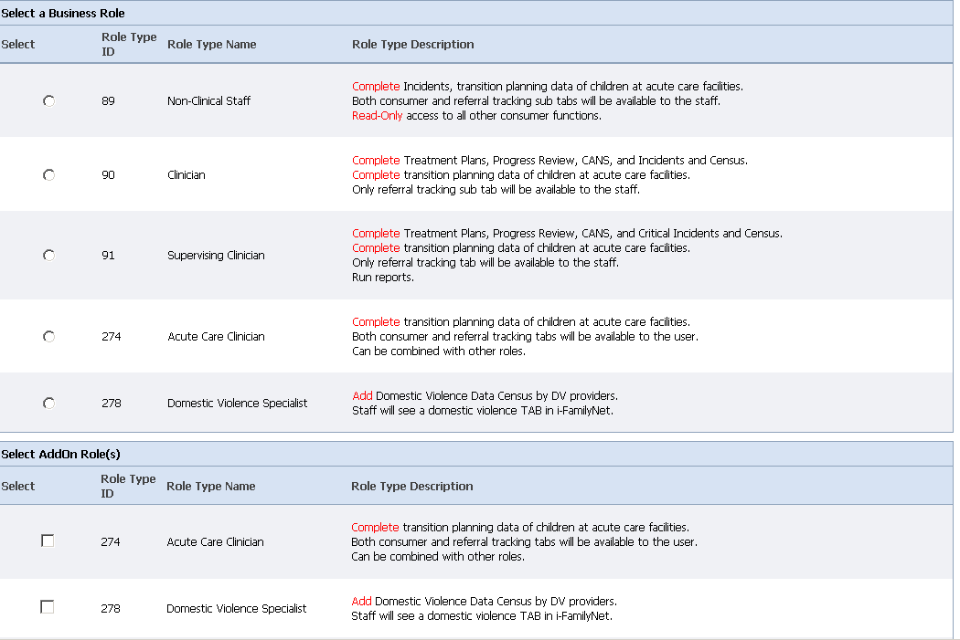
- Select ONE appropriate Business Role and Add-On Roles (If applicable) from the list presented.
- Please note that a staff person with a role at the corporate level can also be attached to a different role at a Service Division / Service Delivery Site (This shouldn't be a frequent situation)

How to Edit/End Date a Staff Association

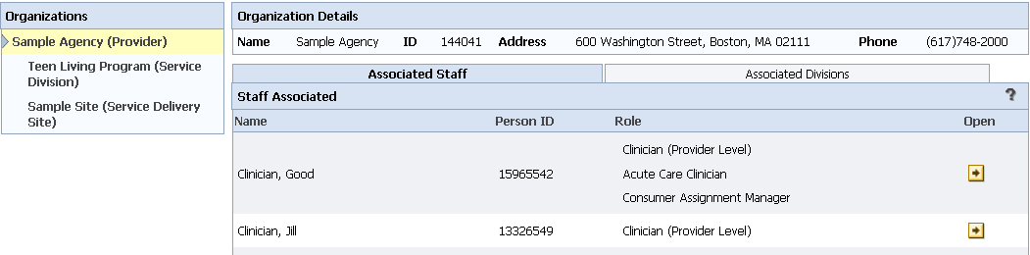
- Click the “Admin” tab, then the “Staff” sub-tab. This will display all staff from your agency that have a Virtual Gateway account.
- Select the staff member whom you would like to apply changes to. You will see each of their Organizational relationships and specific role within each organization. (see picture above)
- Click the Open button to the right to edit or end date a role.

How to Edit/End Date a Staff Association

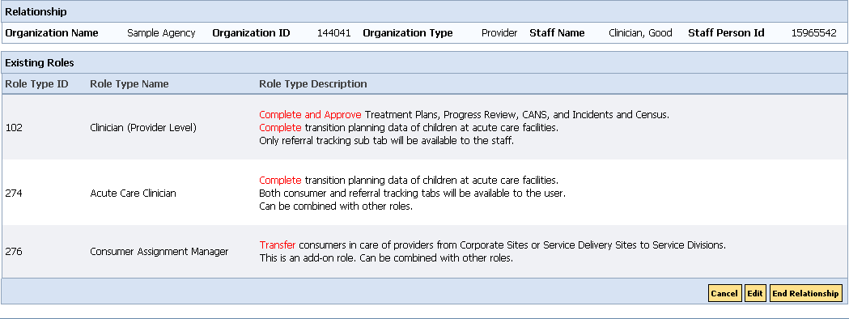
Click on the Edit button to edit the roles
Click on End Relationship button to terminate the association of a staff to an organization

Creating Divisions

Network Provider/ Family Resource Provider: This functionality allows System Administrators the ability to create one or more organizational divisions within a network provider main organization or Service Delivery Site. Once divisions have been created providers can assign cases, consumers, or family resource homes to those divisions. (Family resource homes are assigned to a staff member within a division). Divisions allow the user to select a specified grouping of cases, consumers, or family resource homes.

Lead Agencies: This functionality will allow the creation of case divisions within a Lead Agency in order to assign cases to specific staff persons. Divisions can be created only by users with a role of system administrators.

Creating Divisions.. Continued

- Select the Corporate Level Provider, at the top, or a Service Delivery Site (SDS), or a Lead Agency from the navigation pane.
- Click the “Associated Divisions” tab to the right. You will see any existing Divisions that have been created for that location.
- Click Add to create a new Division.

Creating Divisions.. Continued

How to End a division
- Select the Corporate Level Provider, at the top, or a Service Delivery Site (SDS), or a Lead Agency from the navigation pane.
- Click the “Associated Divisions” tab to the right. You will see any existing Divisions that have been created for that location.
- Click Add to create a new Division.

- Click the “End Division” button.
- Click the “Action” button to the right of the Division that you would like to end.
You cannot end a division that still has consumers/cases/homes assigned to it. If you attempt to do so you will receive an error message. You must reassign these before completing the steps noted above.

Questions

Please contact your DCF planner.

or

Contact EHS IT Service Center at 617.994.5050

(Monday through Friday: 6AM – Midnight)

