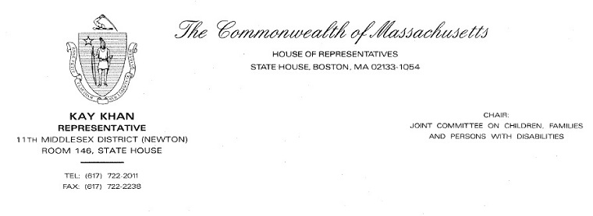
October 6, 2016
His Excellency Charlie Baker
Governor of the Commonwealth of Massachusetts
State House, Room 280
Boston, MA 02133

Dear Governor Baker,

I write to you today in regards to the recent proposal put forth by the Board of Registration in Nursing (BORN), which would amend 244 CMR 3.00, 6.00, 7.00, and 10.00 of the Nurse Practice Act. More specifically, I wish to voice my concerns and request clarification on the proposed amendments, which I believe should be reconsidered before the Administration proceeds in adopting any changes.

The changes of particular concern are those to 244 CMR 3.00, which regulates the scope of practice for licensed practical nurses and registered nurses, and sets requirements for delegation by nurses. Administration of complex and potentially life-threatening medication is a critical piece of licensed nurses’ specialized education, training, and practice, and guidelines surrounding delegation to nursing assistive personnel must be clear in order to ensure quality delivery of care and patient safety.

However, as currently written the BORN proposal could be interpreted as a broad expansion of the delegation of nursing activities, including permitting unlicensed individuals to perform medication administration in any setting, even those that are acute or long-term. This change stands in contrast to existing practice which carefully dictates that only licensed nurses may administer medication, with the exception of two specific programs related to limited group home and school settings.

In addition to ambiguity surrounding the setting of medication administration, I believe the regulations could also be strengthened in 244 CMR 3.04 and 3.05, relative to nursing activities that can and cannot be delegated. In particular, I believe the regulations should require that delegating activities meet all of the listed criteria, rather than ‘one or more.’ Such a change would more closely align the regulations with the delegation model recommendations promulgated by the American Nurses Association and the National Council of State Boards of Nursing and ensure that delegation is employed in the appropriate circumstance and in a way that results in safe and effective nursing care.

Because of the concerns raised above, I believe that the regulatory proposal as written may have unintended consequences that negatively impact our health care delivery system by increasing risks for medication errors and lowering the high standards of safety and care for which Massachusetts is known.
My understanding is that BORN has put forth these changes with the aim of clarifying and strengthening previously vague guidance for nurses in the delegation of medication to an unlicensed individual. While I appreciate BORN’s intentions, I do not support the Administration’s adoption of the regulations as currently drafted.

As such, I respectfully request that BORN reassess and redraft the regulatory proposal in order to ensure clarity on who specifically is qualified to perform medication administration and in what settings it is permissible. I would also urge BORN to extend the public comment period for a period of 60 days, in order to clarify the proposed changes, continue to solicit feedback from key stakeholders, and potentially improve the regulations.

I thank you for your commitment to engaging the public on this important health care issue and hope that you will consider the concerns that have been raised during the public comment period.

Sincerely,
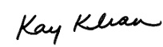
State Representative Kay Khan
House Chair, Joint Committee on Children, Families & Persons with Disabilities
11th Middlesex District (Newton)

Cc: Catrice C. Williams, Office of the General Counsel, Department of Public Health

