Summary of Pricing Methodology for Accountable Care Organizations and Managed Care Organizations – February 7, 2017
In December 2016, EOHHS released a detailed overview of the Accountable Care Organization (ACO) rate and benchmark setting methodology for MassHealth’s ACO program. In addition, EOHHS has described its Managed Care Organization (MCO) rate development process as part of its MCO procurement process. The appended documents, previously shared for informational purposes as part of the ACO and MCO procurements, describe the methodology by which EOHHS will develop rates and benchmarks for ACOs, and base capitation rates for MCOs; EOHHS encourages Bidders for the Request for Responses (RFR) for ACOs, Bidders for the RFR for MCOs, and other interested stakeholders to review these documents. Given that pricing methodologies for the ACO and MCO programs are linked, this document has been prepared to provide interested stakeholders a clarifying summary of critical features of EOHHS’s integrated pricing approach.
Specifically, EOHHS’s unified pricing approach:
- Combines historical MCO encounters and Primary Care Clinician (PCC) plan claims, and other claims and encounters for managed care eligible members, to set a common market-based Total Cost of Care (TCOC) standard
  - EOHHS will combine the experience of members in the PCC plan and MCO program to calculate a common market-based TCOC standard for members in each region and rating category; this market-based TCOC standard will be a key input into ACO and MCO rate and benchmark development.
- Sets TCOC for each individual ACO and the MCOs as a class, which will inform rate and benchmark development
  - Each Accountable Care Partnership Plan will receive a prospective capitation rate with the Medical component of such rate based on its TCOC.
  - Each Primary Care ACO and MCO-administered ACO will have a TCOC benchmark against which savings and losses are calculated after the end of the performance period.
  - MCOs will receive a prospective base capitation rate for the entire MCO class with the Medical component of such rate based on the class’s TCOC.
  - See the appended documents for a more detailed description of the adjustments made to determine TCOC Benchmarks for the Primary Care ACOs and MCO-administered ACOs and capitation rates for the Accountable Care Partnership Plans and MCOs.
- Assumes fee schedule parity across the Managed Care-eligible MassHealth population
  - Historically, EOHHS has built into the MCO prospective capitation rates the assumption that hospitals will be paid no more than 105% of the MassHealth fee schedule and professional services will be paid no more than 110% of the MassHealth fee schedule.
  - Under the new pricing approach, EOHHS will (1) in aggregate increase the MassHealth fee schedules, including but not limited to hospital and professional fee schedules, and (2) assume that providers get paid (in aggregate/on average) at the MassHealth fee schedule when setting the capitation rates for Accountable Care Partnership Plans and MCOs and the TCOC benchmarks for Primary Care ACOs and MCO-administered ACOs. EOHHS intends to make this change in a way that is budget neutral for the Commonwealth and for impacted classes of providers.
- Transitions ACO and MCO TCOCs toward the common market-based TCOC standard over many years
  - EOHHS will calculate a “historical” TCOC for each ACO and the MCO class based on the TCOC for members that were historically attributed to each entity’s primary care providers in the combined MCO-PCC base dataset described above. EOHHS will then calculate a “Network Variance Factor” (NVF) for each ACO and the MCO class overall; the NVF will be the ratio of each entity’s “historical” TCOC to the common market-based TCOC standard, after normalizing for historical differences in unit prices paid and members’ risk scores, and other actuarial adjustments. Put another way, the NVF represents unexplained variance in entities’ “historical” TCOC after accounting for historical differences in unit price paid and member risk.
  - Each ACO, and the MCO class overall, will receive a rate or benchmark based on a TCOC that incorporates its specific NVF. The weight placed on the NVF will decline for ACOs and MCOs over the next seven to ten years, with the effect of bringing each entity’s base TCOC closer to the common market-based TCOC standard.
  - The NVF for each ACO and the MCO class will be calculated such that the weighted average NVF for all Managed Care-eligible members will equal 1.0.
  - Consider the following example for Rate Year 2018:
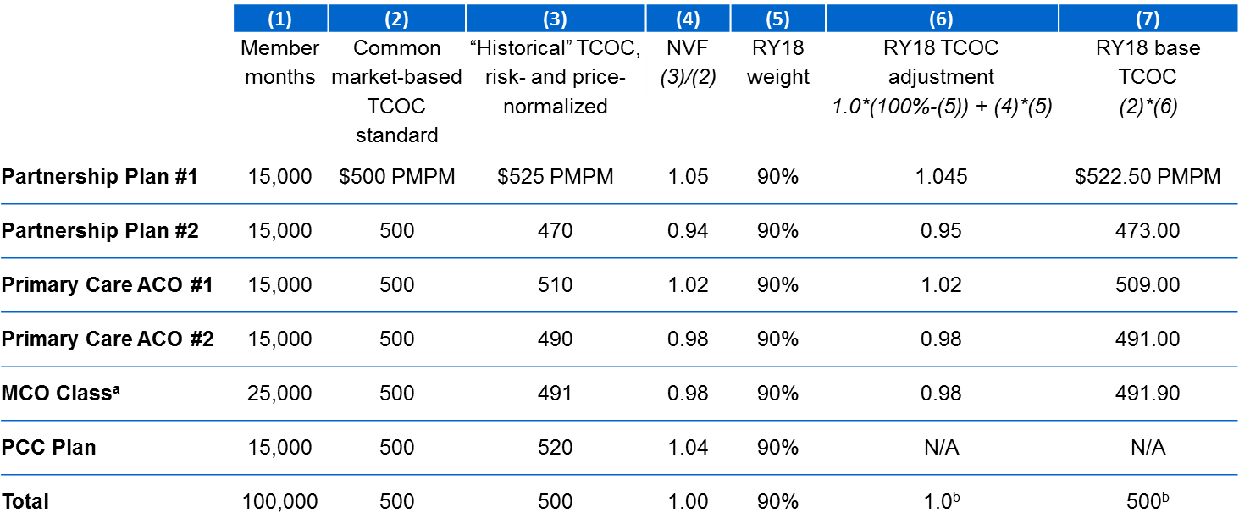
ª The MCO class’s base TCOC, which will inform the medical component of the MCO base capitation rate, reflects historical experience of MCO-administered ACOs, which will be included in MCO networks; those ACOs will share savings and losses with MCOs based on their own ACO-specific TCOC.
^{b} Totals arrive to a base TCOC of $500 PMPM (the common market-based TCOC standard) only under the assumption that the PCC plan incurs medical spending equal to $518 PMPM, in line with a NVF of 1.04 applied with a 90% weighting; that is, if the PCC plan achieves a TCOC analogous to an ACO with an identical NVF based on historical experience.
  - To calculate the actual TCOC benchmarks for Primary Care ACOs and MCO-administered ACOs, and the medical components of capitation rates for Accountable Care Partnership Plans and the MCO class, the base TCOCs illustrated above will be further adjusted for the acuity of attributed members, risk mitigation provisions, and several other factors.

Future information sharing
In March, EOHHS anticipates releasing further details on its pricing approach for the ACO and MCO programs, including but not limited to the following:
- The planned percentage increases in the MassHealth fee schedule
- The percent weight placed on the NVF for ACOs and MCOs in the first two years of the programs
- Risk mitigation details for Hepatitis C therapeutics in the ACO and MCO programs
- Details on the ACO quality slate, which impacts ACO shared savings and losses
In April, EOHHS anticipates releasing further details related to the following:
- Funding for administrative spending for Primary Care ACOs
- Details on how rates and benchmarks will be risk-adjusted
- The methodology for updating rates and benchmarks based on substantial network changes

EOHHS ACO Rate and Benchmark Setting Methodology for
The Request for Responses for Accountable Care Organizations
December 2016
NOTE: This document was posted in December 2016 on the COMMBUYS site for the Request for Responses for Accountable Care Organizations.
Executive Summary
Overview
This document provides a summary of the Executive Office of Health and Human Services’ (EOHHS) Accountable Care Organization (ACO) rate and benchmark setting methodology. EOHHS’ ACO rate and benchmark setting methodology is based on a set of consistent assumptions across ACO models, and balances risk mitigation with financial accountability for total cost of care (TCOC). EOHHS’ rate and benchmark setting methodology across all three ACO models will follow standard actuarial principles and methods, as well as annual processes for rate and benchmark development, communication, and acceptance.
EOHHS will provide ongoing information and support to potential ACO bidders in understanding rate and benchmark setting for ACO models. Please see the November process update document posted on COMMBUYS for additional details.
The information provided in this document is subject to change and is not binding on EOHHS. All information provided in this document, including example calculations, is for information and illustrative purposes only. Examples incorporate illustrative numbers (e.g., for administrative rates, capitation payments, etc.) that may not reflect actual values, and example calculations use simplifying assumptions that may not reflect actual calculations.
Methodologies and information provided in this document are subject to change as required to comply with any applicable laws and regulations and to obtain necessary approvals. All final terms and conditions of ACO participation shall be set forth in contracts to be entered into pursuant to the Request for Responses for Accountable Care Organizations (RFR).
Overview of Financial Accountability for ACO Models
All ACOs, across all three models, will be financially accountable for their populations’ utilization of included services. All ACOs are also accountable for the clinical quality and member experience of care.
An Accountable Care Partnership Plan (a Partnership Plan) is accountable under a prospective payment and is responsible for negotiating rates with providers and paying providers’ claims for services. A Partnership Plan is therefore accountable for both unit cost/provider rates as well as for utilization.
A Primary Care ACO is accountable to a price-normalized TCOC Benchmark compared to the Primary Care ACO’s price-normalized TCOC Performance. The Primary Care ACO is therefore primarily accountable for utilization, not differences in provider fee schedules.
An MCO-Administered ACO is also accountable to a price-normalized TCOC Benchmark. While the actual costs incurred by the MCO-Administered ACO’s Contracting MCO may vary based on the rates that MCO negotiates with individual providers, these costs will be price-normalized, so that the MCO-Administered ACO’s TCOC Benchmark and TCOC Performance are compared on a price-normalized basis. The MCO-Administered ACO is therefore primarily accountable for utilization, not differences in provider fee schedules.
“Price normalization” refers to a process EOHHS will use to ensure that costs of care are being compared “apples to apples” between a base period and a Performance Year, and across different EOHHS plans. Through price normalization, EOHHS will use a standard payment amount for a given type of event in a member’s care (e.g., a particular procedure performed by a particular type of provider), regardless of the “amount paid” shown on the claim or encounter, which may incorporate variation in fee schedules paid in different programs. For example:
During a base data year Member A was enrolled in an MCO and had a standard primary care office visit with the member’s PCP. Member A’s MCO paid that PCP $90 for that visit. During a Performance Year Member A is enrolled in Primary Care ACO 1 and has another standard primary care office visit with the member’s PCP. Under EOHHS’s fee schedule, EOHHS pays the PCP $110.
  - Without price normalization, Primary Care ACO 1 would look as if it had $20 in losses (22% of the cost of care for this visit) even though the actual utilization of care in the two periods is the same
  - With price normalization, EOHHS may, for example, count all primary care office visits with Member A’s PCP as $110, thereby allowing EOHHS to compare actual utilization of services.
EOHHS may provide additional details on EOHHS’s price normalization methodology, e.g., which services will be normalized, how these services will be defined, and how the normalization will be calculated and applied.
ACO-specific Benchmarks: Blend of market-based standard and ACO-specific TCOC
EOHHS intends to move to a pricing structure over time in which all ACOs are, after accounting for the risk profile of the members they serve, accountable to perform to the same, market-based standard. However, given that same ACOs may serve populations with historically higher or lower TCOC than average (even on a risk- and price-normalized basis), EOHHS will take a gradual, sustainable approach in shifting ACOs toward this full market-based accountability.
Initially, each Partnership Plan’s rate and each Primary Care ACO’s and MCO-Administered ACO’s TCOC Benchmark will be adjusted based on that ACO’s historical experience. EOHHS will make this adjustment by:
- Calculating a “market-based” rate for Accountable Care Partnership Plans and a “market-based” TCOC Benchmark for Primary Care ACOs and MCO-Administered ACOs
- Calculating a “historical” rate for Accountable Care Partnership Plans and a “historical” TCOC Benchmark for Primary Care ACOs and MCO-Administered ACOs, based on the TCOC for members that were historically attributed to each ACO’s primary care providers in the base data
- Blending these two values together in a weighted average to produce an ACO-specific adjusted TCOC
EOHHS intends to reduce the weighting of ACOs’ historical experience and increase the weighting of the market-based standard over the course of the ACO program, transitioning ACOs sustainably toward market-based accountability. For example, EOHHS anticipates that in Performance or Contract Year 1 of the ACO program, each ACO’s historical experience will be weighted between 70-90%. This weighting is preliminary and subject to change.
Setting the market-based standard
Accountable Care Partnership Plans’ rates and Primary Care ACOs’ and MCO-Administered ACOs’ TCOC Benchmarks will be based on a common market-based standard. EOHHS will develop this standard by combining historical MCO encounters, PCC Plan claims, including behavioral health encounters, into a base actuarial dataset. EOHHS will use actuarial methods to normalize unit cost and other differences across programs. EOHHS will develop this standard for each population rate cell (i.e., combination of managed care region and rating category). This standard will also be adjusted for acuity, trend, program changes, and other factors that will take into account ACO-specific considerations. There will be separate rates for adults and children.
Because EOHHS’ PCC Plan and MCO program have historically assumed different fee schedules and had different cost patterns, producing a unified base rate that normalizes differences among programs, accounting for the ratio of historical PCC Plan vs. MCO members enrolled in the ACO, allows for fair standards for accountability in new models. For example:
- ACO 1’s enrolled members were, during the base period, 50% PCC Plan and 50% MCO enrollees. ACO 2’s enrolled members were, during the base period, 25% PCC Plan and 75% MCO enrollees.
- By setting the market-based standard across all managed care eligible members (i.e., both PCC Plan and MCO enrollees) in the base data, ACO 1 and ACO 2 are held accountable to the same, market-based standard for a given member. If a given member with a particular rating category, region, and risk score were to enroll in ACO 1, ACO 1 might get paid (or have incorporated into its TCOC Benchmark) a market-based standard of $500 (prior to modifying this rate for the ACO’s historical experience). If that member were to enroll in ACO 2, ACO 2 would similarly get $500 for this member.
- If instead EOHHS calculated separate TCOC standards for MCO and PCC Plan enrollees, and used each ACO’s historical mix of attributed members to determine the ACO’s TCOC Benchmark or rate, ACO 1 and ACO 2 might get different amounts (or have different TCOC Benchmarks) for this same member because of their different historical mixes of PCC Plan vs. MCO enrollees.
Fee schedule parity
EOHHS will incorporate the same fee schedule assumptions in its pricing of Accountable Care Partnership Plan rates, TCOC Benchmarks for Primary Care ACOs and MCO-Administered ACOs, and MCO rates going forward. EOHHS will use the EOHHS fee-for-service (FFS) fee schedule in setting capitation rates for Accountable Care Partnership Plans. EOHHS will assume that providers get paid (in aggregate/on average) at the EOHHS FFS fee schedule when setting the TCOC Benchmarks for Primary Care ACOs and MCO-Administered ACOs. EOHHS intends to make this change in a way that is budget neutral for the state and for impacted classes of providers, as a whole, e.g., EOHHS will raise the EOHHS FFS fee schedule for certain services. EOHHS may also establish additional policies to assist Accountable Care Partnership Plans and MCOs in developing networks that include geographically remote and specialty hospitals.
Risk mitigation for Hepatitis C Virus drugs
For Performance Year 1, EOHHS intends to mitigate ACOs’ financial risk associated with high-cost drugs that treat Hepatitis C Virus (HCV). EOHHS intends to provide details on the precise mechanism used to mitigate ACOs’ financial risk in early spring 2017. EOHHS may have additional risk mitigation strategies, including for high-cost pharmacy outside of HCV.
Section 1. Introduction and overview

1.1 Overview of this document
This document includes methodology detail for how EOHHS anticipates setting capitation rates for Accountable Care Partnership Plans and setting TCOC Benchmarks for Primary Care ACOs and MCO-Administered ACOs. The information provided in this document is subject to change and is not binding on EOHHS. All information provided in this document, including example calculations, is for information and illustrative purposes only. Examples incorporate illustrative numbers (e.g., for administrative rates, capitation payments, etc.) that may not reflect actual values, and example calculations use simplifying assumptions that may not reflect actual calculations.
Methodologies and information provided in this document are subject to change as required to comply with any applicable laws and regulations and to obtain necessary approvals. All final terms and conditions of ACO participation shall be set forth in contracts to be entered into pursuant to the Request for Responses for Accountable Care Organizations (RFR).
This document is organized into five sections:
- Section 1. Introduction and overview
- Section 2. TCOC measurement for all ACO models
- Section 3. Methodology for setting ACO rates and benchmarks
- Section 4. Reconciliation

1.2 Overview of ACO accountability
All ACOs, across all three models, will be financially accountable for their populations’ utilization of included services.
An Accountable Care Partnership Plan is accountable under a prospective payment and is responsible for negotiating rates and paying claims for services, and is therefore accountable for both unit cost/provider rates as well as for utilization.
A Primary Care ACO is accountable to a price-normalized Total Cost of Care (TCOC) Benchmark compared to the Primary Care ACO’s price-normalized TCOC Performance. The Primary Care ACO is therefore primarily accountable for utilization, not differences in provider fee schedules.
An MCO-Administered ACO is also accountable to a price-normalized TCOC Benchmark. While the actual costs incurred by the MCO-Administered ACO’s Contracting MCO may vary based on the rates that MCO negotiates with individual providers, these costs will be price-normalized, so that the MCO-Administered ACO’s Benchmark and Performance are compared on a price-normalized basis. The MCO-Administered ACO is therefore primarily accountable for utilization, not differences in provider fee schedules.
“Price normalization” refers to a process EOHHS will use to ensure that costs of care are being compared “apples to apples” between a base period and a Performance Year, and across difference EOHHS plans. Through price normalization, EOHHS will use a standard payment amount for a given type of event in a member’s care (e.g., a particular procedure performed by a particular type of provider), regardless of the “amount paid” shown on the claim or encounter, which may incorporate variation in fee schedules paid in different programs. For example:
Example 1: Price normalization
During a base data year Member A was enrolled in an MCO and had a standard primary care office visit with their PCP. Member A’s MCO paid that PCP $90 for that visit. During a Performance Year Member A is enrolled in Primary Care ACO 1 and has another standard primary care office visit with their PCP. Under EOHHS’s fee schedule, EOHHS pays the PCP $110.
  - Without price normalization, Primary Care ACO 1 would look as if it had $20 in losses (22% of the cost of care for this visit) even though the actual utilization of care in the two periods is the same
  - With price normalization, EOHHS may, for example, count all primary care office visits with Member A’s PCP as $110, thereby allowing EOHHS to compare actual utilization of services.
EOHHS will provide future information on the details of EOHHS’s price normalization methodology, e.g. which services will be normalized, how these services will be defined, and how the normalization will be calculated and applied.

1.3 Overview of prospective and retrospective accountability
All EOHHS ACOs will have financial accountability for the cost (and quality) of care for defined populations of members. However, the mechanism for this accountability differs between different models. In general, Accountable Care Partnership Plans are prospectively accountable, while Primary Care ACOs and MCO-Administered ACOs are held accountable through retrospective payment arrangements for shared savings and shared losses.
Accountable Care Partnership Plans
- EOHHS will pay an up-front payment (capitation payment) each month. This payment includes an administrative component and a medical component. The medical component is based on a per-member, per-month (PMPM) rate, which is different for each rate cell (i.e., region and rating category).
- The medical component of each month’s payment is risk adjusted based on each Partnership Plan’s members. These risk scores are updated quarterly based on the most complete encounter and claims data available for each Partnership Plan’s enrollees. The medical component does not include costs for wrap services that are paid on a fee-for-service basis by EOHHS and excluded from the covered services of the Partnership Plan Contract (e.g., LTSS). Section 2.4 further describes how LTSS will be incorporated in future program years.
- Because Partnership Plans are responsible for paying for enrollees’ covered services, Partnership Plans incur “prospective accountability” – they realize medical gains or losses based on the costs they pay relative to the up-front capitation payments they receive each month. For example:
Example 2: Medical gain and loss under prospective capitation
A Partnership Plan is paid a capitation rate with a medical component of $200 PMPM for all ACO-covered services in a given rate cell:
  - Member #1, enrolled for two full months, incurs no services in one month and $100 in cost in a second month. During this two month period, the ACO received a total of $400 for the cost of covered services, but only pays out $100. In this case, the ACO realizes a “gain” of $300 for this member over this time period.
  - Member #2, enrolled for the full first month, but only half the second month, incurs a cost of $150 in one month, and $250 in a second month. In this situation, the ACO is paid a total of $300, but pays out a total of $400. In this case, the ACO realizes a “loss” of $100 for this member over this time period.
- Partnership Plans maintain a risk sharing corridor arrangement with EOHHS, under which they share excess gains with EOHHS or are eligible to receive payments from EOHHS to mitigate excess losses. Under this arrangement, the ACO will retain full risk for the first ±3% of total gain or loss. Gain or loss beyond ±3% is shared on a 50/50 basis between the ACO and EOHHS. For example: suppose a Partnership Plan is paid, on average, a capitation rate of $500 PMPM for all rate cells, of which $460 PMPM is specific to projected medical costs. The table below illustrates the risk sharing provisions that would apply under various actual claim cost scenarios:
Example 3: Risk corridor calculations for Partnership Plans
DESCRIPTION | ACO 1 | ACO 2 | ACO 3
- Capitation Rate PMPM | $500.00 | $500.00 | $500.00
- Medical Component PMPM | $460.00 | $460.00 | $460.00
- Actual Claims Cost PMPM | $455.00 | $400.00 | $500.00
- Total Gain/(Loss) (#3 - #2) | $5.00 | $60.00 | ($40.00)
5. Gain/(Loss) Percentage (#4 / #2) | 1.1% | 13.0% | -8.7%
- Outside ±3% Window? | No | Yes | Yes
- Incremental PMPM in excess of ±3% Window (#4 – [3% x #2]) | N/A | $46.20 | ($26.20)
- Amount Paid to/(by) EOHHS (50% of #7) | N/A | $23.10 | ($13.10)
Primary Care ACOs and MCO-Administered ACOs:
- EOHHS will establish a preliminary TCOC benchmark for the Performance Year for each Primary Care ACO and MCO-Administered ACO. This TCOC benchmark will be a PMPM amount that is different for each rate cell, and EOHHS will provide an estimated composite TCOC benchmark based on the ACO’s anticipated number of enrollees in each rate cell.
- After the Performance Year, EOHHS will measure the ACO’s TCOC performance and reconcile it against the TCOC benchmark to determine whether the ACO has achieved savings or losses, as described in Section 4.1. During this reconciliation, EOHHS will update the ACO’s preliminary TCOC benchmark to calculate the ACO’s final TCOC benchmark, adjusting for actual program experience (e.g., member-level stop-loss), the ACO’s count of delivery events (see Section 2.3) and unforeseen program and/or fee schedule changes.
- EOHHS will also conduct risk adjustment based on the risk profile of the ACO’s enrollees or attributed members over the course of the Performance Year. EOHHS will also conduct TCOC reconciliation separately for each rate cell and then combine results based on each ACO’s actual mix of enrollees or attributed members, thereby fully adjusting for the mix of enrollees the ACO had during the Performance Year.
- Primary Care ACOs and MCO-Administered ACOs will share savings or losses based on the terms of each ACO’s risk track arrangement.
  - Primary Care ACOs will share savings or losses with EOHHS
  - MCO-Administered ACOs will share savings or losses with their contracted MCO(s), based on TCOC reconciliation calculations using a standard EOHHS methodology
Because the mechanism for accountability differs between Partnership Plans (which are prospectively paid) and the other ACO models (which are reconciled retrospectively), there are certain differences in the types of risk borne by ACOs in different models. Partnership Plans will bear “insurance risk,” like EOHHS MCOs, while Primary Care ACOs and MCO-Administered ACOs will bear “performance risk.” For example:
- Partnership Plans are at risk for program-wide higher than expected claims costs, whereas Primary Care ACOs and MCO-Administered ACOs’ final TCOC benchmarks incorporate retrospective updates to their preliminary TCOC benchmark, as described above, to capture unexpected variations in utilization and/or unit cost due to unforeseen events
- Certain types of risk mitigation (e.g., a risk corridor for the pharmacy category of service) are only applied for Primary Care ACOs and MCO-Administered ACOs. See Section 3.5 for more detail
Accountable Care Partnership Plans, like MCOs, will also receive actuarially developed administrative payments as part of the actuarially certified capitation rate. EOHHS may make smaller administrative payments to Primary Care ACOs.

1.4 Blend of market-based and ACO-specific TCOC
EOHHS intends to move to a pricing structure over time in which all ACOs are, after accounting for the risk profile of the members they serve, accountable to perform to the same, market-based TCOC standard. However, given the variation in TCOC performance among providers that is evident in the Commonwealth today, EOHHS will take a gradual, sustainable approach in shifting ACOs toward full market-based accountability.
Initially, each Accountable Care Partnership Plan’s rate and each Primary Care ACO and MCO-Administered ACO’s TCOC Benchmark will be adjusted based on that ACO’s historical experience. EOHHS will make this adjustment by:
- Calculating a “market-based” rate for Accountable Care Partnership Plans and a “market-based” TCOC Benchmark for Primary Care ACOs and MCO-Administered ACOs
- Calculating a “historical” rate for Accountable Care Partnership Plans and a “historical” TCOC Benchmark for Primary Care ACOs and MCO-Administered ACOs, based on the TCOC for members that were historically attributed to each ACO’s primary care providers in the base data
- Blending these two values together in a weighted average to produce an ACO-specific adjusted rate or benchmark
EOHHS intends to reduce the weighting of ACOs’ historical experience and increase the weighting of the market-based standard over the course of the ACO program, transitioning ACOs sustainably toward market-based accountability. For example, EOHHS anticipates that in Performance Year 1 of the ACO program, each ACO’s historical experience will be weighted between 70-90%. This weighting is preliminary and subject to change. EOHHS anticipates making this transition over the course of 7-10 years, although may adjust the pace of this transition. Exhibit 1 below illustrates how rates of two illustrative ACOs would blend historical performance with the market-based standard.
Exhibit 1: Blending ACOs’ historical performance with a market-based standard

- ACO 1: This ACO has lower historical TCOC compared to the market-based standard after price- and risk/rate cell-normalizing its experience. This ACO will receive capitation rates/TCOC benchmarks that are lower than the market-based standard in the initial years of the program, but the rates/benchmarks will converge to the market-based standard over time. This ACO would thus see higher increases in capitation rates/TCOC benchmarks from year to year compared to the market-based standard increases.
- ACO 2: This ACO has historical performance reflecting higher costs compared to the market-based standard, even after price- and risk/rate cell-normalizing its experience. This ACO will receive capitation rates/TCOC benchmarks that are higher than the market-based standard in the initial years of the program, but the rates/benchmarks will converge to the market-based rate over time. This ACO would thus see lower increases, or even decreases, in capitation rates/TCOC benchmarks from year to year compared to the market-based standard increases.
The following graphic illustrates the overall workflow EOHHS will follow to set capitation rates for Partnership Plans and TCOC benchmarks for Primary Care ACOs and MCO-Administered ACOs. The remainder of this document described this workflow in additional detail.
Exhibit 2: Illustrated workflow for setting ACO rates and TCOC benchmarks
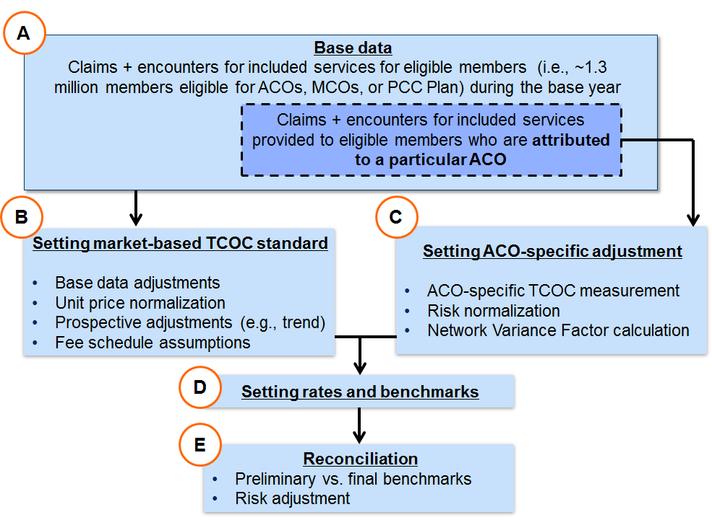
Section 2 of this document details base data (A); Sections 3.1-3.3 detail setting the market-based TCOC standard (B); Section 3.4 details setting ACO-specific adjustments (C); Section 3.5 details setting ACO rates and benchmarks (D); and Section 4 details reconciliation (E).
Section 2. TCOC measurement for all ACO models

This section describes the base data, its inclusions and exclusions, and how TCOC is defined for EOHHS’s ACO program.
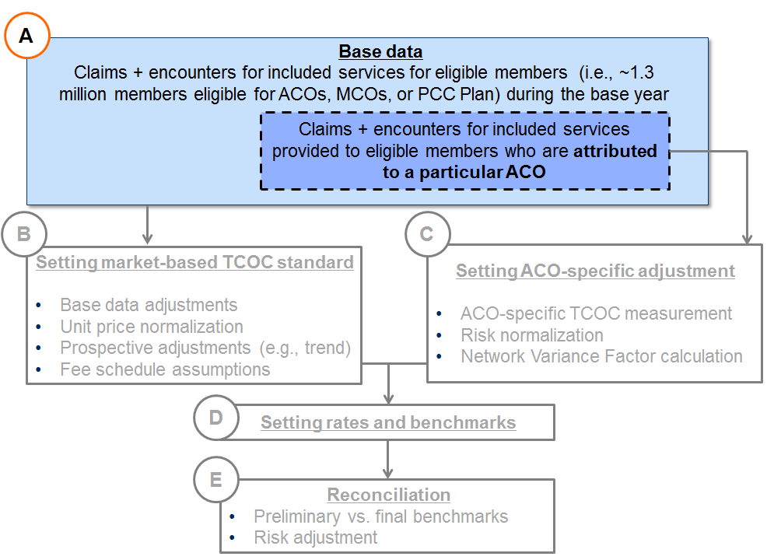

2.1 Included vs. excluded members
EOHHS will set ACO capitation rates and TCOC benchmarks based on costs for members eligible to enroll in EOHHS ACOs, MCOs, or the PCC Plan, which consists of those categories of individuals eligible to enroll in the current MCO Program and the PCC Plan. Coverage type eligibility criteria are described in more detail in 130 CMR 505.000.
Members who are not eligible to enroll in EOHHS MCOs or the PCC Plan include, for example:
- Most members with dual Medicare/Medicaid eligibility
- Most members with other third-party liability, such as partial commercial coverage, or who receive premium assistance rather than primary coverage from EOHHS
- Certain members in institutional settings of care
- Members not otherwise eligible for the current PCC Plan or MCO program.
Additional information regarding managed care eligibility can be found at 130 CMR 508.000.
2.2 Rate Cells
EOHHS will set capitation rates and TCOC benchmarks individually for each rate cell. Rate cells are based on EOHHS’s managed care regions and EOHHS’s rating categories. There are five regions and six rating categories (and therefore thirty rate cells) for ACO rate- and benchmark-setting:
EOHHS’s five managed care regions: EOHHS enrollees are assigned to one of five geographic regions based on member eligibility profiles: Greater Boston, Central, Northern, Southern, and Western. Distinct capitation rates and TCOC benchmarks will be developed for each of the regions.
EOHHS’s six rating categories: EOHHS uses a rating category approach to ensure that differences between populations of members are adequately accounted for in actuarial calculations. The managed care eligible populations are divided into six rating categories, described below, that account for each enrollee’s age and coverage type. Capitation rate development, TCOC benchmark development, analysis, and reconciliation will combine enrollees of the same rating category.
- RC I Child: enrollees who are non-disabled and under the age of 21
- RC I Adult: enrollees who are non-disabled and age 21 to 64
- RC II Child: enrollees who are disabled and under the age of 21
- RC II Adult: enrollees who are disabled and age 21 to 64
- RC IX: Adult-only enrollees who are age 21 to 64, and in the EOHHS CarePlus coverage type, as well as not receiving Emergency Aid to the Elderly, Disabled, and Children through the EOHHS Department of Transitional Assistance.
- RC X: Adult-only enrollees who are age 21 to 64, and in the EOHHS CarePlus coverage type, and are receiving Emergency Aid to the Elderly, Disabled, and Children through the EOHHS Department of Transitional Assistance.
Actuarial analyses have shown that claim costs are materially different between the various rating categories described in this section. Setting capitation rates and TCOC benchmarks at the rate cell level (in conjunction with risk adjustment) appropriately accounts for the acuity level of the population enrolled in or attributed to the ACO, and automatically adjusts total program costs to reflect the actual demographic mix of the program. Costs for the entire Medicaid populations could be materially different than assumed to the extent that market-wide demographic shifts occur. For example:
Example 3: Effect of changes in rate cell mix
Suppose average costs for RC I and RC II members are $300 and $700 PMPM, respectively. If capitation rates were developed based on base data with an even distribution of RC I and RC II members, the overall PMPM would be $500. However, if the actual RC I and RC II distribution is 40% and 60%, respectively, the expected average costs would be $540, or 8% greater than the calculated rate. Calculating separate rates for each individual rating category allows for the rate to reflect this change in the mix; calculating a single rate for the population would not allow for this type of adjustment and would mean that ACOs are at risk for these changes.
Child/adult categories: EOHHS is moving to a more granular rate cell level in the ACO program compared to the current MCO program to reflect differences in costs between children (under 21 years of age) and adults (21-64 years of age). To the extent there are significant changes in the demographic mix between children and adults, the capitation rate and TCOC benchmark will adjust to reflect the difference in mix. Note: As described above, RC IX and RC X are adult-only rating categories (21-64 years of age) and are therefore not bifurcated into child/adult rating categories.

2.3 Included vs. excluded services
With the exception of specific services that are adjusted for risk mitigation (see Section 3.5 below), all ACOs will be financially accountable for the services that are covered by EOHHS MCOs and Partnership Plans. These services include, broadly, any services that are part of EOHHS coverage for managed care eligible members for physical health, behavioral health, pharmacy, or certain other services such as most home health and durable medical equipment. Please refer to the TCOC Included Services Appendix or ACO Covered Services Appendix of the appropriate Model Contract attachment to the RFR for a more detailed list.
EOHHS will include the historical costs for these services for EOHHS managed care eligible members (as described in Section 2.1 above).
There are certain EOHHS-covered services for managed care enrollees (e.g., LTSS) that are not paid for by MCOs today but are instead covered directly through EOHHS; these will continue to be covered by EOHHS for the initial years of the ACO program. ACOs will not be financially accountable for these costs during those initial years (see Section 2.4 for more detail on the future incorporation of LTSS into ACO models).
The table in Example 5 below illustrates several scenarios that might occur in the base data and whether, for each, those costs would be included in or excluded from the base data for setting ACO rates and benchmarks:
Example 4: Included vs. excluded services
Member | Service | Included in base data for rates or benchmarks?
MCO enrollee | Inpatient care paid for by MCO | Yes. This is an MCO Covered/ACO Covered Service provided to an eligible member
PCC Plan member | Outpatient BH paid for by behavioral health vendor | Yes. This is an MCO Covered/ACO Covered Service provided to an eligible member
FFS dually-eligible member | Inpatient care paid for by MassHealth | No. This is not an ACO-eligible member
MCO enrollee | LTSS care paid FFS by EOHHS (i.e., a Non-MCO Covered Service), e.g. Personal Care Services | Not in years 1-2. LTSS services, like PCA, are not MCO Covered or ACO Covered Services in years 1 and 2, and are not part of ACO accountability. On or about year 3, EOHHS intends to introduce LTSS (see Section 2.4)
Delivery payments: Deliveries are MCO Covered/ACO Covered Services; however, EOHHS will treat these costs differently from other costs in setting ACO rates and TCOC benchmarks. Deliveries will be initially excluded from the claims used to develop capitation rates and preliminary TCOC benchmarks and will instead be used to develop a separate per-delivery payment amount. Partnership Plans will receive a separate, supplemental delivery payment, which is retrospectively calculated by multiplying the actual number of deliveries each Partnership Plan’s enrollees have for a particular period, by the per-delivery payment amount. Primary Care ACOs and MCO-Administered ACOs will similarly have an amount added to their final TCOC benchmarks that is calculated by multiplying the actual number of deliveries each ACO’s enrollees have for the Performance Year, by the per-delivery payment amount. ACOs are therefore accountable for per-delivery costs, but not for the number of deliveries.

2.4 Incorporation of LTSS on or about Year 3
One of EOHHS’s goals for delivery system reform is to increase coordination among providers, including long-term services and supports (LTSS) delivery systems.
On or around the third year of each applicable contract, Primary Care ACOs and MCO-Administered ACOs will be accountable for the costs of LTSS. Accountable Care Partnership Plans will be responsible for managing and providing LTSS at such time, and will be required to provide a range of community-based services and supports as alternatives to traditional high-cost services. LTSS may include, but may not be limited to, services such as the following:
- Inpatient Chronic Disease and Rehab Hospitals (post-100 days of service)
- Outpatient Chronic Disease and Rehab Hospitals (post-100 days of service)
- Nursing Facilities (post-100 days of service)
- Adult Day Health
- Adult Foster Care
- Group Adult Foster Care
- Day Habilitation
- Continuous skilled nursing
- Personal Care Attendant (including a Transitional Living Program)
ACOs’ responsibilities around LTSS will be set forth and further specified in an amendment to the ACO contracts. ACOs may also have new requirements related to LTSS, such as continuity of care for LTSS, assessment and care planning, and integrated care management.

Section 3. Methodology for setting ACO rates and Benchmarks

This section describes the development of the market-based standard (sections 3.2 and 3.3) and ACO-specific adjustment (section 3.4), as well as how they are combined to produce capitation rates for Partnership Plans and TCOC benchmarks for Primary Care ACOs and MCO-Administered ACOs (section 3.5).
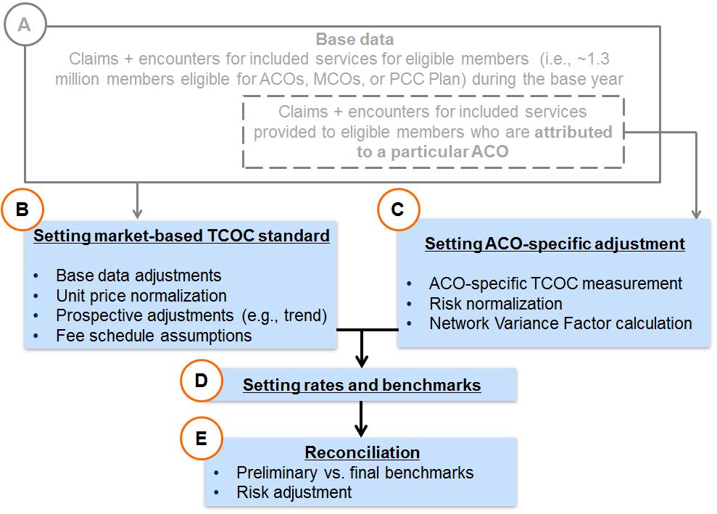

3.1 Recap of approach
EOHHS intends to establish all ACO capitation rates and TCOC benchmarks using the same market-based standard for the risk-adjusted costs of each rate cell, allowing for consistent accountability across the program. EOHHS also acknowledges that ACOs are starting in different places – some ACOs will have historically higher TCOC for their attributed populations, while others will have historically lower TCOC, even on a price- and risk/rate cell-normalized basis. Therefore, EOHHS will set each ACO’s capitation rate/TCOC benchmark based on both a market-based standard and an ACO-specific adjustment for the ACO’s historical performance. EOHHS will decrease the weighting of the ACO-specific adjustment over time to sustainably transition ACOs to a market-based standard. EOHHS anticipates making this transition over the course of 7-10 years, although may adjust the pace of this transition. Exhibit 1 above illustrates how rates of two illustrative ACOs would blend historical performance with the market-based TCOC standard.

3.2 Market-based standard
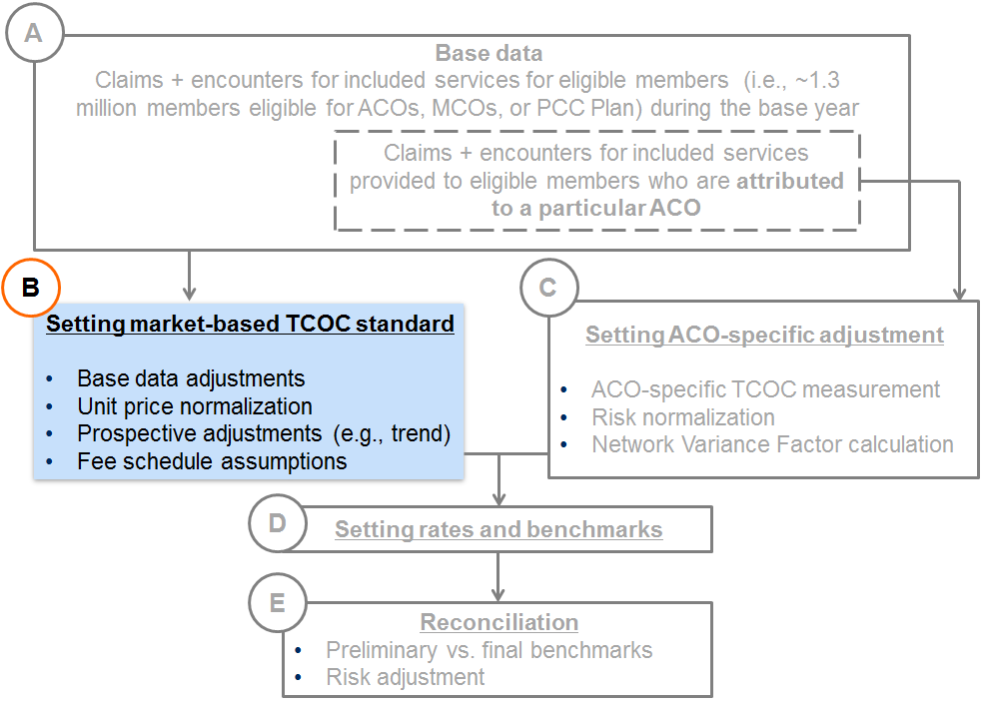
The market-based standard will vary by rate cell, as previously described. The development of the market-based standard will utilize eligibility and claims information from EOHHS’ MCO, ACO, and PCC Plan managed care programs and will represent the average expected cost of EOHHS Medicaid members across these managed care programs. The market-based standard will be developed as follows:
Step 1 - Base Data: Historical eligibility, encounter (e.g., from MCO and the PCC Plan’s behavioral health vendor), and claims data for eligible members will be combined for the purposes of the market-based standard development.

Step 2 - Base Data Adjustments: Historical data will be adjusted to develop a complete and consistent base data set:
  - Base period program adjustments: Historical experience will be adjusted for program events that occurred during the base period. The base data will also be adjusted for program differences that exist between the various managed care programs (MCO and PCC Plan, including the behavioral health vendor) to ensure that the base data reflects a consistent program definition in terms of covered populations and covered services.
  - Incurred but Not Reported Claims (IBNR): Claims will be adjusted for estimated IBNR claims unreported to EOHHS as of the latest runout date available. IBNR completion factors are developed using the claim lag method or other appropriate actuarial techniques.

Step 3 – Unit Price Normalization: Unit pricing across the base data set will be adjusted to reflect a common unit price level for covered services as determined by EOHHS. This is done to ensure that costs of care can be compared and combined on an “apples to apples” basis between different data sources (such as MCO encounters and PCC Plan claims) and between different time periods. EOHHS will apply a standard unit price amount for a given cost of care (e.g., a particular procedure performed by a particular type of provider), which will replace the actual “amount paid” shown on the claim or encounter. Without this adjustment, costs for the same services would potentially vary across members (or across time) due to variation in fee schedules paid in different programs. See additional information on assumed unit pricing levels discussed below in section 3.3, Fee schedule assumptions.

Step 4 - Prospective Adjustments:
  - Prospective program changes: Adjustments will be made for changes in the covered population, covered services, payment methodology, etc., that are expected to occur between the base period and the contract period. EOHHS will work with EOHHS’ actuary during the rate- and benchmark-setting process to identify upcoming fee schedule and other program changes that will impact expected rate or benchmark levels.
  - Prospective fee schedule changes: Pricing will be adjusted to reflect expected fee schedule changes between the base period and the contract period. See additional information on assumed unit pricing levels discussed below in section 3.3, Fee schedule assumptions.
  - Trend: Trend is intended to capture expected changes in utilization and service mix from the base period to the contract period. Note that unit cost trends will already have been captured in the fee schedule adjustment. As part of the development of trend, statistical methods, such as regression analysis and confidence intervals will be performed on EOHHS managed care data (i.e., MCO encounters and PCC Plan claims, including behavioral health vendor encounters). These statistical methods give a historical view of changes in the mix of services and utilization patterns over time. This retrospective review reflects a variety of influences, including potential changes in medical management practices, network construction and population risk. Some of these influences are accounted for in other adjustments described throughout this document, and should be considered within the broader context of other capitation rate and TCOC benchmark setting assumptions. However, a retrospective review of historical experience may not provide the full picture of utilization changes expected after the base data period. For this reason, several other sources of qualitative information will be utilized to inform the prospective trend adjustments applied to the base data.

Step 5 – Market-based standard: Expected costs of covered services, developed in steps 1 through 4, will be used to set separate rate or benchmark PMPMs by rate cell.
The resulting market-based standard represents the expected costs during the Contract or Performance Year on a price-normalized basis at the average performance level historically achieved across all ACOs, MCO plans, PCC Plan providers, etc., across the market.

3.3 Fee schedule assumptions
EOHHS will incorporate the same fee schedule assumptions in its pricing of Accountable Care Partnership Plan rates, TCOC Benchmarks for Primary Care ACOs and MCO-Administered ACOs, and MCO rates going forward. EOHHS will use the EOHHS FFS fee schedule in setting capitation rates for Accountable Care Partnership Plans. EOHHS will assume that providers get paid (in aggregate/on average) at the EOHHS FFS fee schedule when setting the TCOC Benchmarks for Primary Care ACOs and MCO-Administered ACOs. EOHHS intends to make this change in a way that is budget neutral for the state and for impacted classes of providers, as a whole, e.g., EOHHS will raise the EOHHS FFS fee schedule for certain services. EOHHS may also establish additional policies to assist Accountable Care Partnership Plans and MCOs in developing networks that include geographically remote and specialty hospitals.
Historically, EOHHS has established capitation rates that incorporated the following contracting efficiency assumptions (i.e., percentage of fee schedule assumptions):
- Inpatient contracting: MCO-reported encounters were adjusted to account for inpatient admission costs as calculated using the Adjudicated Payment Amount per Discharge (APAD) methodology. Capitation rates were adjusted to reflect inpatient hospital services at 105% of the APAD costs.
- Outpatient contracting: MCO-reported encounters were adjusted to account for outpatient hospital visit costs as calculated using the Payment Amount per Episode (PAPE) methodology. Capitation rates were adjusted to reflect outpatient hospital services at 105% of the PAPE costs.
  - Note: Effective December 2016, EOHHS will change from the PAPE to the Adjudicated Payment per Episode of Care (APEC) methodology. Future capitation rates and TCOC benchmarks will be determined using the APEC methodology.
- Physician contracting: MCO-reported encounters were adjusted to account for unit costs for Healthcare Common Procedure Coding System (HCPCS) Level I procedure codes 00000–99999. Capitation rates were adjusted to reflect physician services at 110% of the EOHHS FFS fee schedule.
- Other services: Contracting efficiency adjustments for all other services were not developed in the most recent MCO program capitation rates.
EOHHS will no longer incorporate such contracting efficiency assumptions for its Partnership Plan rates.
3.4 ACO-specific adjustments for historical TCOC performance
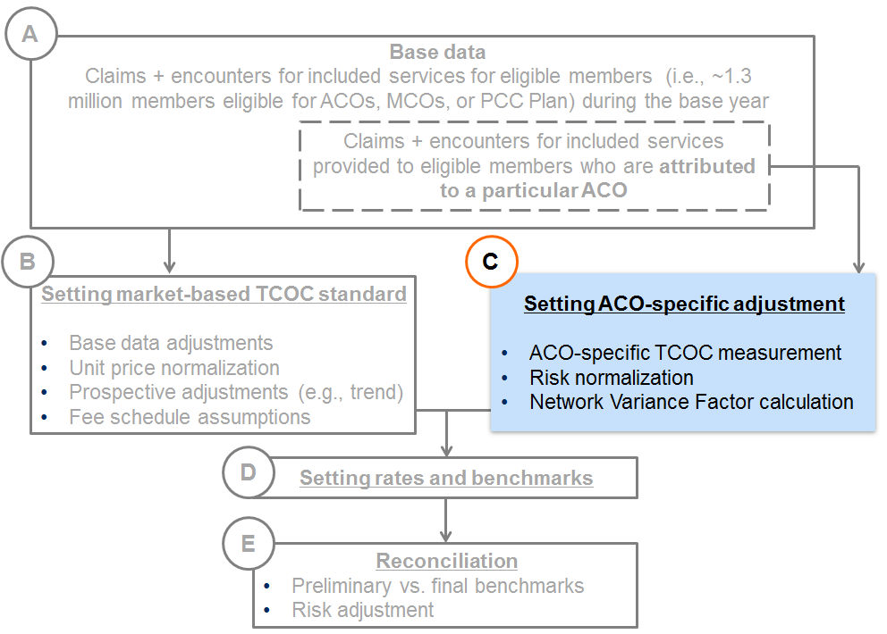
EOHHS intends to move to a pricing structure in which all ACOs over time are, after accounting for the risk profile of the members they serve, accountable to perform to the same, market-based standard. However, given that some ACOs may serve populations with historically higher or lower TCOC than average (even on a risk- and price-normalized basis), EOHHS will take a gradual, sustainable approach in shifting ACOs toward this full market-based accountability.
The weight assigned to ACO-specific TCOC performance will decrease over time, eventually leading to capitation rates and TCOC benchmarks that are fully in line with the market-based standard. EOHHS anticipates making this transition over the course of 7-10 years, although may adjust the pace of this transition. See Exhibit 1 above for an illustration of this transition. The development and application of the ACO-specific TCOC performance component of capitation rates/TCOC benchmarks is described below. The development varies slightly by ACO model due to the different risk mitigation adjustments applicable to each model (described in Section 3.5).
EOHHS will apply this ACO-specific adjustment through the following steps, each of which is described in additional detail below:
- Step 1: Calculating an ACO-specific TCOC
- Step 2: Risk-normalizing this ACO-specific TCOC
- Step 3: Developing a Network Variance Factor based on the risk-normalized ACO-specific TCOC
- Step 4: Applying the Network Variance Factor to the ACO’s market-based TCOC to develop the ACO’s adjusted TCOC
Step 1: Calculating an ACO-Specific TCOC
EOHHS will use the same base data used to calculate the market-based standard (see Section 3.2 above) and will attribute a population of members in this base data to each ACO, based on the primary care provider each member in the base data was assigned to and based on the set of primary care providers that are Participating PCCs/PCPs or Network PCPs for each ACO. EOHHS will then calculate a TCOC value for each ACO, based on the set of attributed members in the base data and the costs of covered services provided to those members. This value represents each ACO’s ACO-specific TCOC, based on historical performance.
Because ACO-specific TCOC is calculated using the same base data underlying the market-based standard, which is price-normalized, ACO-specific TCOC values will also be price-normalized. In other words, differences in ACO-specific TCOC will be driven by utilization and mix of services, not differences in historical unit pricing.
Step 2: Risk-normalizing this ACO-specific TCOC
Each ACO-specific TCOC will be risk normalized to back out the differences in risk scores for the populations attributed to each ACO. Risk scores are developed using EOHHS’ risk adjustment model, described further in Section 4.2. Average risk scores will be calculated for each ACO, as well as for the total population underlying the market-based standard. Relative risk scores will be calculated for each ACO by dividing the ACO-specific average risk score by the market-wide average risk score.
For example, if an ACO’s enrolled or attributed member population has an average risk score of 1.26, and the average risk score across the entire market is 1.05, then the relative risk score for this ACO would be 1.26/1.05 = 1.20.
The ACO-specific TCOC will then be divided by the ACO-specific relative risk score to calculate the risk-normalized ACO-specific TCOC. The example below illustrates the mechanics of this normalization process:
Example 5: Risk normalizing ACO-specific TCOC
 | TCOC | Risk  Score | Relative  Risk Score | Risk-  Normalized  TCOC
ACO 1 | $540.00 | 1.260 | 1.200 | $450.00
ACO 2 | $525.00 | 1.050 | 1.000 | $525.00
…
Market | $500.00 | 1.050 | 1.000 | $500.00

- TCOC: ACO-specific TCOC reflects total historical costs for each ACO’s enrolled or attributed member population. In this example, both ACO 1 and 2 have ACO-specific TCOC amounts above the market-based standard.
- Risk Score: This is the “raw” risk score calculated using EOHHS’ risk adjustment model. Note that the market-wide average score does not equal 1.00 when using raw scores.
- Relative Risk Scores: All scores are divided by the market-average score to calculate the relative risk score. Note that now the market average score equals 1.00. ACO 1 has a relative risk score above the market-average, while ACO 2 has a risk score equal to the market average.
- Risk-Normalized TCOC: The ACO-specific TCOC amounts are divided by the relative risk scores. Note that ACO 1 had the highest TCOC on an unadjusted basis, but now has the lowest TCOC on a risk-adjusted basis. This means that ACO 1’s TCOC performance is better than ACO 2, as well as the market-based TCOC, after considering that ACO 1’s population had much higher risk scores and acuity levels.
Step 3: Developing a Network Variance Factor (NVF) based on the risk-normalized ACO-specific TCOC
For each ACO, a network variance factor is determined by dividing the risk-normalized ACO-specific TCOC by the market-based standard. The network variance factor reflects the ratio of expected TCOC by ACO relative to the market-based standard, but excludes differences driven by unit pricing and risk score levels between ACOs. The example below calculates the network variance factors for ACO 1 and 2 included in the prior example above:
Example 6: Calculating Network Variance Factors for two ACOs
 | Risk-Normalized TCOC | Network Variance Factor
ACO 1 | $450.00 | 0.900
ACO 2 | $525.00 | 1.050
…
Market | $500.00 | 1.000
Step 4: Applying the NVF to the market-based standard to develop the ACO’s adjusted TCOC
Each year, each ACO’s capitation rate or TCOC benchmark will be based on a blend of the market-based standard and the ACO-specific TCOC. This blend is achieved by adjusting the market-based standard by a factor determined as a weighted average of the ACO-specific network variance factor and the market-based network variance factor (which will always equal 1.00). The weight applied to the ACO-specific network variance factor will be determined by EOHHS each year; higher weights will be used in the initial years of the program, with the weight reduced each year until full weight is given to the market-based standard.
The example below calculates the network variance factors for ACO 1 and 2 included in the prior examples above. This illustration assumes that a 90% weight will be applied to the ACO-specific network variance factor:
Example 7: Calculating ACOs’ NVF-adjusted TCOC
 | Risk-Normalized TCOC | Network Variance Factor | Blended Factor (90% ACO/  10% Market) | Market-Based Standard | ACO-Specific Rate
ACO 1 | $450.00 | 0.900 | 0.910 | $500.00 | $455.00
ACO 2 | $525.00 | 1.050 | 1.045 | $500.00 | $522.50
…
Market | $500.00 | 1.000 | 1.000 | $500.00 | $500.00

- Risk-Normalized TCOC: ACO-specific TCOC after risk-normalization.
- Network Variance Factor: ACO-specific Risk-normalized TCOC divided by the market-based standard.
- Blended Factor: Calculated as a weighted average of the ACO-specific network variance factor with the market-based factor (equal to 1.00). In this example, 90% weight is applied to the ACO-specific factor and 10% is applied to the market-based factor.
- Market-Based Standard: This is the market-based standard to which the blended network efficiency factor gets applied.
- ACO-Specific Rate: This is equal to the market-based standard times the blended network efficiency factor. These ACO-specific amounts form the basis for the medical component of Partnership Plan capitation rates and for the TCOC benchmarks for Primary Care ACOs and MCO-Administered ACOs.

Section 3.5 Additional steps in developing capitation rates and TCOC benchmarks
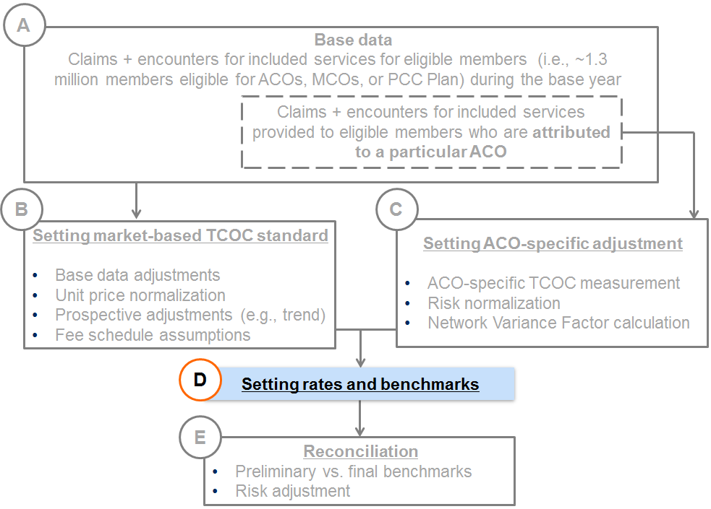
Partnership Plan Capitation Rates: Partnership Plan capitation rates will consist of the NVF-adjusted TCOC rate for each rate cell, calculated as described in Section 3.4 above, plus additional amounts for specific benefit add-ons, administrative expenses, and underwriting gain. The delivery payment (see Section 2.3) will be paid separately from the capitation rates. The example below illustrates how these additional PMPM items will be added to the ACO-specific rate (calculated above) to determine final capitation rates.
Example 8: Finalizing Partnership Plan capitation rates
 | ACO-Specific Rate | PMPM Benefit Add-ons | Administrative Expense | Underwriting Gain | Final Capitation Rate
ACO 1 | $455.00 | $5.00 | $30.00 | $15.00 | $505.00
ACO 2 | $522.50 | $5.00 | $30.00 | $18.00 | $575.50
…
Primary Care ACOs and MCO-Administered ACOs: Primary Care and MCO-Administered ACOs will have additional risk mitigation provisions in place compared to Partnership Plans (see Section 3.5), such as stop loss. Since these provisions will impact TCOC levels, both the market-based standard and the network variance factors applicable to these ACOs will be calculated using data that has been adjusted to reflect these provisions. The example below illustrates the calculation of ACO-specific network variance factors and weights after accounting for these risk mitigation provisions:
Example 9: Incorporating risk mitigation into TCOC benchmarks
 | TCOC | Adjusted TCOC | Relative Risk Score | Risk-Normalized Adjusted TCOC | Network Variance Factor
ACO 1 | $540.00 | $534.00 | 1.200 | $445.00 | 0.908
ACO 2 | $525.00 | $505.00 | 1.000 | $505.00 | 1.031
…
Market | $500.00 | $490.00 | 1.000 | $490.00 | 1.000

- TCOC: These are the ACO-specific TCOC amounts shown in previous example. These amounts are before adjusting for the Primary Care ACO and MCO-Administered ACO risk mitigation provision.
- Adjusted TCOC: These are the ACO-specific TCOC amounts after stop-loss claims have been adjusted, and service carve-outs have been excluded.
- Relative Risk Score: These are the ACO-specific relative risk scores described previously.
- Risk-Normalized TCOC: Calculated as the adjusted TCOC divided by the relative risk score.
- Network Variance Factor: Calculated as the ratio of the ACO-specific risk-normalized TCOC to the market-based adjusted standard (i.e., the market-based standard with similar adjustments applied as for the ACO’s TCOC – see example below). Note that these factors differ from those calculated in the prior example due to the differential impact of the risk mitigation provisions on the ACO-specific TCOCs.
Note that, to develop ACO-specific TCOC benchmarks, the network variance factor will be applied to the market-based TCOC after risk mitigation adjustments, as illustrated below:
 | Risk-Normalized Adjusted TCOC | Network Variance Factor | Blended Factor (90% ACO/  10% Market) | Market-Based Standard | ACO-Specific Rate
ACO 1 | $445.00 | 0.908 | 0.917 | $490.00 | $449.50
ACO 2 | $505.00 | 1.031 | 1.028 | $490.00 | $503.50
…
Market | $490.00 | 1.000 | 1.000 | $490.00 | $490.00

Section 4. Reconciliation and risk adjustment
This section describes how EOHHS will perform TCOC reconciliation calculations to determine shared savings and losses, and how risk adjustment is factored into this process.
Note
For Partnership Plans, TCOC and the associated capitation rates will be set prospectively prior to the contract period. These prospective rates will be risk adjusted on a quarterly basis, as described below. Aside from this risk adjustment, capitation rates will not be adjusted retrospectively. See section 4.3.
For Primary Care and MCO-Administered ACOs, TCOC benchmarks will not be finalized until after the performance period has ended. EOHHS will provide ACOs with preliminary TCOC benchmarks for informational and management purposes only, and will update these during reconciliation to produce the final TCOC benchmarks for shared savings/losses calculations. See sections 4.1 and 4.2
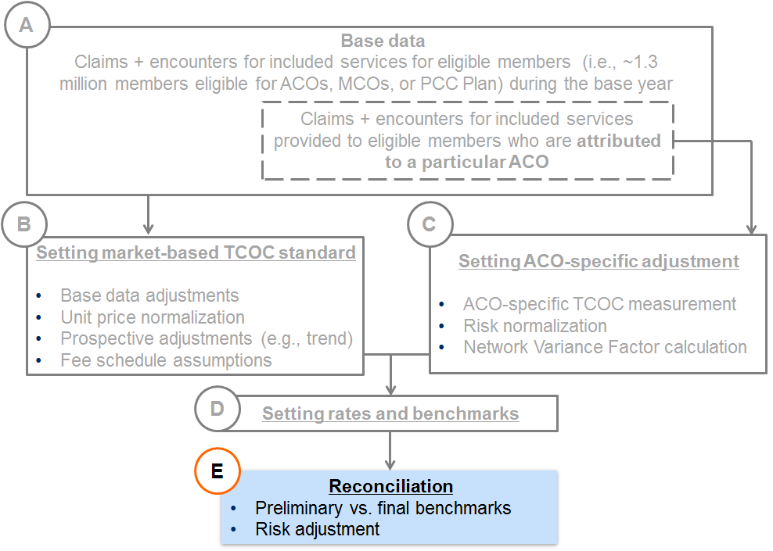

4.1 Retrospective reconciliation for Primary Care and MCO-Administered ACOs

Preliminary vs. Final TCOC Benchmark Adjustments
The intent of providing preliminary benchmark calculations to ACOs is to provide a meaningful target for ACO planning purposes. However, as outlined above, preliminary TCOC benchmarks will at a minimum change for each ACO to reflect: 1) performance period risk scores, 2) performance period enrollment mix by benchmark cohort, 3) performance period actual number of deliveries, 4) other factors.
EOHHS will consider the materiality and impact of updating the TCOC benchmark base period data to a more recent time period to see if retrospective base data corrections are needed. EOHHS may also adjust the preliminary benchmarks retroactively to reflect substantial shifts in policy introduced during the performance period that has an effect on TCOC, or to reflect other unforeseen events that have a material impact on TCOC. Examples of potential events that may warrant adjustments include the introduction of new high cost treatments that have a material and unforeseen impact on TCOC, or expansion of coverage to a previously ineligible population with significantly different average costs compared to other members.
TCOC Benchmark Aggregation
The TCOC benchmarks developed for each rate cell will be aggregated based on the actual enrollment distribution of ACO members by rate cell. The table below illustrates this concept for both the preliminary and final TCOC benchmarks.
Example 10: Illustrative TCOC benchmark aggregation
 | A | B | C
Rating category | Projected Member Months/Delivery Count | Preliminary TCOC Benchmark PMPM | Final TCOC Benchmark PMPM | Contract Period Member Months/Delivery Count
RC I – Child | 20,000 | $175.00 | $183.75 | 22,500
RC I – Adult | 10,000 | $450.00 | $450.00 | 15,000
RC II – Child | 2,000 | $1,000.00 | $1,010.00 | 1,500
RC II – Adult | 8,500 | $1,400.00 | $1,428.00 | 7,500
RC IX | 1,000 | $500.00 | $540.00 | 1,350
RC X | 100 | $1,000.00 | $1,079.00 | 150
Delivery Payment  (per event) | 50 | $6,000.00 | $6,000.00 | 75
TCOC Benchmark | 41,600 | $548.08 | $509.38 | 48,000

        - Projected Member Months/Delivery Count — Reflects the projected member months distribution for each ACO for the performance period. The figure shown for the delivery count represents the projected number of deliveries. This distribution is used to calculate the preliminary TCOC benchmark PMPM.
        - Preliminary TCOC Benchmark PMPM — This reflects the expected benchmark costs for each ACO and rate cell, reflecting the various adjustments outlined earlier in this document. These are calculated prior to the performance period and are provided to ACOs for planning purposes only.
        - Final TCOC Benchmark PMPM — These benchmarks are risk-adjusted based on the risk profile of the ACO’s enrolled or attributed members during the performance period. The final TCOC benchmark is calculated as the weighted average of each rate cell, using performance period member months and delivery counts as the weights. Note the denominator in the calculation of the weighted average PMPM excludes the number of deliveries. The final TCOC benchmark is the value that the ACO’s actual TCOC will be measured against for shared savings/losses calculations.
        - Contract Period Member Months/Delivery Count — This reflects the actual member months distribution for each ACO during the performance period. The figure shown for the delivery payment represents the actual number of deliveries. This membership distribution is used to calculate the final TCOC benchmark PMPM.

4.2 Risk Tracks and quality modifiers for Primary Care ACOs and MCO-Administered ACOs
Minimum Savings Ratio (MSR)
The MSR represents the minimum savings or losses that must be achieved before any savings/loss is shared by the ACO. It is determined as the savings/loss relative to the final TCOC benchmark. If savings/loss is below the MSR, then there are no shared savings or loss. Savings/loss above the MSR will be shared back to the first dollar at risk, i.e. shared savings/loss will include the value of the amount below the MSR. The purpose of the MSR is to ensure that any savings/loss is not the result of statistical random fluctuation but due to the performance of the ACO and its ability to provide appropriate care in the right setting at the right time while maintaining quality. Regardless of the ACO model risk track selected, the MSR will initially be set at 2%.
Savings/Loss Cap
Shared savings/loss for Primary Care ACOs and MCO-Administered ACOs will be capped such that these ACOs are not responsible for any additional savings or losses if performance differs from the benchmark by more than 10% of the TCOC benchmark. Instead, Primary Care ACOs and MCO-Administered ACOs with such performance levels will be treated as if they had savings or losses of 10%, the maximum amount under the cap, and will receive or pay shared savings/losses against this 10% amount based on their risk track. This threshold is in place to limit the maximum savings or losses payment for ACOs, mitigating risk.
Risk Tracks
Primary Care ACOs and MCO-Administered ACOs must choose one of the risk tracks within each model. Note the shared savings/losses are tiered between 0-3% and 3%-10%. To limit the exposure of the ACOs, the ACO’s percentage share of each dollar of savings/loss between 3%-10% of the TCOC benchmark is half the ACO’s share of each dollar of savings/loss between 0-3% within each track. The shared savings/loss for all tracks will gradually ramp up after the initial year.

Primary Care ACOs
The Primary Care ACO model has two tracks. They are:
- Risk Track 1- Shared Accountability
- Risk Track 2 - Full Accountability
The following chart compares the level of accountability under each Primary Care ACO risk track option:
Exhibit 3: Primary Care ACO Risk Tracks
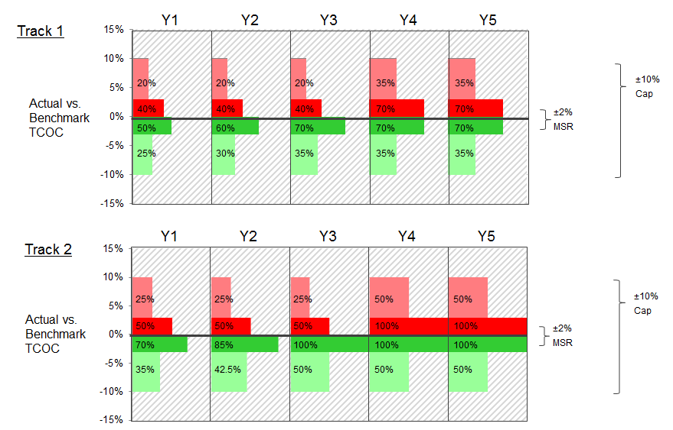

MCO-Administered ACOs
MCO-Administered ACOs have the option to choose between 3 different risk tracks. They are:
- Risk Track 1 – Limited Accountability
- Risk Track 2 – Moderate Accountability
- Risk Track 3 – Increased Accountability
The following chart compares the level of accountability under each Primary Care ACO risk track option:
Exhibit 4: MCO-Administered ACO Risk Tracks
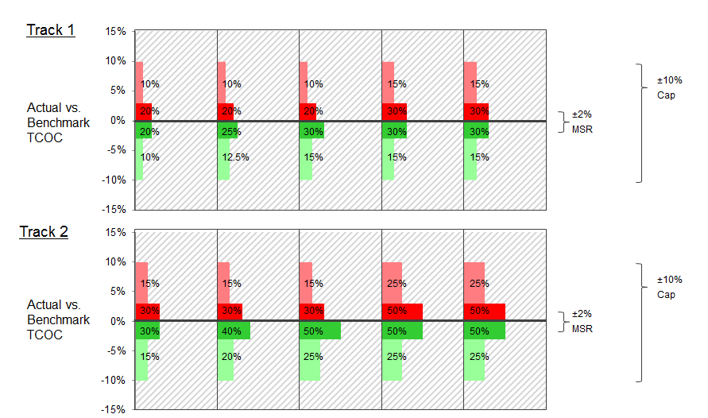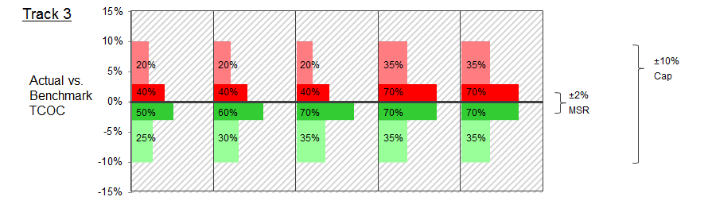Primary Care ACOs will share savings/losses with EOHHS. MCO-Administered ACOs will share savings/loss with Contracting MCOs, based on EOHHS’ standard TCOC calculation methodology, including reconciliation.
Shared savings and losses are also subject to each ACO’s quality score. See example below.
Example 11: Illustrative full TCOC reconciliation calculations
The table below shows three illustrative reconciliation calculations for a Primary Care ACO under Risk Track 1 in Performance Year 1 to demonstrate the mechanics of the reconciliation process. The shared savings and loss percentages will vary between the Primary Care ACO model and the MCO-Administered ACO model, and by risk track within each model. However, the illustrative concepts outlined in the table would apply to all tracks within each model if the appropriate risk sharing percentages are substituted in the calculations. Note that the reconciliation would be performed retrospectively after the end of the performance period.

Illustrative Shared Savings/Loss Reconciliation Calculations
(Dollar Values are PMPMs)
DESCRIPTION | ACO 1 | ACO 2 | ACO 3
Market Rate | $500.00 | $500.00 | $500.00 | A
Stop-Loss/Carve-out | 0.97 | 0.97 | 0.97 | B
ACO Specific Network Variance Factor | 1.01 | 1.02 | 0.98 | C
ACO Specific Risk Adjustment | 0.98 | 1.05 | 1 | D
Final TCOC Benchmark Target | $480.05 | $519.44 | $475.30 | E=AxBxCxD
Actual ACO Composite Performance | $480.15 | $503.69 | $594.18 | F
IBNR Completion Adjustment | 1.01 | 1.01 | 1.01 | G
Stop Loss Adjustment | 0.98 | 0.97 | 0.99 | H
Final ACO Composite Performance | $475.25 | $493.46 | $594.13 | I=FxGxH
Total Savings/(Losses) | $4.80 | $25.97 | ($118.83) | J=E-I
Performance vs. Target Percentage | 1% | 5% | -25% | K=J/E
Outside ±2% MSR Window? | No | Yes | Yes | L
Outside of Savings/Losses Cap? | N/A | No | Yes | M
Capped Savings/(Losses) | N/A | $25.97 | ($47.53) | N
Savings/Losses between 0 – 3% | N/A | $15.58 | ($14.26) | O
Sharing Percentage between 0 – 3% | N/A | 50% | 40% | P
Shared Savings/Losses between 0 – 3% | N/A | $7.79 | ($5.70) | Q=O*P
Savings/Losses between 3 – 10% | N/A | $10.39 | ($33.27) | R=N-O
Sharing Percentage between 3 – 10% | N/A | 25% | 20% | S
Shared Savings/Losses between 3 – 10% | N/A | $2.60 | ($6.65) | T=R*S
Shared Savings/Losses Before Quality Adjustment | N/A | $10.39 | ($12.36) | U=Q+T
Quality Score | 0.5 | 0.95 | 0.25 | V
Final Shared Savings/Losses | N/A | $9.87 | ($11.74) | Savings=U*V  Losses=U*(.8+.2*(1-V))

4.4 Risk adjustment in prospective and retrospective models
Risk adjustment will apply within each ACO model to adjust ACO-specific capitation rates/TCOC benchmarks to the risk level for each ACO.
For all ACO models, risk scores will be calculated using the Massachusetts Social Determinants of Health (SDH) Model, which is the same model that is currently used in the MCO program. This model currently relies on the following predictors: DxCG v4.2 concurrent Medicaid RRS, selected medical conditions, social determinants of health (disability indicators, housing indicators, and medical/behavioral indicators), and neighborhood-based predictors of health.
For Partnership Plans, capitation payments will be risk adjusted quarterly. Risk scores will be calculated and updated quarterly and will be based on a prior twelve month claims period. Specific adjustments will be made for enrollees with limited historical data and eligibility, including newborns. Risk adjustment will only apply to the medical expense component of the capitation rates, excluding delivery payments and explicit benefit add-ons.
Primary Care ACO and MCO-Administered ACO TCOC benchmarks will be risk adjusted using the same risk scoring model as described above. However, in contrast to the lagged claims data period used for Partnership Plan risk adjustment, Primary Care ACO and MCO-Administered ACO risk scores will be calculated on a fully concurrent basis using claims from the Performance Year.

Managed Care Organizations Bidders’ Conference – January 10, 2017
The enclosed materials were presented on January 10, 2017 at the Bidders Conference for the MassHealth Managed Care Organizations Procurement. The full presentation can be found on the COMMBUYS site for the Managed Care Organizations Procurement. The following materials have been converted from PowerPoint slides
Agenda / Contents
Highlights for RY18:
- Administrative component bidding
- Impact of Administrative Bid on Capitation Rate
- Level-setting fee schedule assumptions
- Rating categories and regions
- Market-based standard
- Supplemental Maternity payment
- Risk sharing with MCO-Administered ACOs
- Other Highlights
Rate Development Process
- Summary
- Base data
- MCO covered services
- Calculating the market-based standard
- MCO-Class adjustments
HIGHLIGHTS FOR RY18
Administrative component bidding
- New in RY18, Bidders have an opportunity to submit a bid for the Administrative Component of the Base Capitation Rate as outlined in Section 7.
- Exhibit 1 of Attachment E (Cost Response Information and Template) shows the average Administrative Component of the Base Capitation Rate under EOHHS’ current MCO and CarePlus Contracts for Contract Year 2017.
- The Bidder shall propose, as a per member per month (PMPM) rate for each rate cell, the lowest Administrative Component of a Base Capitation Rate with which the Bidder could successfully execute the responsibilities set forth in the Contract at Attachment A (Model Contract Managed Care Organization and Program).
- The Bidder shall only submit Administrative Components in its Cost Response that are equal to or below the administrative PMPM rates listed for each Rating Category and region in Exhibit 1 of Attachment E.
Impact of administrative bid on capitation rate
- Setting capitation rate in RY 2018 for each Rating Category and Region:
  - If the sum of the Bid and the Medical Component of the Base Capitation Rate announced by EOHHS is Actuarially Sound, that sum shall be the Contractor’s Base Capitation Rate for Contract Year 2018.
  - If the sum of the Bid and the Medical Component of the Base Capitation Rate announced by EOHHS is below EOHHS’ Actuarially Sound rate range for Contract Year 2018, the Contractor’s Base Capitation Rate for Contract Year 2018 shall be the lower bound of EOHHS’ Actuarially Sound rate range.
  - If the sum of the Bid and the Medical Component of the Base Capitation Rate announced by EOHHS exceeds the Base Capitation Rate announced by EOHHS prior to Contract execution, the Contractor’s Base Capitation Rate shall be the Base Capitation Rate announced by EOHHS.
  - If the Contractor’s Regions under this Contract are fewer than the Regions for which the Contract submitted a response to the RFR, the Contractor’s Base Capitation Rate for Contract Year 2018 shall be the Base Capitation Rate announced by EOHHS.
- Base Capitation Rates for Subsequent Contract Years
  - After the first Contract Year, EOHHS shall annually develop the Base Capitation Rates for each Rating Category in each Region.
  - EOHHS shall meet with the Contractor annually, upon request, to announce and explain the Base Capitation Rates, including the Medical Component and Administrative Component of the Base Capitation Rates.
  - Prior to the beginning of the new Contract Year, the Contractor may propose to increase or decrease the Administrative Component of its Base Capitation Rate from the previous year; provided, however that:
    - Such increase or decrease is reasonable, in EOHHS’ determination; and
    - The sum of the Contractor’s proposed Administrative Component and EOHHS’ announced Medical Component for the new Contract Year shall not exceed EOHHS’ announced Base Capitation Rate for the new Contract Year and shall be Actuarially Sound.
  - Alternatively, prior to the beginning of the new Contract Year, the Contractor may propose to decrease EOHHS’ announced Base Capitation Rate. If such proposal is reasonable in EOHHS’ determination and is Actuarially Sound, EOHHS may accept the Contractor’s proposed Base Capitation Rate, in its discretion
Level-setting fee schedule assumptions
- Historically, EOHHS has built into the MCO prospective capitation rates, the assumption that hospitals will be paid no more than 105% of the MassHealth fee schedule and professional services will be paid no more than 110% of the MassHealth fee schedule.
- EOHHS will now use 100% of the EOHHS fee-for-service (FFS) fee schedule equivalent in setting capitation rates for Managed Care Plans. EOHHS will assume that providers get paid (in aggregate/on average) at the EOHHS FFS fee schedule when setting the capitation rates.
- EOHHS intends to in aggregate increase the EOHHS FFS schedules, including but not limited to hospital and professional fee schedules, to arrive at an adjusted level of pricing parity across all MassHealth products and in order to ensure benchmark is achievable.
- EOHHS intends to make this change in a way that is budget neutral for the Commonwealth and for impacted classes of providers, as a whole.

Rating categories and regions
- MassHealth will set capitation rates at the rate cell level which is a unique combination of managed care regions and RCs.
- Starting in RY18 for the MCO Program, RC I and RC II will have separate capitation rates for Child and Adult. RCs IX and X are only for adults only so those RCs will not change.
- The RCs will be defined as:
  - RC I Child: ages 0–20 year non-disabled members
  - RC I Adult: ages 21–64 years non-disabled members
  - RC II Child: ages 0–20 years disabled members
  - RC II Adult: ages 21–64 years disabled members
  - RC IX: ages 21–64 years members
  - RC X: ages 21–64 years members
- Regions under the contract are as follows: Greater Boston, Central, Northern, Southern, and Western (please refer to Attachment A, Appendix F)
Market-based standard
- EOHHS intends to move to a pricing structure over the next 5–10 years in which all contracted entities (including ACOs and MCOs) are accountable to perform to the same market-based standard for medical costs, after accounting for the risk profile of the members they serve
- The development of the market-based standard will utilize eligibility and claims information from the MCO and PCC programs and will represent the average expected cost of EOHHS Medicaid members across all managed care programs (MCO, ACO, and PCC Plan).
- The market-based standard affects the medical component of capitation rates only; the administrative component will not be affected by this.
Supplemental maternity payment
- Starting in RY18, delivery payments will be used to eliminate differences in an enrolled population’s birth rate compared against a projected birth rate.
- The Supplemental Maternity Payment shall be for the inpatient MCO Covered Services for newborn deliveries.
- These MCO Covered Services shall be excluded from the development of the Base Capitation Rates and shall not be reflected in the Contractor’s monthly Capitation payment.
- As further specified by EOHHS, the Supplemental Maternity Payment shall not include costs associated with newborn infant admission post-partum or ante-partum, or costs of inpatient care associated with any maternity cases that end in termination or miscarriage
- A fixed payment will be made to cover the facility costs of each delivery event.
Risk sharing with MCO-Administered ACOs
- In year one, each MCO will be required to contract with all MCO-Administered ACOs in the MCO’s covered regions.
- MCO will share gains/losses with these ACOs resulting from utilization-driven decreases/increases in TCOC attributed to each ACO.
- MCO-Administered ACOs are not intended to be accountable for TCOC deviations due to MCO-specific unit pricing levels. ACO TCOC performance will be measured on a unit-price normalized basis.
Other highlights:
- Data Performance Deduction
  - Current MCO contract included a performance bonus for Managed Care Plans who achieve specified benchmarks for data submission.
  - The RY 18 contract includes a premium deduction that will be applied to contracted Managed Care plans that do not meet specified data submission criteria. (See Section 5.3.K.5 of the model contract, Intermediate Sanctions)
- Minimum Medical Loss Ratio
  - All contracted plans will be required to achieve a minimum Medical Loss Ratio of 85%.
Rate Development Process
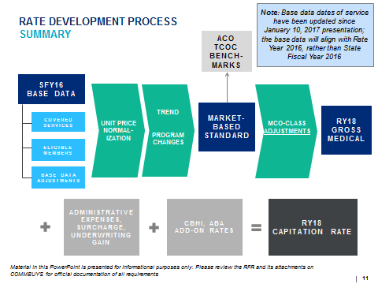
Base data:
- Rates for all managed care products will start with same base data for RY18.
- The base data will include all managed care eligible PCC Plan claims and MCO Program encounter data incurred from July 1, 2015 through June 30, 2016 (SFY16) paid through August 2016.
- Data standardization across data sources (PCC Plan and MCO). E.g., categories of service.
- Unit pricing will be normalized to be on a MassHealth FFS equivalent basis for major categories of service.
- Base data will be adjusted, as necessary, for:
  - Completion of unpaid claims
  - Historical population changes
  - Sub-capitated encounters

Calculating the market-based standard:
- Step 1 — Base Data
  - Includes eligibility, encounters, and claims from all managed care programs (MCO, PCCP, and MBHP)
- Step 2 — Base Data Adjustments
  - Unpaid claims completion
  - Historical eligibility changes
- Step 3 — Unit Price Normalization
  - Base data unit pricing levels will be normalized to a consistent price level, based on the fee schedule assumptions outlined
- Step 4 — Prospective Adjustments (including trend)
  - Trend
  - Prospective program changes
- Step 5 — Market-Based Standard
  - Reflects average expected RY18 TCOC and utilization levels for all managed care eligible members across all managed care programs (MCO, ACO, PCCP)
MCO-Class adjustments:
- Clinical Efficiencies
  - Rates may incorporate medical management efficiency adjustments to reflect the expectation of efficient service delivery, such as:
    - Low acuity non-emergent (LANE) emergency department (ED) efficiency.
    - Potentially preventable admissions (PPAs) inpatient efficiency.
  - Clinical criteria are applied to the encounter data to identify potentially avoidable events and costs.
  - Mercer quantifies the cost of potentially avoidable events and develops rate adjustments to reflect EOHHS’s value-based purchasing goals.
- Other adjustments
  - There may be other MCO-class adjustments made
- Adjustments will be reviewed in total to ensure all adjustments in aggregate are reasonable, appropriate, and attainable.

http://www.mass.gov/eohhs/docs/EOHHS/regulations/member-eligibility/130-cmr-505-000.pdf
http://www.mass.gov/eohhs/docs/masshealth/regulations/member-eligibility/130-cmr-508-000.pdf

