This job aid describes how to enter a Prior Authorization request for a Non-Dedicated Device via the Provider Online Service Center.
ACCESS ENTER A PA REQUEST
From the Provider Online Service Center home page:
- Click Manage Service Authorizations.
- Click Prior Authorizations.
- Click Enter a PA Request. The Prior Authorization Templates page is displayed.
SELECT ASSIGNMENT TYPE
The assignment types are grouped into three categories: Basic Medical, Durable Medical Equipment, and Therapy Services.
On the Prior Authorization Templates page:
- Under the Durable Medical Equipment Assignment
- Select Assignment type: AAC NON-DEDICATED DEVICE
- Click the Continue button.
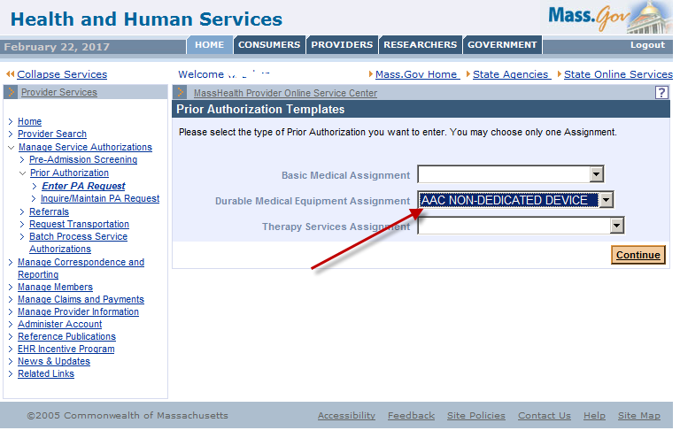

ENTER MEMBER AND PROVIDER INFORMATION
On the Base Information page:
- Enter the MassHealth Member ID.
- Enter the member’s Height (optional).
- Enter the member’s Weight (optional).
- Select the Requesting Provider from the drop-down list.

Note: This is the Therapist/ MassHealth Provider ID and Service Location (PID/SL). The drop-down list displays provider IDs, service locations, NPIs (national provider identifiers), and names accessible to your login ID.
- Select Place of Service from the drop-down menu (optional).
- Enter the Primary AND Secondary Diagnosis Codes (mandatory)
Note: When entering diagnosis codes, do not enter periods. Example: diagnosis code F84.0 enter it as F840
- The primary diagnosis corresponding to the speech impairment
- The secondary diagnosis corresponding to autism spectrum disorders, if applicable
TIP: You can click the Field Search icon ( ) to perform a search for the correct diagnosis code.
- Enter Clinical Rationale (medical reason for PA).
- Enter Comments (non-medical explanation of PA).
- Click the Line items tab.
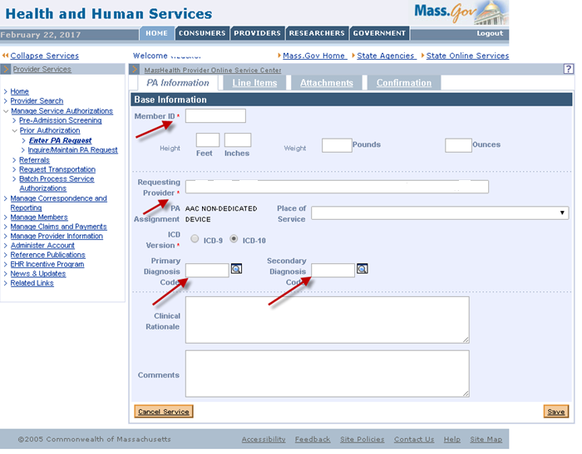
Note: Remember to save your document as you enter your information.

ADD A LINE ITEM FOR THE iPad
On the List of Line Items tab:
- Click New Item.
On The Basic Medical Details page is displayed.
- Enter the HCPC Code for iPad: E2510.
- Enter the Modifier in the field labeled Modifier 1: TW
Note: Please do not enter more than one modifier
- Enter or click on the calendar icon to select the Requested Effective Date.
- Enter or click on the calendar icon to select the Requested End Date.
- Enter the number of Requested Units.
- Enter the Servicing Provider MassHealth Provider ID and Service Location (PID/SL).
Note: The Servicing Provider is the Therapist.
- Click Add.
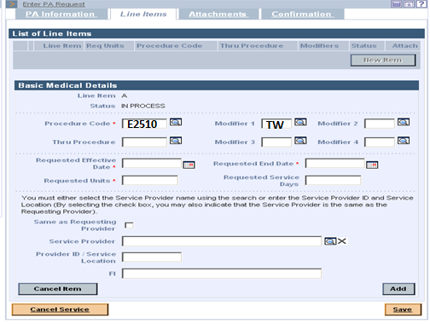

ADD A LINE ITEM FOR THE iPad SOFTWARE

- Click New Item.
On The Durable Medical Details page is displayed.
- Enter the HCPC Code for iPad: E2511.
- Enter the Modifier in the field labeled Modifier 1: TW
Note: Please do not enter more than one modifier
- Enter or click on the calendar icon to select the Requested Effective Date.
- Enter or click on the calendar icon to select the Requested End Date.
- Enter the number of Requested Units.
- Enter the MassHealth Servicing Provider ID and Service Location.
Note: the Servicing Provider is the Therapist
- Click Add.
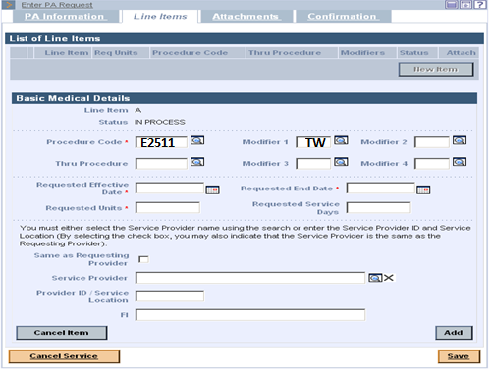
Note: Remember to save your document as you enter your information.

ADD A LINE ITEM FOR THE IPad PROTECTIVE CASE
- Click New Item.
On The Durable Medical Details page is displayed.
- Enter the HCPC for iPad: E2599.
- Enter the Modifier in the field labeled Modifier 1: TW
Note: Please do not enter more than one modifier
- Enter or click on the calendar icon to select the Requested Effective Date.
- Enter or click on the calendar icon to select the Requested End Date.
- Enter the number of Requested Units.
- Enter the MassHealth Servicing Provider ID and Service Location.
Note: the Servicing Provider is the Therapist
- Click Add.
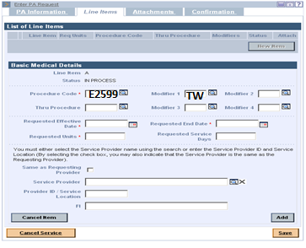

ADD A LINE ITEM FOR THE FOLLOW UP VISIT
- Click New Item.
On The Durable Medical Details page is displayed.
- Enter the Procedure Code for Follow up Visit: 92609.
- Enter the Modifier in the field labeled Modifier 1: TW
Note: Please do not enter more than one modifier
- Enter or click on the calendar icon to select the Requested Effective Date.
- Enter or click on the calendar icon to select the Requested End Date.
- Enter the number of Requested Units.
- Enter the MassHealth Servicing Provider ID and Service Location.
Note: the Servicing Provider is the Therapist
- Click Add.
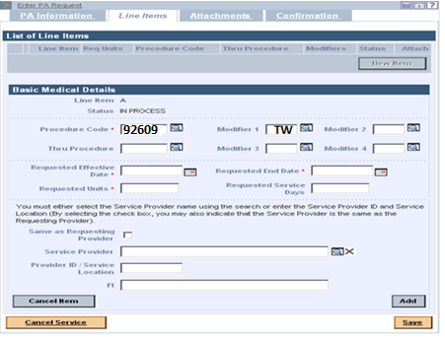

ADD A LINE ITEM TO ENTER DME INFORMATION
FOR DME INFORMATION
- Click New Item.
On The Durable Medical Details page is displayed.
- Enter the HCPCS (for example: E2512)
- Enter the Modifier (for example: TW) if applicable
Note: Please do not enter more than one modifier
- Enter or click on the calendar icon to select the Requested Effective Date.
- Enter or click on the calendar icon to select the Requested End Date.
- Enter the number of Requested Units.
- Enter the MassHealth Servicing Provider ID and Service Location.
Note: The Servicing Provider is the MassHealth DME Provider. Enter the MassHealth Provider DME Provider Number and Service Location
TIP: You can click the Field Search icon ( ) to perform a search for the Provider ID

- Click Add.
Repeat steps 1-8 if you have additional DME accessories to enter.
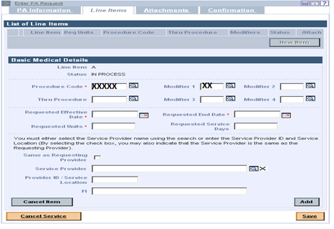
Note: Remember to save your document as you enter your information.

ADD AN ATTACHMENT
On the List of Attachments tab:
- Click New Item. The Attachment Details page is displayed.
- Select the Report Type from the drop-down list.
Note: Choose the one that most closely matches the type of document being attached.
- Select the Transmission Code from the drop-down list.
Note: Select Electronically Only for electronic documents.
- Enter a brief description or comment in the Description field.
- Click Browse. The Open window is displayed.
- Navigate to the file you want to attach and click Open.
- Click Add/Upload.
- Click the Confirmation tab
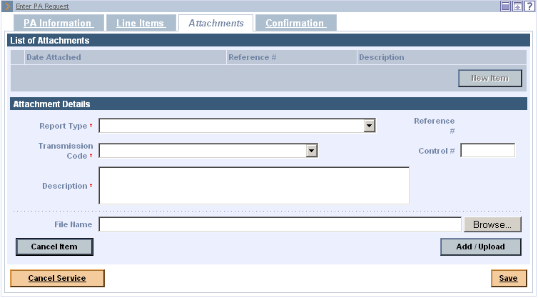

SUBMIT REQUEST
On the PA Confirmation
- Verify the information is correct.
- Click Submit. The Confirmation submits message displays.
- Review any messages and select checkbox to bypass warning messages, if applicable.
- Click Submit. Prior Authorization Response page will indicate if you have successfully submitted the PA request.

GLOSSARY OF TERMS
Adjudicate – There are header level PA statuses to tell where the PA request is in the process. Adjudicated means MassHealth has made a decision on the PA and that all lines have been finalized. Finalized is when all line statuses are cancelled, approved, modified, or denied. When the PA is adjudicated, a letter is sent to the member (with right to appeal for denied or modified lines), and provider.

Assignment Code – Code to indicate to whom PA request is assigned for review.
AAC NON-Dedicated Device: Assignment code for Non Dedicated Devices

Report Type – drop down list of document types. Frequently used types include:
Initial Assessment – initial request
Patient Medical History Document - reevaluation

Status – Indicates where the request is in the process of being reviewed and adjudicated. Status options:
Additional Information Received – Indicates information missing from the original request has been received.
Adjudicated – Indicates PA review has been completed.
Approved – Request is approved by MassHealth. A PA letter is generated and sent to the member and provider.
Cancelled by Provider – Status used for all lines when Provider Voids the PA Request.
Note: provider can only void a PA while the PA is in Ready for Review status.
Denied – Request has been denied by MassHealth. A PA letter is generated and sent to the member (with right to appeal), and to the provider.
In Process – Request has only been saved, and has not been submitted to MassHealth for review.
In Review – Request has been submitted by provider and assigned to a MassHealth reviewer.
Modified – Request has been altered by MassHealth reviewer either in adjudicating or as an adjustment requested by the provider. A PA letter is generated and sent to the member (with right to appeal), and to the provider.
Submitted – Request has been submitted, and Ready for Review, but has not been assigned to MassHealth reviewer.
Void – Request has been voided by MassHealth. A PA letter is not generated.

Tracking Number – Number assigned to PA request prior to MassHealth review.

Transmission Code – Method by which provider transmits attachment to MassHealth. Only the two transmission code listed below will be accepted.
By Mail
Electronically

