|  |
| --- |
|  |
| Regulation Review Project: |
| The Implementation of Executive Order 562: To Reduce Unnecessary Regulatory Burden |
| Final Report |
|  |
| March 31, 2017 |

|  |
| --- |
|  |

**A Letter from Secretary Lepore**

Early in the Baker-Polito administration, Governor Baker issued Executive Order 562: To Reduce Unnecessary Regulatory Burden, which directed the Executive Office for Administration and Finance (A&F) to conduct a review of all Executive Branch regulations. The last time the Commonwealth undertook such a broad review of state regulations was in 1996 under Governor Weld, when Governor Baker served as the Secretary of Administration and Finance.

Establishing a comprehensive regulatory review project was no small task. The project directed eight Secretariats and over 50 Executive Branch agencies they oversee to review 1,723 regulations. I am pleased to provide a final report on the results of this project.

I would like to extend my sincere thanks and appreciation to A&F Undersecretary Rachel Madden, who led this project, and to my fellow Secretaries and our staffs. Their hard work made this review a success, and this project could not have been accomplished without each Secretariat fully committing to this project and prioritizing their review. They dedicated select staff from across 20 agencies to serve as part of A&F’s Project Review Team to carefully review each Executive Branch regulation.

We could not have completed this review without the thoughtful feedback from stakeholders and the public, who attended 131 listening sessions held across the Commonwealth and submitted over 1,000 comments through our online web portal or directly to agencies. The crucial feedback they provided to the A&F team led to significant changes, including easing regulatory burden through simplification or consolidation of regulations; rescinding obsolete, outdated or unnecessary regulations; and aligning regulations with federal standards when appropriate.

Through collaboration over the course of this project, we made positive changes and created a clearer regulatory code that makes the Commonwealth a better place to live, work and do business.

Kristen Lepore

Secretary of Administration and Finance

***Executive Summary***

In one of its first acts after taking office, the Baker-Polito administration instituted a pause in the filing of new Executive Branch regulations in January 2015. Governor Baker then issued Executive Order 562 on March 31, 2015 which charged the Executive Office for Administration and Finance (A&F) to initiate a comprehensive regulation review process. The goal of the review was to ensure that all regulations serve a legitimate purpose in making Massachusetts a safe, healthy, and effective place to do business without imposing undue burdens or costs.

A&F led a transparent process that included public listening sessions across the state and a website to track the progress and provide real-time updates of the review.

Executive agencies reviewed and made recommendations to rescind, amend or retain 1,723 Executive Branch regulations. The project concluded on December 30, 2016 with more than two thirds of the regulations amended or rescinded and the remaining third retained.

Based on recommendations they provided to A&F during this process, agencies will be required to once again review regulations within a one to five year timeframe to ensure all Executive Branch regulations are kept up to date and continue to comport with the criteria set forth in Executive Order 562.

***Process***

Governor Baker and Lieutenant Governor Polito tasked A&F to lead the Regulation Review Project and develop a process for encouraging public input, creating a system to track and monitor regulations, and establishing standards and procedures for ensuring the successful review of 1,723 regulations.

***Public Outreach***

An integral part of the Regulation Review Project was public outreach and stakeholder engagement. As directed by A&F at the start of the project, state agencies held 131 listening sessions across the Commonwealth, from Barnstable to Great Barrington, to seek feedback from the public. The sessions provided the public with the opportunity to interact with senior level officials from every Secretariat and for state officials to hear directly from the public on challenges they faced under the state’s regulatory framework and improvements that could be made to ease regulatory burden.

In an effort to provide stakeholders with early input in the review process, these listening sessions were held before agencies made proposed changes, a departure from the traditional public comment period held under the Administrative Procedures Act (Chapter 30A), where stakeholders respond to an agency’s proposed regulatory changes.

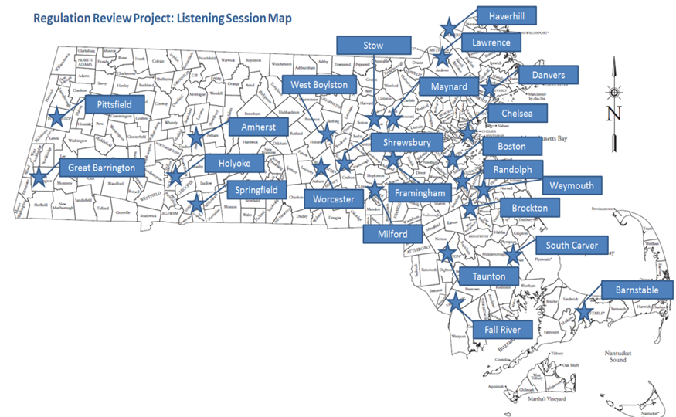

In addition to the listening sessions, A&F developed a central website, *A Clearer Code,* through which stakeholders, advocates and the public could access information and updates on the Regulation Review Project to promote public engagement and transparency as the review progressed. *A Clearer Code* provided a central location for the public to submit comments that were then forwarded to appropriate agencies for further review. This is the first time the public had a single, online portal available for information and updates as part of a regulatory review project.

Through *A Clearer Code*, the public was able to:

* Find the compiled Code of Massachusetts Regulations;
* View proposed amendments to regulations in red-lined form;
* Submit written comments on specific regulations or on the existing regulatory climate in general;
* View public comments submitted via the web portal and written comments submitted to agencies;
* Locate the schedule for all public listening sessions, public hearings, and public comment periods for regulations being amended or rescinded through the review process; and
* Review a comprehensive listing of regulatory review outcomes, including retains.

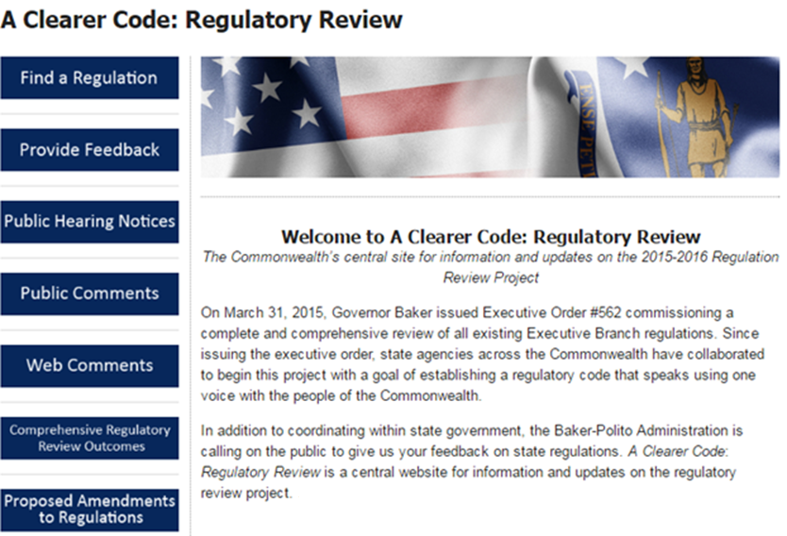

During listening sessions, many members of the public commented that the regular process of obtaining draft regulations from agencies was inconsistent and difficult as individuals had to reach out to agencies directly to request red-lines. In order to address these concerns, A&F required all agencies to post red-lines of proposed regulatory changes to their webpages. *A Clearer Code* compiled these pages, providing easy access for stakeholders to all proposed changes. In order to ensure continued transparency of regulatory changes, this feature will continue beyond the Regulation Review Project.

Another critical component of the successful review was the input the team received from cities and towns surrounding challenges they faced in the state’s regulatory climate. Many of these comments led to changes instituted in the Baker-Polito administration’s municipal modernization legislation.

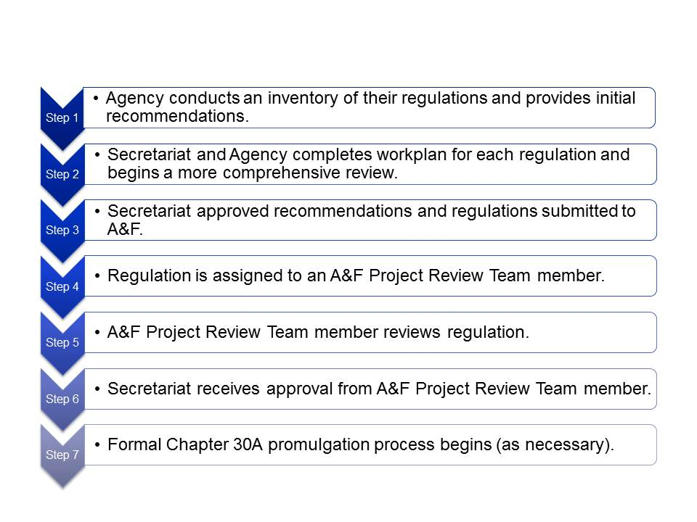***Review* *Process***

The internal review began with the creation of a cross-Secretariat database in which each agency was required to post detailed information on each regulation, including the purpose of the regulation, when the regulation was last amended, an explanation of why the regulation was necessary and an initial recommendation on whether the regulation should be amended during the review. After the initial inventory, agencies developed “workplans” in the database detailing the timeline for their review process, which were used by A&F to track and monitor the status of the review.

Agencies then began a comprehensive review and completed an Executive Order 562 Regulation Review Checklist and a Regulatory Impact Statement for each regulation to demonstrate that the recommendation met the goals of the executive order. Their recommendations were then submitted to their Secretariat for approval, and Secretariat-approved recommendations and regulations were submitted to A&F for review and approval.

In order to review 1,723 regulations, A&F assembled 31 subject matter experts from across the Executive Branch to review and approve agency recommendations and regulations. The cross-Secretariat review often led to further suggestions for improvement or collaboration.

After completion of the Project Team’s review and approval, each agency updated the database to reflect the outcome and, when applicable, moved forward with the formal process for promulgating regulations under Chapter 30A of the General Laws. In order to ensure that agencies continually review and improve upon their regulations, agencies will be required to review all regulations within a one to five year timeframe and were required to identify a timeline for review in the database. In the future, A&F will work with Secretariats and agencies to ensure the regulations are continuously reviewed in the timeframe identified during the process.

***Project Results: Tangible Examples***

Through the regulation review process, 67% of the regulations were amended or rescinded and 33% were retained unchanged.

**Executive Order 562 Project Results**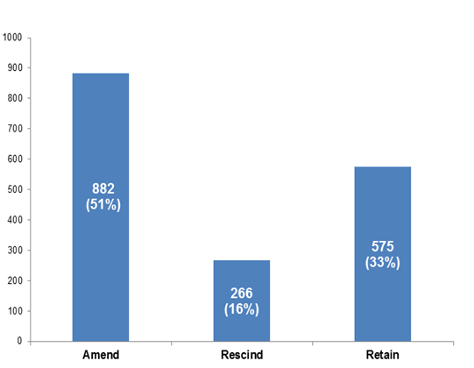

**Outcomes by Secretariat**

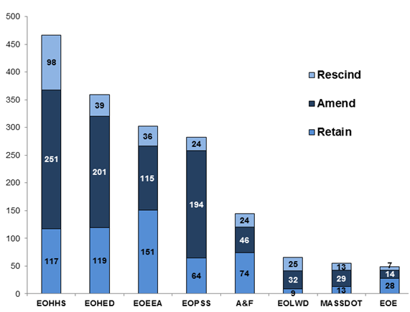

The changes made during this process accomplish the following:

* Consolidate regulations on the same or similar subject matters to make it easier for regulated parties;
* Remove obsolete, outdated or unnecessary regulatory requirements;
* Align regulatory requirements with federal standards, when appropriate, to create consistency and limit duplication; and
* Reduce complexity, simplify and ease regulatory burdens.

**Amended and Rescinded Regulations:**

**Outcome Classifications**

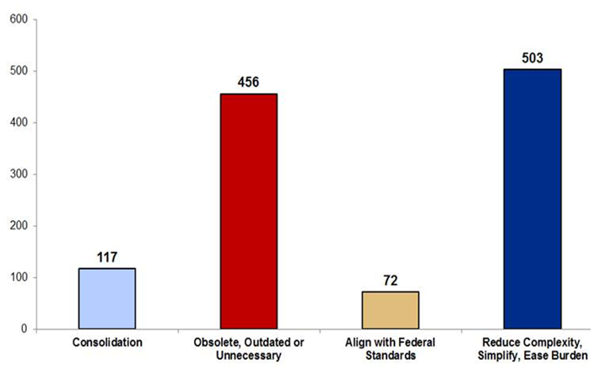

***Consolidation***

**Consolidating Rabies Vaccination Requirements:** Both the Department of Public Health (DPH) and the Department of Agricultural Resources (DAR) had regulations governing the vaccination of dogs and cats against rabies. DPH rescinded their regulation and combined relevant portions into the DAR regulation to simplify compliance and create a more centralized system of rabies prevention and control within one regulation and one agency.

**Creating a Single Room Occupancy Excise Regulation:** The Department of Revenue combined room occupancy excise related regulations in order to create a single comprehensive regulation, making the regulatory framework more efficient for taxpayers.

**Good Manufacturing Practices for Food:** DPH consolidated 10 regulations into one to oversee food manufacturing, while deferring to federal standards where appropriate. By consolidating these regulations, DPH aims to streamline existing requirements, delete outdated requirements, and increase efficiencies while standardizing much of the regulatory framework for food manufacturing, processing and distribution in Massachusetts.

**Creating a Single Workers’ Compensation Regulation:** The Division of Insurance combined workers’ compensation insurance regulations in order to create a single comprehensive regulation governing all workers’ compensation deductible plans in the Commonwealth, making the regulatory framework more efficient for the insurance industry.

***Obsolete, Outdated or Unnecessary***

**Banning Use of a Common Drinking Cup:** In 1929, the use of a common drinking cup and a common towel in industrial establishments was banned for sanitary reasons through regulation. The regulation was rescinded because it was superseded by federal Occupational Safety and Health Administration requirements and therefore clearly outdated and obsolete.

**Clearing Up Old Regulations:** A regulation utilized to implement the Safe Driver Insurance Plan was superseded by a new Division of Insurance regulation in 1996; however, the regulation was never formally rescinded and had remained on the books for 20 years despite being obsolete.

**Transferring Responsibility for School Construction:** The regulation was promulgated in 1948 to establish the process and criteria for the awarding of school construction grants to cities and towns. In 2000, the Massachusetts School Building Authority (MSBA) was created and the responsibility for school construction was transferred from the Department of Elementary and Secondary Education to MSBA. The MSBA had promulgated regulations and this regulation was superseded because it was outdated and obsolete.

**Updating the Food Code for Local Boards of Health:** The state sanitary code regulation adopting the latest model Retail Food Code to be used by municipalities when regulating the retail and food service industry had not been updated since 1999. This led to local food inspectors having to enforce two conflicting standards. The amendments updated the Massachusetts Retail Food Code by removing outdated references to the 1999 FDA Food Code and adding references to the 2013 FDA Food Code.

***Align with Federal Standards***

**Aligning ATM Use with Federal Law:** The regulation sets forth procedures for the establishment of Automated Teller Machines (ATMs) and provides safeguards for consumers in ATM and electronic funds transfer (EFT) transactions. The amendments significantly simplified the regulation by stating that compliance by depository institutions with federal law regarding EFTs to be sufficient to satisfy Massachusetts law, with the exception of limited circumstances.

**Dairy Industry Regulations:** The dairy market is now governed by federal regulations and the United States Federal Milk Marketing Order. The regulations were rescinded because they were superseded by federal regulations and no longer reflect market practices in the industry.

**The Operation, Approval and Licensure of Clinical Laboratories:** The amendments streamline state licensure categories and eliminate confusion between federal and state standards by deferring to the federal requirements contained in the Clinical Laboratory Improvement Amendments (CLIA), promulgated at 42 CFR 493 – Laboratory Requirements, except where the state statute provides more stringent standards.

**Updating Flying Requirements in the Commonwealth:** Massachusetts Department of Transportation’s Aeronautics Division regulations were promulgated decades ago.  Updates and amendments were made to the regulations to reflect changes in state and federal aviation law, as well as incorporating best practices from aeronautics agencies in other states.

***Reduce Complexity, Simplify, Ease Burden***

**Reducing Animal Quarantine:** The Department of Agricultural Resources updated their regulation to current federal standards for rabies to reduce quarantine times. This change positively impacted thousands of animals and their owners, who previously were required to undergo a 6-month quarantine if the animal was potentially exposed to rabies. The updated standards reduced quarantine periods to a maximum of 4 months.

**Streamlining the Hoisting Licensure Process:** The Department of Public Safety updated the hoisting licensure process to streamline requirements and simplify the process, making licensure less burdensome for municipalities, public utilities and other licensees. This included reducing the continuing education requirements, making it easier to receive medical clearance, streamlining equipment attachment requirements and restoring the public utility exemption.

**Board of Registration of Cosmetology and Barbering:** The Board proposed a number of important changes to its regulations that removed or eliminated barriers for licensed professionals in Massachusetts, including allowing “dual-use” rooms for licensees holding both cosmetology and massage therapy licenses and who wish to provide both services in the same setting.

**Home Improvement Contractors:** The regulation provides for procedures for the registration of home improvement contractors and the enforcement of requirements as they relate to such contractors. The Office of Consumer Affairs and Business Regulation (OCABR) proposed a number of changes to the regulation to effectively streamline, update and improve organization and readability of the regulation, as it had not been amended since 2010. Additionally, in response to many in the home improvement contracting industry, OCABR amended the regulation to provide an alternative form of payment of registration fees by contractors, such as by credit card, thereby facilitating a less cumbersome registration process. Previously, under the regulation the registration process required payment of fees by bank check only, a requirement that many contractors found to be onerous.

***Regulation Review Project Team***

**A&F Regulation Review Project Administration**

*Rachel Madden*, Undersecretary, Regulation Review Project Leader

*Lisa Dixon*, Special Counsel for Regulatory Reform

*Brian McKeon*, Deputy Chief of Staff, Regulation Review Project Manager

**Regulation Review Project Team Members**

**Executive Office for Administration and Finance:**

*Mireille Eastman*, Counsel to the Commissioner, Department of Revenue

*Julie Flynn*, Tax Counsel, Department of Revenue

*Tori Kim*, Deputy General Counsel, Executive Office for Administration and Finance

*Maribeth Ladd*, Senior Counsel, Operational Services Division

*Julia Mandeville*, Counsel I, Department of Revenue

*Lauren Peters*, Associate General Counsel & Healthcare Policy Director, Executive Office for Administration and Finance

**Executive Office of Energy and Environmental Affairs:**

*Linda Benevides*, Environmental Engineer, Executive Office of Energy and Environmental Affairs

*Bob Brown*, Senior Counsel, Department of Environmental Protection

*Jessica Burgess*, Counsel, Department of Agricultural Resources

*Jennifer Bush*, Legal, Department of Public Utilities

*Priscilla Geigis*, Director of State Parks, Department of Agricultural Resources

*Lauren Morris*, Hearing Officer, Department of Public Utilities

*Angela Motley*, Engineer, Department of Public Utilities

*Benjamin Pignatelli*, Economist, Department of Public Utilities

*Deneen Simpson*, Program Manager, Department of Environmental Protection

*Alissa Whiteman*, Energy Efficiency Program Manager, Department of Energy Resources

*Tara Zadeh*, General Counsel, Department of Agricultural Resources

**Executive Office of Health and Human Services:**

*Stephanie Kahn*, Senior Deputy General Counsel, Executive Office of Health and Human Services

*Carin Kale*, Internal Control Manager, Massachusetts Rehabilitation Commission

*Marianne Meacham*, General Counsel, Department of Developmental Services

*Cecely Reardon*, General Counsel, Department of Youth Services

**Executive Office of Housing and Economic Development:**

*James Poplasky*, Program Manager, Executive Office of Housing and Economic Development

**Massachusetts Department of Transportation:**

*Neha Dhupar*, Legal Counsel, MassDOT

*Michelle Lavoie Vaughn*, Director of Strategic Planning and Partnerships, MassDOT

**Executive Office of Public Safety and Security:**

*Brian Domoretsky*, Public Policy and Public Affairs Manager, Executive Office of Public Safety and Security

*Jacqueline Faherty*, General Counsel, Office of the Chief Medical Examiner

*Agapi Koulouris*, General Counsel, Department of Criminal Justice Information Services

*Louise McCarthy*, General Counsel, State 911 Department

*Shannon Sullivan*, Assistant General Counsel, Executive Office of Public Safety and Security

*Peter Senopoulos*, Chief Deputy General Counsel, Department of Fire Services

**Executive Office of Labor and Workforce Development:**

*Jessica Muradian*, Legislative Director, Executive Office of Labor and Workforce Development

***Thank You***

A special thank you to Steve Kfoury, Executive Director of the Secretary of the Commonwealth’s State Publications and Regulations Division, and his team, for their tireless efforts processing all of the regulatory changes made during this project.