Data Brief:
FATAL OCCUPATIONAL INJURIES IN MASSACHUSETTS, 2008-2013
March 2017
Massachusetts Department of Public Health RELEASED: March 2017

Background
Work-related fatalities are a significant public health problem in Massachusetts, as they are in the United States. Information about the occupations, industries and circumstances in which these fatalities occur is essential to guide efforts to prevent future fatalities. Since 1991, the Massachusetts Department of Public Health has collected information on all fatal occupational injuries in the Commonwealth as part of the national Census of Fatal Occupational Injuries, conducted in cooperation with the Bureau of Labor Statistics in the U.S. Department of Labor. The Department of Public Health also conducts on-site investigations of fatalities with the aim of identifying workplace factors that increase the risk of fatal injury.
This brief provides a summary of fatal occupational injuries in Massachusetts during 2008–2013. It includes a comparison of the occupational fatality experience in Massachusetts during this time with that of the nation as a whole as well as with the Massachusetts findings for the previous surveillance period (2000–2007). Findings are intended to guide the many stakeholders – government agencies, employers, unions, safety professionals, advocacy organizations, researchers, job trainers, and equipment design engineers – all of whom have important roles to play in preventing fatal injuries at work.

Fatal Occupational Injuries
A fatal occupational injury is defined as a death resulting from traumatic injury or other external cause that occurred while the person was at work. This definition includes fatalities due to acute exposure to toxic chemicals or physical agents as well as lack of such essentials as heat or oxygen. Examples include those events traditionally linked with factors in the work environment such as falls, electrocutions, and crushings, as well as workplace homicides and suicides and motor vehicle fatalities that occur while traveling on the job.

- During 2008–2013, a total of 356 workers were fatally injured at work in Massachusetts – an average of more than one worker death each week.
- The annual average rate of fatal occupational injury was 2.0 deaths per 100,000 full-time workers. There was no consistent upward or downward trend in the rate over the six-year period. There was, however, a decline in the rate over the ten-year period 2004-2013.
Sex and Age
- The great majority of victims (93.0%, n=331) were male, and the fatality rate for male workers was more than ten times higher than the rate for female workers.
- The rate of fatal occupational injury increased with the age of the workers. The fatality rate for workers 65 years of age or older was more than three times higher than the rate for workers under 35 years of age.
Race, Hispanic Origin, and Nativity
- Workers of Hispanic origin had a higher rate of fatal occupational injury than White non-Hispanic workers.
- Approximately one in five workers fatally injured at work was born outside of the United States, and the fatality rate among foreign-born workers was higher than the rate for U.S.-born workers.
- The Construction industry, a high hazard industry, accounted for the greatest percentage of fatalities among minority workers (18.8%, n=16) and among foreign-born workers (24.7%, n=21).
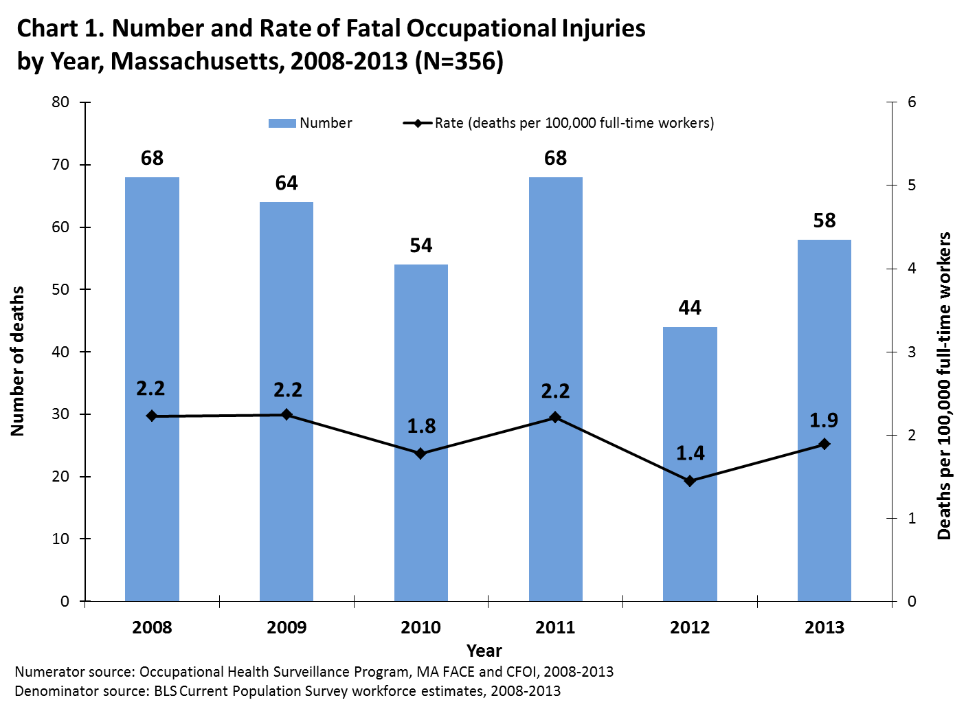
Industry and Occupation
- The Agriculture, Forestry, Fishing, and Hunting industry sector had the highest fatal occupational injury rate, more than 22 times higher than the rate for all industry sectors. Twenty-two of the 30 victims in this industry sector worked in commercial fishing.
- The Construction industry sector had the highest number of fatal injuries (n=85, 23.9%) and one of the highest fatal occupational injury rates. A majority (67.0%) of the victims worked in a specialty trade such as roofing or painting. More than half of fatal injuries in the Construction sector resulted when workers fell to a lower level.
- During 2008–2013, workers in the Farming, Forestry and Fishing occupation group had the highest fatal occupational injury rate, nearly 40 times higher than the rate for all occupation groups. Most of the workers in this group (22 of 26) were fishers. More fishing workers lost their lives than any other single occupation.
Fatal Event
- Falling to a lower level was the leading fatal event in Massachusetts, claiming 75 lives (21.1%) during the six-year period.
- Most fatal falls to a lower level occurred in the Construction industry (47 of 75), and this industry had a high rate of fatal falls to a lower level – about 10 times the fatal fall rate for all industry sectors. The majority of these falls were from a height of 20 feet or less.
Table 1. Leading Events/Exposures resulting in Fatal Occupational Injuries, Massachusetts, 2008–2013 (N=356)
Event/Exposure Category (n) | Events/Exposures with Three or More Fatalities (n)
Transportation Incident (101) | Highway motor-vehicle related incident (41)  Collision between vehicles or mobile equipment (21)  Collision between vehicles and other objects (10)  Non-collision incident (10)  Worker struck by motor vehicle or mobile equipment (24)  Water vehicle incident (17)  Sinking or capsizing water vehicle (8)  Fall from ship or boat (8)  Non-highway motor vehicle related incident (9)  Non-collision incident (6)  Collision (3)  Aircraft crash (8)
Violence and Other Injuries by Persons or Animals (88) | Suicide (54)  Homicide (29)  By shooting (17)  By hitting, kicking, beating, shoving (5)  By stabbing, cutting, slashing, piercing (5)  Injury by animal (3)
Falls, Slips, Trips (87) | Fall to a lower level (75)  Fall from ladder (30)  Fall from or through roof (12)  Fall from scaffolding (7)  Fall from boom truck (3)  Fall on same level (10)
Contact with Objects and Equipment (41) | Struck by falling objects (10)  Caught in running machinery or equipment (9)  Struck by powered vehicles that were not in normal operation (5)  Struck, caught, or crushed in collapsing structure, equipment, or material (5)
Exposure to Harmful Substances And Environments (31) | Electrocution and other injuries resulting from contact with electric current (11)  Nonmedical use of drugs or alcohol—unintentional overdose (8)  Drowning, submersion (5)
Fires and Explosions (7) | Unintended fire in residence, building, or other structure (4)  Explosion of non-pressurized vessel, drum, or pressurized tire (3)
Source: Occupational Health Surveillance Program, MA FACE and CFOI, 2008-2013
NOTE: Event/Exposure sub-categories with < 3 fatalities and one unknown event are not included in Table 1.

- Suicide at the workplace (n=54, 15.2%) was the second leading cause of injury death at work in this period.
- Roadway motor vehicle incidents resulted in 41 fatalities (11.5%).
- All transportation-related incidents – including incidents occurring on land, on the water, or in the air – accounted for more fatal occupational injuries (n=101, 28.4%) than any other event category.
Public Sector, Employment Status, Employer Establishment Size, and Investigations by the Occupational Safety and Health Administration (OSHA)
- During 2008–2013, 51 public sector (government) employees were fatally injured at work. The fatality rate for these government workers was comparable to the rate for all workers.
- Self-employed workers had a fatal occupational injury rate that was more than twice the rate for wage and salary workers. Self-employed workers are disproportionately employed in high risk industries such as Construction.
- Small establishments (with 19 or fewer employees) had a high fatal occupational injury rate, more than double the rate for establishments of all sizes.
- Almost two-thirds of the occupational fatalities were not inspected by OSHA, either because: they did not fall under OSHA’s jurisdiction; they resulted from events that are not routinely investigated by the agency; or the death occurred more than 30 days after the injury.
Comparison with the previous surveillance period in Massachusetts (2000–2007)
The patterns of fatal occupational injury during the two surveillance periods were generally very similar with several notable exceptions:
- From the period of 2000-2007 to the period of 2008-2013, the average age at death increased from 43 to 48. Correspondingly, the fatality rate for workers over 55 increased, while the rate for workers younger than 45 decreased.
- The percentage of deaths attributed to Black non-Hispanic, Asian non-Hispanic, and Hispanic workers rose slightly.
- Suicides in the workplace surpassed homicides and highway motor vehicle incidents to become the second leading cause of traumatic workplace death in Massachusetts.
Comparison with the national occupational fatality experience
- Each year from 2008 through 2013, Massachusetts had a lower fatal occupational injury rate than the nation. The difference in rates was explained in part by differences in the industry makeup of the Massachusetts workforce as compared with that of the United States. Low homicide and motor vehicle-related death rates among the population at large in Massachusetts also contributed to the low fatal occupational injury rate for the state.
- Falls and workplace suicides accounted for higher proportions of fatal occupational injuries in Massachusetts than in the nation as a whole.
Priorities for prevention
It is important when reporting statistics about fatal occupational injuries to acknowledge the individuals that these numbers represent. Continued efforts are needed to reduce the human as well as economic toll of preventable deaths at work in the Commonwealth. Successful prevention efforts have targeted specific industries, hazards, and populations. Falls in construction continue to stand out as a leading fatal event that can be reduced through outreach about a specific hazard that is tailored for a particular industry. Commercial fishing and tree work performed by landscaping companies also resulted in a number of deaths this period, deaths that could be prevented with additional outreach to those industries. Transportation incidents, such as roadway motor vehicle crashes or workers being struck by vehicles or equipment, as well as workplace suicides, are fatal events that are experienced across most industries and could be reduced through prevention efforts that speak to those specific hazards. Hispanic and foreign-born workers continue to have elevated work-related injury fatality rates; prevention efforts that engage these communities to share information on workplace rights and to tailor safety messaging can help to reduce this disparity.
For further details about fatal occupational injuries in Massachusetts, please go to: http://www.mass.gov/dph/FACE.

This data brief and accompanying report was generated by the Occupational Health Surveillance Program of the Massachusetts Department of Public Health with the support of the National Institute for Occupational Safety and Health and the U.S. Department of Labor, Bureau of Labor Statistics.

Throughout this brief, comparative terms, such as higher, lower, increased, or decreased, were used only when the difference was statistically significant at the 95% probability level.

