All sections of the 262 Budget Amendment #1 must be completed and submitted to EEC at least 15 days prior to the proposed change and/or no later than April 25, 2017 for final budget amendments.
Budget Amendment Requests received after April 25, 2017 will NOT be accepted.
PLEASE NOTE STARTING IN FY 2017, WHEN A BUDGET AMENDMENT IS CREATED IN THE 262 ONLINE APPLICATION, THE END DATE IN COLUMN B WILL BE EXTEND FROM AUGUST 31, 2017 TO JUNE 30, 2018.
Preliminary Expenditure Review
- EEC strongly recommends that grantees conduct a Preliminary Expenditure Review so that a determination can be made as to whether your school district will be able to spend these funds as allocated in your original approved budget or whether a budget amendment request is needed.
- Please review your approved FY17 262 budget, your grant expenditures, MTRS contributions and your FY17 262 Request for Funds to ensure that your budget amendment request will account for any anticipated changes in your forth coming grant funded activities and /or projected spending of these funds.
Reasons a grantee may need to submit a FY17 262 budget amendment request include:
- Line Item Changes: To request changes in proposed spending between line items (such as moving funds from Salaries to Professional Development and/or adjusting the MTRS contribution).
- Carry Over Changes:
- Requesting changes to move funds from one state fiscal year to another (such as moving funds designated for spending before June 30, 2017 to support summer activities to be implemented after July 1, 2017).
OR
- Requesting to use the FY17 Budget Amendment process to move funds through that will not be expended by June 30, 2017 (in FY17) so they may be spent early in FY 18 but no later than June 30, 2018.
This option may be used if your school district has not yet requested payment for these funds, and gives school districts access to these funds without having to apply through a Tydings Amendment Request during the next school year (SY17-18).

Since the FY 2017 ECSE – Fund Code 262 is a federal entitlement grant the designated project period of the FY 2017 ECSE - Fund Code 262 was issued in accordance the federal fiscal year, for spending between September 1, 2016 through August 30, 2017, which is the original Project Duration.
In order to comply and align with the state fiscal year that ends on June 30, 2017, the original budget divides funding into two sections: State Fiscal Year 2017 which is school year September 1, 2016 through June 30, 2017 and State Fiscal Year 2018 for summer services to be conducted July 1, 2017 through August 31, 2017.
In your originally approved FY17 262 budget
- Column A includes funding for activities to be conducted between 9/1/2016 - 6/30/2017 and
- Column B includes funding for activities to be conducted between 7/1/2017 - 8/31/2017.

STARTING IN FY 2017, WHEN A BUDGET AMENDMENT IS CREATED IN THE 262 ONLINE APPLICATION, THE END DATE IN COLUMN B WILL BE EXTEND FROM AUGUST 31, 2017 TO JUNE 30, 2018.
In the FY17 Budget Amendment Request
- Column A includes funding for activities to be conducted between 9/1/2016 - 6/30/2017, while
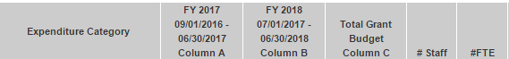
- Column B includes funding for activities to be conducted between 7/1/2017 - 6/30/2018.

EEC must be in receipt of all Budget Amendment request by or before April 25, 2017

General Instructions:

- A Budget Amendment must be used if a grantee proposes to increase (+) or decrease (-) a category by more than 10% of the category.
- A Budget Amendment must be used if a grantee proposes to move funds assigned to one fiscal year to another fiscal year (Fund Code 262 Only).
- Proposed Programmatic changes: A Budget Amendment must be filed if the justification for programming and implementation of the grant will change significantly, even if there is no funding change on the line items.
- Any changes to indirect costs must continue to adhere to the approved indirect cost rate.
- All sections of the 262 Budget Amendment #1 must be completed and submitted to EEC at least 15 days prior to the proposed change and/or no later than April 25, 2017 for final budget amendments. Amendments received after April 25, 2017 will NOT be accepted.
- Grantees may only amend their budgets up to two (2) times per fiscal year.
- Grantees must adhere to amendment guidelines and Budget Amendment Instructions for their specified grant program.
- All communications from EEC related to the budget amendment request will be addressed to the person listed under the “Name of person completing this Amendment” on the Budget Amendment Cover page. This person is also responsible for communicating all EEC APPROVED budget changes to the Lead Agency grant program coordinators, fiscal staff, and any subcontractors.
PLEASE DO NOT SEND ANY HARD COPIES TO EEC UNTIL YOU ARE NOTIFIED TO DO SO.
ANY ACTIVITIES ASSOCIATED WITH YOUR BUDGET AMENDMENT REQUEST MUST NOT BE IMPLEMENTED PRIOR TO RECEIVING NOTIFICATION FROM EEC THAT YOUR BUDGET AMENDMENT REQUEST HAS RECEIVED “EEC APPROVAL”.

Login to 262 Online Grant Application

- In order to complete a Budget Amendment request you must enter the Online Application by clicking Login to Online Application.

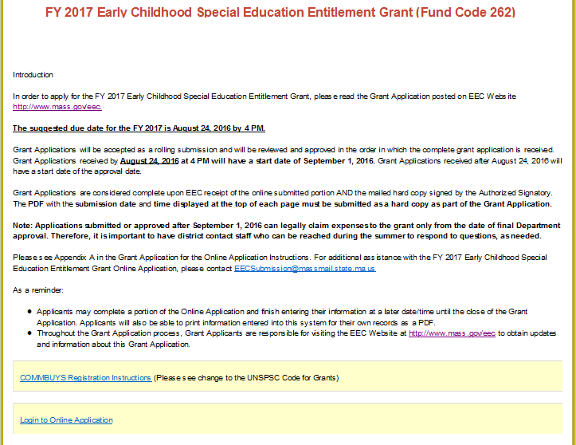

Select your School District

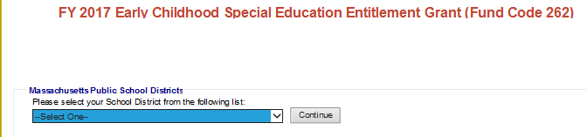

Enter your school districts Fund Code 262 PASSWORD
- Enter your existing password. If you need assistance, please send an email to EECSubmission@massmail.state.ma.us with the name of the grant in the subject line.

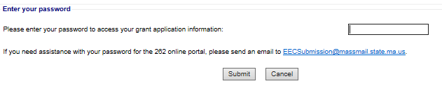

HOME PAGE - FY 2017 EARLY CHILDHOOD SPECIAL EDUCATION GRANT – FUND CODE 262

- CONTACT INFORMATION: Update any changes to your contact information, if applicable.
Once the contact information has been updated, click Save and return to the home page.

- Scroll down to the bottom of the home page To complete a Budget Amendment, and
  - Click: Budget Amendment # 1 or
  - Click Budget Amendment # 2 if you already have an EEC Approved FY17 Budget Amendment # 1

Budget Amendment Home Page

- To request a budget amendment for your Lead Agency budget, click Add New Lead Agency Amendment.
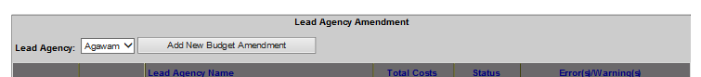

Lead Agency Budget Amendment
Enter Budget Amendment changes and Budget Narrative changes.
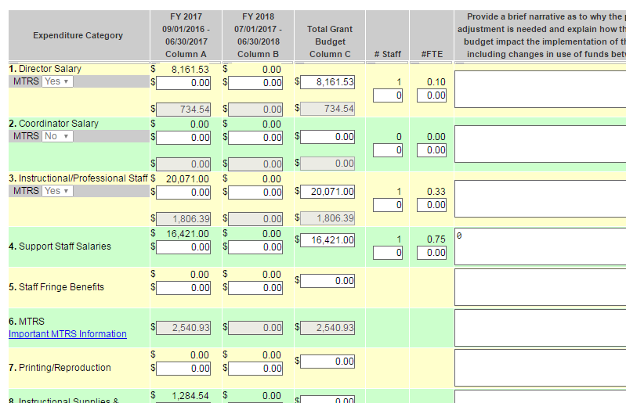
Instructions:
In order to reduce or add funds to a line item or to move funds between state fiscal years (from FY 17 so that funds may be expended on activities conducted between 7/1/2017 - 6/30/2018 (FY 18), dollar amounts must be entered into Column A and/or Column B
- Use positive numbers to add funds and negative numbers to subtract funds. (A minus sign (-) must be use to enter negative numbers.)
- # of Staff: If you are reducing the number of staff, please enter a negative number i.e. (-1).
- # of FTES: If you are reducing the FTE, please enter a negative number i.e. (-1.0).
- Budget Narrative: Provide a brief explanation as to why the proposed budget adjustment is needed and explain how these changes to the budget impact the implementation of the grant activities including changes in use of funds between fiscal years.

  - Error messages will appear in RED at the top of the Lead Agency Budget Amendment. Errors are outlined in RED BOX (ES) for each item that has an error. A Budget Amendment cannot be submitted with any errors.

- MTRS: If salaries for staff who are members of MTRS are increased, is the MTRS sub-line (Line 6) under fringe benefits increased accordingly? If salaries for staff who are members of MTRS are decreased, is the MTRS sub-line under fringe benefits decreased accordingly?
To save your lead Agency budget Amendment, you must click on the Save Budget Information button at the bottom of the page.

BUDGET AMENDMENT SUMMARY

The Budget Summary combines all line items requested in the Lead Agency Budget
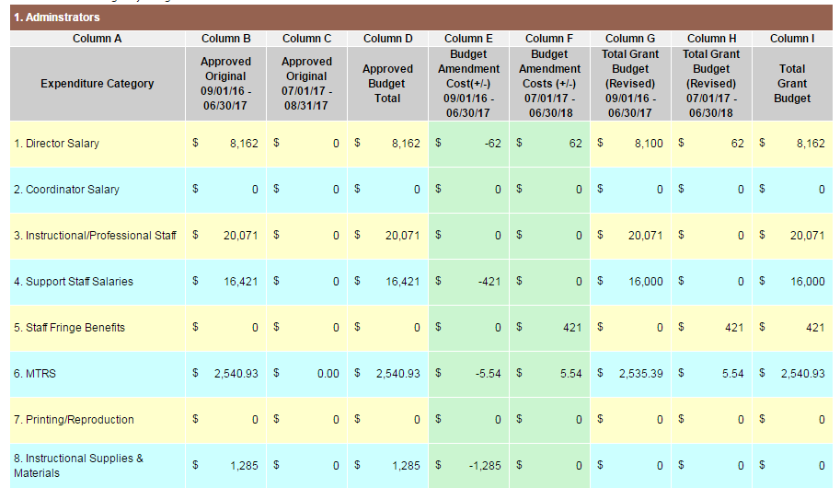
- Amendment and all Subcontractor Budget Amendments. (This is read-only document).
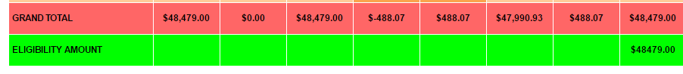
- If the Eligibility amount has been exceeded, an Alert will appear on the Budget Amendment Summary. CHANGES will need to be made to the Lead Agency so that the Eligibility amount has not been exceeded.

Budget Amendment Cover Page:

Click New Amendment Cover Page to complete the Budget Amendment Cover Page.
The following is a screen shot of the Budget Amendment Cover Page. The person completing the amendment will enter their name, title, email address and phone number.
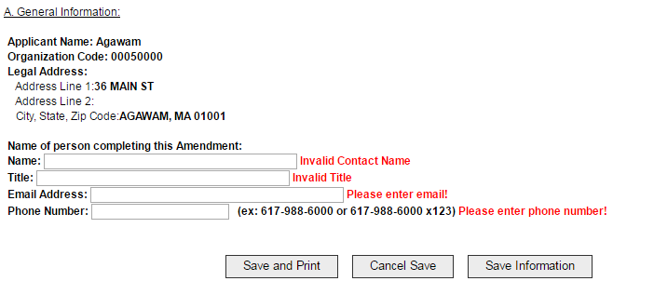

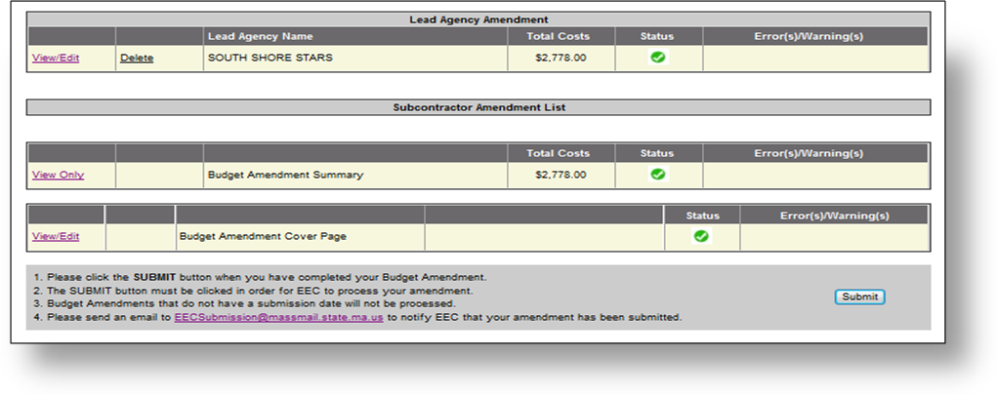
- This is a screen shot of the Budget Amendment Home Page. When the green checks appear in the status box, you are able to submit the budget amendment request.
Submitting a Budget Amendment Request
- After completing the Budget Amendment and Budget Amendment Cover Page, please click the SUBMIT button. This will generate a submission date on Budget Amendment Request.
- Please send an email to EECSubmission@massmail.state.ma.us to notify EEC that your budget amendment request has been submitted via the FY17 262 Online Grant Application.
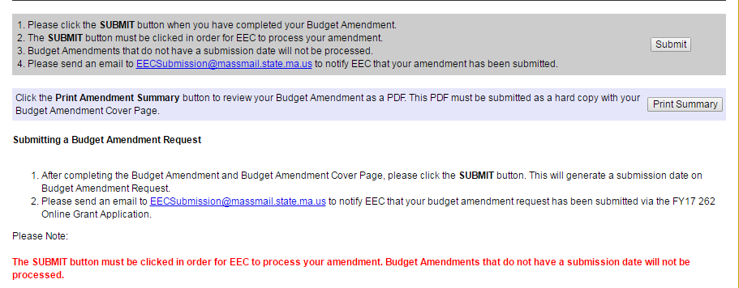
The SUBMIT button must be clicked in order for EEC to process your amendment.
Budget Amendments that do not have a submission date will not be processed
Budget Amendment PDF: Below is a screen shot of the Budget Amendment PDF.
Note the Submission date that is required in order for EEC to process your request.

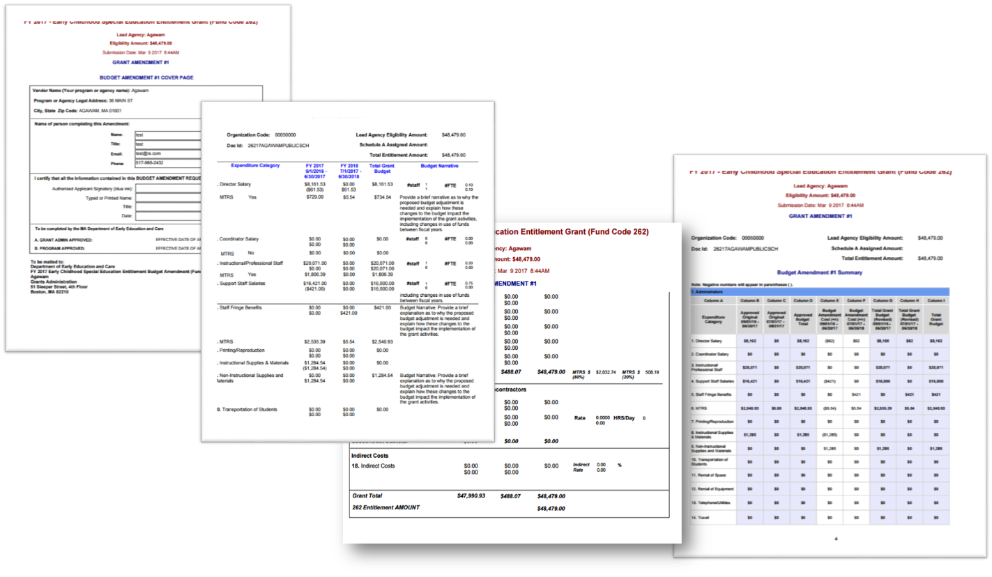

Budget Amendment Review and Approval Process

Budget Amendment Review Process
- After EEC is in receipt of your email notification, the Budget Amendment Request will be reviewed programmatically by the assigned EEC Policy Analyst in tandem with Grants Administration for approval of fiscal revisions.
- Once the review process is complete, EEC will send an email to inform you that your Budget Amendment Review is complete.

Any activities associated with your Budget Amendment Request must not be implemented prior to receiving notification from EEC that your Budget Amendment has received “EEC Approval”.

Send the Budget Amendment Request via Mail for EEC Approval
- After receiving a confirmation email from EEC that your Budget Amendment Review is complete, click the Print Summary button to print the Budget Amendment #1 and the Budget Amendment #1 Cover page;
- Obtain the original signature from your lead agency’s authorized signatory in blue ink.
- One (1) original of the entire PDF that includes the Budget Amendment #1 and the Budget Amendment #1 Cover page with an original signature in blue ink must be mailed to EEC.

Budget Amendments that do not contain all of these documents will NOT be processed.
- Please note: Once the PDF is printed, the Budget Amendment Cover Page must be signed with an original signature (in blue ink) by an authorized signatory.
  - Hit the Submit button for the submission date to appear.
All signed Budget Amendment #1 should be mailed to:
Department of Early Education and Care
FY 2017 Early Childhood Special Education Entitlement Grant Budget Amendment
Grants Administration
51 Sleeper Street, 4th floor
Boston, MA 02210
Notification of Budget Amendment Approval from EEC
- Once the PDF with your Budget Amendment #1 and the Budget Amendment #1 Cover page with an original signature is received by EEC, Grants Administration will send an email to notify grantees that the Budget Amendment has been APPROVED and was submitted to EEC’s Grants Contract staff for fiscal processing.
- Grantees can begin to implement activities/funding changes ONLY AFTER this EEC APPROVAL email is received.
- Grants Contract staff will send via email the EEC Approved Budget Amendment to the designated contact within two weeks of receipt Notification of EEC Approval from Grants Administration.

If you receive the email notice that your Budget Amendment has been approved but have not yet received a copy of the signed and approved request from EEC after two weeks, contact the Grants Contract Staff: Loida Marquez at loida.marquez@massmail.state.ma.us (Grants 391 & 262 only)

