The Commonwealth of Massachusetts
Executive Office of Health and Human Services
Department of Public Health
250 Washington Street, Boston, MA 02108-4619

CHARLES D. BAKER
Governor
KARYN E. POLITO
Lieutenant Governor

MARYLOU SUDDERS
Secretary
MONICA BHAREL, MD, MPH Commissioner

Tel: 617-624-6000
www.mass.gov/dph

June 30, 2017

August 16, 2017

Steven T. James
House Clerk
State House Room 145
Boston, MA 02133

William F. Welch
Senate Clerk
State House Room 335
Boston, MA 02133

Dear Mr. Clerk,

Pursuant to Chapter 55 of the Acts of 2015, as amended by Chapter 133 of the Acts of 2016, enclosed, please find a report entitled “An Assessment of Fatal and Nonfatal Opioid Overdoses in Massachusetts (2011 – 2015).” The report was prepared under the direction of Monica Bharel, MD, MPH, Commissioner of Public Health and reaffirms the administration’s commitment to provide data for public understanding and policy direction.

If you have any questions, please do not hesitate to contact us.

Sincerely,

Marylou Sudders
Secretary
Executive Office of Health and Human Services

Cc: Monica Bharel, MD, MPH
Commissioner
Department of Public Health

An Assessment of Fatal and Nonfatal Opioid Overdoses in Massachusetts (2011 – 2015)
August 2017
Legislative Mandate

The following report is hereby issued pursuant to Chapter 55 of the Acts of 2015, as amended by Chapter 133 of the Acts of 2016 as follows:

Notwithstanding any general or special law to the contrary, the secretary of health and human services, in collaboration with the department of public health, shall conduct or provide for an examination of the prescribing and treatment history, including court-ordered treatment or treatment within the criminal justice system, of persons in the commonwealth who suffered fatal or nonfatal opiate overdoses in calendar years 2013 to 2015, inclusive. Any report or supplemental reports resulting from this examination shall provide any data in an aggregate and de-identified format

Notwithstanding any general or special law to the contrary, to facilitate the examination, the department shall request, and the relevant offices and agencies shall provide, information necessary to complete the examination from the division of medical assistance, the executive office of public safety and security, the center for health information and analysis, the office of patient protection and the chief justice of the trial court, which may include, but shall not be limited to: data from the prescription drug monitoring program; the all-payer claims database; the criminal offender record information database; and the court activity record information. To the extent feasible, the department shall request data from the Massachusetts Sheriffs Association, Inc. relating to treatment within houses of correction.
Not later than 1 year from the effective date of this act, the secretary of health and human services shall publish a report on the findings of the examination including, but not limited to: (i) instances of multiple provider episodes, meaning a single patient having access to opiate prescriptions from more than 1 provider; (ii) instances of poly-substance access, meaning a patient having simultaneous prescriptions for an opiate and a benzodiazepine or for an opiate and another drug which may enhance the effects or the risks of drug abuse or overdose; (iii) the overall opiate prescription history of the individuals, including whether the individuals had access to legal prescriptions for opiate drugs at the time of their deaths; (iv) whether the individuals had previously undergone voluntary or involuntary treatment for substance addiction or behavioral health; (v) whether the individuals had attempted to enter but were denied access to treatment for substance addiction or behavioral health; (vi) whether the individuals had received past treatment for a substance overdose; (vii) whether any individuals had been previously detained or incarcerated and, if so, whether the individuals had received treatment during the detention or incarceration.
The report shall be filed with the clerks of the senate and house of representatives, the house and senate chairs of the joint committee on mental health and substance abuse, the joint committee on public health, the joint committee on health care financing and the house and senate committees on ways and means. The secretary of health and human services may publish supplemental reports on the trends identified through its examination; provided, however, that any supplemental report shall be filed not later than July 1, 2017 and shall be filed with the clerks of the senate and house of representatives, the house and senate chairs of the joint committee on mental health and substance abuse, the joint committee on public health, the joint committee on health care financing and the house and senate committees on ways and means.

Notwithstanding any general or special law to the contrary, the executive office of health and human services may contract with a non-profit or educational entity to conduct data analytics on the data set generated in the examination, provided that the executive office shall implement appropriate privacy safeguards.

Table of Contents
Executive Summary 7
Section I. Re-Estimating Baseline Statistics 10
Section I.a Estimating the Size of the Population with OUD 11
Section I.b Estimating the Number of Nonfatal Overdoses (NFO) 14
Section I.c Estimating the Total Number of Opioid-related Overdose Deaths (OROD) 18
Section II. Timeline and Influences 22
Section II.a Risks for Fatal Opioid Overdose among the Opioid Naïve 23
Section II.b Continued Use of Prescription Opioids and Risk of Fatal Overdose 26
Section II.c Risk of Overdose and Death after a Nonfatal Opioid Overdose 29
Section II.d Estimating the Impact of Fentanyl on Fatal Opioid-Related Overdoses 32
Section III. Identifying At-Risk Populations 35
Section III.a Massachusetts Veterans Using the VA Pharmacies and DVS Services 36
Section III.b Individuals Experiencing Homelessness 39
Section III.c Individuals with Serious Mental Illness (SMI) 43
Section III.e Persons Released from Incarceration in Prisons and Jails 49
Section III.f Mothers with Opioid Use Disorder 53
Section III.g Estimating Opioid Burden for All Massachusetts Communities 57
Appendix A: Dataset Descriptions 61
Appendix B: Data Linkage 74
Appendix C: Data Privacy and System Architecture 76
Appendix D: Supplemental Data 81
Appendix E: Legal Agreements 104

Executive Summary
In the twelve months since the first Chapter 55 report was released in July 2016, nearly 2,000 Massachusetts residents have died of opioid-related overdoses. The total number of deaths has increased five-fold in the last 20 years, but the rate of increase of opioid-related overdose deaths was particularly sharp between 2013 and 2014. The maps below show a graphic depiction of the increasing and spreading opioid crisis in Massachusetts between 2011 and 2015 (the darkening area on the maps below). Not since the AIDS epidemic of the 1980s and 1990s has Massachusetts seen such a sharp increase in a single category of deaths.

Increasing and Spreading Opioid-Related Overdose Death Rates in Massachusetts from 2011 to 2015
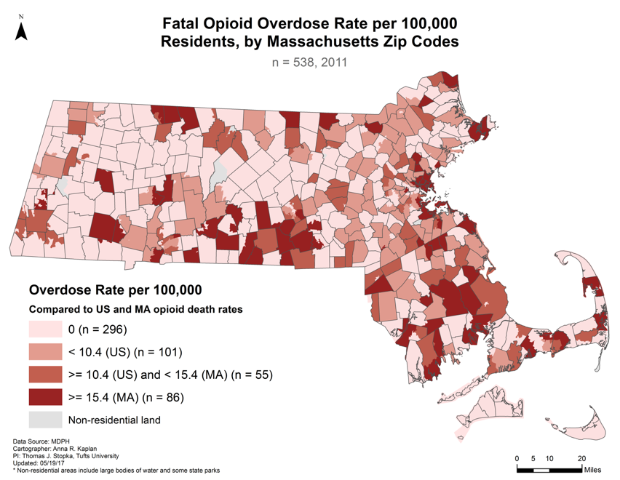
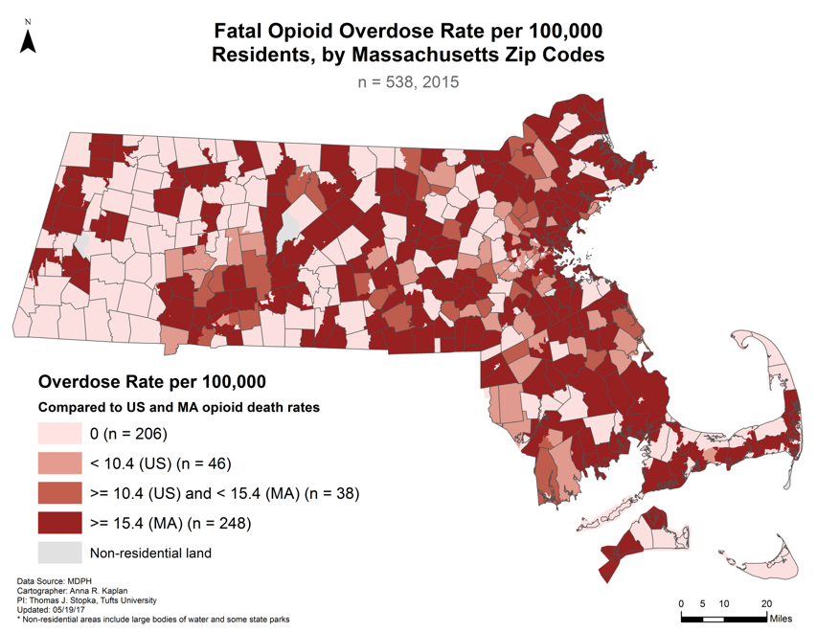
2011 2015

The characteristics of the epidemic in Massachusetts are similar to other states. What is especially notable is that this epidemic does not conform to the stereotypical boundaries of race, class, gender, and geography. Almost every community is affected. Opioid-related overdose deaths and nonfatal opioid-related overdoses are highest among younger males, but all population subgroups have seen increases in recent years. Individuals released from incarceration are also at high risk of death upon re-entering the community, but so too are individuals experiencing homelessness, veterans, mothers with opioid use disorder, and individuals with serious mental illnesses.

Fighting the current opioid epidemic has been a priority of the Baker-Polito Administration since day one. In February 2015, Governor Baker appointed a working group to develop a plan to reduce the rate of opioid-related deaths in the Commonwealth. In June 2015, the Governor’s Opioid Working Group released 65 recommendations and a comprehensive Action Plan aimed at curbing the current opioid epidemic. These short- and long-term recommendations focus on prevention, intervention, treatment, and recovery support. Today, nearly all of these recommendations are underway, making Massachusetts a national leader in terms of both investments and policy.

Understanding the complexity of this epidemic with precision is imperative to respond effectively. One part of this response includes the passage of Chapter 55 of the Acts of 2015 (Chapter 55) by the Massachusetts Legislature and Governor Charles D. Baker, and its reauthorization in Chapter 133 of the Acts of 2016. These laws enabled an unprecedented linkage and analysis of existing data across state government in order to better guide policy development and programmatic decision-making. The findings included in this report are a result of the linkages and analyses of more than 20 administrative datasets.

Contained within this report are descriptions of analyses providing the state with important new insights into the profile of overdose-related deaths and nonfatal opioid-related overdoses and the relative risks faced by the Commonwealth’s diverse populations. The report is divided into three main sections:

- Re-Estimating Baseline Statistics: This section provides more accurate estimates for Opioid Use Disorder (OUD), Nonfatal Overdose (NFO), and Opioid-Related Overdose Deaths (OROD).
- Timeline and Influences: This section offers an initial glimpse into the length of time between the stages of opioid use from an individual’s perspective from initial use of prescription medications to fatal overdose.
- Identifying At-Risk Populations: This section includes estimates of the risk of fatal and nonfatal overdose for each of seven at-risk populations including the homeless, veterans, and individuals diagnosed with severe mental illness.

In each section, the left column contains succinct take-home messages including current status, data sources, and key findings and is organized for quick reference. The larger right hand area of each page contains more information including the background, basic methods used for conducting the analysis, teams involved in the analysis, and key findings for further analysis and for policy consideration. Finally, the appendices provide in-depth explanations and background information.

Key Findings: Massachusetts 2011-2015
In 2015, it is estimated that over 4% of persons age 11 and older in Massachusetts had opioid use disorder.
Nonfatal overdoses recorded by emergency medical services (EMS), hospitals, and bystander interventions increased ~200% between 2011 and 2015. The total number of nonfatal overdoses between 2011 and 2015 exceeded 65,000.
Almost half of the individuals who died of an opioid-related overdose during the study period were at one time classified as opioid naïve during the study period. Risk for fatal and nonfatal opioid overdose grows as use continues.
Compared to the general population, those who received three months of prescribed opioids in 2011 were 4 times as likely to die from an opioid-related overdose within one year, and 30 times as likely to die of an opioid-related overdose within five years.
It is estimated that roughly one in every 25 adults has been homeless at some point between 2011 and 2015. The risk of opioid-related overdose death for persons who have experienced homelessness is up to 30 times higher than it is for the rest of the population.
The risk of fatal opioid-related overdose is six times higher for persons diagnosed with a serious mental illness (SMI) and three times higher for those diagnosed with depression.
Compared to the rest of the adult population, the opioid-related overdose death rate is 120 times higher for persons released from prisons and jails.
The five-year opioid-related overdose death rate of mothers with evidence of opioid use disorder was 321 times higher than the rate among mothers without evidence of opioid use disorder.

This effort also marks a continuation of the significant collaboration between state and federal government, academia, the health care system, and private industry. The Chapter 55 initiative has clearly demonstrated that partnerships can cross governmental and non-governmental boundaries to quickly address a public health problem of acknowledged urgency. However, for these types of partnerships to become institutional and routine, it is critical to formalize relationships. Access to a unique dataset in a time of crisis may temporarily attract multidisciplinary partners, but sustainability is best assured through formalizing data governance, mutually beneficial partnerships, and a plan for ongoing resourcing and data maintenance. These issues must be addressed to ensure continued success.

The Department’s ability to engage academic partners and private industry to support monitoring and evaluation activities will be crucial, and collaborative, data-driven efforts such as this should become standard practice in Massachusetts and beyond.

Section I. Re-Estimating Baseline Statistics
There were indications in the information gathered during the first year of Chapter 55 work that data collected by government agencies about the opioid crisis portrayed an incomplete picture of the scope of the problem. The figure below depicts this hypothesis. In the center of the diagram is the Universe of Known Events, consisting of data recorded in administrative data sets like medical claims, ambulance trip records, and death certificates about Opioid Use Disorder (OUD), Nonfatal Overdose (NFO), and Opioid-related overdose deaths. The fact that we are in a crisis is made clear when we look at these data. The scope of the crisis, however, is not.

Opioid Use Disorder (OUD)

Universe of Known Events (Recorded)

Fatal Overdoses
Nonfatal Overdoses

Specifically, what is unknown are the actual number of unrecorded nonfatal overdoses and the total number of people with OUD. If we are to improve allocation of resources for individuals with OUD, we need to know how many people fit this definition and where they live. If we are to improve emergency services for people who have nonfatal opioid overdoses, we need to know how many people have overdosed, how many have overdosed repeatedly, and what proportion of reversals are overseen by bystanders. While opioid-related deaths are recorded on death certificates, there are strong indications that additional deaths may also be opioid-related. Internal data patterns suggest that publically reported counts of opioid-related deaths may still underestimate the size of the problem and also mask the impact of fentanyl on the death rates.

This section of the report examines the interrelationships among all the data sets to establish estimates for Opioid Use Disorder (OUD), Nonfatal Overdose (NFO), and Opioid-related Overdose Deaths (OROD) that are more internally consistent and consistent with all the relevant data.

Section I.a Estimating the Size of the Population with OUD
Current Status: The best available estimate is that the rate of Opioid Use Disorder (OUD) in MA is nearly one-third higher than the national rate.
Background: The rise in opioid-related overdose death rates nationally between 1999 and 2010 parallels the increase in consumption of opioid analgesics. While this general trend applies to Massachusetts, reliable state-level numbers for Opioid Use Disorder (OUD) are difficult to obtain. Without citing a specific rate, one recent study using 2012 data suggested that the rate of opioid use disorder in Massachusetts was nearly one-third higher than the national rate. However, opioid-related overdose deaths in Massachusetts have more than doubled since 2012. Given this increase, it is more important than ever to obtain a reliable estimate of the size of the population with OUD.
Basic Methods: In the normal course of business, government agencies collect vast amounts of administrative data to track events and transactions. While the data is often comprehensive, there are limitations to its use. One commonly cited limitation of administrative data is the likelihood that some information recorded is incomplete. Events may not be captured or diagnosis codes may not be listed.
Data sources:

- Medical claims
- Hospital, ED, and outpatient data
- Death records
- Ambulance trips
- Post-mortem Toxicology
- Prescription Drug Monitoring Program
- Substance Abuse Treatment
- Birth records
- Dept of Mental Health
- Dept of Correction
- Houses of Correction
- Cancer Registry
- Dept of Housing and Community Development
- Dept of Veterans’ Services
Analysts used records that were linked at the individual level across more than 10 administrative data sets. OUD is specifically coded in the All Payer Claims Database, Case Mix (hospital, ED and outpatient), death records, and the post mortem toxicology reports recorded by the Office of the Chief Medical Examiner. These values were used to form what was referred to as the “Gold Standard” measure for OUD.
A “capture-recapture” analysis was used to estimate the true prevalence of opioid use. Individuals were identified using markers consistent with OUD in each Chapter 55 data source (i.e., the Gold Standard). It was assumed that this data was an incomplete accounting of OUD in Massachusetts.
Data was organized in tables by age group, sex, and county. Log linear models were used to fit the data to markers. The final model produced aggregate estimates by year, county, gender, and age group. A combination of Poisson and zero inflated Poisson models were used to estimate the population prevalence. Estimates were validated by comparing projected OUD rates with rates of fatal opioid-related overdose deaths.
Key Findings:
- Using only data specifically coded for OUD, it is estimated that approximately 4.4% of Massachusetts residents age 11 and older have opioid use disorder. No single Chapter 55 data set included all individuals identified by the Gold Standard of OUD. Linkage was critical to increase accuracy.
- The capture-recapture methodology produced annual estimates of OUD. There is an indication that the size of the OUD population may be increasing. Further study will refine these estimates.

Key Finding: In 2015, over 4% of Massachusetts residents age 11 and older had opioid use disorder.

- The proportion of the OUD population dying each year from opioid-related overdoses has nearly doubled between 2011 (0.40%) and 2015 (0.68%).

Key Finding: The proportion of the OUD population dying each year from opioid-related overdoses has nearly doubled between 2011 (0.40%) and 2015 (0.68%).

- Epidemics occur in stages from growth to equilibrium to decay. The fact that the OUD population may still be increasing despite the fact that the proportion of population dying is also increasing may suggest that we have not yet reached the equilibrium phase.
Recommendations for Further Analysis:
- Develop analytic models for making estimates of OUD for individuals.
- Compare current OUD services for demographic and geographic populations to determine if services should be adjusted.
- Examine changing demographic trends to determine whether the need for specific services is likely to change over time. The population in Massachusetts is getting older and more ethnically diverse.
- Evaluate the impact of transitions of care for the OUD population on fatal and nonfatal overdose.

Section I.b Estimating the Number of Nonfatal Overdoses (NFO)

Background: Some research has estimated that there are 20 nonfatal opioid-related overdoses (NFO) for every fatal overdose. For Massachusetts, that would suggest that there could be 30,000-40,000 nonfatal overdoses in 2015 alone. However, hospital, ED, and ambulance data record fewer than 20,000 events combined. Furthermore, the 20 to 1 ratio comes from a study that is 15 years old and predates the influx of fentanyl into drug supply system. The actual estimates could be either higher or lower. More recent data from Vancouver found that nearly half of people who die of fatal opioid-related overdose had a previous nonfatal overdose in the preceding five years. Since death rates in Massachusetts have increased so markedly since 2012, it is important to know whether nonfatal overdoses have increased at the same rate.
Current Status: Some research has estimated that there are 20 nonfatal opioid-related overdoses (NFO) for every fatal overdose. This estimate predates the influx of fentanyl into the drug supply system.
Records of nonfatal overdoses capture events when illegal activity may have been involved. As a result, those records are most likely incomplete accountings of the total number of events. To complete the picture, it is important to review data sources to ensure that estimates for different aspects of the opioid crisis are logically consistent with each other. That is why the linked Chapter 55 data set is such a valuable resource. All known sources were brought together to provide this composite estimate.
Basic Methods: Linkage is required to identify any nonfatal overdose event in the administrative data sets available for Chapter 55. Overdoses are captured in hospital and ambulance data, but those events must be linked with death records to determine whether the overdose was fatal or nonfatal.
Data sources:

- Hospital, ED, and outpatient data
- Death records
- Ambulance trips
- Post-mortem Toxicology
- Census data (zip level)
- Community bystander reversals

Overdose events for individuals are recorded in the Case Mix (hospital, ED and outpatient data), and MATRIS (ambulance trips). While the Case Mix data is thought to be a fairly complete accounting of NFO seen in Massachusetts hospitals, it is less clear that the APCD captures all NFO events for which medical claims are paid. MATRIS data has known gaps. Some emergency medical services have failed to report required data. Also, NFOs from MATRIS are based on a composite of information recorded by the EMTs to produce a likely NFO event. Lastly, DPH’s Bureau of Substance Abuse Services tracks some overdose reversals by community. However, this is also an incomplete picture of bystander reversals across the state. Given the variety of data sources used in this analysis, data linked at the individual as well as community level data was used to estimate the total number of NFO. Extensive de-duplication of NFO events was required across the different data sets.
All sources of data were used to develop a model of NFO that yielded a statistically reliable annual estimate of events in the state. Final estimates of missing NFO data from MATRIS were computed by comparing the ratio of projected NFO population rates at a community level to the rate of fatal overdoses by community. Values for community level “undercounts” were recorded. Finally, bystander reversals reported by communities were added to the community level “undercounts” from MATRIS.
Key Findings:
Key Finding: Ambulance trips due to a probable opioid-related overdose increased as much as by 110% in two years. Naloxone was administered by EMS in roughly 2 of every 5 of these overdoses.

- Reliable MATRIS data is only available starting in 2013. Ambulance trips due to opioid-related overdose increased by 110% in the two following years. Overdoses are counted by an algorithm that incorporates many different pieces of information from the trip record for each ambulance run.

- Naloxone was administered by an EMT in roughly two of every five overdose events between 2013 and 2015. While the actual number of naloxone administrations has increased over time, the percentage of opioid-related events where naloxone was administered has remained relatively unchanged.
- Multiple naloxone administrations by EMTs were up 27% from 2013 to 2015, which aligns with the time period during which the presence of illicit fentanyl sharply increased in the drug supply system.
Key Finding: Multiple naloxone administrations by EMTs up 27% from 2013 to 2015 which aligns with the period of sharply increased presence of illicit fentanyl in the drug supply system.
- No single Chapter 55 data set included all individuals identified with NFO. Linkage between data sets was critical for this analysis.
- Nonfatal opioid overdoses increased by ~200% between 2011 and 2015. The total number of nonfatal overdoses between 2011 and 2015 exceeded 65,000.
Key Finding: Nonfatal overdoses recorded by EMS, hospitals, and bystander interventions increased ~200% between 2011 and 2015. The total number of nonfatal overdoses between 2011 and 2015 exceeded 65,000.

- Annual estimates for nonfatal overdoses were compared to the number of fatal overdoses between 2011 and 2015. The figure below shows the year to year changes.

Recommendations for Further Analysis:
- Since many nonfatal overdoses go unrecorded, the total number, and geographic and demographic distributions may still be underestimated. To better understand these aspects of the opioid crisis, more complex analytic tools (e.g., machine learning) should be used to estimate the number and distribution of nonfatal opioid overdoses in Massachusetts.
- A careful examination of Naloxone distribution to communities should be studied using the Chapter 55 data sets to determine the effectiveness of this program. It will also tell us whether this program is increasing the proportion of “lives saved” to total overdoses, and where to target program resources in the future.

Section I.c Estimating the Total Number of Opioid-related Overdose Deaths (OROD)

Background: Nationally and in Massachusetts, fatal opioid-related overdoses have dramatically increased since 2000. In May 2017, DPH reported that there were at least 1,933 confirmed opioid‐related deaths in Massachusetts during 2016. In comparison, there were just one‐fifth as many confirmed opioid‐related deaths (338) in 2000.
Current Status: The rate of recorded opioid-related deaths and number of deaths are higher than ever in Massachusetts. In 2016, there were five times as many confirmed opioid‐related deaths compared to 2000. This number may still be an underestimate.

While the number of opioid-related overdose deaths (OROD) is at the highest level ever, initial analyses of Chapter 55 data indicated that the reported total may be an undercount. For example, opioid overdose was the listed cause of death for only 49.8% of those who died the same day as the naloxone administration by EMS. Similarly, there was a dip in the number of opioid-related overdose deaths for persons in their late 30’s and early 40’s. To better understand these unexpected results, the data was examined to determine if the reported numbers of OROD should be revised upward.

Unlike the examination of undercounts of opioid use disorder (OUD) and nonfatal overdoses (NFO), undercounts of OROD are not caused by incomplete data. The Office of the Chief Medical Examiner (OCME) certifies virtually all opioid-related deaths in the state. However, the linked Chapter 55 data provides analysts with an opportunity to examine data patterns across many data sets that the OCME could not have seen at the time the cause of death was being certified. For example, when making a determination of the cause of death, the OCME cannot systematically examine treatment and prescription histories or other administrative records indicating long-term opioid use. These additional pieces of information can be used to shed light on whether there may be an undercount of opioid-related deaths.
Data sources:

- Medical claims
- Hospital, ED, and outpatient data
- Death records
- Ambulance trips
- Post-mortem Toxicology
- Prescription Drug Monitoring Program
- Substance Abuse Treatment

Basic Methods: Analysts used 253,378 linked records of deceased individuals. These records were linked at the individual level across eight additional administrative data sets. All causes of death were included. OROD for individuals was coded using the Medical Examiner’s determination of cause of death. A predictive model was developed using 15 dependent variables. Causes of deaths assigned to cases that had been referred to the Medical Examiner were assumed to be correct.

The model produced results that could be interpreted conservatively or more broadly. The conservative approach focused only on a narrow range of cases with the specific ICD 10 codes for the cause of death that were drug related, related to respiratory or cardiovascular conditions, or were undefined or unknown. The sum of the probabilities from the logistic model was counted as the additional opioid-related overdose deaths. The broader model utilized all cases not referred to the Medical Examiner and summed the probabilities to obtain an estimate of the additional opioid-related overdose deaths.

Key Findings:

- The percent of total opioid-related deaths by age group shows a drop between age 30 and 50 suggesting the possibility that deaths may have been undercounted.
Key Finding: Plots of opioid-related deaths suggest that fewer cases were recorded among persons age 30 to 50.

- Before estimating total deaths, opioid-related deaths were examined for several temporal patterns: seasonality, weekend/weekday differentials, and concentrations of deaths near the beginnings of months when benefit checks are often distributed. Approximately 20% more deaths occurred per day on weekends and also 20% more during the first 3 days of a month. There was no seasonality effect.
Key Finding: Approximately 20% more opioid-related deaths occurred per day on weekends and also 20% more during the first 3 days of a month.
- The number of opioid-related overdose deaths coded by the Office of the Chief Medical Examiner more than doubled between 2011 and 2015. Two predictive models were developed to determine if the “official” count was lower than what might be expected when looking across the breadth of Chapter 55 data.
Key Finding: Predictive models suggest that there might be an additional 6% to 33% opioid-related overdose deaths between 2011 and 2015. The more conservative estimate (6%) is thought to be closer to the “true” value.

- These models suggest that there might be an additional 6% to 33% opioid-related overdose deaths between 2011 and 2015. Model 2 estimates were highest for 2011 (43% increase) and 2012 (42% increase) compared to 2015 (25% increase).
- Since the broader model included many categories of death that were less related to long-term substance misuse or causes of death that were undefined or vague, it was felt that the re-estimate from the conservative model is most likely closer to the true value for OROD.

Recommendations for Further Analysis:
- A much deeper examination of undercounted opioid-related deaths should be undertaken. Knowledge of which demographic groups are misclassified more frequently than others, and whether patterns exist that indicate more frequent misclassification of official causes of death, can guide further work in this area.

Section II. Timeline and Influences
Opioid Naïve Continued Use Nonfatal Overdose Impact of Fentanyl

Introduction

In addition to being able to look across many different data sets as was the case in the previous section, the Chapter 55 data set also allows analysts to look at individuals for up to a five year time period. There has been much discussion about the role of prescription medications in fueling the opioid crisis in Massachusetts and elsewhere. There is also growing evidence of the impact of fentanyl on the sharp increase in fatal and nonfatal overdoses in the state. While the Chapter 55 data can be used to establish the risk of fatal and nonfatal opioid overdose at each stage of the timeline, it can also be used to estimate the average length of time between the different stages.

What is the growing risk following first use of medications? How rapidly does that risk increase? When does more continuous use become risky and how long does that take? After a nonfatal overdose (NFO), what are the risks for a second NFO and how long does that take? Finally, how has the availability of illicit fentanyl in the drug supply system changed these timelines?

To fully understand how the transitions operate from one stage of opioid use to the next and how individual risk can be reduced, individual demographics, social determinants, medication use and other factors should be examined in concert to develop an individualized risk model. That work is beyond the scope of this report. The following section will provide an initial glimpse of timeline from opioid naive to fatal opioid overdose.

Section II.a Risks for Fatal Opioid Overdose among the Opioid Naïve

Background: In the 1990s, support was building for greater use of opioids to manage pain. Throughout the early 2000s, there was a steady increase in opioid prescribing for acute and chronic pain. For many years, this increase closely paralleled an increasing opioid-related death rate in Massachusetts and elsewhere, but rates for opioid prescribing and opioid related overdose deaths have gone in different directions in recent years. That fact could be used to argue against the importance of examining opioid naïve individuals. However, given the long-term statistical relationship between prescribing and overdose deaths from the early 2000s, it is important to better understand the rate at which this risk increases.
Current Status: While there is consensus that long-term and high dose prescribing of opioids puts patients at increasing risk of fatal and non-fatal opioid-related overdose, additional evidence is needed about the short-, mid-, and long-term risks of opioid prescribing to the opioid naïve.

Studies also show that the transition from opioid naïve to opioid tolerant can be very brief – as little as one week. Despite the short time it takes for the body to develop tolerance to opioids, relatively little is known about the short, mid, and long-term risks of opioid prescribing to the opioid naïve. The Chapter 55 data set provides an opportunity to examine the risk for persons with little or no exposure to prescription opioids and to track those risks over time.

Basic Methods: A binary operational definition for persons who were opioid naïve was developed using Chapter 55 data. All individuals were classified as either opioid naïve or not opioid naïve. To be categorized as opioid naïve, the individual’s records had to show a period of six months or more without an opioid prescription before their first opioid prescription. Patients excluded from the group include those who:
Data sources:

- Medical claims
- Hospital, ED, and outpatient data
- Death records
- Ambulance trips
- Prescription Drug Monitoring Program
- Substance Abuse Treatment

- had any advanced cancer (other than non-melanoma skin cancer)
- had a substance use disorder diagnosis in the six months preceding their first opioid prescription, or
- whose first prescription was for any buprenorphine formulation indicated for treatment of substance use disorder
Opioid naïve populations were examined annually between 2011 and 2015. They were compared to the general population for rate of fatal opioid overdose.

Key Findings:

- The number of new opioid prescriptions dropped by roughly 50% between 2012 and 2015. Over three million individuals received new opioid prescriptions during the study period with a death rate of 6.2%. It is possible that the high death rate may reflect use of opioids for palliative care.
- The number of first prescriptions for patients classified as opioid naïve using the definition above dropped by nearly half between 2012 and 2015.

Key Finding: The number of initial prescriptions for patients classified as opioid naïve using the definition above dropped by nearly half between 2012 and 2015.

- Opioid naïve patients were tracked for up to 66 months following the initial prescription. For those who died of an opioid-related cause, the mean length of time from initial prescription to the opioid-related overdose death was 36 months.

Key Finding: For those who died, the mean length of time from initial prescription to opioid-related overdose death was 36 months
Key Finding: Almost half of all individuals who died of an opioid-related overdose during the study period were at one time classified as opioid naïve during the study period.

- Almost half of all individuals who died of an opioid-related overdose during the study period were at one time classified as opioid naïve during the study period.

Recommendations for Further Analysis:
- Examine the risk of this population to determine other factors which increase, decrease, or mitigate the risk of fatal opioid overdose.
- Compare the data for this population to the post-mortem toxicology reports to determine if people are dying from prescribed opioid medications or if they have made the transition to illegal drugs such as heroin.
- Measure the average length of time between opioid naivety and coding of opioid use disorder in administrative data sets.

Section II.b Continued Use of Prescription Opioids and Risk of Fatal Overdose

Background: Concern about changes in opioid prescribing practices has been evident for over a decade. Most people who receive an initial prescription for opioids after surgery or for pain do not continue to receive opioids after completing the initial prescription. However, since most Massachusetts adults have filled an opioid prescription between 2011 and 2015, any increasing risk associated with the continued use of prescription opioids puts hundreds of thousands of individuals at some ongoing risk for fatal and nonfatal opioid overdose. The analyses presented in this section will be a continuation of the work presented in the previous section on the opioid naïve population. The same cohorts will be tracked and estimates of fatal overdose risk will be calculated for different lengths of time of continued use.
Current Status: Since many Massachusetts adults have filled an opioid prescription between 2011 and 2015, any increasing risk associated with continued use of prescription opioids puts hundreds of thousands of individuals at some increased level of risk for fatal and nonfatal opioid-related overdose.

Basic Methods: A cohort who filled an opioid prescription for three months in 2011 or six months in 2011 or all 12 months in 2011 was tracked from 2011 through 2015 to see how many of them died from opioid-related overdoses each year. Data from the Prescription Drug Monitoring Program was linked to death records for this analysis. The goal was to see how risk of death increased through time and as a function of the number of months an individual had a prescription for opioids in 2011.
Data Sources:

- Death records
- Prescription Drug Monitoring Program

Key Findings:
- There has been a 47% decrease in the number of opioid naïve individuals between 2011 and 2015, and the total number of opioid prescriptions dropped 10% from its peak in 2012 to 2015.
Key Finding: While there has been a 47% decrease in the number of opioid naïve individuals since between 2011 and 2015, the total number of opioid prescriptions only dropped 10% from its peak in 2012 to 2015.

- 1.1 million people who filled opioid prescriptions in 2011 were tracked over time. Of these, over 40,000 persons were prescribed opioids for the entire year, over 120,000 had more than six months of prescribed opioids, and over 220,000 persons had over three months of prescribed opioids.
- Compared to the general population, those who received three months of prescribed opioids in 2011 were four times as likely to die from an opioid-related overdose within one year, and 30 times as likely to die of an opioid-related overdose within five years.

Key Finding: Compared to the general population, those who received three months of prescribed opioids in 2011 were four times as likely to die from an opioid-related overdose within one year, and 30 times as likely to die of an opioid-related overdose within five years.

Recommendations for Further Analysis:
- A deeper analysis is required to understand the impact of fentanyl on the risk timeline for this 2011 cohort. It is possible that the trends seen for the persons prescribed opioids in 2011 may be different than in years where fentanyl was prevalent and opioid prescribing had dropped to some extent.
- The analysis should be combined with post-mortem toxicology to determine if it is possible to pinpoint with some accuracy the point at which individuals transition from legal to illegal opioids.

Section II.c Risk of Overdose and Death after a Nonfatal Opioid Overdose

Background: Identifying individuals with a non-fatal overdose (NFO) related to opioids and determining treatment patterns and use of substance use treatment services may provide an opportunity to intervene and improve future outcomes. Previous research has shown that mortality among individuals with substance use disorders is high, even among those receiving treatment. Additionally, individuals having an NFO from opioids, heroin, or related drugs may suffer from substantial morbidity from injuries and illnesses caused by the NFO. Increased access to opioid agonist treatment has been shown to be associated with a decrease in heroin associated deaths.
Current Status: Previous research has shown that mortality among individuals with substance use disorders is high, even among those receiving treatment.

Understanding the post-NFO risk can guide government agencies and the health care system to deliver more integrated care that reduces the likelihood of subsequent fatal opioid overdose. Additionally, treating conditions related to opioid use and NFOs may be very expensive for private and government insurers, so better understanding treatment access and provision may improve the evidence available for policy on appropriate treatment access and utilization.

Basic Methods: A cohort was constructed of Massachusetts residents ages 11 years or older who had either an opioid-related fatal overdose or NFO within the 2011-2015 period. Individuals were identified for this cohort using hospital discharge data, data on ambulance responses, and death records. The cohort was tracked to determine whether individuals had 1) an overdose (fatal or non-fatal) at any point, and 2) a repeat overdose after the original NFO. Insurance status was determined using the All Payer Claims Database.
Data Sources:

- Medical claims
- Hospital, ED, and outpatient data
- Death records
- Ambulance trips
- Post-mortem Toxicology

For the overdose cohort, we constructed two datasets – one with follow-up information for 12 months including the month of the first fatal overdose or NFO, and one with follow-up information for 24 months including the month of the first overdose. Estimates of the rate of fatal and repeat nonfatal overdoses were calculated.

Key Findings:
Key Finding: Repeat overdoses were common in the cohort, with 14.9% having one or more repeat overdoses during the one-year follow-up period and 19.1% during the two year follow-up period.
- Of the Massachusetts residents who had a nonfatal overdose (NFO) between 2011 and 2015, 94.8% of them were insured for the majority of the two-year follow-up period. Of those who were insured, 76.8% were enrolled in Medicaid.
Key Finding: 6.2% of the sample had a fatal opioid-related overdose within one year following the initial overdose. 9.3% of the sample had a fatal opioid-related overdose during the following two years.
- Of the Massachusetts residents who had a nonfatal overdose (NFO) between 2011 and 2015, 6.2% had a fatal opioid-related overdose within one year following the initial overdose; 9.3% of the sample had a fatal opioid-related overdose within two years following the initial nonfatal overdose.
- Repeat overdoses were common in the cohort, with 14.9% having one or more repeat overdoses during the one-year follow-up period and 19.1% during the two year follow-up period.

- For the two year period, being insured (versus uninsured) is associated with a 5% increase in the probability of a repeat overdose, controlling for demographics and health services utilization. However, being insured (versus uninsured) is associated with a 7% reduction in the probability of having a fatal opioid-related overdose at any point during the period (including the initial overdose).

Recommendations for Further Analysis:
- More advanced statistical modeling should be conducted to control for length of follow-up, comorbidities that impact medical care utilization, and differences in socioeconomic status.
- Examining associations between insurance status and type with opioid prescriptions and prescription use following an NFO is an important area for further study.
- There should be further examination of treatment provided to high-risk individuals by insurers in order to ensure that they have appropriate access to evidence-based treatment.

Section II.d Estimating the Impact of Fentanyl on Fatal Opioid-Related Overdoses

Background: Fentanyl is a synthetic opioid. It is a schedule II prescription drug, and it is typically used to treat patients with severe pain or to manage pain after surgery. While similar to morphine, fentanyl is estimated to be 50 to 100 times more potent. However, fentanyl is also increasingly manufactured illicitly and distributed for non-medical purposes often mixed with heroin or substituted for heroin without the users’ knowledge.
Current Status: Nationally, two in five heroin-related deaths have involved fentanyl and the rate appears to be higher in Massachusetts.

Nationally, two in five heroin-related deaths have involved fentanyl and the rate appears to be higher in Massachusetts. Adding to the public health concern is the fact that new synthetic opioids are now being found in New England. A recent warning about carfentanil is evidence of the evolving risk. In some cases, these new Illicit synthetics are many times as potent as fentanyl which is almost always illicit as well.

When illicit fentanyl became common in the drug supply in Massachusetts, the death rates went up sharply. While evidence is emerging that fentanyl is a strong contributor to the sharp increase in opioid-related deaths in Massachusetts. this analysis will attempt to shed some additional light on that question.

Basic Methods: Two models were developed to estimate the impact of fentanyl on opioid related deaths in Massachusetts. Model 1 used the annual counts of opioid-related deaths between 2000 and 2011 to project annual opioid-related deaths for the period from 2011 through 2015. Fentanyl was first noticed in Massachusetts deaths beginning around 2011. Actual deaths were compared to the expected deaths from the projection model to yield additional deaths that may be attributable to fentanyl.
Data Sources:

- Medical claims
- Hospital, ED, and outpatient data
- Death records
- Ambulance trips
- Post-mortem Toxicology
- Substance Abuse Treatment

Model 2 also used the individual death records but supplemented this information with data from post-mortem toxicology reports as well as basic demographics and the individual’s history of opioid use disorder (OUD) including medication assisted and other OUD treatments. The model was designed to determine the unique contribution that fentanyl has played in the increased death rate in Massachusetts.

Key Findings:
Key Finding: While seizures of heroin and other opioids doubled in this time, fentanyl seizures barely registered in 2011 and increased 70-fold between 2014 and 2015.
- According to the New England High Intensity Drug Trafficking Area (NE-HIDTA) group, seizures of pure fentanyl increased sharply between 2011 and 2015. While seizures of heroin and other opioids doubled in this time, fentanyl seizures barely registered in 2011 and increased 70-fold between 2014 and 2015.
Key Finding: A simple model was used to estimate that 2,066 deaths were attributable to increased levels of illicit fentanyl in the drug supply.
- Oxycodone is the most commonly prescribed opioid. One in five persons dying of an opioid overdose had an active oxycodone prescription at the time of death. Less than 2% had an active prescription for fentanyl, a number that barely changed over the course of a year. This indicates that almost all fentanyl involved in deaths is illicitly obtained.
- The fentanyl predictive model used trended death data from 2000 through 2010 to estimate likely deaths in 2011 through 2015. This is the dashed line in the figure below. Based on this model, the number of additional deaths since 2010 due to fentanyl exceeds 2,000.

Recommendations for Further Analysis:
- While the increasing levels of fentanyl in the illicit drug supply roughly parallel the temporal increase in deaths, a deeper analysis looking at each individual’s history of opioid use disorder, previous nonfatal overdoses, and mental and physical health co-morbidities is required to better understand the impact of fentanyl
- A geographic time series analysis should be conducted to show the spread of fentanyl and its relation to fatal and nonfatal overdose locally. If possible, algorithms should be developed to project where hot spots may occur in the future.

Section III. Identifying At-Risk Populations
The Chapter 55 data enables the state to simultaneously examine many different groups who may be at risk for fatal and non-fatal opioid overdose. This work marks the first population-specific examination of opioid related overdose risk for several of the populations characterized in this report.

The strength of the Chapter 55 data comes from the breadth of information gathered together in a single place. For example, data on homelessness is limited or not well validated in virtually all data sets. However, evidence of homelessness can be found in 12 different Chapter 55 data tables. Pulling together these data enables analysts to fill in the gaps in individual histories or even to model missing data. This approach has been used to provide a more complete picture of the homeless population in the state. The same is true for veterans, those with mental health co-morbidities, young adults, those leaving Massachusetts jails and prisons after serving a sentence, mothers with opioid use disorder, and individuals served by a number of other government agencies.

The core information presented in each subsection will provide estimates of the risk of fatal and nonfatal overdose for each of the populations studied. In addition, the overlap in these populations will be presented. This is of particular interest for persons receiving service or aid from a specific government agency. Knowing the likelihood that an individual is also connected to another agency may offer opportunities to collaborate across government to address the opioid problem.

The subpopulations examined were:

- Massachusetts Veterans served by VA Pharmacies and the Department of Veterans' Services
- Individuals experiencing an episode of homelessness or housing instability
- Individuals with Serious Mental Illness (SMI)
- Young Adults (ages 18-25)
- Individuals Recently Released from Incarceration in Prisons and Jails
- Mothers with Opioid Use Disorder
- Residents of Massachusetts Communities and Regions

Section III.a Massachusetts Veterans Using the VA Pharmacies and DVS Services

Background: Veterans comprise 5% of the Massachusetts population – more than 355,000 persons. A recent survey of Massachusetts veterans indicates that they reported problems with binge drinking, symptoms of depression and post-traumatic stress disorder along with financial, housing, and educational needs, making this group an at-risk population for opioid use disorder.
Current Status: Massachusetts veterans report problems with binge drinking, symptoms of depression and posttraumatic stress disorder along with financial, housing, and educational needs. Little is known about the specific risk of fatal and nonfatal opioid overdose among Veterans.

While a Chapter 55 analysis of the broader relationship between Veterans’ status and fatal and nonfatal opioid overdose will be examined at a later date, the population of interest here are Veterans who receive services and entitlements from the Department of Veterans’ Services (DVS) along with those who dually utilize the Federal VA pharmacy for prescriptions, including opiate prescriptions.

Basic Methods: DVS provided a complete list of persons receiving financial support with DVS funds. Fewer than 10% of the total Veteran population in the state received benefits from DVS between 2011 and 2015. In order to expand the population to other Veterans, an operational definition of “Veteran” status was developed. To be counted as a “Veteran” in the Chapter 55 data set, an individual had to meet ANY of the following criteria:
Data Sources:

- Medical claims
- Hospital, ED, and outpatient data
- Death records
- Ambulance trips
- Post-mortem Toxicology
- Dept of Veterans’ Services

- At least one record for housing, medical or other benefits in the DVS data between 1/1/2011 and 12/31/2015 AND was at 18 years old or more.
- At least one prescription filled at a VA pharmacy between 1/1/2013 – 12/31/2015 (the period for which data were available).
- At least one prescription in the PMP data between 1/1/2011 and 12/31/2015 where the type of payment was identified as ‘Military Installations and VA.’
- A record of death in which the occupation was classified as ‘military.’

This definition identified 98,433 individuals. The Veterans identified using the definition above were cross-tabulated with the other at-risk groups reported on in this section. Finally, estimates of the rates for fatal overdoses were calculated for this group of Veterans.

Key Findings:
- The average veteran identified was 54 years old, but the age distribution indicated that there were two distinct groups of veterans – one with an average age of 32 and the other with an average age of 67. More than half of the Massachusetts veterans identified were men.
- Unlike most at-risk populations, the Massachusetts veterans examined here had relatively little overlap with other at-risk groups. One quarter were insured through MassHealth.

Key Finding: Unlike other at-risk populations, the Massachusetts veterans examined here had relatively little overlap with other at-risk groups.

- The percentage of identified veterans who had a fatal opioid overdose was three times the state average. This was an unadjusted estimate, which did not control for Veteran specific characteristics such as age, physical and mental health co-morbidities, etc. Generation of an adjusted estimate is planned as part of further analyses.
Key Finding: The percentage of identified veterans who had a fatal opioid-related overdose was three times the state average.

Recommendations for Further Analysis:
- Examine “dual use” in this Veteran sample for opioid prescriptions (i.e., how many Veterans are getting their opioid prescriptions from both VA and non-VA pharmacies as compared to only VA pharmacies). Further, examine whether these dual users are at an increased risk of opioid use disorder, non-fatal opioid overdose and fatal opioid overdose.
- Estimate prevalence of opioid use disorder, non-fatal opioid overdose, and fatal opioid overdoes in sub-groups of at-risk Veterans (i.e., homeless, depressed, and those with PTSD).
- Examine effect of the VA’s Opioid Safety Initiative launched in 2013 on the rates of opioid use disorder and opioid related deaths in Veterans in Massachusetts.

Section III.b Individuals Experiencing Homelessness

Background: Homelessness has been a persistent societal problem in Massachusetts and nationwide for decades. Despite the length of time policymakers have recognized the problem, accurate and complete data is difficult to obtain primarily because data systems are not well organized to track individuals experiencing homelessness. Some estimates, however, do exist. A 2016 point-in-time count in Massachusetts found that roughly 19,600 persons were experiencing homelessness on a given night—of whom about two thirds were persons in families and the remaining one third were single homeless adults. Point-in-time counts, however, do not adequately capture the issue of housing instability or episodic homelessness since an individual’s or family’s risk of homelessness may be transient.
Current Status: Homelessness has been a persistent societal problem in Massachusetts and nationwide for decades. Despite the length of time policymakers have recognized the problem, accurate and complete data on individual homelessness is difficult to obtain primarily because data systems are not well organized to track a population that is periodically transient.

With respect to risk of fatal and nonfatal opioid-related overdose, a 2003-2008 study of homeless adults in Boston found that drug overdose was the leading cause of death for this population, occurring at rates 16-24 times higher than in the general population. Opioids were a factor in over 80% of these deaths. In light of dramatic recent increases in opioid-related fatalities nationally, a more comprehensive and updated assessment of opioid overdose deaths among individuals experiencing homelessness in Massachusetts is warranted.
Data Sources:

- Medical claims
- Hospital, ED, and outpatient data
- Death records
- Ambulance trips
- Post-mortem Toxicology
- Prescription Drug Monitoring Program
- Substance Abuse Treatment
- Birth records
- Dept of Mental Health
- Dept of Correction
- Houses of Correction
- Cancer Registry
- Dept of Housing and Comm Development
- Dept Veterans’ Services

Basic Methods: Government agencies routinely collect vast amounts of administrative data to track events and transactions. These data include information about homelessness and housing instability in various forms, and while extensive, these data are limited in important ways. One commonly cited limitation of administrative data is the likelihood that some information recorded is incomplete. For example, data on emergency shelter utilization represent one of the most commonly used sources of administrative data to identify homelessness but do not identify homeless persons who do not use the emergency shelter system. Other administrative data sources such as medical records, data collected about ambulance trips, and death records include indicators of homelessness and housing instability, but not all episodes of homelessness are likely to be captured and diagnosis codes indicating homelessness may not be listed during a medical encounter even for those who are experiencing an episode of homeless. For this study, mathematical modeling was therefore used to project the incomplete parts of data sets in order to yield a reliable prevalence estimate for individuals experiencing homelessness in Massachusetts.

Analysts used 5,050,639 records that were linked at the individual level across 14 administrative data sets. To be included, individuals had to have data in at least one data set in addition to the All Payer Claims Database.

The records were randomly split into two portions – a training data set with 75% of the records and a test data set with the remaining 25%. Homelessness was specifically coded in the All Payer Claims Database, CaseMix (hospital, ED and outpatient data), ambulance trip, Prescription Drug Monitoring Program, and Department of Mental Health data, and an indicator in any of these datasets was categorized as a coded instance of homelessness. Predictive models using logistic regression were developed on the training data set to estimate the likelihood of coded homelessness using more than 100 predictors.

The resulting model was validated on the test data set on the coded homelessness measure described above and also other related variables. Since the validation demonstrated that the estimated homelessness values were predictive of expected outcomes, a final homelessness measure was created using actual coded values where available and predicted probabilities where no code existed. These values were examined with respect to fatal and nonfatal opioid overdose to determine the risk for this vulnerable population.

Key Findings:
Key Finding: When relying exclusively on homeless-specific administrative codes, only 1% of the population was homeless between 2011 and 2015. However, by linking data sets together and modeling patterns that could be related to homelessness, it was estimated that 1 in 25 adults (3.7%) was likely to have been homeless at some point between 2011 and 2015.
- By linking data sets together and modeling patterns that could be related to homelessness, it is estimated that 1 in 25 adults (3.7%) was likely to have been homeless at some point between 2011 and 2015.
- At least three in eight adults who experienced homelessness between 2011 and 2015 have a coded diagnosis of a serious mental illness.
Key Finding: 39% of Homeless adults have had contact with the Dept of Transitional Assistance while 20% have been recently incarcerated in Massachusetts jails or prisons.

- The opioid overdose death rate is between 16 and 30 times higher for the homeless individuals compared to the rest of the adult population.

Key Finding: The opioid-related overdose death rate is 16 to 30 times higher for homeless individuals compared to the rest of the adult population.

Recommendations for Further Analysis:
- Build on this initial analysis of the relationship between homelessness and opioid overdose to assess other questions of interest related to homelessness housing status. Potential areas for inquiry include: examining whether homeless status modifies (either positively or negatively) the effectiveness of naloxone; assessing whether persons experiencing homelessness are more likely to experience fatal overdoses in which fentanyl is present; examine health care utilization patterns among persons experiencing homelessness to identify potential intervention points.
- Since the risk of opioid related death is significant for individuals experiencing homelessness, we should also examine fatal and non-fatal opioid overdose specifically among families who use the DHCD Emergency Assistance family shelter system.

Section III.c Individuals with Serious Mental Illness (SMI)

Background: Persons with substance use disorder (SUD) have been found to be twice as likely to have mood or anxiety disorders. However, among the criminal justice involved population, almost half have both a diagnosis of a serious mental health condition and substance use disorder. In January 2017, the Substance Abuse and Mental health Services Administration (SAMHSA) estimated that 1.5 million adults with serious mental illnesses (SMI) had misused opioids in the previous year. SAMHSA defined SMI as “a diagnosable mental, behavioral or emotional disorder (excluding developmental and substance use disorders) of sufficient duration to cause serious functional impairment in an individual’s major life activities (going to work, school, interacting with family, etc.).” The specific diagnostic categories included were mood disorders, schizophrenia, and other psychotic disorders. While the rate of opioid misuse is higher in the SMI population, the impact on fatal and nonfatal overdoses is not known. The Chapter 55 data system can shed much light on these relationships.
Current Status: SAMHSA estimated that 1.5 million adults with serious mental illnesses (SMI) had misused opioids in the previous year. While the rate of opioid misuse is higher in the SMI population, the impact on fatal and nonfatal overdoses is not known.

Basic Methods: MassHealth prepared data that flagged persons with SMI using ICD 9 and ICD 10 diagnosis codes found in any medical claims administered by MassHealth. This flag was only available for MassHealth Clients and was based on the MassHealth definition of SMI. Other diagnosis groups were examined using the Case Mix hospital, ED, and outpatient data sets. These included Stress/Anxiety, Depression, Early Onset/ADHD, and Neuro-Cognitive diagnoses. Comparisons between the SMI group using MassHealth data and the hospital-based diagnoses using Case Mix should be done with caution.
Data Sources:

- Medical claims
- MassHealth
- Hospital, ED, and outpatient data
- Death records
- Dept of Mental Health

The risk of fatal and nonfatal overdose may be overestimated if based on the opioid-related risk for the populations identified from hospital events, since hospital-related events may capture persons with more serious conditions than those identified through medical claims. All five groups examined with respect to fatal opioid overdose and comparisons were made to the rest of the adult population in Massachusetts. Additional comparisons were made between SMI and other at-risk populations.

Key Findings:
Key Finding: Nearly two in five MassHealth members with a serious mental illness have been homeless for some period of time between 2011 and 2015.
- Roughly one in four persons ages 11 and older in the MassHealth population was identified as having a serious mental illness. Of these individuals, nearly two in five have been homeless for some period of time between 2011 and 2015 while one in four has been served by the Department of Transitional Assistance.

- Of individuals diagnosed with SMI in the MassHealth population, the opioid-related overdose death rate is more than six times the state average.
- In the Chapter 55 data set, through hospital records, one in six persons was identified having a stress or anxiety diagnosis, one in 10 persons in was identified as having a depression diagnosis, and one in 40 persons was identified as having a neuro-cognitive diagnosis.
- The opioid-related overdose death rate was roughly two times higher than the state average for those identified as having a stress or anxiety diagnosis.
- The opioid-related overdose death rate was roughly three times the state average for those identified as having a depression diagnosis.
- The opioid-related overdose death rate was roughly seven times higher than the state average for those identified as having a neuro-cognitive diagnosis.

Key Finding: The risk of fatal opioid-related overdose is six times higher for persons diagnosed with a serious mental illness (SMI) and three times higher for those diagnosed with depression.

Recommendations for Further Analysis:
- Examine all deaths that might be considered premature in order to better understand whether a larger number of cases involving persons with a serious mental illness might actually be intentional deaths (i.e., suicides).
- Examine nonfatal overdoses to see if the proportion is related to greater degrees of isolation.

Section III.d Young Adults (18 – 25 years old)

Background: Eight percent of the state’s population (538,000 persons) are 18-25 years old (i.e., “young adults”). Nationally, young adults have a higher prevalence of prescription drug misuse than any other group with 5.9 percent reporting nonmedical use in the past month. Between 2002-2004 and 2011-2013, heroin use in young adults increased 108% and fatal overdoses increased 86%. In 2014, young adults had the highest prevalence of past-year heroin use (0.8%) and prescription drug misuse (12.0%) compared to other age groups. When examining recent illicit drug use, young adults are almost three times as likely to report past year illicit drug dependence and misuse as the general population. Young adults who use substances are also three times more likely to be HIV positive and twice as likely to have past year history of civil commitment (Section 35) to treatment.
Current Status: 18 to 25 year olds are three times more likely to report past year illicit drug dependence and misuse than the general population.
Data sources:

- Medical claims
- Hospital, ED, and outpatient data
- Death records
- Ambulance trips
- Post-mortem Toxicology

Since young adults may respond to engagement and treatment differently than older adults, further examination into developmental differences in this age group and the need to take a tailored approach to understanding their specific risk factors and treatment needs are critical.

Basic Methods: Age is a core demographic variable in the All Payer Claims Database (APCD) and thus young adults are represented in the Chapter 55 data as fully as they are represented in the APCD. The Center for Health Information and Analysis (CHIA) estimates that annual representation of Massachusetts residents in the APCD exceeds 97%. Since the vast majority population was represented, no mathematical modeling or weighting was required.

Key Findings:
- In general, young adults did not overlap with other at-risk groups. Approximately one-third were insured by MassHealth. One in 20 had been homeless and one in 20 had a diagnosis for a serious mental illness.

Key Finding: Of all individuals experiencing a nonfatal opioid-related overdose between 2012 and 2014, 19% were young adults. Young adults were 189% more likely to be HIV positive and 79% more like to have a history of civil commitment to treatment within the past year.

- Of all individuals experiencing a nonfatal opioid-related overdose between 2012 and 2014, 19% were young adults (they made up 8% of the overall population).
- Young adults were 189% more likely to be HIV positive and 79% more like to have a history of civil commitment to treatment within the past year than older adults.

Key Finding: While the opioid-related overdose death rate is lower for young adults, it is a critical time to intervene since death rates for older adults increases dramatically.
Key Finding: The opioid-related death rate is one-third lower for young adults compared to the rest of the population.
- While the opioid-related overdose death rate is lower for young adults, it is a critical time to intervene since death rates for older adults increases dramatically. Among individuals who had a nonfatal overdose, there were no differences between young adults and older adults in gender, recurrent overdose, or subsequent fatal overdose.

Recommendations for Further Analysis:
- Catalog the specific services that are already in place for young adults in order to determine whether more (and how many more) should be allocated.
- Describe the geographic distribution of nonfatal overdoses among young adults.
- Determine whether there are gender-specific risk factors for young adults who experience a nonfatal overdose that have implications for public health interventions or policy.
- Examine the factors associated with engaging in medication treatment for young adults (buprenorphine, methadone, or naltrexone) after an overdose.
- Evaluate the rates of nonfatal opioid-related overdose in this population.

Section III.e Persons Released from Incarceration in Prisons and Jails

Background: At the end of 2011, 7 million Americans were under correctional supervision, including 2.2 million held in jail or prison. Of those incarcerated, nearly two-thirds (1.5 million) have substance use disorders, including up to one-quarter with opioid use disorder,,. It has been estimated that one-third of heroin users pass through correctional facilities annually. Few inmates with opioid use disorder receive addiction treatment during incarceration, and rates of relapse and opioid overdose-related deaths (109 deaths per 100,000 person years, or 15 percent of all deaths among former inmates) are tragically high following release .
Current Status: the 2016 Chapter 55 opioid report found an approximately 50 times higher opioid overdose death rate in formerly incarcerated people than among non-incarcerated Massachusetts residents. Individuals incarcerated in Massachusetts jails were not examined previously.

Data from Massachusetts prisons and jails were used in this report. The Massachusetts Department of Corrections (DOC) manages all seventeen state correctional facilities or prisons. The 15 county jails or Houses of Correction (HOC) are managed by the county sheriffs. According to the DOC, the MA prison population continued to decline for the fourth year, dropping 15% after a peak of 11,723 inmates on January 1, 2012 to 10,014 inmates on January 1, 2016. The number of criminal releases increased averaging 277 per month (3,329 total) during 2015. The DOC has acknowledged the drug problem within the prison population. Indeed, the 2016 Chapter 55 opioid report found an approximately 50 times higher opioid overdose death rate in formerly incarcerated people compared with non-incarcerated Massachusetts residents.
Data sources:

- Medical claims
- Hospital, ED, and outpatient data
- Death records
- Ambulance trips
- Post-mortem Toxicology
- Dept of Correction
- Houses of Correction

Basic Methods: The DOC and the county-based HOC data provided a complete listing of persons “released to the street” for the Chapter 55 study. DOC records covered the period 1/1/2011 through 12/31/2015. HOC records covered a slightly shorter period – 7/1/2011 through 12/31/2015. Since nearly the entire population was represented, it was decided that no mathematical modeling would be required to estimate the likelihood that a person had been released from a prison or jail. The linkage rate of DOC and HOC records to the APCD spine were 89.7% and 81.8% respectively.

Key Findings:
Key Finding: The majority of individuals with history of incarceration have insurance through MassHealth; 42% of former inmates were considered homeless and 54% were considered as having an opioid use disorder.

- During the time period, there were 30,056 recently released inmates from the Department of Correction (DOC) and 29,068 from the House of Correction (HOC) for a total of 53,956 former inmates. Twenty-five percent of Massachusetts prison inmates from DOC received treatment during their incarceration.
- The opioid overdose death rate is 120 times higher for those recently released from incarceration compared to the rest of the adult population.
Key Finding: Compared to the rest of the adult population, the opioid-related overdose death rate is 120 times higher for persons released from prisons and jails.
- About three in five former inmates were considered homeless (coded plus estimated), over half were considered as having an opioid use disorder. Less than 2% were also among the veterans examined in this study.
Key Finding: Opioid-related deaths have increased over 12-fold between 2011 and 2015. Nearly one of every 11 opioid-related overdose deaths were to persons with histories of incarceration in Massachusetts jails and prisons.

- Opioid-related deaths among persons recently released from incarceration have increased over 12-fold between 2011 and 2015. Two in five deaths were opioid-related corresponding to one of every six opioid-related overdoses deaths in the state.
- In 2015, nearly 50% of all deaths among those released from incarceration were opioid-related.

- Inmates who died from opioid-related overdoses were significantly younger than those inmates that died from other causes (36.2 vs. 46.5 years).

- For individuals who died, the mean time from release to death was 19 months, ranging from dying within the same month as release (or in prison) to 58 months later. The first month after release proved to be a critical time period for former inmates. Opioid-related overdose death rates were significantly higher than for subsequent months.
Key Finding: Our findings also confirm that there is a significantly elevated mortality risk in the earliest time-periods after being released from a state correctional facility, when compared with other non-critical time periods.

- Former inmates who died from opioid-related overdoses were on average younger, more likely to be male, more likely to be White non-Hispanic, more likely to have a high school education or less, less likely to be married at or around the time of death, less likely to be in a management or professional occupation, more likely to be in a service and in farming/fishing/construction profession, and more likely to be recorded as a veteran on death certificates compared with those who died from all other reportable causes.

Recommendations for Further Analysis:
- Examining the impact of treatment on fatal and nonfatal overdose to determine if specific models are more effective with individuals who have been released from incarceration.
- More advanced statistical modeling should be conducted to control for length of prison time, comorbidities that impact medical care utilization, and other differences in socioeconomic status.

Section III.f Mothers with Opioid Use Disorder

Background: Mothers with opioid use disorder (OUD) are a population of particular concern, since perinatal opioid use is not only associated with adverse health outcomes for the mother, but also with adverse health outcomes for her offspring across the life course. While 2013 estimates of current illicit drug use among persons aged 12 and older are higher for men than for women (11.5% vs.7.3%), research indicates women progress more rapidly to problem use.
Current Status: Pregnancy-associated deaths with an indication of substance use increased from 14% in 2011 to 41% in 2014. Little is known about the risk of nonfatal opioid-related overdose during pregnancy and following delivery.

The proportion of pregnancy-associated deaths (deaths during or within one year of the end of pregnancy) in Massachusetts related to substance use increased from 14% in 2011 to 41% in 2014. Opioids were the most common substance indicated in these deaths. However, little is known about nonfatal opioid-related overdoses during pregnancy and following delivery. Because screenings of women in primary or prenatal care is not universal, opportunities are likely missed to identify women in need of OUD evaluation and treatment referral. The breadth of the Chapter 55 data set provides an opportunity to better understand whether pregnant women and new mothers with OUD are at greater or lesser risk of fatal and nonfatal overdose compared with new mothers who do not have an OUD and understand the timing of overdose events during the prenatal and postpartum periods. By linking the data of the mother and child, the Chapter 55 data set allows close tracking of the impacts on the substance-exposed dyad and estimation of future risks.

Basic Methods: A cohort of women who delivered a live birth in Massachusetts between 2011—2015 was identified by linking birth certificate records to maternal records in the All Payer Claims Database (APCD). Infant diagnosis codes for neonatal abstinence syndrome (NAS) documented in APCD and CaseMix were also linked to mothers via birth certificate records. Fatal and nonfatal opioid overdose events were identified using CaseMix hospital records, MATRIS ambulance records, and death certificates. Women were classified as having evidence of OUD if any of the following were documented during the 5 year time period:
Data sources:

- Medical claims
- Hospital, ED, and outpatient data
- Death records
- Birth records
- Ambulance trips
- Post-mortem Toxicology
- Substance use treatment records
- Prescription records

- A fatal or nonfatal opioid overdose
- A diagnosis code related to OUD
- A claim for methadone or prescription for buprenorphine
- Record of opioid-related enrollment/treatment in the Bureau of Substance Abuse Services (BSAS) database
- Record of opioid-related treatment while incarcerated
Finally, data from APCD, Case Mix, birth certificate records, and BSAS were used to describe maternal socio-demographic and substance use characteristics

Key Findings:
- A majority of mothers with OUD had interaction with the Department of Transitional Assistance, were insured by MassHealth, and had evidence of serious mental illness. One in six had a history of incarceration in Massachusetts prisons and jails.

Key Finding: Mothers with OUD had a significantly higher co-occurrence of mental health diagnoses. 82% of mothers with an overdose during pregnancy or the first year postpartum had a diagnosis of depression compared with 63% of mothers with OUD and 18.0% of mothers without evidence of OUD.
- Compared to mothers without evidence of OUD or overdose, mothers with a fatal or nonfatal overdose and mothers with OUD were significantly more likely to be less than 30 years old, White non-Hispanic race, born in the United States, unmarried, without paid employment, less educated, receive their prenatal care at a hospital clinic, and have public insurance.
- Mothers with OUD had a significantly higher co-occurrence of mental health diagnoses.
  - 82% of mothers with an overdose during pregnancy or the first year postpartum had a diagnosis of depression during the study period compared with 63% of mothers with OUD and 18% of mothers without evidence of OUD.
  - 79% of mothers with an overdose during pregnancy or the first year postpartum had a diagnosis of anxiety during the study period compared with 62% of mothers with OUD and 18% of mothers without evidence of OUD.
- More than a third (38.3%) of deaths among women delivering a live birth between 2011 and 2015 were fatal opioid-related overdoses, compared to a fifth (19.9%) among women who did not deliver a live birth.
- The five-year opioid-related overdose death rate of mothers with evidence of OUD was 321 times higher than the rate among mothers without evidence of OUD and the opioid-related overdose death rate among mothers delivering an infant with NAS was 27 times higher than the rate for all other mothers.

Key Finding: The five-year opioid-related overdose death rate of mothers with evidence of opioid use disorder was 321 times higher than the rate among mothers without evidence of opioid use disorder.

- Among women with OUD, women who delivered a live birth between 2011-2015 were 2.1 times less likely to have a fatal overdose compared to women who did not deliver a live birth
Key Finding: The opioid-related overdose rate increases almost four-fold between the third trimester of pregnancy and the first six weeks postpartum. They are highest six to 12 months post-partum.
- Rates of opioid-related overdose decrease during pregnancy and are lowest during the second and third trimesters, but significantly increase in the postpartum period, with the highest rates six months—one year after delivery.

Recommendations for Further Analysis:
- Assess the impact of treatment engagement and retention on maternal overdose during the postpartum period.
- Determine factors that may predict or protect against overdose among mothers in the first year postpartum.
- Evaluate infant outcomes for women who have nonfatal overdose events during pregnancy.

Section III.g Estimating Opioid Burden for All Massachusetts Communities

Background: The scope of the data assembled for the Chapter 55 project has enabled the Department of Public Health to examine trends in the data for small communities, which is a process that has not previously been possible. Standard statistics, based on very limited data, do not lend themselves to making clear statements about the burden of specific health conditions when community populations are small. However, by linking the Chapter 55 data at the community level, it is possible to gain insight into the opioid burden for all Massachusetts communities.
Current Status: Other than counts of opioid-related deaths (which are unstable for smaller communities), little is known about the burden of the opioid crisis in all 351 Massachusetts communities.

Basic Methods: A four-step process was used to estimate overall opioid burden for all towns in Massachusetts. An assumption was made that the overall burden of the opioid crisis at a community level could best be measured using multiple data points that captured different aspects of the crisis. While some measures might be higher in one town and lower in another, considering multiple measures across time would make the results more reliable. The graphic below depicts the basic approach of combining years, using reliable data, adjusting the population for very small towns, and using multiple data sources to make all estimates more accurate.

Step 1 (Combine Years): Averaging across years or computing rates for multiple years tends to produce more reliable estimates. Because some data elements were available for all years, only data from 2013 and 2014 were used for this analysis.

Step 2 (Use Only What’s Reliable): Estimating rates for very small communities is difficult, because isolated events can alter rates dramatically. It was necessary to determine the point at which data were reliable enough to use. This was called the threshold of stability. The threshold was established to be 3,000 residents.

Step 3 (Make Small Towns Seem Bigger): After determining the threshold of stability, data for the 75 smallest towns in Massachusetts were adjusted so that changes in rates would be similar to a town of 3,000 people.

Step 4 (Find Data with Similar Patterns): The level of community burden was estimated using information about fatal opioid overdoses for residents of a community, nonfatal opioid overdoses for residents of a community, Naloxone kits distributed to communities, and the number of infants born with neonatal abstinence syndrome (NAS) to mothers who lived in these communities. These four data points were chosen because they were expected to show similar changes over time and across communities. If a community was high or low on one measure, it would be similarly high or low on others.

Key Findings: A measure of the overall burden of the opioid crisis on the community level was developed using four data points (described above) that captured different aspects of the crisis. The map below shows the burden for all 351 Massachusetts communities divided by quintiles (i.e., five equally-sized groups ordered from lowest to highest burden) – the darker the shade, the higher the burden of opioid use in that community.

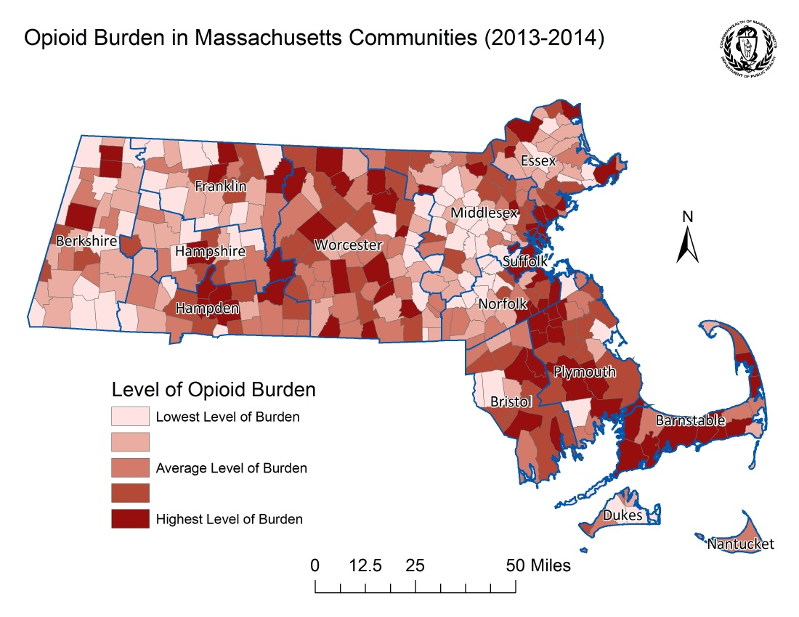

Recommendations for Further Analysis:
- A comprehensive geospatial analysis of opioid burden should be conducted at the micro-geographic-level (e.g., census tract, block group, block) to identify neighborhood level burden.
- Hotspot cluster analysis should be conducted at the census tract or block group level to identify statistically significant clusters of opioid burden on the neighborhood level across Massachusetts.
- A thorough geospatial analysis should look at the relationship between local opioid burden and available services such as pharmacies, SEPs, OEND, MAT, detox programs, hospitals, etc.
- A composite variable for available services should be developed and mapped geospatially. Several variables should be considered for this composite variable:
  - Numerator: naloxone distribution, number of people receiving medication assisted therapy (MAT: methadone maintenance, buprenorphine, suboxone), number of people in drug detoxification programs;
  - Denominator: number of people with opioid use disorder (OUD)
- Development of novel variables and analyses to assess access to services should be considered:
  - MAT services received per 1,000 fatal overdoses; MAT services per 1,000 people with OUD;
  - Naloxone kits distributed per 1,000 people with OUD
  - Ratio: number of providers to number of people with OUD
- Statistical models should be considered to identify community-level factors associated with opioid burden and access to services.
- Trends in opioid burden should be examined in order to make estimates of future risk on a community by community basis.

Appendix A: Dataset Descriptions

The diagram below shows the 22 datasets linked to produce this report. Sixteen of the data sets were linked at the individual level while six data sets provided additional community level data either at the town or zip code level. The MassHealth data also included service flags for individuals receiving services from the Department of Children & Families, the Department of Youth Services, the Department of Developmental Services, the Department of Transitional Assistance, and the Massachusetts Commission for the Blind.

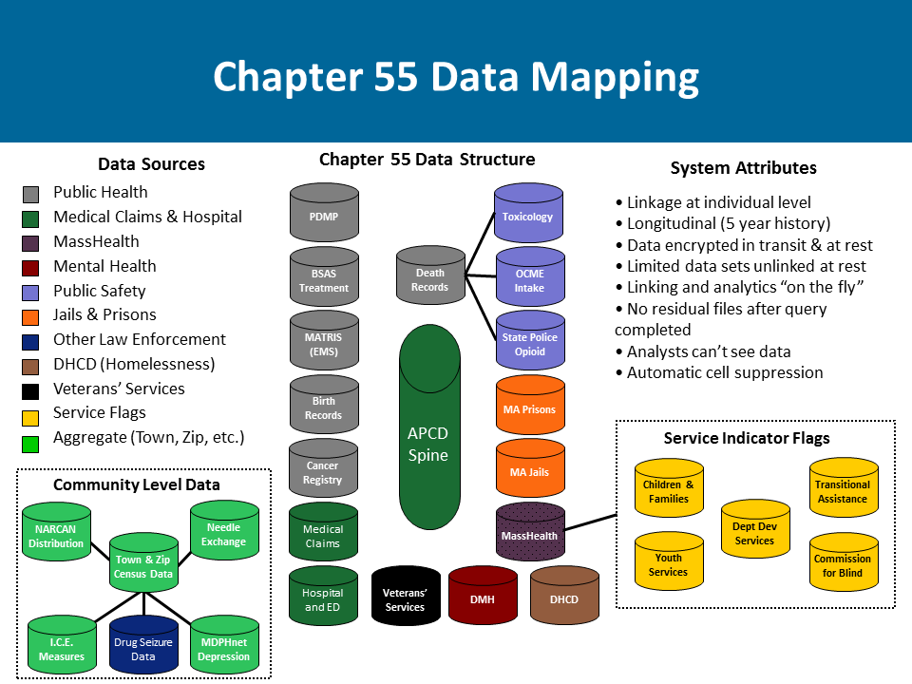

The remainder of Appendix A provides a description of each of the 22 datasets used for this report. Each description outlines the information collected, the frequency, the limitations, the lag time between data collection and data availability, the relevance to opioids, and the authorization for collecting the data.

Registry of Vital Records and Statistics (RVRS) – Death Records
What data are collected: Opioid-related deaths are the primary focus of this work and the most basic source of this information comes from death certificates filed with the Registry of Vital Records and Statistics (RVRS). The official cause of death and the manner of death (i.e., intentional, unintentional, or undetermined) are assigned by physicians and medical examiners. Each death certificate also includes demographic information such as age, race, Hispanic ethnicity, gender, educational attainment, marital status, and occupation. These basic demographics are recorded by the funeral director and are typically provided by a family member.
Availability of data: Mortality information is reported electronically using the Vitals Information Partnership (VIP). The VIP system is web-based and receives information 24 hours a day seven days a week. For analytic purposes, data can be exported from VIP with all the data elements listed above. Opioid-related deaths and other complex cases are almost always referred to the Office for the Chief Medical Examiner (OCME) for determination of cause and manner of death. This results in a reporting lag for these deaths. That said, basic data on demographics is available on a near-real time basis.
Limitations of the data: As legal records, the information recorded on death certificates is considered highly accurate. However, some information like race, Hispanic ethnicity, educational attainment, marital status, and occupation are not always fully populated. Causes of death from the OCME often lag the date of death making some elements of death data less timely than others.

Bureau of Substance Abuse Services (BSAS) – Substance Abuse Treatment Data
What data are collected: Massachusetts Bureau of Substance Abuse Services (BSAS), of the Department of Public Health, is the single state authority responsible for regulating and licensing substance abuse treatment providers. The services provided range from acute detoxification to residential and outpatient based services. All treatment providers who receive funding from BSAS are required to submit data to BSAS to carry out the responsibilities listed under the law. The required data fields include but are not limited to client characteristics, enrollment information, disenrollment information, services and outcomes. Currently, only treatment providers that receive funding from the Department submit this data to BSAS.
Availability of data: Processing of linked clients also allows us to construct treatment episodes and entire client histories. There is a one to two month lag between the time the data are reported and the time it is available for analysis/reporting from BSAS.
Limitations of the data: The BSAS data set poses several limitations. First, BSAS data does not represent all substance abuse treatment provided in the commonwealth. BSAS only collects data from its contracted providers. Of the data that is submitted to BSAS, outpatient treatment data is incomplete and does not include all non-BSAS paid services. BSAS does not collect data from providers that prescribe Vivitrol or from non-contracted Buprenorphine providers. At the time of this analysis, Methadone data was incomplete. Due to challenges associated with recent system changes related to data submission, some Methadone providers have been unable to submit data. Data collected in regards to section 35 commitments are incomplete in the BSAS data set. For example, in 2015 there were 2,068 Section 35 commitments served in settings outside the scope of data submitted to BSAS (e.g. MASAC and MCI Framingham). As a result of these data limitations, it is possible that some of the analyses using BSAS treatment data may provide an incomplete picture.

Prescription Drug Monitoring Program (PDMP) – Schedule II through V medications
What data are collected: Information about filled prescriptions for schedule II through V medications is reported electronically each business day to the Prescription Drug Monitoring Program (PDMP) in the Department of Public Health’s Office of Prescription Monitoring and Drug Control (OPMDC) by all Massachusetts community, hospital outpatient and clinic pharmacies as well as from out-of-state mail order pharmacies that deliver to patients in Massachusetts. Schedules II through V medications consist of those prescription drug products with recognized potential for abuse or dependence (e.g., narcotics, stimulants, sedatives). Consequently, they are among those most sought for illicit and non-medical use. The specific medication as well as the dosage and the number of pills or amount are also captured. In order to facilitate the monitoring of individuals who receive scheduled medications, basic identifying information like full name, gender, date of birth, and full address are also recorded as well as information about the prescriber and dispensing pharmacy.
Availability of data: PDMP reporting is comprehensive for pharmacies within the Commonwealth with very few instances of non-compliance among pharmacies. PDMP data arrives daily and is considered complete and accurate for export and analysis within approximately two weeks.
Limitations of the data: The PDMP dataset has a few noteworthy limitations. First, methadone clinics do not report to the Massachusetts PDMP as they are exempt by statutory language. Specifically, the PDMP only collects data on prescriptions dispensed, and methadone in clinics is administered pursuant to medical order, not prescription. Methadone is only included when prescribed for pain. Second, controlled substance prescriptions dispensed by Veterans Administration (VA) facilities are not included. This represents a high risk population and a significant data gap. Third, prescription drugs that are obtained illegally (e.g., stolen, purchased on the street, etc.) are a potentially significant contributor to the opioid overdose epidemic and are not captured within an individual’s PDMP history, but may be captured by the OCME toxicology screens. Finally, a filled prescription should not be interpreted to mean that an individual took all or even any of that medication. Linking these records with toxicology data can provide some insight into the proportion of scheduled medications that are illegally diverted for other purposes than originally intended.

Massachusetts Ambulance Trip Record Information System (MATRIS) – Office of Emergency Medical Services (OEMS)
What data are collected: The Department of Public Health’s Office of Emergency Medicine (OEMS) established the Massachusetts Ambulance Trip Record Information System (MATRIS) in December 2010 as a statewide system collecting emergency medical service (EMS) incident data from licensed ambulance services. Under EMS System regulations, ambulance services are required to document each EMS call and include the data elements pertaining to the call specifically referenced in an administrative requirement issued by OEMS governing the statewide EMS minimum data set. MATRIS data elements are based on the National Emergency Medical Service Information System (NEMSIS) Version 2.2.1 dataset standard developed in 2005. This includes demographic, clinical, operational, and billing data. Demographics required are patient age, birth date, gender, and patient home address. Also required are incident type, incident address, dates, times, destination facility type, destination facility name, and destination facility address. Patient name is not currently required but is submitted approximately 70% of the time. MATRIS can identify nonfatal-opioid-related events, even when the patient refuses transport to the hospital. MATRIS tracks when naloxone was administered either by the EMT or as “prior aid” by other first responders, (fire, police) or bystanders (friends, family). Evaluation on interventions provided by EMTs can be performed to correlate survival and other outcome rates when linked with outcomes from ED and death data.
Availability of data: Ambulance incident information is submitted into the MATRIS secure website electronically from all licensed ambulance services in Massachusetts within 14 days of the call; however frequency of submission varies by service. Many of the larger ambulance services have automated daily submission, while others can take longer to submit. There are currently over 6.4 million ambulance trip records in MATRIS. There were 1.3 million records in MATRIS for incidents occurring in both 2013 and 2014. There are 1.4 million for 2015 available for future analysis.
Limitations of the data: MATRIS has several limitations. The first is that the NEMSIS standard does not specifically identify incidents as being opioid-related, but rather “poisoning/ingestion.” The second, the data are not uniformly reported by EMS providers. The third limitation is that the overall usability of the data submitted by ambulance services varies by provider, with roughly 30% of the provided data being partially or completely unusable. These issues are partially mitigated through the integration with other datasets listed above. Finally, whether a specific ambulance trip involves an opioid overdose is not a simple judgment. The classification of opioid trips was based on an algorithm developed in conjunction with the Centers for Disease Control and Prevention. Their assistance was invaluable.

Registry of Vital Records and Statistics (RVRS) – Birth Records
What data are collected: The collection and dissemination of this data are to facilitate the surveillance of births and birth trends in the state of Massachusetts, including those based on demographic information and data on birth outcomes. Data are reported to the Registry of Vital Records and Statistics (RVRS) by all licensed birthing hospitals and birthing centers and by city and town clerks if they are establishing a home birth that occurred in their city/town in Massachusetts. The birth data contains identifying information about the parents of record and the child. These data are critical to understand the health risk to a mother who delivers a Substance Exposed Newborn (SEN) or an infant with Neonatal Abstinence Syndrome (NAS).
Availability of data: Natality information is reported electronically using the Vitals Information Partnership (VIP). The VIP system is web-based and receives information 24 hours a day, seven days a week. Substantial quality control efforts are required to assess the accuracy and completeness of birth records. As a result, the final dataset of birth records is usually available by May of the following year.
Limitations of the data: As legal records, the information recorded on birth certificates is considered highly accurate. However, some information like race and Hispanic ethnicity are not always fully populated.

Massachusetts Cancer Registry (MCR) – Cancer Staging
What data are collected: The Massachusetts Cancer Registry (MCR), a database managed by the Department of Public Health, is a population-based registry that tracks the incidence of cancer within the Commonwealth. Since 1982, the MCR has captured key data elements such as date of diagnosis and cancer stage at diagnosis, in addition to various demographic data elements. For this purposes of this work, MCR data was included because palliative treatment for late stage cancers often includes the use of opioid medications to control pain. Being able to distinguish those cases of high opioid use for cancer treatment from cases where an individual may be abusing prescription medications was critical to this study.
Availability of data: Reporting facilities are required to report case level data to the MCR within 180 days of diagnosis or first date of patient interaction. Analysis of supporting documentation related to determining the stage of a cancer also takes considerable time. Typically, MCR data availability lags the calendar by approximately two years.
Limitations of the data: Defining the stage of a cancer is not an exact science. It is based on a number of written reports and laboratory tests. Furthermore, not all cancers cause significant pain even in late stages. These data can provide an indication that medications may have been prescribed for pain but they cannot definitively rule out the possibility that there was underlying abuse.

Office of the Chief Medical Examiner (OCME) – Circumstances of Death and Toxicology Reports
What data are collected: The OCME, a part of the Executive Office of Public Safety and Security, gathers a great deal of information about unattended and other deaths where the underlying causes may not be apparent. Not of all of the information collected is relevant to opioid-related overdose deaths, so the work reported here has focused on the circumstances of death recorded on the OCME intake forms and the toxicology reports used to determine the cause of death. The data field labeled “circumstances of death” is a brief narrative that describes the setting and environment of an unattended death. It is often written by the State Police in the case of acute opioid-related overdoses. These narratives are analyzed by searching for the presence of key words. The toxicology reports describe the presence of hundreds of specific chemical compounds that might be found in the body of the decedent. This study has focused primarily on the presence of natural and synthetic opioids.
Availability of data: The intake forms that contain the circumstances of death narratives are usually available within about 72 hours of a case being accepted by the OCME. Toxicology screening and confirmatory tests are conducted by the Crime Laboratory run by the Massachusetts State Police as well as the NMS Labs (Willow Grove, PA). Toxicology tests lag the date of death by about 60 days.
Limitations of the data: Written narratives will provide initial impressions of the circumstances of death. As first impression, these can be misleading in some cases. Final causes of death must be provided by physicians and medical examiners. Toxicology results can be extremely complex to interpret. Levels of drugs found a decedent’s tissue are affected by the timing of the test, the type of tissue, and other factors. Many drugs also metabolize into a variety of different chemical compounds. For all these reasons, toxicology results are generally examined in broad categories to simplify interpretation. OCME data are connected directly to the death records using name, date of birth and date of death. A unique OCME ID number is used to link to toxicology reports. Finally, the vast majority of the toxicology records for early 2013 were only available on paper and thus not practical to include in this report.

Case Mix Database – Inpatient hospitalization, emergency department visits, and outpatient observations managed by the Center for Health Information and Analysis (CHIA)
What data are collected: The Case Mix data contains all inpatient hospitalizations, emergency department visits, and outpatient observation in the state. Massachusetts acute care hospitals are required to submit Case Mix data to the Center for Health Information and Analysis (CHIA) in order to track disease burden and associated costs statewide. Detailed information is available for each encounter, including geography (e.g., zip code, town, county, state, country), demographics (e.g., age, race, ethnicity), and costs by service (e.g., medical/ surgical, behavioral health), admission and discharge dates, diagnosis, and the facility providing patient care. Case Mix data can identify individuals who received past treatment for a substance overdose including healthcare encounters associated with detoxification, psychiatric care, and overdose based on procedures rendered or diagnoses made when these services are offered by acute-care hospitals.
Availability of data: The Center for Health Information and Analysis (CHIA) receives data quarterly. Significant work is required to clean and harmonize the data across hospitals. As a result, there is approximately a one year lag between final data submission to CHIA by acute care hospitals and receipt of the data by DPH and other approved organizations.
Limitations of the data: The Case Mix data does not include hospital services rendered to Massachusetts residents by non-Massachusetts hospitals or hospitals operated by the Veterans Administration (VA), thus reducing the observable analytic universe. Similarly, CHIA does not currently collect information from behavioral health hospitals. Demographic data included in Case Mix is not considered as accurate as those recoded on birth of death records. Consequently, the linkage of these records to other datasets may be incomplete. Furthermore, the coding of encounters for overdose or for behavioral health services is not considered fully complete. Finally and possibly most important for the Chapter 55 project is that Case Mix data are available on a Federal fiscal year. The most recent data available is through 9/30/2014 which means that any data on nonfatal overdoses, substance abuse treatment, or mental health diagnosis codes will not be captured in the final three months of the study period. The low linkage rate for infant records produced a smaller number of NAS-related records for mothers.

Non-Scheduled Pharmacy Claims – Massachusetts All Payer Claims Database (APCD)
What data are collected: The Massachusetts All Payer Claims Database (APCD) is managed by the Center for Health Information and Analysis (CHIA). The APCD contains health and pharmacy insurance claims data from the approximately 80 private health care payers, public health care payers (including Medicare and MassHealth) and publicly-supported managed care organizations and senior care organizations across the entire state of Massachusetts. The APCD insurance eligibility files include basic identifying information like full name, address, gender, date of birth, race, ethnicity, and Social Security number. Most APCD data requested from CHIA focused on pharmacy claims for non-scheduled medications.
Availability of data: The APCD is overseen by CHIA, the independent state agency responsible for collecting, cleaning, maintaining, and managing access to the data. Data are reported out once a year and each report contains all data from the previous calendar year. The newest version is available approximately six months after the close of the preceding calendar year.
Limitations of the data: The APCD forms the backbone or spine of the linked datasets. Its completeness and accuracy are critical to the entire effort. In recent years, CHIA has expended significant resources to link records across payers. The current APCD contains roughly 15 million unique records which is substantially above the 6.3 million residents in Massachusetts. Most of these records are single records unconnected to a full set of identifiable records. Other analyses undertaken for this project suggest that the unique records prepared for the APCD serve the purpose intended. Other known limitations of the APCD include exclusions such as Workers’ Compensation, TRICARE/Veteran’s Health Administration, and the Federal Employees Health Benefit Plan claims. Additionally, uninsured individuals (approximately 3% of the state’s population) are not captured. Finally, healthcare services provided but paid for out of the patient’s own finances, e.g., cash payment for a convenience care clinic service like a strep throat culture, are excluded because these services do not generate claims.

Department of Correction (DOC) – Incarceration and Treatment
What data are collected: The Department of Correction (DOC), a part of the Executive Office of Public Safety and Security, is required by statute to maintain adequate records of persons committed to the custody of the Department. In addition, DOC must establish and maintain programs of research, statistics, and planning, and conduct studies relating to correctional programs and responsibilities of the Department. To achieve those goals, DOC maintains a database of individuals incarcerated in Massachusetts prisons. This database includes the substance abuse treatment received by prisoners. Identifiers like full name, gender, date of birth and Social Security numbers are also included.
Availability of data: As releases from prison are routine, these data are kept current. Releases from January 1, 2011 to December 31, 2015 were included.
Limitations of the data: DOC data includes incarcerations for those in prison and does not include data for people in jails or houses of correction (HOC). That data is separate and does not include all the same information as the DOC data. Analyzing only the DOC data could yield misleading results since HOC serves a higher volume of inmates per year in comparison to DOC, primarily due to shorter sentences and those waiting trial within HOC. An additional limitation arises if residents of Massachusetts are incarcerated outside of Massachusetts as that data is not captured by DOC.

Department of Mental Health (DMH)
What data are collected: The Department of Mental Health, as the State Mental Health Authority, assures and provides access to services and supports to meet the mental health needs of individuals of all ages, enabling them to live, work and participate in their communities. The Department of Mental Health (DMH), under the umbrella of the Executive Office of Health and Human Services (EOHHS), is required by statute to maintain adequate records of persons receiving services of the department. This database includes psychiatric hospitalizations, substance abuse treatment and the desire for change and stage of change, loss of housing, incarceration, use of crisis stabilization beds and employment status between January 1, 2011 and December 31, 2015. Identifiers included gender, race, and age.
Availability of data: Different programs and services provided by DMH are kept current and are available for the period from 1/1/2011 through 12/31/2015.

Limitations of the data: The Chapter 55 DMH data only includes data for services provided by DMH such as Community Based Flexible Supports (CBFS) and Clubhouse Coalition programs. It does not include routine or crisis mental health services provided in hospitals, emergency departments, and the private offices of licensed mental health providers. Some of these data can be found in the APCD and Case Mix data sets.

Department Housing and Community Development (DHCD) – Family Homelessness
What data are collected: DHCD's mission is to strengthen cities, towns and neighborhoods to enhance the quality of life of Massachusetts residents. This agency provides leadership, professional assistance and financial resources to promote safe, decent affordable housing opportunities, economic vitality of communities and sound municipal management. DHCD collects and maintains data on all persons receiving services from the Department. For this report, DHCD created a subset of the records of families (heads of household) who received services from the Emergency Assistance Program between January 1, 2011 and December 31, 2015. Identifiers included gender, race, age, veteran status and disability.
Availability of data: Different programs and services provided by DMH are kept current and are available for the period from 1/1/2011 through 12/31/2015.
Limitations of the data: While DHCD offers supportive services for individuals who are homeless, the Chapter 55 data only includes services provided to families. The linkage to the APCD is made through the listed Head of Household in the DHCD data set. This may represent an underestimate of housing instability even for individuals within families because only the head of household is linked to the APCD.

Department of Veterans’ Services (DVS) – Benefits Programs
What data are collected: The mission of the Department of Veterans’ Services (DVS) is to be the chief advocate for the nearly half-million veterans of the Commonwealth and their families. DVS establishes policy, proposes legislation, ensures that adequate funding for veterans’ programs is included in the Governor’s budget, and represents the interests of veterans in matters coming before the General Court. In addition, DVS represents all state agencies and individual veterans before the federal Department of Veterans Affairs in securing federal compensation and other benefits that might be available. DVS collects information of all Massachusetts veterans receiving benefits through DVS. Among other data, DVS collects data on persons who received DVS medical, housing or other benefits from DVS through communities. Identifiers included name, date of birth, social security number, race, gender and address.
Availability of data: For Chapter 55, DVS provided DPH with payment information for medical, housing or other benefits made between January 1, 2011 and December 31, 2015.
Limitations of the data: These data include only benefits directed to Massachusetts veterans by DVS. Any federal, private, other donations are not captured in the DVS data set. Therefore, these data will be an underestimate of all services provided to Massachusetts veterans.

MassHealth – Opioid Related Services for the Massachusetts Medicaid population
What data are collected: In Massachusetts, Medicaid and the Children’s Health Insurance Program (CHIP) are combined into one program called MassHealth. MassHealth maintains and updates reports quarterly on member enrollment, application activity and services provided. Identifiers included name, date of birth, social security number, gender, race and city of residence. Variables included disability status, type of MassHealth Plan and coverage type, dually eligible status (Medicare and Medicaid), and number of enrollment days per month. Variables also included if client received services from Department of Developmental Services, Department of Mental Health, Department of Children & Families, Department of Transitional Assistance, Department of Youth Services, and Massachusetts Commission for the Blind. Using CCS, ICD-9 and 10 codes other variables included inpatient psychiatric hospital, semi-acute hospital, specialty hospital for substance use disorder, Serious Mental Illness diagnosis, Mental Illness diagnosis, Substance Use Disorder diagnosis. Payment variables included MassHealth payments, patient payment amounts, third party payment amounts, pass through claim payments and claims passing through MassHealth for federal match. Unstable housing was an additional variable (defined as three or more street addresses in a calendar year).
Availability of data: MassHealth medical claims are included in the APCD dataset. The additional data provided by MassHealth for Chapter 55 includes information on type of coverage, disability status, payment amounts, specific types of opioid related services and whether an individual was served by any of the following agencies: Department of Developmental Services, Department of Mental Health, Department of Children & Families, Department of Transitional Assistance, Department of Youth Services, and the Massachusetts Commission for the Blind.
Limitations of the data: As with any medical claim, the information contained in the MassHealth records cannot be tied directly to a specific clinical judgment about an individual or about that person’s behavior. For example, diagnosis codes may be included for the purposes of billing and may not provide a full picture of a patient’s health. Similarly, the fact that a payment was made for a medication cannot guarantee that an individual used the medications as prescribed. Opioid -services tracked and paid for by MassHealth will not include any services privately paid for or provided free of charge; therefore, these services could be underrepresented if only MassHealth records are included. Finally, the information provided by MassHealth only includes person covered by MassHealth for the period they were covered. If a person had interruptions in their MassHealth, equivalent services may have been provided by other insurers or entities for which we do not have comparable data.

Massachusetts Sheriff’s Association – Incarceration in Houses of Correction
What data are collected: It is the mission of the Massachusetts Sheriffs' Association to promote, advocate and support the office of sheriff in all fourteen counties of the Commonwealth, to secure their cooperative working relationship with one another, to enhance their work as the chief law enforcement officers of the counties, and to advance efforts to unify their efforts in policy development, operations and training while preserving the autonomy of each office. The Houses of Correction operate on a county level. They are required to track releases to the public through the Executive Office of Public Safety and Security. Individual releases are the basis for the data included in Chapter 55. The information includes basic identifiers as well as specific release dates.
Availability of data: The Chapter 55 data set include releases of sentenced offenders between July 1, 2011 through December 31, 2015 as reported by the county sheriffs’ departments. These data are reported to the Massachusetts Executive Office of Public Safety (EOPSS) quarterly.
Limitations of the data: Incarceration dates are not reported for all county releases, so the full period of incarceration is not available for the data set. Hampshire and Berkshire counties did not submit data for FY2012 quarter 2, and Worcester county did not provide offender date of birth for CY2012 through CY2013 Q4, so their information is excluded for this analysis. These data should be combined with data from the Department of Correction to provide a fuller perspective of incarcerations for Massachusetts residents. However, residents of Massachusetts incarcerated outside of Massachusetts are not captured.

Community Level Data
Census:
What data are collected: name of city/town, EOHHS Region, EMS Region, total population, age group (18 age groupings), median age, gender, race, spoken language, unemployed individuals, food assistance received, income below poverty level, median household income, own or rent, and education level.
Availability of data: Data from the American Community Survey, five year-Estimates: 2006-2010
Limitations of the data: Since the data from a community or a zip code are applied to all residents of that community or zip code, the data can help in understanding the context in which an individual lives but not whether that data applies to any specific individual in the data set.

Naloxone:
What data are collected: Data from the MDPH Naloxone program from 2011-2015 including enrollments by month and town, refills by month and town and rescues by month and town.
Availability of data: 2011-2015 by city/town
Limitations of the data: Since the data from a community or a zip code are applied to all residents of that community or zip code, the data can help in understanding the context in which an individual lives but not whether that data applies to any specific individual in the data set.

Needle Exchange:
What data are collected: The Bureau of Substance Abuse Services has gathered data on needle exchange programs by town.
Availability of data: 2011-2015 by city/town
Limitations of the data: Since the data from a community or a zip code are applied to all residents of that community or zip code, the data can help in understanding the context in which an individual lives but not whether that data applies to any specific individual in the data set.

MDPHnet Depression Scores by Town:
What data are collected: MDPHnet is a distributed network of EHR-based data depositories. MDPHnet utilizes custom algorithms to detect cases that integrate diagnosis codes, laboratory tests, prescriptions, and other clinical indicators to accurately identify key conditions. In this case, MDPHnet was used to produce town level estimates of depression.
Availability of data: 2011-2015 by city/town
Limitations of the data: Since the data from a community or a zip code are applied to all residents of that community or zip code, the data can help in understanding the context in which an individual lives but not whether that data applies to any specific individual in the data set.

Drug Seizure Data:
What data are collected: Massachusetts Executive Office of Public Safety & Security records the number of incidents where drugs were seized between 2011-2015 by month. Each seizure is recorded by town. Variables included the type and amount of each drug seized.
Availability of data: 2011 to 2015.
Limitations of the data: These data report the number of incidents where drugs were seized, many may have resulted in arrests but not all of them.

ICE (Index of Concentration at the Extremes):
What data are collected: There are three ICE measures by census tract – one for income, another for race/ethnicity and the third which combines race/ethnicity. ICEinc sets as the extremes the American Community Survey household income categories that most closely approximate cutpoints for the US 20th and 80th household income percentile, currently <$25k and >=$100k. ICErace sets as the extreme groups persons who self-identify as non-Hispanic White vs. non-Hispanic Black, over the total population for whom race/ethnicity data are available. ICEwbinc combines race/ethnicity and income and sets as the extreme groups non-Hispanic White persons whose household income is great than or equal to the 80th income percentile vs. non-Hispanic Black persons in households below the 20th income percentile, over the total population for whom data on race x income are available.
Availability of data: American Community Survey five year estimates (2011- 2015).
Limitations of the data: Since the data from a community or a zip code are applied to all residents of that community or zip code, the data can help in understanding the context in which an individual lives but not whether that data applies to any specific individual in the data set.

Appendix B: Data Linkage

Data linkage for the Chapter 55 work was conducted by the Center for Health Information and Analysis (CHIA) in consultation with the Department of Public Health (DPH). Ten levels of matches were tested between individual Chapter 55 datasets and identifiers found in the All Payer Claims Database (APCD). All matches were deterministic. A conservative approach to matching was used, so no “near” or “close” matches were considered. In other words, all successful matches had to be exact at one of ten levels. The complete matching scheme is described below. The most reliable match is a “1,” and so on down the chart to the least reliable, a “10.”

Match Level | Identifiers To Be Matched
1 | Exact match on first name, last name, Social Security number, gender, birth date, street address #1, street address #2, town of residence, and zip code.
2 | Exact match on last name, Social Security number, gender, birth date, town of residence, and zip code.
3 | Exact match on Social Security number, gender, and birth date.
4 | Exact match on first name, last name, gender, birth date, street address #1, street address #2, town of residence, and zip code.
5 | Exact match on first name, last name, gender, birth date, town of residence, and zip code.
6 | Exact match on first name, last name, gender, and birth date.
7 | Exact match on first name, last name, gender, and birth date
8 | First and third letters of first name, first and third letters of last name, gender, birth date
9 | Street address #1, street address #2, town of residence and zip code
10 | Exact match on first name, last name, and birth date

CHIA processed each Chapter 55 file independent of all other files. To speed the process of the linkage work, there was no requirement for CHIA to perform data standardization or to deduplicate the data within or across files. Since data fields, collection methods, oversight, and quality vary from source to source – and even record to record – it is possible that “John Smith” got a Level 1 match in File1 but then the same “John Smith” appeared twice in File2, getting a Level 2 and a Level 3 match due to algorithm rules and/or missing data. Alternatively, the various John Smiths may not be related.

Without a focused deduplication effort, or a secondary weighted probabilistic match, it is impossible to know how often this might have occurred. Other tests of reliability of the matching scheme indicated that this was not a frequent occurrence. If duplicates were found within a file, each of these records was assigned the same project-specific ID. A summary of the matches across all datasets can be found in table below.

- All Payer Claims Database | 100.0%
- Births Records linking Mothers (Vitals) | 91.7%
- Bureau of Substance Abuse Services (Treatment) | 88.6%
- Cancer Registry | 88.3%
- Case Mix (Hospital, ED, and Outpatient Records) | ~70.0%
- Deaths Records (Vitals) | 96.7%
- Department of Housing & Community Development | 82.6%
- Department of Mental Health | 97.8%
- Department of Correction | 89.7%
- Department of Veterans Services | 78.4%
- Houses of Correction (MA Sheriffs’ Association) | 81.8%
- MassHealth | 99.8%
- Massachusetts Ambulance Trip Information System (MATRIS) | 71.1%
- Office of the Chief Medical Examiner | 96.7%
- Prescription Drug Monitoring Program | 92.3%

After reviewing the detailed matching data for each table, it was determined that match level 9 was too vague to be useful. It was dropped from consideration for record level matches. That issue aside, the matching procedure described above produced matches across all the tables in that data set that ranged from 71.1% on the low end for MATRIS to above 95% on the high end for the APCD (100%), Death records from the Registry of Vital Records and Statistics (96.7%), Department of Mental Health (97.8%), and MassHealth (99.8%).

Appendix C: Data Privacy and System Architecture

A determination was made at the outset of the Chapter 55 project to be able to examine all datasets in relation to each other. This required the development of a linkage or crosswalk so that individuals in one set could be located in the others, yet without revealing the identity of the matched person. The privacy concerns about holding, managing, and processing direct identifiers for so many sensitive datasets are considerable, and the processes developed to address these concerns were both thoughtful and innovative. In order to protect the privacy of the individual datasets, four approaches were used:
- Encryption: All data were encrypted in transport and at rest.
- De-identification: Direct identifiers were removed from each dataset prior to analyst access. The unique identifiers randomly generated for individuals were project-specific, meaning that no record IDs could be used to trace information back to any dataset held by any data owner now or in the future.
- Securing the Server: The server on which the Chapter 55 datasets were stored was secured so the likelihood of unauthorized access was minimized to the extent possible.
- Preventing Misuse by Analysts: Additional restrictions were placed on authorized access to the server on which the Chapter 55 datasets were stored in order to minimize the likelihood of intentional or unintentional misuse of the data.
Each of these approaches is described briefly below.

Encryption
Given the sensitivity of the data involved in the Chapter 55 analysis, multiple levels of encryption were used with the intent to limit data access to only authorized parties. Whenever data was stored at rest, whether on the server or other hard media, it was protected by at least 256-bit encryption and industry-standard strong passwords. Further, whenever data needed to be transported – for example between DPH and CHIA – it was placed in an encrypted file container on physical media that used hardware-based encryption. This doubly-encrypted drive was then manually transported by a trusted and authorized team member to its destination and hand-delivered to the proper recipient, or similarly retrieved for a return trip.

De-identification
Chapter 55 datasets are not truly linked in the most commonly used sense of that word. In most cases, linkage implies a merger of datasets. For Chapter 55, a crosswalk is developed between datasets but the datasets themselves were never actually merged. This is an important distinction. By not merging data, it is argued that risk of re-identification of individuals who have information in two or more datasets is minimized. Furthermore, the unique identifiers contained in each dataset are not found in any other project. Thus, if any breach of data or transmission protocol occurred, then the data could not be linked back to any source data file.

The specific steps taken to minimize of the risk to data privacy through de-identification are below. See Figure F.1 for a visual depiction of this process.
- A pool of roughly 54 million random, non-sequential, 20-digit IDs (Random IDs or RIDs) was created at DPH. This number of values was sufficient to assign to every record of each of the constituent Chapter 55 raw datasets an ID that was unique across the entire project.
- With RIDs affixed, each dataset was divided into two parts: direct identifiers (Identifier set) and analytic data (Analytic set). The only common information across both was the RID. The Identifier sets were hand delivered to CHIA. As noted under the Encryption section, all data was encrypted using 256-bit AES encryption with strong protection consistent with EOHHS and MassIT policy regarding password contents and length.
- Distinct from DPH’s RID-creation effort, CHIA created an extract of the All Payer Claims Database (APCD) that included only the fields to be used for the linkage scheme matching (Appendix D), plus an additional project-specific ID (PID). This PID was a random unique 20-digit number. It was in no way related to, nor derivative of, CHIA’s Master Person Index (MPID) or any other persistent identifying code. This master extract-plus-PID is known as the APCD-Spine.
- For each Identifier set, CHIA compared each record to the APCD-Spine. (For additional details on the data linkage, please see Appendix D.) Where a match was found, the PID and match level were associated with the RID from the Identifier set.
- Upon confirmation from CHIA that an Identifier set was successfully matched to the APCD-Spine, DPH then deleted that Identifier set from its server.
- The result set of matched PID/RID and match level were returned to DPH through the same secure mechanism as the delivery of the Identifier sets.
- The RIDs within the returned result set were used to appropriately assign PIDs (and match confidence) to matching records in the Analytic sets. This allows the Analytic sets to be de-identified, but also connectable across datasets.
- Because DPH had deleted the Identifier set, it was never in possession of the PID, RID and direct identifiers at the same time.
- After assigning the PIDs to the Analytic sets, DPH securely delivered each Analytic file to the Massachusetts Information Technology Center (MITC) to be securely loaded onto the designated server.
- In order to prevent merging of data, the project-specific identifiers and the analytic files for each Chapter 55 dataset were permanently stored in separate folders.
- After all Chapter 55 Identifier sets have been matched and the Chapter 55 project no longer needs the APCD-Spine, CHIA will then delete it, destroying any connection between direct identifiers and PIDs at CHIA.

Figure C.1: Step by step process for transferring data securely from DPH tp CHIA to MITC 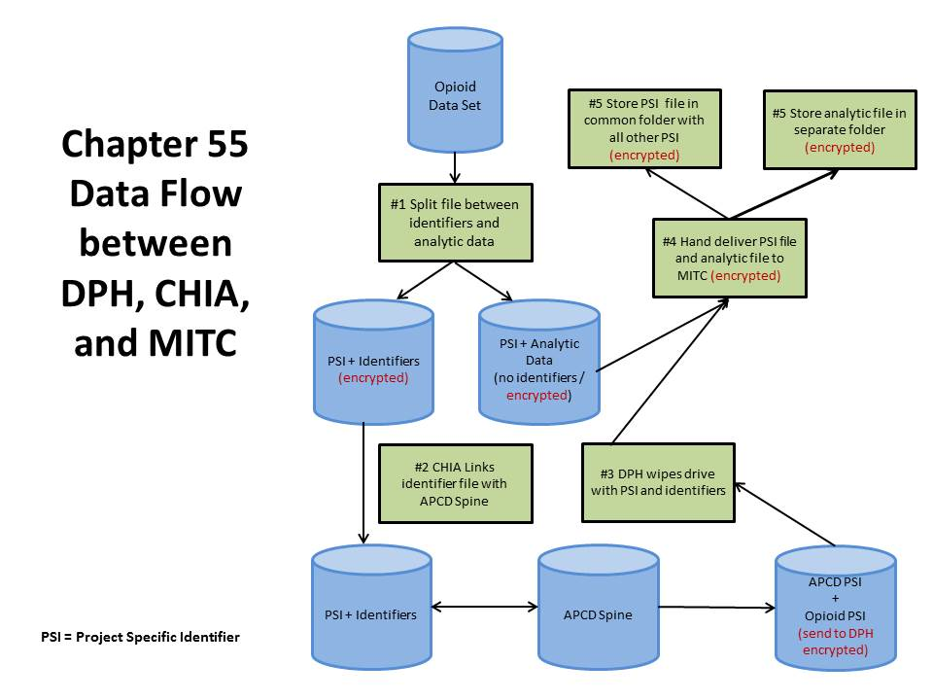

Securing the Server
There were three main goals in securing the SAS server:
- Develop a clear audit process.
- Ensure proper encryption for the different needs of the users.
- Make it so that it was possible to handle more than a small number of group types in the system.
These three goals were achieved in the following manner:
- The disk partition on which the Chapter 55 data was stored was encrypted using LUKS (Linux Unified Key Setup). Linux is the open-source version of the UNIX operating system and LUKS is the standard hard disk encryption method for Linux servers.
- To provide further flexibility in the design of the secure data ecosystem to the needs of the Chapter 55 project, Red Hat Enterprise Linux version 6.0 was used.
- Accounts were authenticated by LDAP, which is the MITC standard, and account creation was handled through specific (not automated) requests to the MITC Linux team.
- A unique mount point for the Chapter 55 project was created so that only group participants could gain access.
- The interface for Chapter 55 work was through the web server interface with data encrypted at rest including all individual work files.
- An audit process was implemented to record when and who was doing maintenance on/for SAS.
- All inbound requests to the server were blocked unless the requestor was on a pre-approved whitelist. The firewall restricted access to specific ports on the server. Ports were continuously monitored.

Preventing Misuse by Analysts:
To minimize the risk of misuse of Chapter 55 data by authorized users, the following processes were implemented as what has been collectively termed a Privacy Shield.
- Access to Chapter 55 data was only permitted using Enterprise SAS Studio software
- Only authorized users were given User IDs and passwords to access the Chapter 55 data.
- Authorized users were required to demonstrate that DPH-required privacy and confidentiality trainings were up to date.
- Only de-identified Analytic sets were accessible by analysts.
- Analysts had “read only” access to Chapter 55 datasets. Writes were not permitted.
- Analysts were not permitted to see the raw Chapter 55 Analytic data. This was accomplished by turning off the ability of authorized users to open and view raw Analytic data files.
- Analysts were not permitted to see small cell sizes. The common SAS procedure for producing counts and cross-tabulations (PROC FREQ) was altered so that it masked (by displaying asterisks) any cell count that was between one and 10.
- All temporary SAS work files were deleted in one of three ways. If shutdown of a process was typical, files were deleted upon shutdown. If shutdown was atypical (e.g., power outage), the system searched for orphaned work files every 15 minutes and these files were deleted. If any data query was open for more than 72 hours, then the system administrator could manually shut down a process which would delete any associated SAS work files.
- An audit process of all commands issued to SAS was implemented. Logs were checked to ensure that no analyst made any attempt to export, print, or otherwise view any Chapter 55 data.

See Figure C.2 for a visual depiction of the Chapter 55 Data Warehouse.

Figure C.2: Data analyst access to Chapter 55 datasets through a secure hardware and software Privacy Shield.
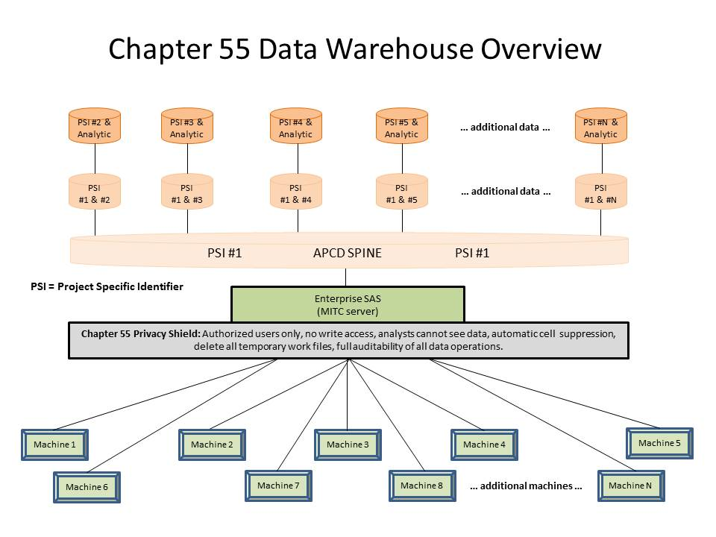

Appendix D: Supplemental Data
Section 1: Chapter 55 Approved Projects

Project Title: Linking Toxicology at Death with Prescription Monitoring Program Records: Implications for Defining Fentanyl and Heroin-related Deaths
Project Lead: Alex Walley (BMC)
Project Team: Marc LaRochelle (BMC), Traci Green (Brown), DPH Resources
Approved: 1/30/2017
Project Summary: Specific opioid toxicology in cause of deaths records has been imprecisely and inconsistently defined and reported across medical examiner jurisdictions. Specifically, likely heroin-related overdoses are inconsistently distinguished from morphine-related deaths because they have similar toxicology. Furthermore, fentanyl-related deaths have been classified as “prescription opioid-related” although young evidence has demonstrated that the fentanyl that is causing increased overdoses is illicitly made outside of the pharmaceutical fentanyl distribution system. Study will thoroughly examine historical and active prescribing along with post-mortem toxicology and how timing of prescriptions relates to fatal and non-fatal overdose. What fraction of overdoses with opioid A are attributable to opioid A prescriptions versus other sources for opioid A?

Project Title: Factors Associated with Overdose Death Among Inpatient Detoxification Patients
Project Lead: Alex Walley (BMC)
Project Team: Marc LaRochelle (BMC), DPH Resources
Approved: 1/30/2017
Project Summary: The population of patients who undergo inpatient detoxification represents a narrow, but specific group of those who have baseline risk for opioid overdose. People who seek inpatient detoxification are trying to reduce their risk of overdose; however, detox lowers opioid tolerance, thus increases overdose risk in the immediate post-detox time period. Patients who seek inpatient detoxification are both easy to define and recognize in the dataset, as well as, relatively easy to reach in the real world if an intervention comes out of this project. The protective and risk factors will be data elements that are both available in the datasets and have clinical and public health implications. This study will examine the protective and risk factors associated with different modalities of substance use disorder treatment.

Project Title: Developing a Predictive Model for Homelessness in Massachusetts and Relating Risk Estimates to Fatal and Non-Fatal Opioid Overdose
Project Leads: Tom Byrne (BU)
Project Team: Marc Dones (C4SI), Travis Baggett (BHCHP), David Smelson (UMASS Med), Asaad Traina (HSPH), Abraar Karan (HSPH), DPH Resources
Approved: 1/30/2017
Project Summary: Homelessness has been related to substance abuse, low education levels, incarceration status, co-morbidity with other chronic conditions, financial catastrophe, and other factors. Identifying the homeless or those at risk of homelessness is challenging because we do not have data directly from homeless shelters, nor is there a direct flag for “homelessness” in most databases. The study will use logistic regression models to identify data patterns associated with homelessness. This predictive model of homelessness will be used to assess ongoing risk of fatal and non-fatal opioid overdose for this population.

Project Title: Multivariate Analysis of Risk Factors for Death Using Data from the PDMP and Fatal Overdoses
Project Lead: Carly Levy (MCPHS)
Project Team: Abhidnya Kurve (MCPHS), Roger Studd (MCPHS), Rania Mekary (MCPHS), Francis Melaragni (MCPHS), DPH Resources
Approved: 1/30/2017
Project Summary: This application proposes to develop a PDMP-specific risk model. All potential factors for risk will be examined and included in a multivariate model if they are supported by the data. The goal is to develop a tool or alert system that could be incorporated into the PDMP to guide prescribers and pharmacists about risks linked specific patients. All algorithms will be self-contained in that they would only utilize PDMP data to compute risk assessments on which alerts would be based.

Project Title: Examination of opioid prescriptions across the VA and non-VA systems to reduce fatal and non-fatal opioid overdoses in Massachusetts
Project Lead: Guneet K. Jasuja (BU/ Bedford VA Medical Center)
Project Team: Omid Ameli (Bedford VA), David Smelson (UMASS Med), Dan Berlowitz (Bedford VA), Donald R. Miller (BU), Keith McInnes (BU), Adam Rose (RAND), Jim Burgess (BU), Avron Spiro (BU), DPH Resources
Approved: 1/30/2017
Project Summary: Veterans may be at particular risk for opioid overdose given that they have high rates of pain that is often treated with prescription opioids. Further, many Veterans are “dual users” who get both VA and non-VA medical care, and this dual use has been shown to increase risk for adverse outcomes in other areas of care. Thus, the objective of these analyses is to examine whether Veterans who receive prescriptions for opioids in both systems (VA and non-VA) are at an increased risk of fatal and non-fatal opioid overdose as compared to Veterans who receive all their opioids in one system. Further, we will examine whether the pattern and times of transition of opioid prescriptions between VA and non-VA systems would increase this risk of opioid overdose.

Project Title: Developing a Dynamic Model for Predicting Opioid Overdoses with the Opportunity to Identify Effective Points of Intervention
Project Lead: Harry Sleeper (MITRE)
Project Team: Project Team Six – The MITRE Corporation, DPH Resources
Approved: 1/30/2017
Project Summary: The team hypothesizes that patterns exist in the timing and type of interactions preceding fatal and non-fatal overdose occurrences. Their objective is to identify patterns in the timing and type of interactions that precede fatal and non-fatal overdose occurrences. Interactions include those that occur with the healthcare and behavioral health systems, the criminal justice system, social services and other interactions that can be analyzed with the available data. The study plans to use most or all Chapter 55 data sets to examine complex interactions related to timing of events and subsequent fatal and non-fatal overdose. A dynamic model will be developed. Survival analyses and logistic regression will be used to define the states of change and the amount of change in the model.

Project Title: Non-Fatal Overdoses, Differential Health Services Utilization, and Subsequent Risk
Project Lead: Kimberley Geissler (UMASS Med)
Project Team: Jennifer Whitehill (UMASS Med), Chelsea Young (UMASS Med), DPH Resources
Approved: 1/30/2017
Project Summary: Based on previous research examining substance use disorders, treatment after an initial non-fatal overdose is likely to vary based on insurance type (e.g., Medicaid, private insurance). Differences in treatment patterns may change the likelihood of repeat overdoses. We hypothesize that individuals with Medicaid insurance receive less treatment after an initial non-fatal overdose and are more likely to have a repeat overdose. Therefore, we will examine differences in repeat non-fatal and fatal overdoses among individuals with different insurance types after an initial non-fatal overdose.

Project Title: A Machine Learning Approach to Identify Patients at Risk of Fatal and Non-Fatal Opiate Overdose
Project Leads: Joscha Legewie (Yale) and Mathijs de Vaan (UC Berkeley)
Project Team: Joscha Legewie (Yale) and Mathijs de Vaan (UC Berkeley), and DPH Resources
Approved: 1/30/2017
Project Summary: The objective of the analysis is to develop a predictive model based on PDMP that produces patient-level risk scores for opioid-related deaths and overdose. The key hypothesis is that consumption of prescription opioids captured in PDMP together with socio-demographic data is predictive of opioid-related deaths. This hypothesis is a pre-requirement for developing a risk score based on PDMP. We will use logistic regression and random forests as our initial models and experiment with other machine learning methods such as support vector machines, adaptive boosting and decision trees. Machine learning methods automate analytical model building and iteratively “learn” from data, which allows computers to find hidden patterns such as complex non-linearities or interactions. These non-linearities and interactions are particularly relevant for the case at hand considering the different pathways and likelihoods of transitioning into illicit drug use. This work may embed other machine learning models within the larger model (e.g., homelessness). The methods proposed in this study promise to significantly improve the prediction of fatal and non-fatal opioid overdose. Cross-validation will be used to limit problems like overfitting and assess how the results of our model generalize to an independent data set.

Project Title: Risk of Opioid Poisoning Associated with Medical Opioid Prescribing
Project Leads: Laura Burke (BIDMC )
Project Team: Austin Frakt, Ashish Jha, and DPH Resources
Approved: 1/30/2017
Project Summary: Medical opioid prescribing is thought to play a key role in this trend and there has been concern that providers have had inadequate information about the risks of medical opioid. There are a number of studies in different settings looking at patient-level risk factors for an opioid poisoning (overdose). However, the absolute risk of an overdose for an individual receiving a new opioid prescription is not well characterized. Empirical evidence about the risk of poisoning is crucial for providers to better evaluate the risk-benefit profile of opioid treatment in patients with potential medical indications for opioid treatment. The objective of this analysis is to characterize the risk of opioid overdose for individuals receiving a new opioid prescription.

Project Title: Risk of Overdose and Death after a Nonfatal Opioid Overdose
Project Leads: Laura Burke (BIDMC)
Project Team: Austin Frakt, Ashish Jha, and DPH Resources
Approved: 1/30/2017
Project Summary: There are a number of studies in different settings looking at patient-level risk factors for an opioid poisoning (overdose). However, more information is needed about the risk of death after a healthcare encounter for opioid overdose and the factors that mediate this risk. The objective of this analysis is to characterize the risk of subsequent death after a healthcare encounter (EMS, ED visit or hospitalization) for opioid poisoning and to understand individual demographic characteristics and co-morbidities as well as indications for opioids that mediate the risk of death after a nonfatal overdose.

Project Title: Receipt of Pharmacotherapy among Adolescents and Young Adults with Opioid Use Disorder and its Impact on Fatal and Non-Fatal Overdose
Project Lead: Scott Hadland (BMC)
Project Team: Sarah Bagley (BMC), Marc Larochelle (BMC), Alex Walley (BMC), and DPH Resources
Approved: 1/30/2017
Project Summary: Despite preexisting clinical practice guidelines and a new policy statement from the American Academy of Pediatrics recommending pharmacotherapy for youth with OUD, no prior studies have examined the extent to which youth in Massachusetts receive medications (buprenorphine, naltrexone, or methadone) and how these medications reduce the likelihood of fatal and non-fatal overdose. The BMC team will address this knowledge gap by obtaining valid, precise, and up-to-date estimates of the percentage of youth receiving pharmacotherapy and relate this information to fatal and non-fatal events. They will also examine retention in care and rate of drug use relapse among youth receiving pharmacotherapy. They will identify time trends and potential disparities in receipt of pharmacotherapy among youth with OUD in Massachusetts using the All Payers Claim Data (APCD), and measure retention in care and rates of drug use relapse among youth receiving pharmacotherapy.

Project Title: Mortality of Patients who Received Pre-hospital Administration of Naloxone
Project Lead: Scott Weiner (Harvard/BWH)
Project Team: Sabrina Poon (Harvard/BWH), Olesya Baker (Partners), and DPH Resources
Approved: 1/30/2017
Project Summary: There has been significant emphasis on availability of naloxone for the lay public and prehospital administration as a means to prevent overdose death. Naloxone is now available as a standing order prescription from most commercial pharmacies, and by a special waiver, it can be administered by Basic Life Support medics. It is theorized that naloxone is saving a significant number of lives in the Commonwealth, but paradoxically, the opioid-related death rate continues to climb despite increased availability of naloxone. The purpose of this study is to determine the medium- and long-term mortality of patients who receive naloxone prehospital. The applicant hypothesizes that naloxone administration is a temporary life-saving measure for many patients, that >50% of patients who eventually died from an overdose had a previous episode of reversal with naloxone.

Project Title: GIS, Spatial Epidemiological, and Geostatistical Analysis of Opioid Overdose in MA
Project Lead: Tom Stopka (Tufts)
Project Team: Kenneth Chui (Tufts), Anna Kaplan (Tufts), Rachel Hoh (Tufts), and DPH Resources
Approved: 1/30/2017
Project Summary: The study will characterize the geospatial distribution and clustering of non-fatal and fatal opioid overdose and its associated outcomes in MA. We will employ descriptive GIS mapping and hotspot cluster analyses that look to control for time, geography, and demographics as we work to portray the unfolding of the opioid epidemic in terms of deaths, non-fatal overdoses, and repeat overdoses in Massachusetts between 2011 and 2015. We will determine whether changes in the epidemic are related to relevant community-level factors to better understand the current state of the opioid epidemic and to project future patterns.

Project Title: Examining Intervention Points to Reduce Fatal and Non-Fatal Opioid Overdoses in Massachusetts
Project Lead: Tom Stopka (Tufts)
Project Team: Marc LaRochelle (BMC), Adam Rose (RAND), Alex Walley (BMC), Kenneth Chui (Tufts), Anna Kaplan (Tufts), David Landy (Tufts), Rachel Hoh (Tufts) , and DPH Resources
Approved: 1/30/2017
Project Summary: This study will examine touchpoints to identify potential opioid use disorder (OUD) interventions in the health care delivery, criminal justice, and public health systems. We will identify distinct subpopulations, times, and venues for which potentially inappropriate prescribing (PIP) is associated with fatal and non-fatal overdose. We will conduct spatial epidemiological analyses to characterize the geographic distribution and clustering of PIP, touchpoints before overdose events, non-fatal and fatal overdoses, and access to OUD services across Massachusetts (MA).

Project Title: Opioid Prescription and Utilization after Orthopedic Surgery
Project Lead: Brandon Earp (BIDMC)
Project Team: Ariana Mora (BIDMC), Praveen Murthy (BIDMC), Jamie Collins (BIDMC), Philip Blazar (BIDMC), and DPH Resources
Approved: March 6, 2017
Project Summary: The purpose of this study is to identify the incidence and risk factors for prolonged use or misuse of opioids, opioid overdose, and opioid-related mortality in patients who have undergone orthopedic procedures in different orthopedic subspecialties. Understanding the characteristics of these patients and their prescribers will facilitate development of future protocols that minimize early opioid dependence after orthopedic surgery, and thereby minimize the risk of long-term opioid-related morbidity and mortality. We hypothesize that there is a substantial and underestimated incidence of prolonged post-operative opioid use beyond the initial perioperative period, and that there are identifiable risk factors that predispose to ongoing prescription opioid use in this population, including both patient factors and prescriber factors listed below.

Project Title: Effect of treatment for opioid use disorder on opioid-related death among patients with intravenous drug associated endocarditis
Project Lead: Simeon Kimmel (BMC)
Project Team: Alex Walley (BMC), Ben Linas (BMC), Marc LaRochelle (BMC), and DPH Resources
Approved: March 6, 2017
Project Summary: In this analysis, we will define the effect of medications for opioid use disorder on opioid related mortality in intravenous drug associated endocarditis (IE-IDU). Reporting the number of patients in Massachusetts with IE-IDU who receive recommended treatment for opioid use disorder after an episode of endocarditis will add to our understanding of the current opioid epidemic. Moreover, describing the impact of treatment for underlying opioid use on overdose and overall mortality can guide public health and clinical strategies to improve mortality in this high-risk population. Treatment with medication for opioid use disorder (MOUD) in patients with injection drug associated endocarditis is associated with reduced opioid-related and all-cause mortality utilization and opioid overdose among families involved in the Emergency Assistance (EA) shelter system

Project Title: Assessing the relationship between patterns of shelter and behavioral health services utilization and opioid overdose among families involved in the Emergency Assistance (EA) shelter system
Project Lead: Thomas Byrne (BU)
Project Team: Margaret Thomas (BU), Daniel Miller (BU), Yoonsook Ha (BU), Travis Baggett (BHCFH) , and DPH Resources
Project Summary: The proposed project seeks to assess the extent to which, among families using the Emergency Assistance (EA) shelter system, different patterns of shelter and behavioral health services utilization are associated with the risk of fatal and non-fatal opioid overdose. . The project is motivated by prior research demonstrating that heads of households in families that make episodic (i.e. multiple discrete episodes over time) use of EA shelter have higher rates of substance abuse and mental health treatment histories than do their counterparts in families that make either transitional (i.e. a single, brief episode) or long term (i.e. a single extended episode) use of EA shelter. By assessing whether such variation in shelter utilization and behavioral health services use is associated with opioid overdose, the project stands to provide actionable information that could be used to help prevent future overdoses among EA-involved families. Specifically, findings could be used to inform the development of a tool that would identify EA-involved families who may be appropriate candidates for targeted screening and intervention efforts.

Project Title: Understanding the Impact that Mental Health has on the Likelihood of Opiate Addiction, Overdose, and Death
Project Lead: Christer Johnson (Ernst & Young)
Project Team: Ankur Jindal (Ernst & Young), Debra Cammer Hines (Ernst & Young), and DPH Resources
Project Summary: Much of the analytical focus in creating insights to reduce the number of opiate related overdoses and deaths has been focused on medical claim and prescription data, but very little focus has been given to behavioral health claims associated with mental health diagnosis and treatment. We propose to use exploratory data mining techniques to examine the relationship between a patient’s mental health diagnosis and treatment history and opiate abuse and overdose. This analysis will allow us to create a patient risk profile for opiate abuse which can be used to inform treatment plans and help health care providers identify patients who are good candidates for interventions before they become addicted and thus prevent opiate related overdose and death

Project Title: Benzodiazepines, ADHD stimulants and overdose in buprenorphine maintenance treatment
Project Lead: Tae Woo Park (BMC)
Project Team: Marc LaRochelle (BMC), Alex Walley (BMC) , and DPH Resources
Project Summary: Benzodiazepines (BZD) and ADHD stimulants are commonly prescribed for psychiatric co-morbidities in patients receiving buprenorphine maintenance treatment (BMT). BZD and stimulant-related poisoning deaths have increased in the US. No large epidemiological study has tested the association between BZD or stimulants and fatal or non-fatal overdose in people receiving BMT. Additionally, the benefits of BZD or stimulants in the BMT patient population are largely unknown. Prescribing BZD or stimulants may increase patient adherence to BMT (see BZD maintenance treatment studies in methadone maintenance) and thus decrease risk of overdose. The study will focus on two primary questions. Is receipt of BZD or stimulant associated with BMT treatment retention? Is the relationship between BZD or stimulant and OD mediated by BMT treatment retention?

Project Title: Assessing Racial Differences In Accessing Treatment Subsequent To A Non-fatal Opioid Overdose Related Hospital Patient Encounter
Project Lead: Dan Dooley (BPHC)
Project Team: Snehal Shah (BPHC), and DPH Resources
Project Summary: Our purpose is to gain a better understanding of the relationship between opioid-related hospital care and subsequent substance abuse treatment admissions. Specifically, we seek to assess whether race and other factors in the hospital record predict follow-up substance abuse treatment among individuals who experienced a non-fatal opioid overdose. To determine if and to the what extent there are racial/ethnic differences in the rates of individual residents receiving subsequent substance abuse treatment services among those who have received acute hospital care for non-fatal opioid overdose and for any substance abuse-related diagnosis within the prior month and to assess factors within the Case Mix record that may play a role in predicting direct follow-up to treatment services.

Project Title: Defining the cascade of care for substance use disorder detoxification in Massachusetts
Project Lead: Jake Morgan (BU)
Project Team: Josh Barocas (BU), Ben Linas (BU), Jenny Wang (BU), Alex Walley (BMC), Jenifer Jaeger (BPHC) , and DPH Resources
Project Summary: The goal of this project is to describe the cascade of care and churn (i.e., frequent relapse and readmission) in substance use disorder (SUD) treatment in Massachusetts for those entering acute treatment services (ATS, detoxification) to inform policies to reduce the risk of fatal and non-fatal opioid overdoses in the Commonwealth. We will describe the movement from ATS post-detox treatment (lower levels of care including CSS and TSS) to longer term residential services, and to outpatient treatment such as outpatient based opioid treatment (OBOT), describing relapse associated with each treatment level and transition (time between treatment services) as well as the rate of successful transitions to lower levels of care. The flexibility of our model will incorporate the variety of paths from ATS through the cascade, and we will describe the impact of each point in the cascade on fatal and non-fatal opioid-related overdose outcomes.

Project Title: Community Distribution of Naloxone Kits and Naloxone Rescues
Project Lead: Alex Walley (BMC)
Project Team: Traci Green (Brown), Tom Stopka (Tufts), Marc Larochelle (BMC), Na Wang (BMC), and DPH Resources
Project Summary: Community overdose response with naloxone is one of the core strategies identified by the US Department of Health and Human Services to address the opioid epidemic. The Massachusetts’ Governor’s Opioid Working Group identified access to naloxone as a key strategy to addressing the opioid crisis. Massachusetts is an early adopter of community overdose education and naloxone distribution. The objectives of this analysis are to use the Chapter 55 databases to generate the amount of naloxone distributed to the community per community (municipality, zip code) over time and the amount of naloxone administered by community members during rescue attempts per community per month. A secondary objective of the project is to assess the geospatial distribution of naloxone, as well as rescue attempts, by zip code. This project will generate community level rates of naloxone distribution and naloxone rescue attempts from multiple sources linked through the chapter 55 databases.

Project Title: Iatrogenic Opioid Addiction and Overdose in Orthopaedic Trauma: Examining a Natural Experiment
Project Lead: Matthew Basilico (Harvard)
Project Team: Abhiram Bhashyam (Harvard), Marilyn Heng (Harvard), Alan Xie (Harvard), Chethan Bachireddy (Harvard), and DPH Resources
Project Summary: This natural experiment utilizes the insight that clinicians differ in their individual propensities to prescribe a particular treatment course among many available options. To identify the relationship between opioid prescribing and addiction, they will use the econometric technique of “instrumental variables,” and use first-year resident assignment as the discharging clinician in orthopedic trauma surgery as an “instrument”—a feature that is essentially random in its assignment—for the opioid prescription the patient receives. For comparison, they will also utilize two additional instruments, differing levels of trauma severity in a motor vehicle accidents, and facility-level propensities to refer to medication assisted treatment after discharge, as well as predictive techniques from machine learning to give context to our causal estimates.

Appendix D Section 2: Full-sized maps of opioid overdose death rates by year.

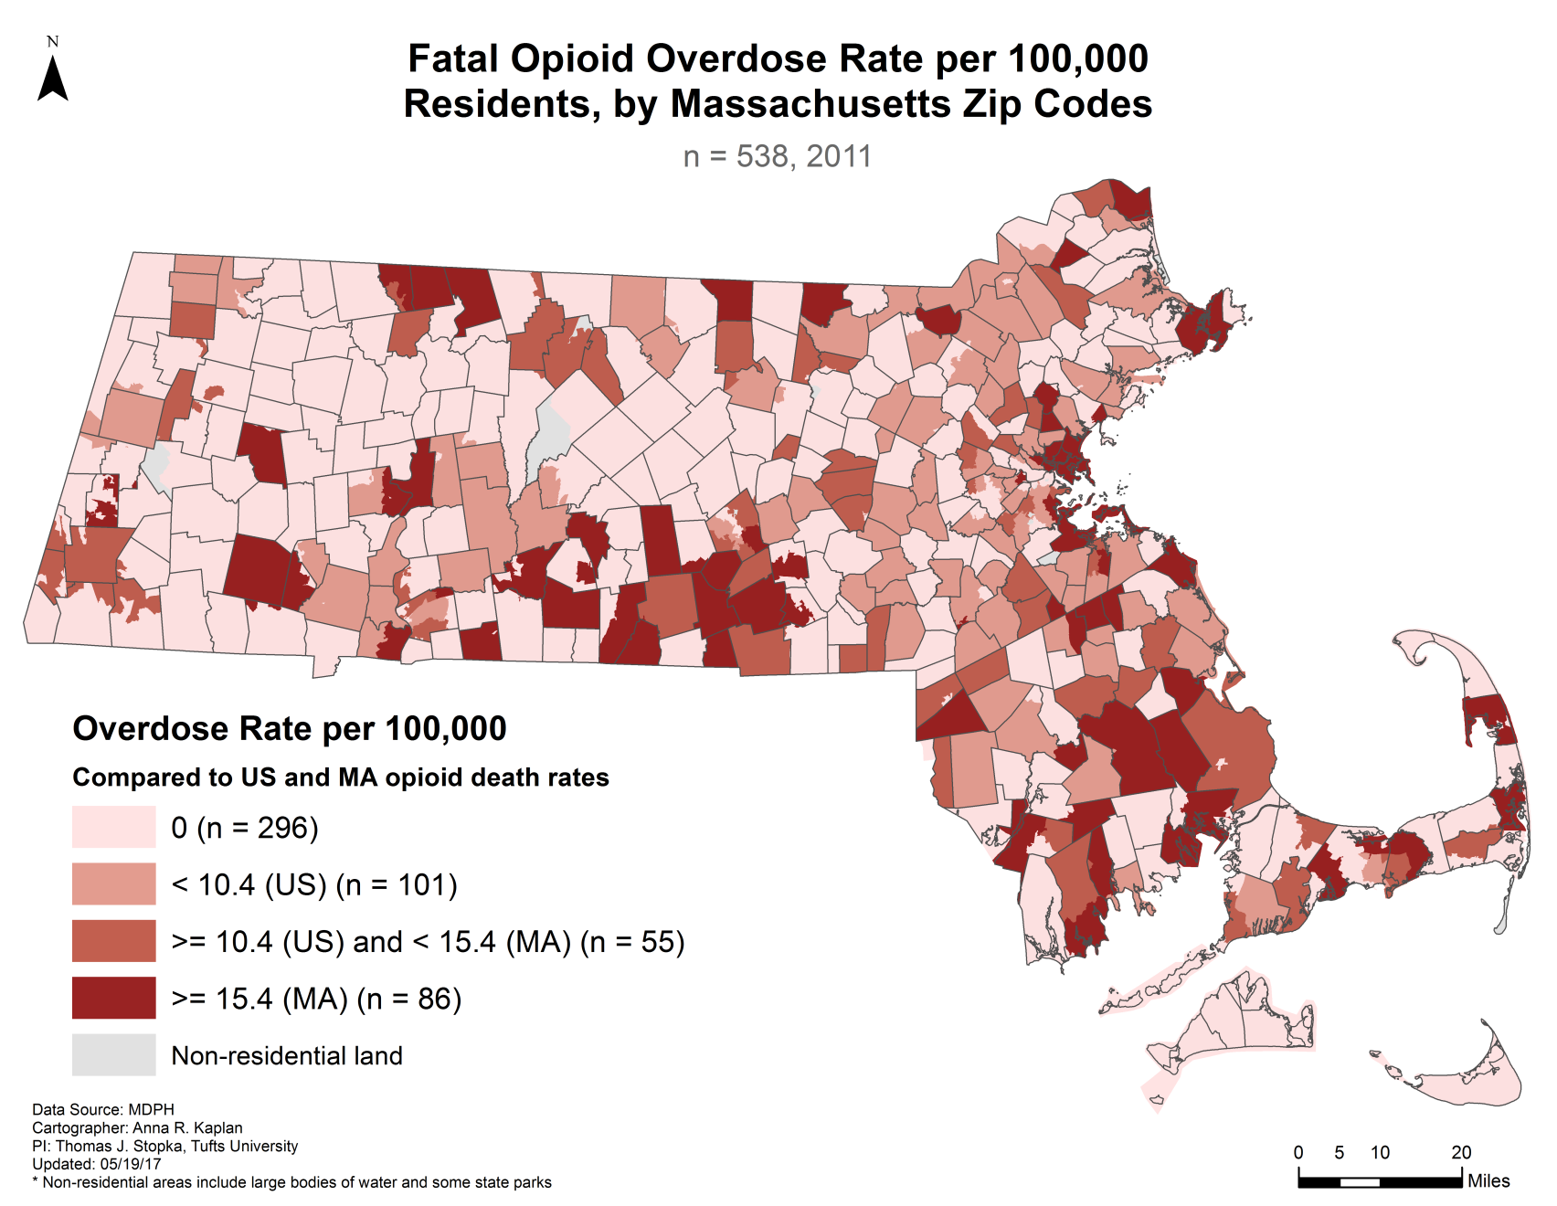
2011
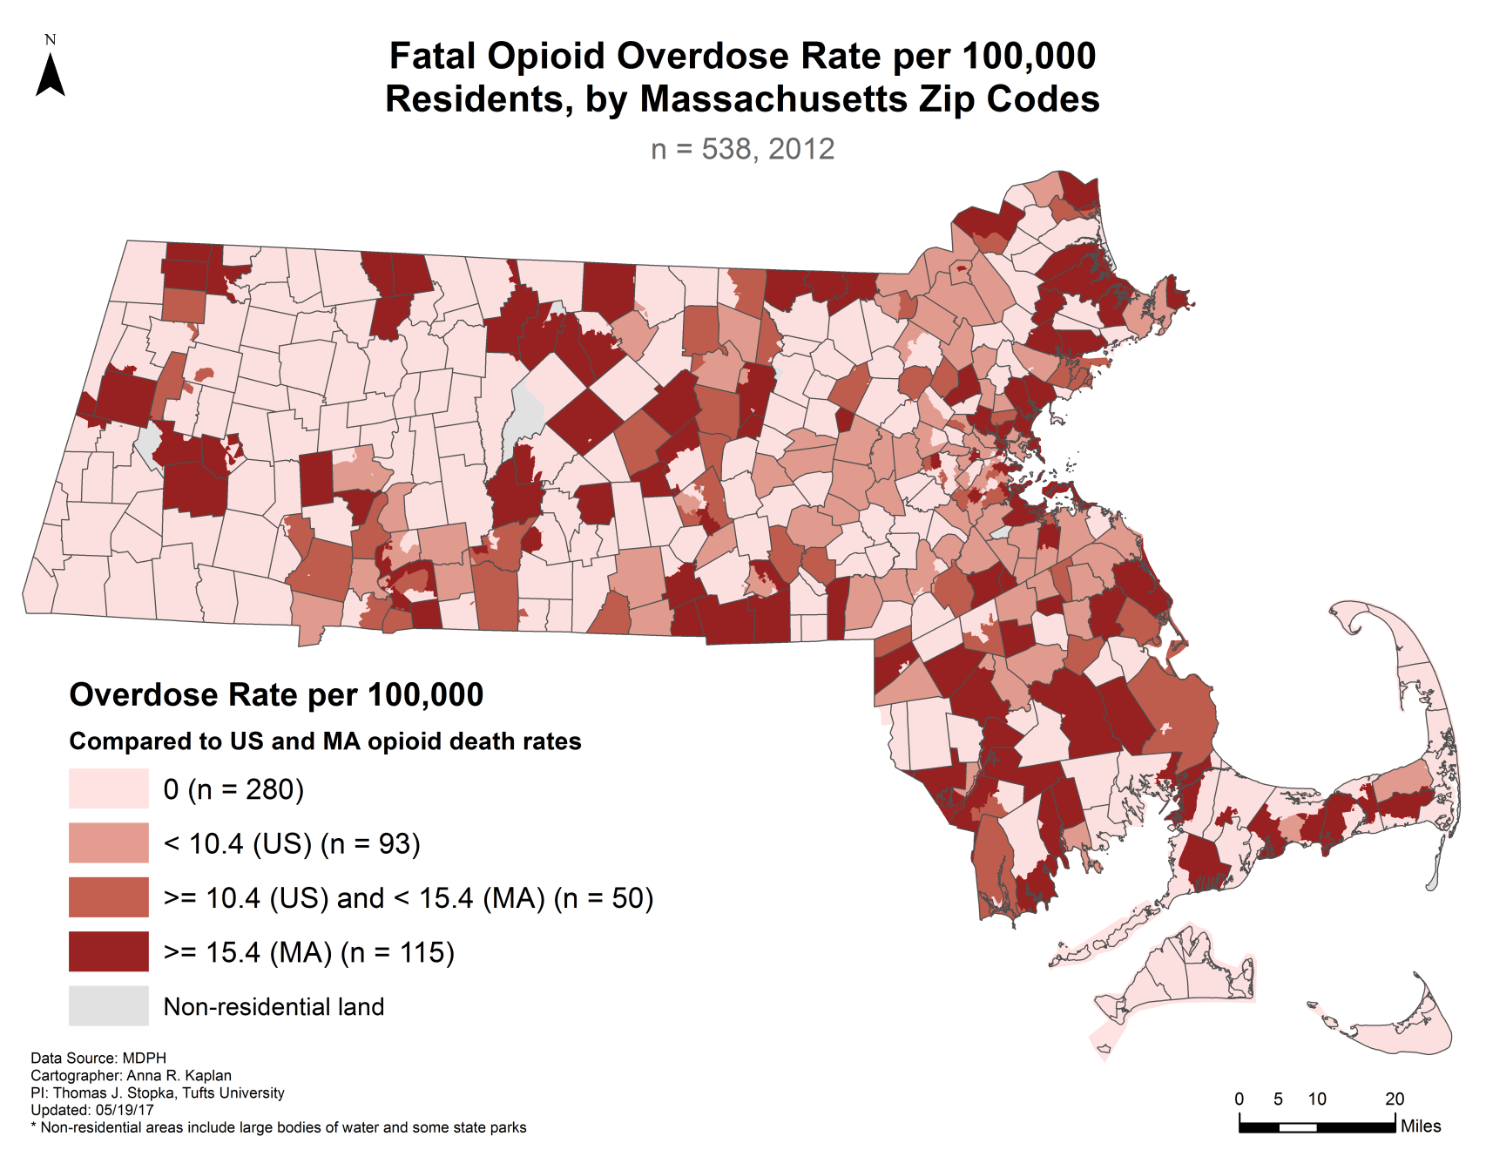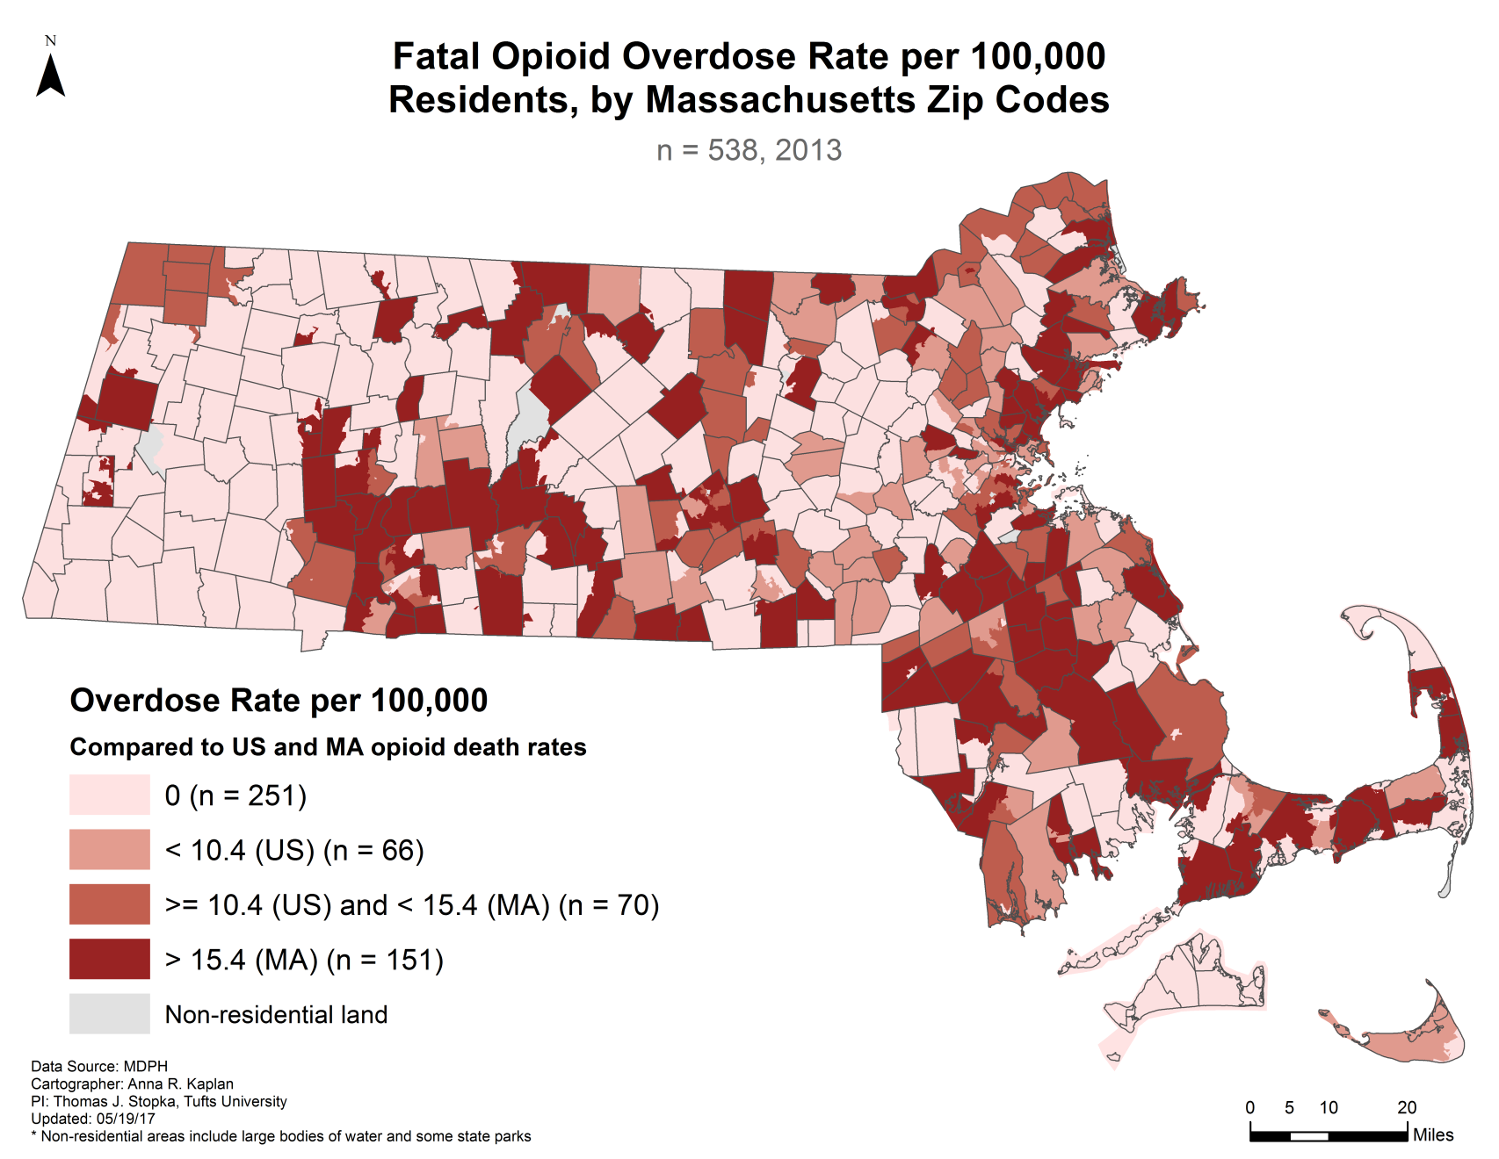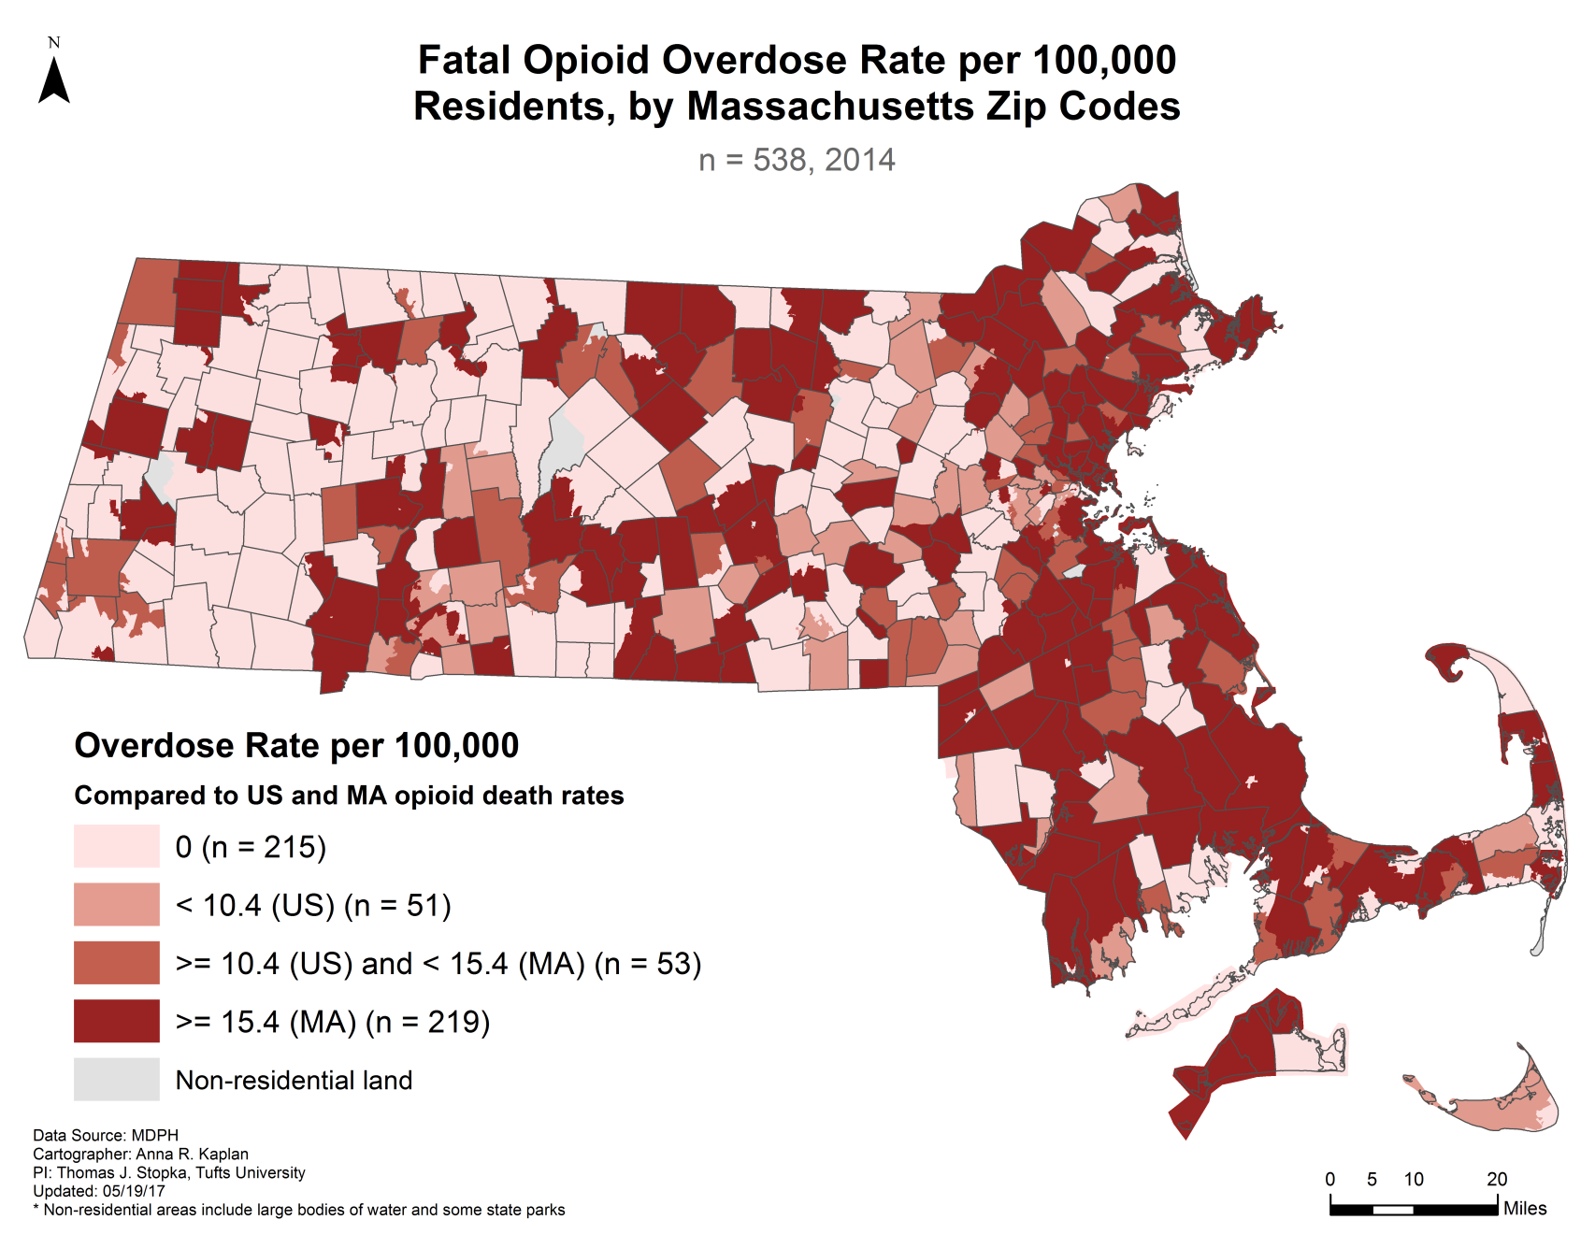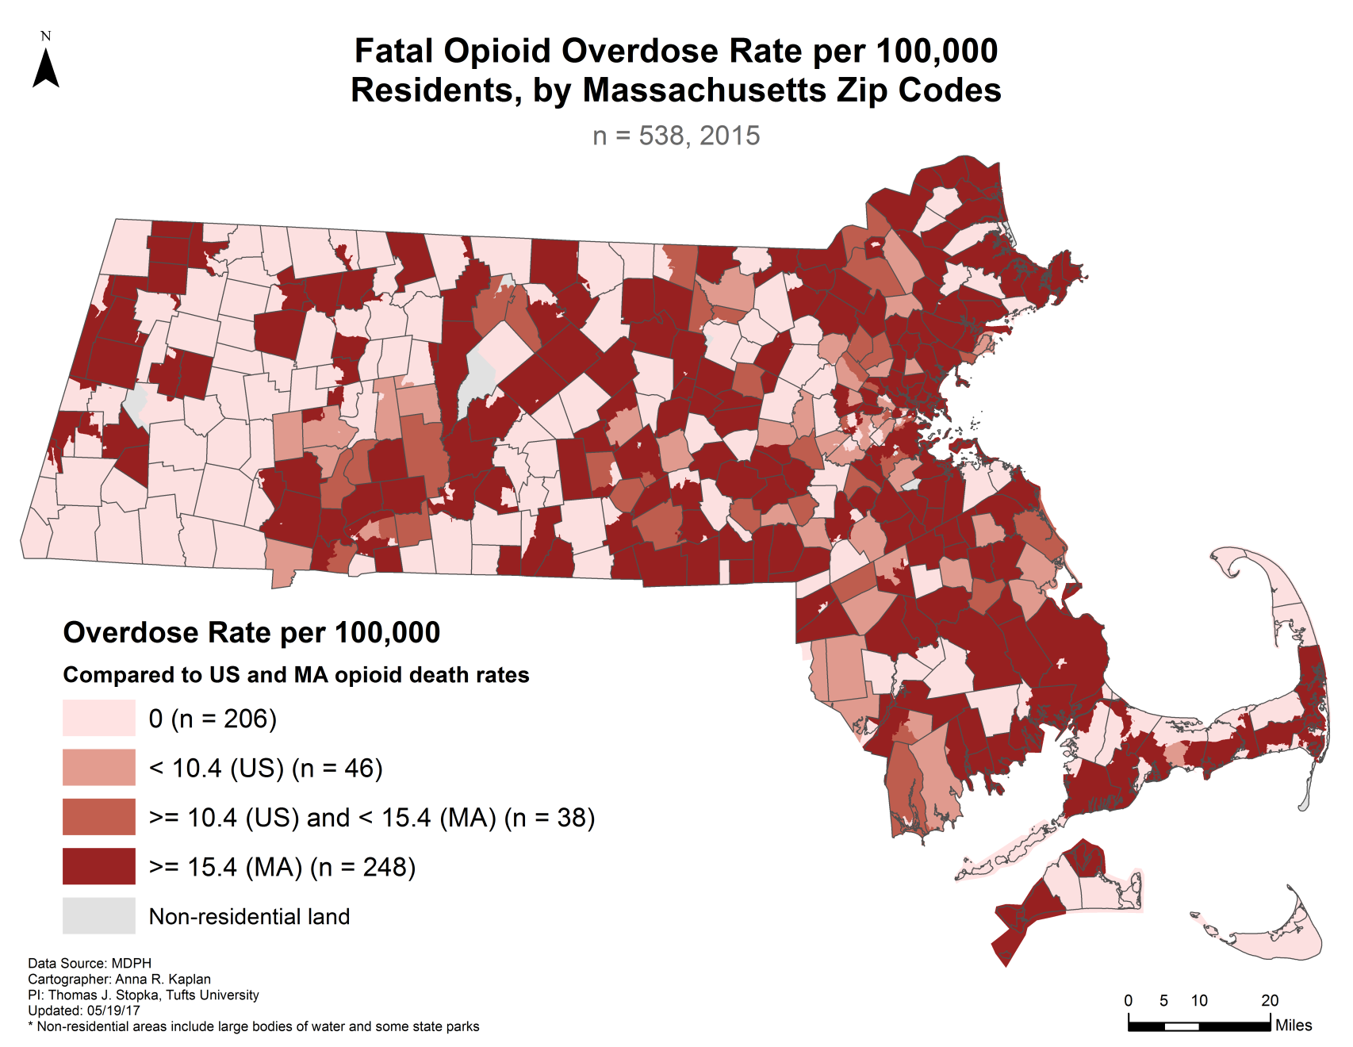
2012
2013
2014
2015

Appendix D Section 3: Community Quintile Scores (Alphabetical Order)

Community | Quintile | Community | Quintile | Community | Quintile
Abington | 1 | Braintree | 2 | Dudley | 3
Acton | 4 | Brewster | 3 | Dunstable | 4
Acushnet | 2 | Bridgewater | 2 | Duxbury | 5
Adams | 1 | Brimfield | 2 | East Bridgewater | 1
Agawam | 2 | Brockton | 1 | East Brookfield | 3
Alford | 2 | Brookfield | 3 | East Longmeadow | 2
Amesbury | 2 | Brookline | 5 | Eastham | 1
Amherst | 5 | Buckland | 4 | Easthampton | 2
Andover | 4 | Burlington | 3 | Easton | 3
Aquinnah | 2 | Cambridge | 4 | Edgartown | 5
Arlington | 4 | Canton | 3 | Egremont | 4
Ashburnham | 4 | Carlisle | 5 | Erving | 2
Ashby | 3 | Carver | 1 | Essex | 5
Ashfield | 5 | Charlemont | 3 | Everett | 1
Ashland | 4 | Charlton | 3 | Fairhaven | 2
Athol | 1 | Chatham | 4 | Fall River | 1
Attleboro | 2 | Chelmsford | 4 | Falmouth | 1
Auburn | 3 | Chelsea | 1 | Fitchburg | 1
Avon | 1 | Cheshire | 5 | Florida | 5
Ayer | 1 | Chester | 4 | Foxborough | 3
Barnstable | 1 | Chesterfield | 4 | Framingham | 2
Barre | 1 | Chicopee | 1 | Franklin | 3
Becket | 4 | Chilmark | 3 | Freetown | 2
Bedford | 4 | Clarksburg | 4 | Gardner | 1
Belchertown | 3 | Clinton | 1 | Georgetown | 4
Bellingham | 3 | Cohasset | 3 | Gill | 3
Belmont | 5 | Colrain | 5 | Gloucester | 1
Berkley | 2 | Concord | 5 | Goshen | 4
Berlin | 5 | Conway | 4 | Gosnold | 5
Bernardston | 1 | Cummington | 3 | Grafton | 3
Beverly | 2 | Dalton | 4 | Granby | 3
Billerica | 2 | Danvers | 2 | Granville | 4
Blackstone | 4 | Dartmouth | 2 | Great Barrington | 4
Blandford | 3 | Dedham | 2 | Greenfield | 1
Bolton | 4 | Deerfield | 4 | Groton | 4
Boston | 1 | Dennis | 1 | Groveland | 4
Bourne | 1 | Dighton | 4 | Hadley | 4
Boxborough | 5 | Douglas | 3 | Halifax | 2
Boxford | 5 | Dover | 5 | Hamilton | 4
Boylston | 3 | Dracut | 2 | Hampden | 3

Community Quintile Scores (Alphabetical Order)

Community | Quintile | Community | Quintile | Community | Quintile
Hancock | 5 | Ludlow | 2 | New Bedford | 1
Hanover | 3 | Lunenburg | 2 | New Braintree | 2
Hanson | 2 | Lynn | 1 | New Marlborough | 5
Hardwick | 2 | Lynnfield | 3 | New Salem | 3
Harvard | 5 | Malden | 1 | Newbury | 4
Harwich | 1 | Manchester | 5 | Newburyport | 4
Hatfield | 2 | Mansfield | 4 | Newton | 5
Haverhill | 1 | Marblehead | 5 | Norfolk | 4
Hawley | 5 | Marion | 3 | North Adams | 1
Heath | 4 | Marlborough | 3 | North Andover | 4
Hingham | 5 | Marshfield | 2 | North Attleboro | 3
Hinsdale | 3 | Mashpee | 1 | North Brookfield | 3
Holbrook | 1 | Mattapoisett | 3 | North Reading | 3
Holden | 3 | Maynard | 3 | Northampton | 1
Holland | 3 | Medfield | 5 | Northborough | 5
Holliston | 4 | Medford | 2 | Northbridge | 1
Holyoke | 1 | Medway | 5 | Northfield | 2
Hopedale | 3 | Melrose | 2 | Norton | 2
Hopkinton | 4 | Mendon | 4 | Norwell | 3
Hubbardston | 2 | Merrimac | 4 | Norwood | 2
Hudson | 2 | Methuen | 2 | Oak Bluffs | 4
Hull | 1 | Middleborough | 1 | Oakham | 4
Huntington | 3 | Middlefield | 2 | Orange | 1
Ipswich | 3 | Middleton | 4 | Orleans | 3
Kingston | 4 | Milford | 3 | Otis | 4
Lakeville | 2 | Millbury | 1 | Oxford | 2
Lancaster | 2 | Millis | 5 | Palmer | 1
Lanesborough | 3 | Millville | 5 | Paxton | 3
Lawrence | 1 | Milton | 4 | Peabody | 2
Lee | 2 | Monroe | 5 | Pelham | 5
Leicester | 2 | Monson | 3 | Pembroke | 2
Lenox | 4 | Montague | 2 | Pepperell | 2
Leominster | 1 | Monterey | 5 | Peru | 5
Leverett | 5 | Montgomery | 5 | Petersham | 3
Lexington | 5 | Mount Washington | 5 | Phillipston | 4
Leyden | 5 | Nahant | 3 | Pittsfield | 1
Lincoln | 5 | Nantucket | 3 | Plainfield | 5
Littleton | 5 | Natick | 4 | Plainville | 3
Longmeadow | 5 | Needham | 5 | Plymouth | 2
Lowell | 1 | New Ashford | 3 | Plympton | 2

Community Quintile Scores (Alphabetical Order)

Community | Quintile | Community | Quintile | Community | Quintile
Princeton | 2 | Springfield | 1 | West Boylston | 3
Provincetown | 4 | Sterling | 5 | West Bridgewater | 1
Quincy | 1 | Stockbridge | 3 | West Brookfield | 3
Randolph | 2 | Stoneham | 2 | West Newbury | 5
Raynham | 1 | Stoughton | 1 | West Springfield | 1
Reading | 3 | Stow | 5 | West Stockbridge | 4
Rehoboth | 5 | Sturbridge | 4 | West Tisbury | 5
Revere | 1 | Sudbury | 5 | Westborough | 4
Richmond | 2 | Sunderland | 4 | Westfield | 2
Rochester | 5 | Sutton | 4 | Westford | 5
Rockland | 1 | Swampscott | 3 | Westhampton | 5
Rockport | 3 | Swansea | 2 | Westminster | 3
Rowe | 5 | Taunton | 1 | Weston | 5
Rowley | 4 | Templeton | 2 | Westport | 3
Royalston | 2 | Tewksbury | 2 | Westwood | 5
Russell | 4 | Tisbury | 3 | Weymouth | 1
Rutland | 4 | Tolland | 5 | Whately | 5
Salem | 1 | Topsfield | 4 | Whitman | 1
Salisbury | 1 | Townsend | 2 | Wilbraham | 4
Sandisfield | 5 | Truro | 2 | Williamsburg | 5
Sandwich | 3 | Tyngsborough | 3 | Williamstown | 5
Saugus | 1 | Tyringham | 3 | Wilmington | 2
Savoy | 4 | Upton | 5 | Winchendon | 1
Scituate | 2 | Uxbridge | 2 | Winchester | 5
Seekonk | 5 | Wakefield | 2 | Windsor | 4
Sharon | 4 | Wales | 3 | Winthrop | 1
Sheffield | 4 | Walpole | 4 | Woburn | 1
Shelburne | 2 | Waltham | 3 | Worcester | 1
Sherborn | 5 | Ware | 1 | Worthington | 4
Shirley | 3 | Wareham | 1 | Wrentham | 4
Shrewsbury | 4 | Warren | 2 | Yarmouth | 1
Shutesbury | 4 | Warwick | 5
Somerset | 2 | Washington | 5
Somerville | 2 | Watertown | 3
South Hadley | 2 | Wayland | 5
Southampton | 3 | Webster | 1
Southborough | 5 | Wellesley | 5
Southbridge | 1 | Wellfleet | 1
Southwick | 3 | Wendell | 4
Spencer | 1 | Wenham | 5

Community Quintile Scores (Quintile 1: Highest Relative Burden)

Community | Quintile | Community | Quintile | Community | Quintile
Abington | 1 | Greenfield | 1 | Rockland | 1
Adams | 1 | Harwich | 1 | Salem | 1
Athol | 1 | Haverhill | 1 | Salisbury | 1
Avon | 1 | Holbrook | 1 | Saugus | 1
Ayer | 1 | Holyoke | 1 | Southbridge | 1
Barnstable | 1 | Hull | 1 | Spencer | 1
Barre | 1 | Lawrence | 1 | Springfield | 1
Bernardston | 1 | Leominster | 1 | Stoughton | 1
Boston | 1 | Lowell | 1 | Taunton | 1
Bourne | 1 | Lynn | 1 | Ware | 1
Brockton | 1 | Malden | 1 | Wareham | 1
Carver | 1 | Mashpee | 1 | Webster | 1
Chelsea | 1 | Middleborough | 1 | Wellfleet | 1
Chicopee | 1 | Millbury | 1 | West Bridgewater | 1
Clinton | 1 | New Bedford | 1 | West Springfield | 1
Dennis | 1 | North Adams | 1 | Weymouth | 1
East Bridgewater | 1 | Northampton | 1 | Whitman | 1
Eastham | 1 | Northbridge | 1 | Winchendon | 1
Everett | 1 | Orange | 1 | Winthrop | 1
Fall River | 1 | Palmer | 1 | Woburn | 1
Falmouth | 1 | Pittsfield | 1 | Worcester | 1
Fitchburg | 1 | Quincy | 1 | Yarmouth | 1
Gardner | 1 | Raynham | 1
Gloucester | 1 | Revere | 1

Community Quintile Scores (Quintile 2: Higher Than Average Relative Burden)

Community | Quintile | Community | Quintile | Community | Quintile
Acushnet | 2 | Hardwick | 2 | Plymouth | 2
Agawam | 2 | Hatfield | 2 | Plympton | 2
Alford | 2 | Hubbardston | 2 | Princeton | 2
Amesbury | 2 | Hudson | 2 | Randolph | 2
Aquinnah | 2 | Lakeville | 2 | Richmond | 2
Attleboro | 2 | Lancaster | 2 | Royalston | 2
Berkley | 2 | Lee | 2 | Scituate | 2
Beverly | 2 | Leicester | 2 | Shelburne | 2
Billerica | 2 | Ludlow | 2 | Somerset | 2
Braintree | 2 | Lunenburg | 2 | Somerville | 2
Bridgewater | 2 | Marshfield | 2 | South Hadley | 2
Brimfield | 2 | Medford | 2 | Stoneham | 2
Danvers | 2 | Melrose | 2 | Swansea | 2
Dartmouth | 2 | Methuen | 2 | Templeton | 2
Dedham | 2 | Middlefield | 2 | Tewksbury | 2
Dracut | 2 | Montague | 2 | Townsend | 2
East Longmeadow | 2 | New Braintree | 2 | Truro | 2
Easthampton | 2 | Northfield | 2 | Uxbridge | 2
Erving | 2 | Norton | 2 | Wakefield | 2
Fairhaven | 2 | Norwood | 2 | Warren | 2
Framingham | 2 | Oxford | 2 | Westfield | 2
Freetown | 2 | Peabody | 2 | Wilmington | 2
Halifax | 2 | Pembroke | 2
Hanson | 2 | Pepperell | 2

Community Quintile Scores (Quintile 3: Average Relative Burden)

Community | Quintile | Community | Quintile | Community | Quintile
Ashby | 3 | Hampden | 3 | Orleans | 3
Auburn | 3 | Hanover | 3 | Paxton | 3
Belchertown | 3 | Hinsdale | 3 | Petersham | 3
Bellingham | 3 | Holden | 3 | Plainville | 3
Blandford | 3 | Holland | 3 | Reading | 3
Boylston | 3 | Hopedale | 3 | Rockport | 3
Brewster | 3 | Huntington | 3 | Sandwich | 3
Brookfield | 3 | Ipswich | 3 | Shirley | 3
Burlington | 3 | Lanesborough | 3 | Southampton | 3
Canton | 3 | Lynnfield | 3 | Southwick | 3
Charlemont | 3 | Marion | 3 | Stockbridge | 3
Charlton | 3 | Marlborough | 3 | Swampscott | 3
Chilmark | 3 | Mattapoisett | 3 | Tisbury | 3
Cohasset | 3 | Maynard | 3 | Tyngsborough | 3
Cummington | 3 | Milford | 3 | Tyringham | 3
Douglas | 3 | Monson | 3 | Wales | 3
Dudley | 3 | Nahant | 3 | Waltham | 3
East Brookfield | 3 | Nantucket | 3 | Watertown | 3
Easton | 3 | New Ashford | 3 | West Boylston | 3
Foxborough | 3 | New Salem | 3 | West Brookfield | 3
Franklin | 3 | North Attleboro | 3 | Westminster | 3
Gill | 3 | North Brookfield | 3 | Westport | 3
Grafton | 3 | North Reading | 3
Granby | 3 | Norwell | 3

Community Quintile Scores (Quintile 4: Lower Than Average Relative Burden)

Community | Quintile | Community | Quintile | Community | Quintile
Acton | 4 | Granville | 4 | Phillipston | 4
Andover | 4 | Great Barrington | 4 | Provincetown | 4
Arlington | 4 | Groton | 4 | Rowley | 4
Ashburnham | 4 | Groveland | 4 | Russell | 4
Ashland | 4 | Hadley | 4 | Rutland | 4
Becket | 4 | Hamilton | 4 | Savoy | 4
Bedford | 4 | Heath | 4 | Sharon | 4
Blackstone | 4 | Holliston | 4 | Sheffield | 4
Bolton | 4 | Hopkinton | 4 | Shrewsbury | 4
Buckland | 4 | Kingston | 4 | Shutesbury | 4
Cambridge | 4 | Lenox | 4 | Sturbridge | 4
Chatham | 4 | Mansfield | 4 | Sunderland | 4
Chelmsford | 4 | Mendon | 4 | Sutton | 4
Chester | 4 | Merrimac | 4 | Topsfield | 4
Chesterfield | 4 | Middleton | 4 | Walpole | 4
Clarksburg | 4 | Milton | 4 | Wendell | 4
Conway | 4 | Natick | 4 | West Stockbridge | 4
Dalton | 4 | Newbury | 4 | Westborough | 4
Deerfield | 4 | Newburyport | 4 | Wilbraham | 4
Dighton | 4 | Norfolk | 4 | Windsor | 4
Dunstable | 4 | North Andover | 4 | Worthington | 4
Egremont | 4 | Oak Bluffs | 4 | Wrentham | 4
Georgetown | 4 | Oakham | 4
Goshen | 4 | Otis | 4

Community Quintile Scores (Quintile 5: Lowest Relative Burden)

Community | Quintile | Community | Quintile | Community | Quintile
Amherst | 5 | Lincoln | 5 | Seekonk | 5
Ashfield | 5 | Littleton | 5 | Sherborn | 5
Belmont | 5 | Longmeadow | 5 | Southborough | 5
Berlin | 5 | Manchester | 5 | Sterling | 5
Boxborough | 5 | Marblehead | 5 | Stow | 5
Boxford | 5 | Medfield | 5 | Sudbury | 5
Brookline | 5 | Medway | 5 | Tolland | 5
Carlisle | 5 | Millis | 5 | Upton | 5
Cheshire | 5 | Millville | 5 | Warwick | 5
Colrain | 5 | Monroe | 5 | Washington | 5
Concord | 5 | Monterey | 5 | Wayland | 5
Dover | 5 | Montgomery | 5 | Wellesley | 5
Duxbury | 5 | Mount Washington | 5 | Wenham | 5
Edgartown | 5 | Needham | 5 | West Newbury | 5
Essex | 5 | New Marlborough | 5 | West Tisbury | 5
Florida | 5 | Newton | 5 | Westford | 5
Gosnold | 5 | Northborough | 5 | Westhampton | 5
Hancock | 5 | Pelham | 5 | Weston | 5
Harvard | 5 | Peru | 5 | Westwood | 5
Hawley | 5 | Plainfield | 5 | Whately | 5
Hingham | 5 | Rehoboth | 5 | Williamsburg | 5
Leverett | 5 | Rochester | 5 | Williamstown | 5
Lexington | 5 | Rowe | 5 | Winchester | 5
Leyden | 5 | Sandisfield | 5

Appendix E: Legal Agreements

In order to meet the legal requirements of working with all of these protected datasets, a number of legal documents were produced. Four different types of agreements were signed.

- Linking – This agreement between DPH and Center for Health Information and Analysis (CHIA) allowed for the exchange of data for the purposes of securely connecting data at the individual level across secure datasets without exposing the identity of the individual so connected.
- Sharing – This agreement outlined the methodology and restrictions allowing for the sharing of data between different departments or agencies that were not previously sharing – or even allowed to share, outside of the Chapter 55 project. Each of the data-supplying entities was a signatory to this ISA. Specifically, signatories include: the Department of Public Health (DPH), the Department of Correction (DOC), the Executive Office of Public Safety and Security (EOPSS) for Houses of Correction data (HOC), the Office of the Chief Medical Examiner (OCME), the Department of Veterans’ Services (DVS), the Department of Mental Health (DMH), the Department of Housing and Community Development (DHCD), MassHealth, and the Center for Health Information and Analysis (CHIA). While CHIA has previously signed the Linking agreement, they are also the provider of analytic data from the All Payer Claims Database (APCD) and Case Mix.
- Hosting – An agreement between DPH and MassIT specifying the hosting responsibilities and restrictions for the data infrastructure.
- Access – An additional agreement created for ad hoc access to data outside of the purview of the prior three agreements. For example: If the Data Office within MassIT were to assist in a way that required analytical data access that is not covered by the 3rd agreement (which is hosting specific). This 4th agreement essentially outlines the responsibilities of being a good data steward and requires a signature for access. There would conceivably be n number of these agreements signed over time.

Appendix F: Partnerships

The Chapter 55 project brought together analysts and researchers from across government, more than a dozen academic institutions, and two private consulting firms. First and foremost, the Department of Public Health would like to thank all those who participated in this effort. Without everyone’s assistance, this report could not have been completed in time. The work done here has been groundbreaking and the collaboration has been extraordinary both inside and outside government institutions.

State Agencies
- Center for Health Information and Analysis  - EOHHS IT  - EOPSS  - Department of Correction  - Department of Housing and Community Development  - Department of Mental Health | - Department of Public Health  - Department of Veterans’ Services  - Massachusetts Sheriffs’ Association  - Massachusetts State Police  - MassHealth  - Mass IT – Data Office  - Office of the Chief Medical Examiner
Academic Institutions and Private Industry
- Beth Israel Deaconess Hospital  - Boston Children’s Hospital Boston Health Care for the Homeless  - Boston Medical Center  - Boston Public Health Commission  - Boston University School of Medicine  - Brigham & Women’s Hospital  - Brown University  - Center for Social Innovation  - Centers for Disease Control and Prevention  - Commonwealth Medicine  - Ernst & Young  - General Electric Foundation  - Harvard Medical School  - Harvard School of Public Health  - Harvard University | - Mass College of Pharmacy and Health Sciences  - Massachusetts Institute of Technology  - MITRE Corporation  - Northeastern University  - Partners Healthcare  - Price Waterhouse Cooper  - RAND Corporation  - SAS Analytics  - Tufts University School of Medicine  - University of Massachusetts, Amherst  - University of Massachusetts, Boston  - University of Massachusetts Medical School  - University of California, Berkeley  - Veterans Administration  - Yale University

Accessed at http://www.mass.gov/eohhs/docs/dph/stop-addiction/current-statistics/data-brief-overdose-deaths-february-2017.pdf on 5/19/2017.
Maps prepared by Department of Public Health and Community Medicine, Tufts University School of Medicine. In 2011, 16% of zip codes were in the highest risk category. By 2015, that number had increased to 46%. The full-sized maps can be examined in Appendix D.
Accessed at http://www.mass.gov/eohhs/docs/dph/stop-addiction/recommendations-of-the-governors-opioid-working-group.pdf on 5/19/2017.
Administrative data refers to information collected primarily for administrative (not research) purposes.
To be categorized as opioid naïve, the individual’s records had to show a period of six months or more without an opioid prescription before their first opioid prescription. Patients excluded from the group were persons who had any advanced cancer (other than non-melanoma skin cancer), had a substance use disorder diagnosis in the six months preceding their first opioid prescription, or whose first prescription was for any buprenorphine formulation indicated for treatment of substance use disorder.
Jones CM. Frequency of prescription pain reliever nonmedical use: 2002-2003 and 2009-2010. Arch Intern Med. 2012;172(16):1265-1267.
Jones CM, Campopiano M, Baldwin G, McCance-Katz E. Am J Public Health. 2015 Aug;105(8):e55-63. doi: 10.2105/AJPH.2015.302664.
Accessed at https://archive.ahrq.gov/data/safetynet/billings.htm on 5/19/2017.
A capture-recapture analysis is often used in ecological studies to estimate the size of a population when data is incomplete.
Darke S., Mattick R. P., Degenhardt L. The ratio of non‐fatal to fatal heroin overdose. Addiction 2003; 98: 1169–71
Caudarella A, Dong H, Milloy MJ, Kerr T, Wood E, Hayashi K. Nonfatal overdose as a risk factor for subsequent fatal overdose among people who inject drugs. Drug Alcohol Depend. 2016;162:51-55
http://www.mass.gov/eohhs/docs/dph/stop-addiction/dph-legislative-report-chapter-55-opioid-overdose-study-9-15-2016.pdf
Data entered into MATRIS by EMTs was never intended to be diagnostic.
This number could be an overestimate since data recorded in 2013 may have more missing information than subsequent years.
Linking data across multiple data systems along with the use of logical estimates of missing data has allowed DPH to determine likely counts for nonfatal opioid overdoses between 2011 and 2015. Nonfatal opioid overdoses in Massachusetts have increased by ~300% in four years.
Accessed at http://www.mass.gov/eohhs/gov/departments/dph/stop‐addiction/current‐statistics.html on 5/19/2017.
Accessed at http://www.mass.gov/eohhs/gov/departments/dph/stop-addiction/current-statistics.html on 5/19/2017.
While some of the increase in opioid-related deaths could be due to more careful reporting, it is unlikely that increases of this magnitude are due to reporting differences over time.
Unreported data from the first Chapter 55 study showed an unusual number of deaths in different age groups with long histories of opioid use and treatment. This study examines the likelihood that some additional deaths may be opioid-related.
The following codes were used: F11, F19, J18, J45, I11, I21, I33, I38, I49, and R99.
Somerville NJ, O’Donnell J, Gladden RM, et al. Characteristics of Fentanyl Overdose — Massachusetts, 2014–2016. MMWR Morb Mortal Wkly Rep 2017;66:382–386. DOI: http://dx.doi.org/10.15585/mmwr.mm6614a2
McQuay H. Opioids in pain management. Lancet 1999, 353: 2229-2232.
Kenan et al. Trends in prescriptions for oxycodone and other commonly used opioids in the United States, 2000-2010. Open Med. 2012 Apr 10;6(2):e41-7. Print 2012.
Okie S. A Flood of Opioids, a Rising Tide of Deaths. N Engl J Med 2010; 363:1981-1985
Pezalla et al. Secular trends in opioid prescribing in the USA. J Pain Res. 2017; 10: 383–387.
Accessed at http://professionals.ufhealth.org/files/2011/11/0312-drugs-therapy-bulletin.pdf on 5/19/2017.
Compton WM, Volkow ND. Major increases in opioid analgesic abuse in the United States: Concerns and strategies Drug and Alcohol Dependence 81 (2006) 103–107.
Clarke H, et. al. Rates and risk factors for prolonged opioid use after major surgery: population based cohort study. BMJ 2014; 348 doi: https://doi.org/10.1136/bmj.g1251 (Published 11 February 2014) Cite this as: BMJ 2014;348:g1251
In the previous section, it was stated that “Over three million individuals received new opioid prescriptions during the study period.”
Gossop M, Stewart D, Treacy S, Marsden J. A prospective study of mortality among drug misusers during a 4-year period after seeking treatment. Addiction. Jan 2002;97(1):39-47.
Warner-Smith M, Darke S, Day C. Morbidity associated with non-fatal heroin overdose. Addiction. Aug 2002;97(8):963-967.
Schwartz RP, Gryczynski J, O'Grady KE, et al. Opioid agonist treatments and heroin overdose deaths in Baltimore, Maryland, 1995-2009. American journal of public health. May 2013;103(5):917-922.
Clark RE, Samnaliev M, McGovern MP. Impact of substance disorders on medical expenditures for medicaid beneficiaries with behavioral health disorders. Psychiatric services. Jan 2009;60(1):35-42.
Note that individuals in the cohort could enter with either an original fatal overdose or a non-fatal overdose. For those whose initial overdose was fatal, we observe them as censored in our follow-up data. However, the construction of the original overdose cohort in this manner allows us to determine overall trends in the insurance status and type of individuals experiencing an opioid overdose at any point in the time period.
This includes individuals who had a fatal overdose as their initial entry into the overdose cohort.
Controlled Substances Act. Vol 21 CFR 1308.12. http://www.deadiversion.usdoj.gov/21cfr/cfr/1308/1308_12.htm.
Nelson L, Schwaner R. Transdermal fentanyl: Pharmacology and toxicology. J Med Toxicol. 2009;5(4):230-241. doi:10.1007/BF03178274.
Volpe DA, Tobin GAM, Mellon RD, et al. Uniform assessment and ranking of opioid Mu receptor binding constants for selected opioid drugs. Regul Toxicol Pharmacol. 2011;59(3):385-390. doi:10.1016/j.yrtph.2010.12.007.
Higashikawa Y, Suzuki S. Studies on 1-(2-phenethyl)-4-(N-propionylanilino) piperidine (fentanyl) and its related compounds. VI. Structure-analgesic activity relationship for fentanyl, methyl-substituted fentanyls and other analogues. Forensic Toxicol. 2008;26(1):1-5. doi:10.1007/s11419-007-0039-1.
Gladden RM, Martinez P, Seth P. Fentanyl law enforcement submissions and increases in synthetic opioid-involved overdose deaths — 27 states, 2013–2014. MMWR Morb Mortal Wkly Rep 2016; 65: 837-43
Accessed at http://www.mass.gov/eohhs/docs/dph/stop-addiction/current-statistics/data-brief-overdose-deaths-may-2017.pdf on 5/19/2017.
Ohannessian, Dana “Re: Situational Awareness Alert for the Drug Carfentanil - Message from DPH.” Received 5/15/2017 via email.
Somerville NJ, O’Donnell J, Gladden RM, et al. Characteristics of Fentanyl Overdose — Massachusetts, 2014–2016. MMWR Morb Mortal Wkly Rep 2017;66:382–386. DOI: http://dx.doi.org/10.15585/mmwr.mm6614a2.
Supporting Those Who Served in Massachusetts Needs, Well-Being, and Available Resources for Veterans by Carrie M. Farmer, Terri Tanielian, Shira H. Fischer, Erin L. Duffy, Stephanie Dellva, Emily Butcher, Kristine Brown, Emily Hoch Copyright: RAND Corporation Availability: Web-Only, DOI: 10.7249/RB9945 Document Number: RB-9945-KLAFF
Lee, B. A., Tyler, K. A., & Wright, J. D. (2010). The new homelessness revisited. Annual review of sociology, 36, 501-521.
https://www.hudexchange.info/resource/5178/2016-ahar-part-1-pit-estimates-of-homelessness/
January 14, 2013. doi:10.1001/jamainternmed.2013.1604
Accessed at https://archive.ahrq.gov/data/safetynet/billings.htm on 5/19/2017.
Our focus in this work is primarily on the single adult homeless population with a future analysis to focus more specifically on the discrete population of persons in families experiencing homelessness. This distinction is warranted in light of evidence of differences in the characteristics of the single adult and family homeless along several dimensions.
Since the APCD forms the spine of the Chapter 55 data system, all individuals have at least some data in the APCD.
Records on the use of the Emergency Assistance (EA) family shelter system were available from the Department of Housing and Community Development (DHCD), but were not included as an indicator of homelessness in the current analysis, as the intent was to identify the single adult homeless population as far as was possible with the available data.
Coded in one or more of the administrative data sets.
The rate is 16 times higher for coded administrative data and 30 times higher for the modeled results.
Accessed at https://www.drugabuse/gov/publications/drgfacts/comorbidity-addiction-other-mental-disorder on 5/19/2017.
Accessed at https://www.drugabuse.gov/sites/default/files/rrcomorbidity.pdf on 5/19/2017.
Accessed at https://www.samhsa.gov/newsroom/press-announcements/201701241230 on 5/19/2017.
Since only MassHealth data was used to identify SMI, all persons with SMI in this study were insured by MassHealth.
Accessed at http://censusviewer.com/state/MA/2010 on 5/19/2017.
Accessed at https://www.drugabuse.gov/publications/research-reports/prescription-drugs/trends-in-prescription-drug-abuse/adolescents-young-adults on 5/19/2017.
Rudd R, Aleshire N, Zibbell J, Gladden M. Rudd RA, Aleshire N, Zibbell JE, Matthew Gladden R. Increases in drug and opioid overdose deaths—United States, 2000–2014. MMWR Morb Mortal Wkly Rep. 2016;64(50-51):1378-1382.
Jones CM, Logan J, Gladden RM, Bohm MK. Vital Signs: Demographic and Substance Use Trends Among Heroin Users - United States, 2002-2013. MMWR Morb Mortal Wkly Rep. 2015;64(26):719-725
Glaze LE, Parks E. Correctional populations in the United States, 2011. Washington DC: U.S. Department of Justice; 2012.
Mumola CJ, Karberg JC. Drug use and dependence, state and federal prisoners, 2004 (revised 1/19/07) Washington, DC: U.S. Department of Justice; 2006.
Fazel S, Baillargeon J. The health of prisoners. Lancet. 2011;377:956–65. doi: 10.1016/S0140-6736(10)61053-7. [PubMed] [Cross Ref]
Karberg JC, James DJ. Substance dependence, abuse, and treatment of jail inmates, 2002. Washington DC: U.S. Department of Justice; 2005.
Boutwell AE, Nijhawan A, Zaller N, Rich JD. Arrested on heroin: a national opportunity. J Opioid Manag. 2007;3:328–32. [PubMed]
Chandler RK, Fletcher BW, Volkow ND. Treating drug abuse and addiction in the criminal justice system: improving public health and safety. JAMA. 2009;301:183–90. doi: 10.1001/jama.2008.976.[PMC free article] [PubMed] [Cross Ref]
Gordon MS, Kinlock TW, Schwartz RP, O’Grady KE. A randomized clinical trial of methadone maintenance for prisoners: findings at 6 months post-release. Addiction. 2008;103:1333–42. doi: 10.1111/j.1360-0443.2008.002238.x. [PMC free article] [PubMed] [Cross Ref]
Binswanger IA, Blatchford PJ, Mueller SR, Stern MF. Mortality after prison release: opioid overdose and other causes of death, risk factors, and time trends from 1999 to 2009. Ann Intern Med. 2013;159:592–600. doi: 10.7326/0003-4819-159-9-201311050-00005. [PubMed] [Cross Ref]
Binswanger IA, Stern MF, Deyo RA, Heagerty PJ, Cheadle A, Elmore JG, et al. Release from prison–a high risk of death for former inmates. N Engl J Med. 2007;356:157–65. doi: 10.1056/NEJMsa064115.[PMC free article] [PubMed] [Cross Ref]
List of Prisons, Mass.gov
Accessed at http://prisonhandbook.com/1688/massachusetts-county-jails/ on 5/19/2017.
Massachusetts Department of Correction, 2015 Annual Report
Accessed at http://www.mass.gov/eopss/agencies/doc/ on 5/19/2017.
Accessed at http://www.mass.gov/eohhs/docs/dph/stop-addiction/dph-legislative-report-chapter-55-opioid-overdose-study-9-15-2016.pdf on 5/19/2017.
For HOC data, incarceration dates are not reported for all county releases, so the full period of incarceration is not available for the data set. Hampshire and Berkshire counties did not submit data for FY2012 quarter 2, and Worcester County did not provide offender date of birth for CY2012 through CY2013 Q4, so their information is excluded for this analysis.
Since the data from Houses Correction only included release data and not dates of incarceration, the analysis focused on data from the Department of Correction.
Derrington TM, Bernstein J, Belanoff C, Cabral HJ, Babakhanlou-Chase H, Diop H, Evans SR, Kotelchuck M. Refining Measurement of Substance Use Disorders Among Women of Child-Bearing Age Using Hospital Records: The Development of the Explicit-Mention Substance Abuse Need for Treatment in Women (EMSANT-W) Algorithm. Matern Child Health J. 2015; 19:2168-78.
ACOG Committee Opinion No. 422: At-risk drinking and illicit drug use: ethical issues in obstetric and gynecologic practice. Obstetrics and Gynecology. 2008; 112(6):1449–60.
Harrison PA, Sidebottom AC. Systematic prenatal screening for psychosocial risks. Journal of Health Care for the Poor and Underserved. 2008; 19(1):258–76. doi:10.1353/hpu.2008.0003.
Massachusetts Department of Public Health, unpublished data.
Since the opioid crisis in Massachusetts accelerated in 2012, no data prior to 2012 was used in the analysis.
To establish our “threshold of stability,” we looked at the standard deviations of community level rates for each of the 4 measures using different population cut points for the communities. Community population size was determined using the 2010 US Census. Multiple population cut points were tested to determine the appropriate threshold: all communities, 1,000 2,000, 3,000 and 20,000 residents. For all four measures, the standard deviation of the rates stabilized once when communities with 3,000 residents or more were considered.
A Poisson probability of the number of actual events occurring in each community was computed for each of the 4 measures. That probability was compared to the probabilities computed for rates for a hypothetical town of 3,000 people. The rate for the hypothetical town replaced the rate for the smaller community to make it more reliable over years.
The actual rates for larger towns and estimated rates for smaller towns were analyzed using a principal components analysis. A one component solution was clearly indicated as it accounted for nearly three-quarters of all differences. Therefore, adding together standardized values for the four measures was a reliable way to estimate the opioid burden on a community level.
With the exception of data from the Department of Transitional Assistance, the data in the service flag fields was poorly populated and therefore was not used in this report.
Accessed at http://www.mass.gov/eohhs/gov/departments/dph/programs/admin/dmoa/vitals/ on 5/19/2017.
The collection of death certificate data is authorized by MGL Chapter 46.
Accessed at http://www.mass.gov/eohhs/gov/departments/dph/programs/admin/dmoa/vitals/vitals-information-partnership-vip.html on 5/19/2017.
Accessed at http://www.mass.gov/eohhs/gov/departments/dph/programs/substance-abuse/ on 5/19/2017.
The collection of detailed substance abuse treatment by BSAS is authorized under MGL Ch.111 B and E. All treatment providers are required to submit data to BSAS to carry out the responsibilities listed under the law. The regulations promulgated to carry out these responsibilities require the providers to submit data in a timely manner. The required data fields include but are not limited to: client characteristics, enrollment, disenrollment information, services and outcomes. Currently, only treatment providers that receive funding from the Department submit the required data to BSAS.
Accessed at http://www.mass.gov/eohhs/gov/departments/dph/programs/hcq/drug-control/PDMP/ on 5/19/2017.
The Department of Public Health’s Office of Prescription Monitoring and Drug Control (OPMDC) established the Massachusetts Prescription Monitoring Program (MA PDMP) in 1992 pursuant to joint regulations (105 CMR 700.012) with the Board of Registration in Pharmacy (247 CMR 5.04).
For more information see: www.mass.gov/dph/oems/matris
The collection of detailed ambulance trip data by OEMS is authorized under 105 CMR 170.345(B).
Accessed at http://www.mass.gov/eohhs/gov/departments/dph/programs/admin/dmoa/vitals/ on 5/19/2017.
The collection of Confidential Birth Information is authorized under 105 CMR 350.000.
Accessed at http://www.mass.gov/eohhs/gov/departments/dph/programs/admin/dmoa/vitals/vitals-information-partnership-vip.html on 5/19/2017.
Accessed at http://www.mass.gov/eohhs/gov/departments/dph/programs/admin/dmoa/cancer-registry/ on 5/19/2017.
The collection of detailed cancer incidence and staging by the MCR is authorized under Chapter 111, Section 111B.
Accessed at http://www.mass.gov/eopss/agencies/ocme/ on 5/19/2017.
The collection of death certificate data is authorized by MGL Chapter 38.
Accessed at http://www.chiamass.gov/case-mix-data/ on 5/19/2017.
Massachusetts acute care hospitals are required to submit Case Mix data in accordance with Regulation 114.1 CMR 17.00.
Accessed at http://www.chiamass.gov/ma-apcd/ on 5/19/2017.
CHIA has statutory authority to collect data from both public and private health care payers under Massachusetts General Laws Chapter 12C, section 10. By July 2010, Regulations 114.5 CMR 21.00 and 114.5 CMR 22.00 formally established the APCD in Massachusetts.
Accessed at http://www.mass.gov/eopss/agencies/doc/ on 5/19/2017.
The collection of detailed incarceration data by DoC authorized under MGL c. 124, s. 1(j) and MGL c. 124, s. 1(k).
Accessed at http://www.mass.gov/eohhs/gov/departments/dmh/ on 5/19/2017.
Accessed at http://www.mass.gov/hed/economic/eohed/dhcd/ on 5/19/2017.
Accessed at http://www.mass.gov/veterans/about-veterans-services/ on 5/19/2017.
Accessed at http://www.mass.gov/eohhs/gov/departments/masshealth/ on 5/19/2017.
Accessed at http://www.mass.gov/msa/ on 5/19/2017.
Case Mix records are stored without the usual complement of identifiers making estimates of linkage rates difficult to compute. Comparisons of non-fatal events in raw Case Mix were made with those same events in the linked data set. Approximately 30% more nonfatal opioid events were found in the raw records, thus the estimate of a 70% linkage rate.
Data from Partners Healthcare for a project proposed by Harvard School of Public Health and Partners was also linked to the APCD data. Since this data was not available to other researchers, it is not included in the table above.
Lower quintiles indicate highest relative burden. Higher quintiles indicate lowest relative burden.
Lower quintiles indicate highest relative burden. Higher quintiles indicate lowest relative burden.
Lower quintiles indicate highest relative burden. Higher quintiles indicate lowest relative burden.
Lower quintiles indicate highest relative burden. Higher quintiles indicate lowest relative burden.
Lower quintiles indicate highest relative burden. Higher quintiles indicate lowest relative burden.
Lower quintiles indicate highest relative burden. Higher quintiles indicate lowest relative burden.
Lower quintiles indicate highest relative burden. Higher quintiles indicate lowest relative burden.
Lower quintiles indicate highest relative burden. Higher quintiles indicate lowest relative burden.

