Data Brief: Confirmed Unintentional/Undetermined1
Opioid-related2 Overdose Deaths Among Massachusetts
Residents – Demographic Data Highlights

Massachusetts Department of Public Health POSTED: MAY 2016

2015.
This data brief highlights demographic data from confirmed overdose deaths from January 2015 through December

Confirmed Unintentional/Undetermined1 Opioid-related Deaths by Gender: 2015

Unintentional/Undetermined Opioid Deaths by Gender:
2015
Male | 1,048
Female | 331
Total | 1,379

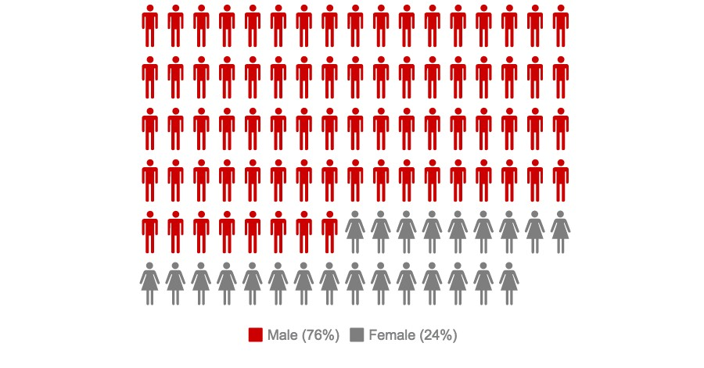

1 Unintentional poisoning/overdose deaths combine unintentional and undetermined intents to account for a change in death coding that occurred in 2005. Suicides are excluded from this analysis.
2 Opioids include heroin, opioid-based prescription painkillers, and other unspecified opioids.
Confirmed Unintentional/Undetermined1 Opioid-related Deaths Compared to All Deaths by Age: 2015

 | Deaths by Age: 2015
 | 0-14 | 15-24 | 25-34 | 35-44 | 45-54 | 55-64 | 65+ | Unknown | Total
All Deaths | 393 | 481 | 1086 | 1270 | 3077 | 5995 | 44,055 | 5 | 56,362
Confirmed Unintentional / Undetermined1 Opioid Deaths | 1 | 142 | 437 | 350 | 302 | 132 | 15 | 0 | 1,379

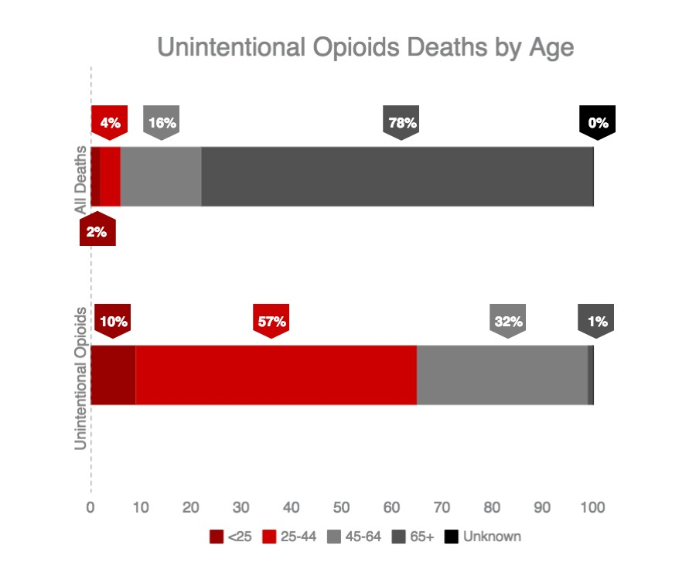

1 Unintentional poisoning/overdose deaths combine unintentional and undetermined intents to account for a change in death coding that occurred in 2005. Suicides are excluded from this analysis.
Confirmed Unintentional/Undetermined1 Opioid-related Deaths Compared to All Deaths by Race: 2015

 | White  non- Hispanic | Black  non- Hispanic | Asian  non- Hispanic | Hispanic | Other/ Unknown | Total
All Deaths | 50,413 | 2,343 | 1,066 | 1,996 | 504 | 56,362
Unintentional/Undetermined1  Opioid Deaths | 1,162 | 63 | 6 | 125 | 23 | 1,379

Unintentional/Undetermined1 opioid-related deaths, compared to all deaths: 2015

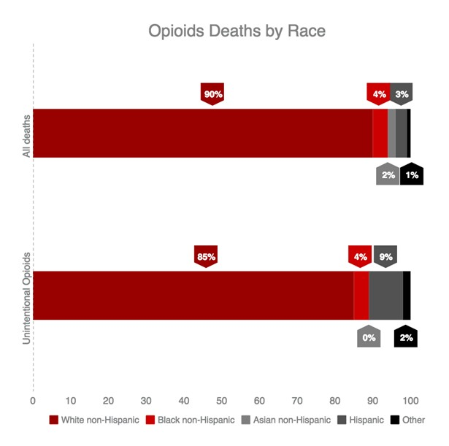

1 Unintentional poisoning/overdose deaths combine unintentional and undetermined intents to account for a change in death coding that occurred in 2005. Suicides are excluded from this analysis.
Technical Notes

2015 death data are preliminary and subject to updates. Case reviews of deaths are evaluated and updated on an ongoing basis. A large number of deaths have yet to be assigned final cause-of-death codes. The information
presented in this report only includes confirmed cases. Data updated on 03/31/2016.

Source: Registry of Vital Records and Statistics, Massachusetts Department of Public Health

