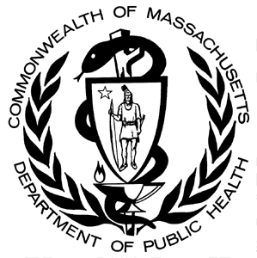
Number of Unintentional¹ Opioid² Overdose Deaths by County, MA Residents, 2000-2014³
Massachusetts Department of Public Health, Office of Data Management and Outcomes Assessment ● January 2016

County | Year of Death
 | 2000 | 2001 | 2002 | 2003 | 2004 | 2005 | 2006 | 2007 | 2008 | 2009 | 2010 | 2011 | 2012 | 2013 | 2014³ | Total  2000-2014
Barnstable | 12 | 17 | 17 | 14 | 16 | 17 | 19 | 29 | 21 | 20 | 19 | 15 | 22 | 40 | 48 | 326
Berkshire | 2 | 3 | 0 | 2 | 3 | 9 | 1 | 8 | 3 | 8 | 3 | 6 | 15 | 21 | 24 | 108
Bristol | 37 | 56 | 60 | 80 | 67 | 75 | 79 | 61 | 78 | 66 | 74 | 76 | 92 | 111 | 134 | 1,146
Dukes | 1 | 0 | 1 | 0 | 0 | 2 | 0 | 3 | 1 | 1 | 0 | 0 | 0 | 1 | 5 | 15
Essex | 41 | 58 | 44 | 74 | 61 | 73 | 83 | 85 | 52 | 69 | 48 | 54 | 85 | 111 | 182 | 1,120
Franklin | 5 | 2 | 1 | 5 | 3 | 4 | 6 | 4 | 2 | 2 | 4 | 6 | 8 | 9 | 11 | 72
Hampden | 30 | 36 | 34 | 44 | 26 | 33 | 42 | 38 | 43 | 45 | 46 | 42 | 51 | 68 | 52 | 630
Hampshire | 5 | 5 | 4 | 10 | 8 | 2 | 9 | 12 | 10 | 9 | 10 | 9 | 10 | 28 | 20 | 151
Middlesex | 56 | 76 | 77 | 102 | 96 | 109 | 106 | 101 | 104 | 113 | 90 | 118 | 106 | 142 | 238 | 1,634
Nantucket | 0 | 0 | 0 | 0 | 0 | 0 | 0 | 1 | 0 | 1 | 1 | 0 | 0 | 1 | 1¹ | N/A⁴
Norfolk | 24 | 39 | 34 | 36 | 37 | 49 | 46 | 53 | 67 | 64 | 55 | 59 | 65 | 79 | 108 | 815
Plymouth | 22 | 24 | 27 | 42 | 24 | 35 | 47 | 49 | 45 | 46 | 39 | 60 | 54 | 83 | 97 | 694
Suffolk | 44 | 79 | 75 | 93 | 73 | 62 | 106 | 101 | 67 | 91 | 60 | 79 | 82 | 105 | 127 | 1,244
Worcester | 59 | 73 | 55 | 47 | 42 | 55 | 71 | 69 | 68 | 64 | 77 | 79 | 78 | 112 | 126 | 1,075
TOTAL DEATHS | 338 | 468 | 429 | 549 | 456 | 525 | 615 | 614 | 561 | 599 | 526 | 603 | 668 | 911 | 1,173 | 9,035

¹Unintentional poisoning/overdose deaths combine unintentional and undetermined intents to account for a change in death coding that occurred in 2005. Suicides are excluded from this analysis.
² Opioids include heroin, opioid-based prescription painkillers, and other unspecified opioids.
³ Please note that 2014 death data are preliminary and subject to updates. Case reviews of deaths are evaluated and updated on an ongoing basis. A large number of death certificates have yet to be received from the municipalities and some have yet to be assigned cause-of-death codes. These counts are based on the estimates rather than confirmed cases. Data updated on 12/10/2015.
⁴ Numbers and calculations based on values less than 5 are suppressed for years in which the death file is not yet closed if they are based on pending cases. The 1 death listed in Nantucket county is a confirmed opioid overdose death.

Please note that there is rounding of counts for 2014.
Technical Notes:
- Cases were defined using the International Classification of Disease (ICD-10) codes for mortality. The following codes were selected from the underlying cause of death field to identify poisonings/overdoses: X40-X49, Y10-Y19. All multiple cause of death fields were then used to identify an opioid-related death: T40.0, T40.1, T40.2, T40.3, T40.4, and T40.6.
- This report tracks all opioid-related overdoses due to difficulties in reporting heroin-associated overdoses separately. Many deaths related to heroin are not specifically coded as such due to the fast metabolism of heroin into morphine.
- To maintain consistency with NCHS reporting, we do not include the ICD-10 code F11.1, which may include opioid-related overdose death.

Source: Registry of Vital Records and Statistics, MDPH

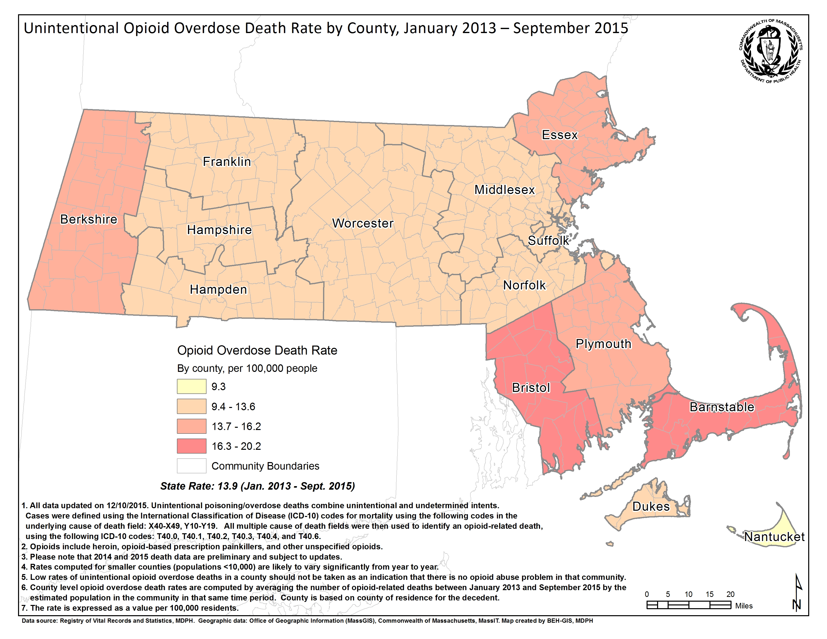
Technical Notes
- Cases were defined using the International Classification of Disease (ICD-10) codes for mortality. The following codes were selected from the underlying cause of death field to identify poisonings/overdoses: X40-X49, Y10-Y19. All multiple cause of death fields were then used to identify an opioid-related death: T40.0, T40.1, T40.2, T40.3, T40.4, and T40.6.
- This report tracks all opioid-related overdoses due to difficulties in reporting heroin-associated overdoses separately. Many deaths related to heroin are not specifically coded as such due to the fast metabolism of heroin into morphine.
- To maintain consistency with NCHS reporting, we do not include the ICD-10 code F11.1, which may include opioid-related overdose deaths.
- Please note that there is rounding of counts for 2014.

Source: Registry of Vital Records and Statistics, MDPH

