Number of Unintentional1 Opioid2- Related Overdose Deaths by County, MA Residents: 2000-20153

Massachusetts Department of Public Health, Office of Data Management and Outcomes Assessment Posted: MAY 2016

County | Year of Death
 | 2000 | 2001 | 2002 | 2003 | 2004 | 2005 | 2006 | 2007 | 2008 | 2009 | 2010 | 2011 | 2012 | 2013 | 20143 | 20153 | Total  2000-2015
Barnstable | 12 | 17 | 17 | 14 | 16 | 17 | 19 | 29 | 21 | 20 | 19 | 15 | 22 | 40 | 53 | 65 | 396
Berkshire | 2 | 3 | 0 | 2 | 3 | 9 | 1 | 8 | 3 | 8 | 3 | 6 | 15 | 21 | 28 | 30 | 142
Bristol | 37 | 56 | 60 | 80 | 67 | 75 | 79 | 61 | 78 | 66 | 74 | 76 | 92 | 111 | 138 | 146 | 1296
Dukes | 1 | 0 | 1 | 0 | 0 | 2 | 0 | 3 | 1 | 1 | 0 | 0 | 0 | 1 | 5 | 5 | 20
Essex | 41 | 58 | 44 | 74 | 61 | 73 | 83 | 85 | 52 | 69 | 48 | 54 | 85 | 111 | 208 | 207 | 1352
Franklin | 5 | 2 | 1 | 5 | 3 | 4 | 6 | 4 | 2 | 2 | 4 | 6 | 8 | 9 | 11 | 16 | 88
Hampden | 30 | 36 | 34 | 44 | 26 | 33 | 42 | 38 | 43 | 45 | 46 | 42 | 51 | 68 | 61 | 94 | 734
Hampshire | 5 | 5 | 4 | 10 | 8 | 2 | 9 | 12 | 10 | 9 | 10 | 9 | 10 | 28 | 25 | 17 | 173
Middlesex | 56 | 76 | 77 | 102 | 96 | 109 | 106 | 101 | 104 | 113 | 90 | 118 | 106 | 142 | 277 | 293 | 1966
Nantucket | 0 | 0 | 0 | 0 | 0 | 0 | 0 | 1 | 0 | 1 | 1 | 0 | 0 | 1 | 1 | 14 | 6
Norfolk | 24 | 39 | 34 | 36 | 37 | 49 | 46 | 53 | 67 | 64 | 55 | 59 | 65 | 79 | 124 | 144 | 976
Plymouth | 22 | 24 | 27 | 42 | 24 | 35 | 47 | 49 | 45 | 46 | 39 | 60 | 54 | 83 | 117 | 151 | 865
Suffolk | 44 | 79 | 75 | 93 | 73 | 62 | 106 | 101 | 67 | 91 | 60 | 79 | 82 | 105 | 145 | 179 | 1441
Worcester | 59 | 73 | 55 | 47 | 42 | 55 | 71 | 69 | 68 | 64 | 77 | 79 | 78 | 112 | 163 | 177 | 1289
TOTAL DEATHS | 338 | 468 | 429 | 549 | 456 | 525 | 615 | 614 | 561 | 599 | 526 | 603 | 668 | 911 | 1,3555 | 1,526 | 10,743
1Unintentional poisoning/overdose deaths combine unintentional and undetermined intents to account for a change in death coding that occurred in 2005. Suicides are excluded from this analysis.
2 Opioids include heroin, opioid-based prescription painkillers, and other unspecified opioids.
3 Please note that 2014-2015 death data are preliminary and subject to updates. Case reviews of deaths are evaluated and updated on an ongoing basis. A large number of death certificates have yet to be assigned
final cause-of-death codes. These counts are based on the estimates rather than confirmed cases. Data updated on 03/31/2016.
4 Numbers and calculations based on values less than 5 are suppressed for years in which the death file is not yet closed if they are based on pending cases. The 1 death listed in Nantucket County in 2015 is a
confirmed opioid overdose death.
5 In 2014, there was also 1 death of an MA resident whose city/town of residence was not known.
Please note that there is rounding of counts for 2014-2015.

Technical Notes:
1. Cases were defined using the International Classification of Disease (ICD-10) codes for mortality. The following codes were selected from the underlying cause of death field to identify poisonings/overdoses: X40-
X49, Y10-Y19. All multiple cause of death fields were then used to identify an opioid-related death: T40.0, T40.1, T40.2, T40.3, T40.4, and T40.6.
2. This report tracks all opioid-related overdoses due to difficulties in reporting heroin-associated overdoses separately. Many deaths related to heroin are not specifically coded as such due to the fast metabolism of
heroin into morphine.
3. To maintain consistency with NCHS reporting, the ICD-10 code F11.1 is not included, which may include opioid-related overdose death.
Source: Registry of Vital Records and Statistics, Massachusetts Department of Public Health

1

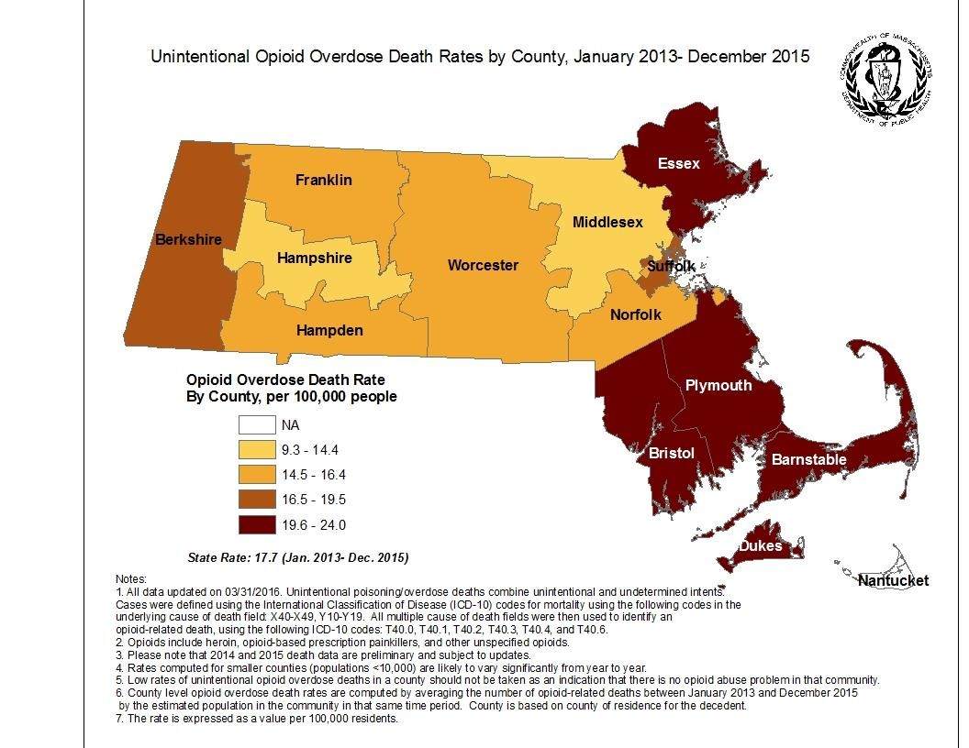

2

