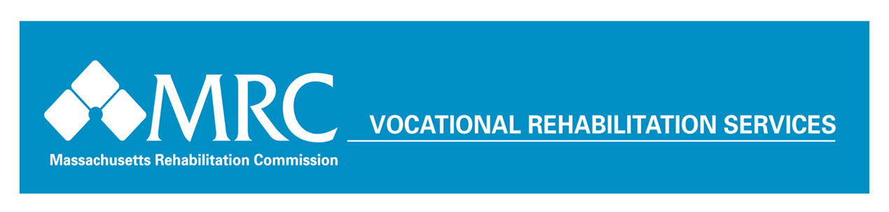

Services to Youth - Year in Review
July 1, 2016 – June 30, 2017
Who Are Our
Young Consumers?

Male 59.5% Female 40.5%
Age Profile* % Served
16 0.8%
17 4.8%
18 13.0%
19 18.0%
20 16.4%
21 14.3%
22 12.6%
23 10.2%
24 9.8%

Referral Source
688 Referral 35.6%
Lead Education Agency 23.4%
TAC-Assigned 0.4%
Other Referral Source 40.6%

Disability Profile
Sensory/Communicative 6.7%
Physical/Mobility 6.8%
Cognitive/Psychological 86.6%

*Age during Fiscal Year 2017

Youth Ages 16-24*
Served in the Vocational Rehabilitation Program

The Vocational Rehabilitation Program served 9,685 youths age 16 to 24 during SFY 2017.

862 of these consumers were placed in employment, with an average hourly wage of $12.41

Employed young consumers worked an average of 27 hours per week.

During SFY2017, MRC served 5,221 high school and post-secondary education students with disabilities aged 16 to 22 through its VR Area Offices. MRC also operated Pre-Employment Transition Service (Pre-ETS) contracts with 20 vendors across the Commonwealth serving 824 students. These programs offer work-based learning experiences, job readiness and skills trainings, assistance with enrollment in post-secondary education and training programs, job exploration, and leadership/mentoring services to students with disabilities.

During SFY2017, MRC provided work-based learning experiences for 1,169 young consumers across the Commonwealth through its Local Area Office Internship Program, CVS Health Summer Internship Program, Pre-ETS Contracts, and Transitional Internship Program (TIP). These work-based learning experiences provide employment related skills and guidance, and references to facilitate permanent future employment opportunities.

*Age at application for MRC services.

FACTS AT A GLANCE
The goal of our services is to promote dignity through employment and community living, one person at a time. We hope all citizens with disabilities in Massachusetts will have the opportunity to contribute as a productive member of their community and family as a result of services provided by the MRC.

Youths actively receiving services 9,685
Youths enrolled in training/education programs 7,583
Average hourly wage for employed youths $12.41

