

### 

**2016 Comprehensive Statewide Vocational Rehabilitation Consumer Needs Assessment**

**Appendix Documents**

**Massachusetts Rehabilitation Commission**

**Research, Development, and Performance Management Department**

**In collaboration with:**

**Statewide Rehabilitation Council**

**Needs Assessment Committee**

**June 2017**

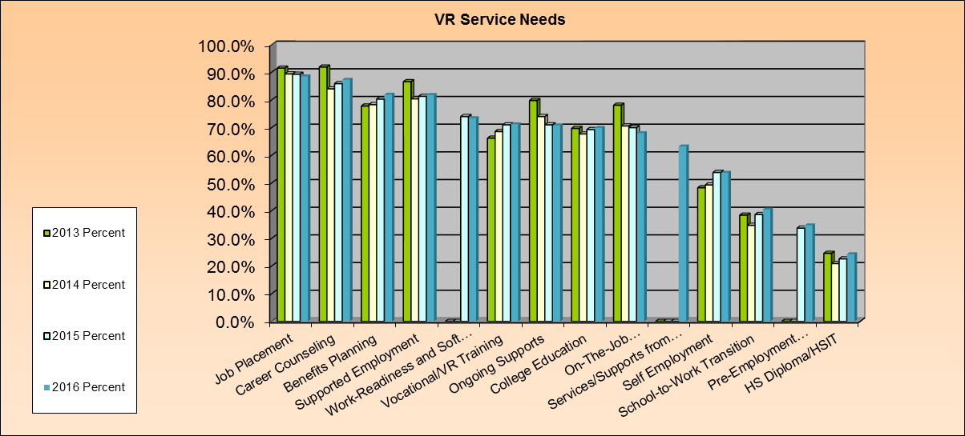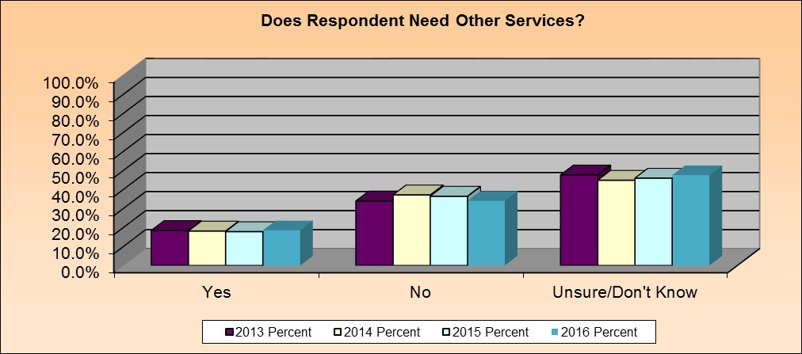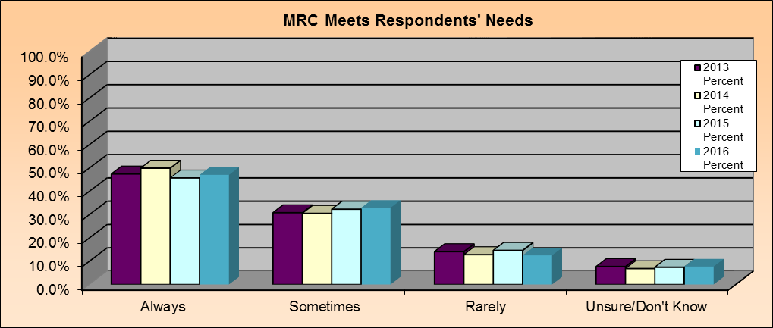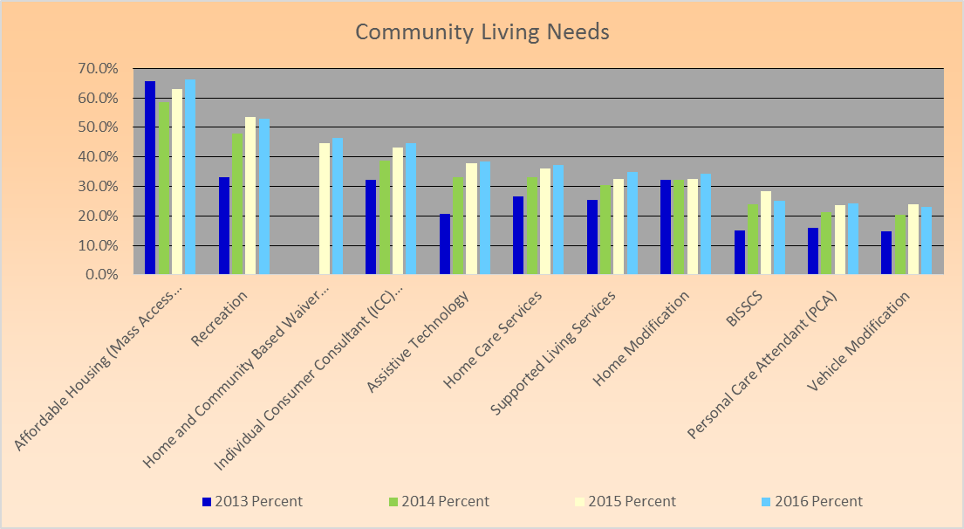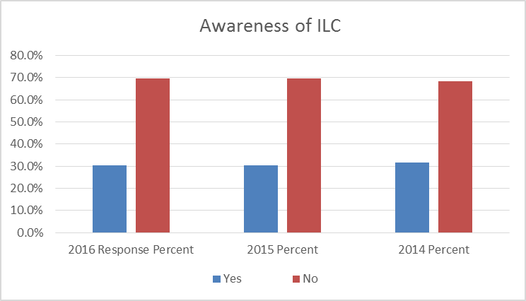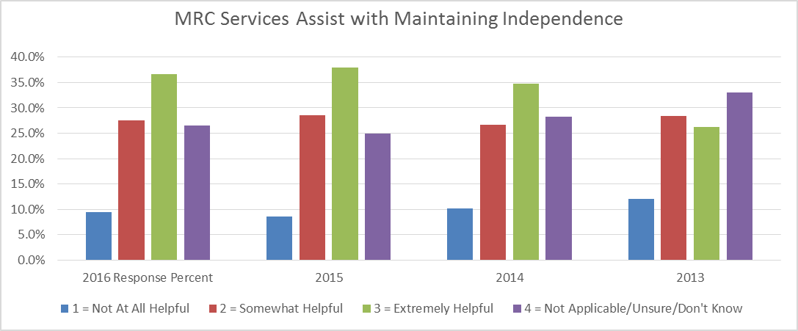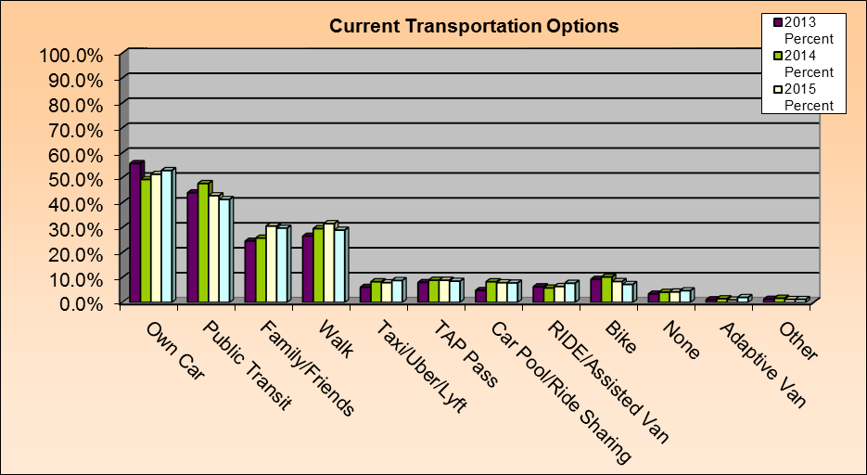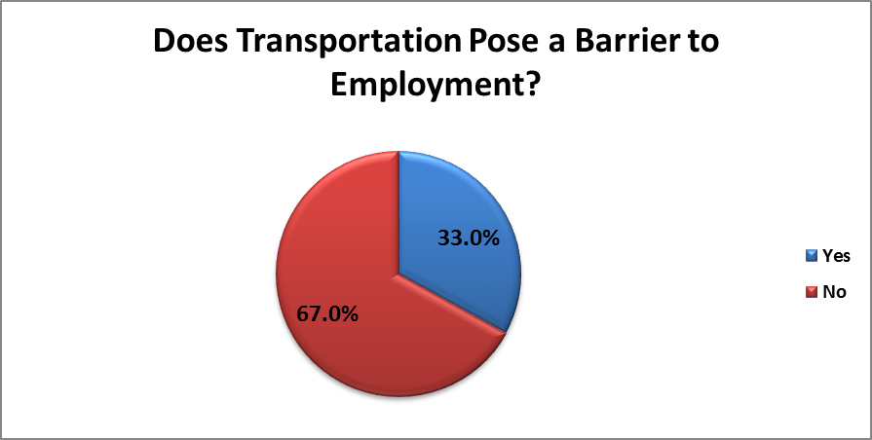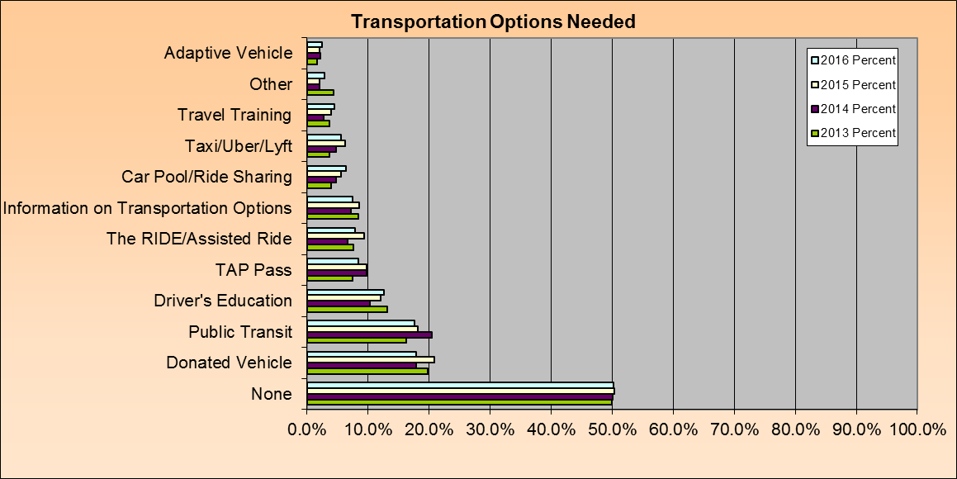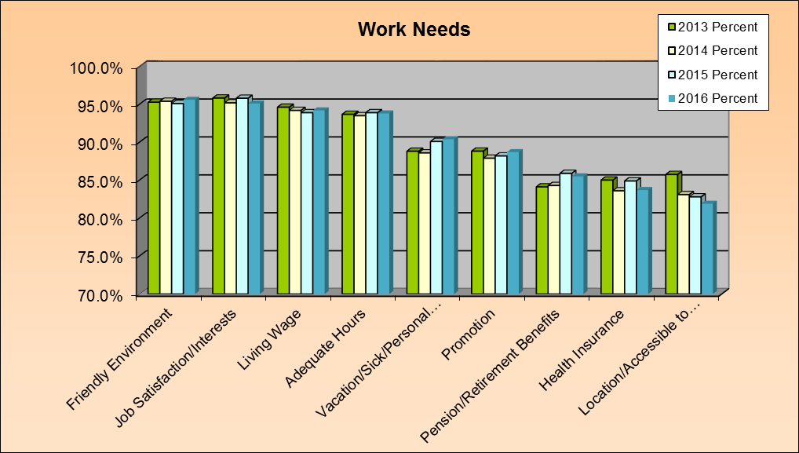

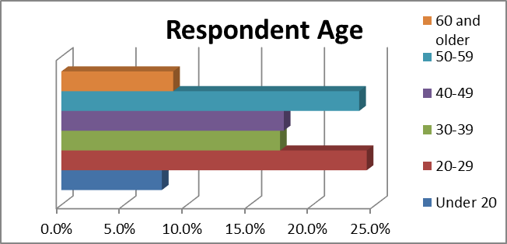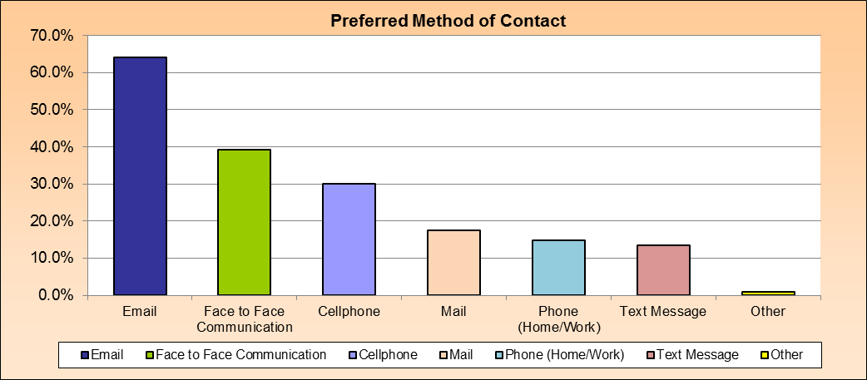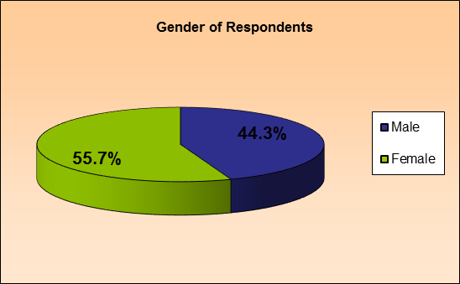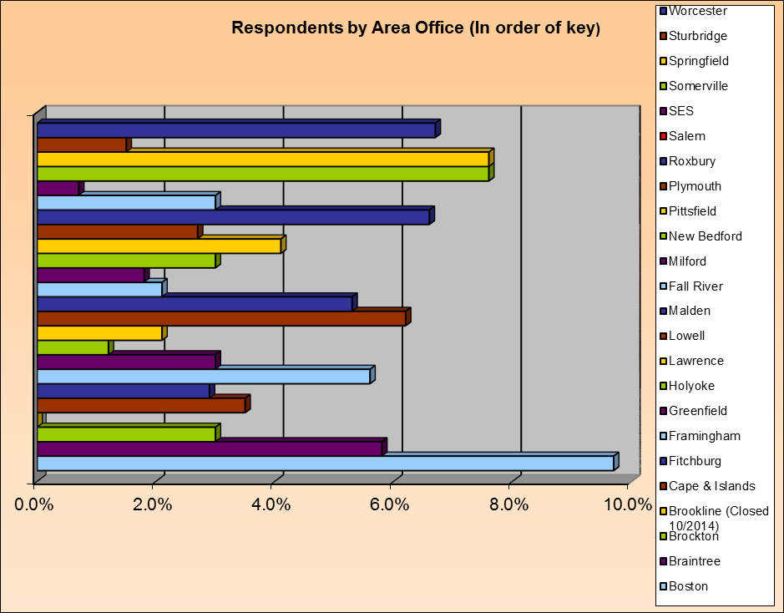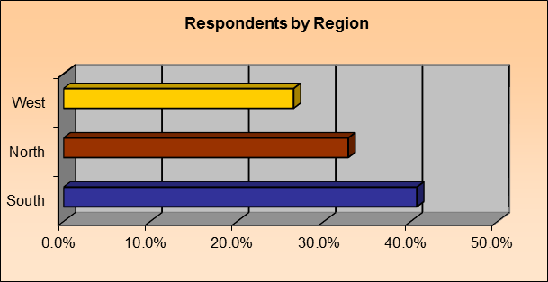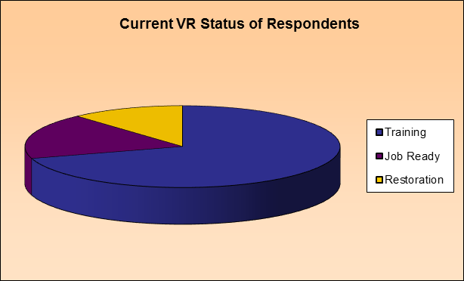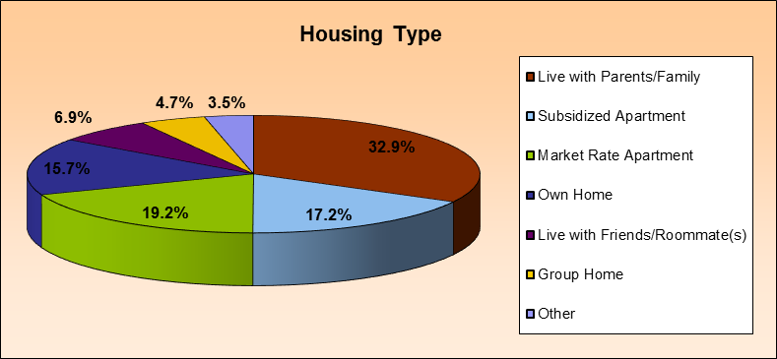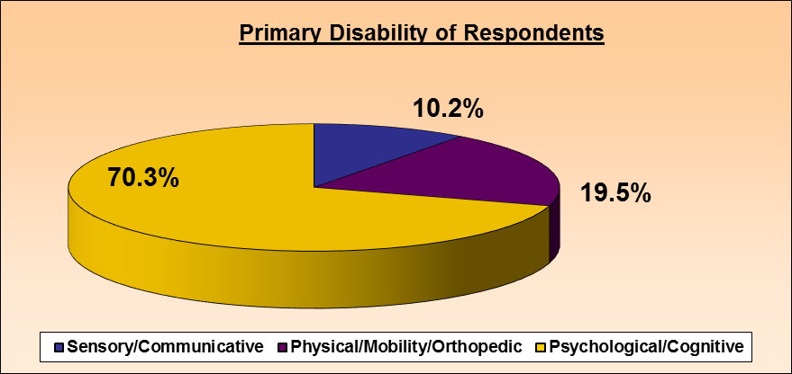

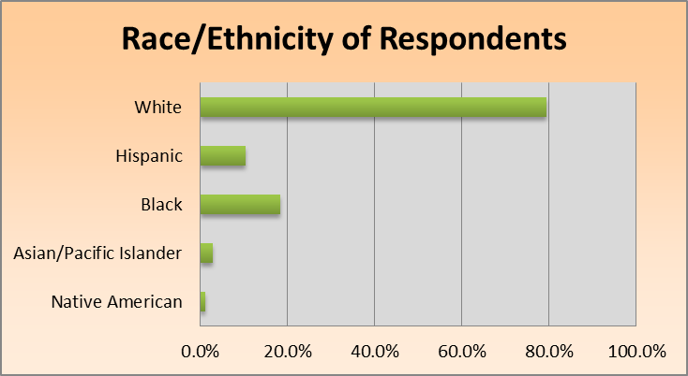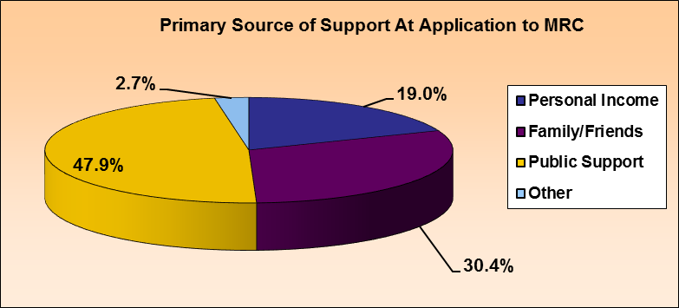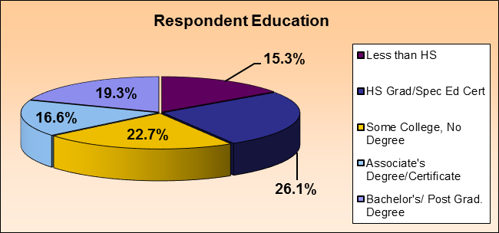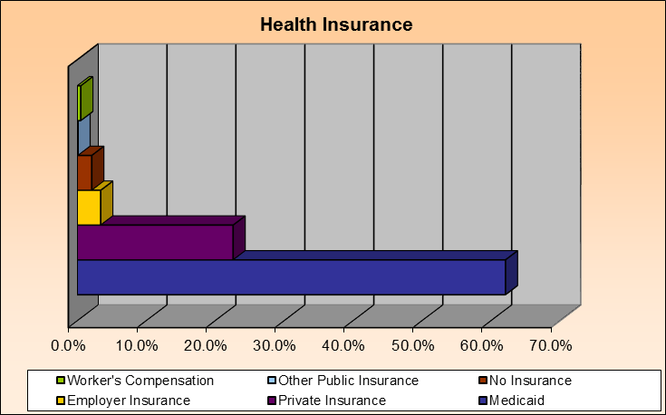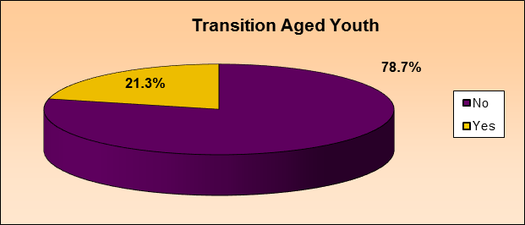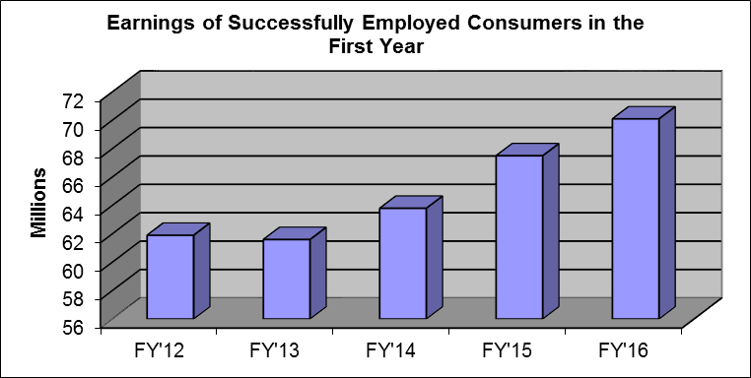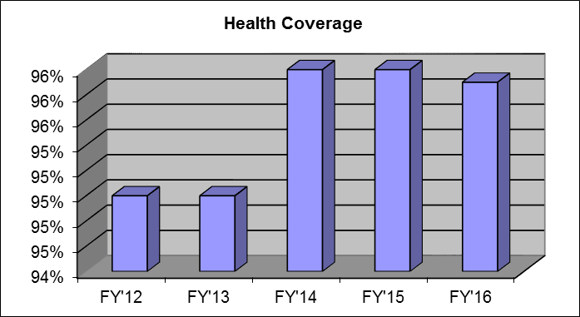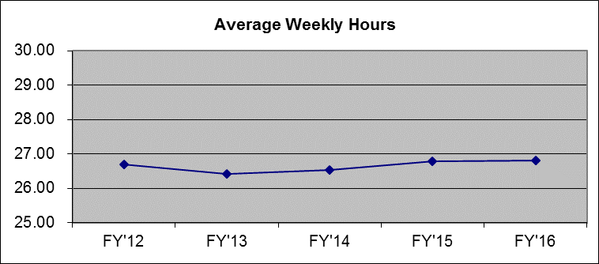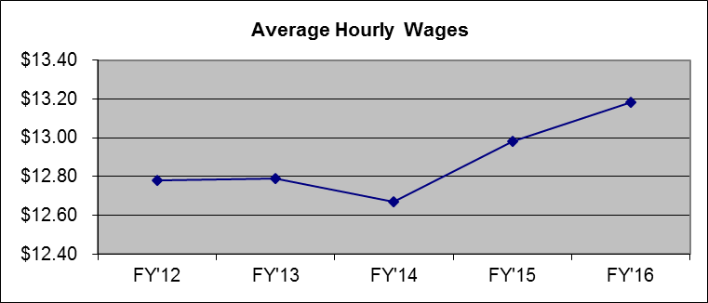



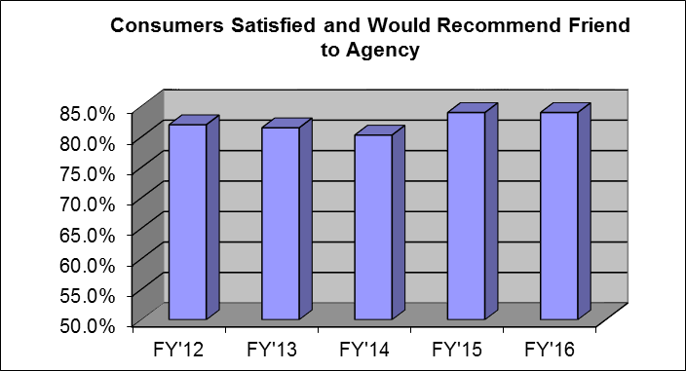



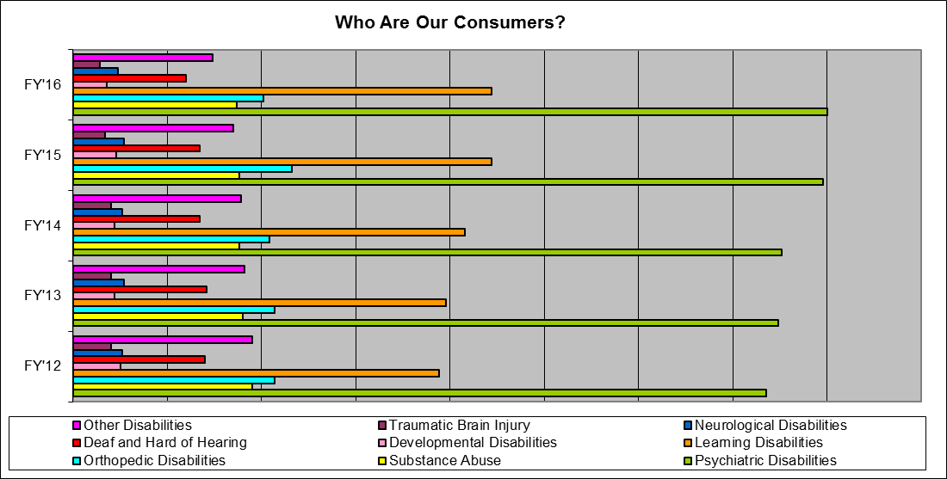

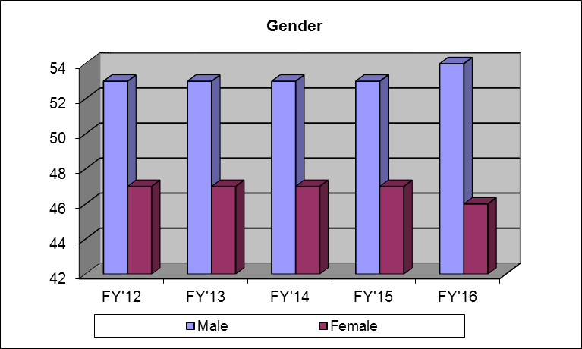



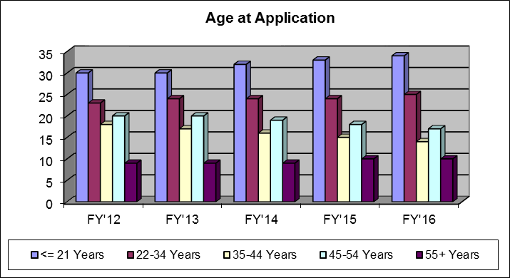



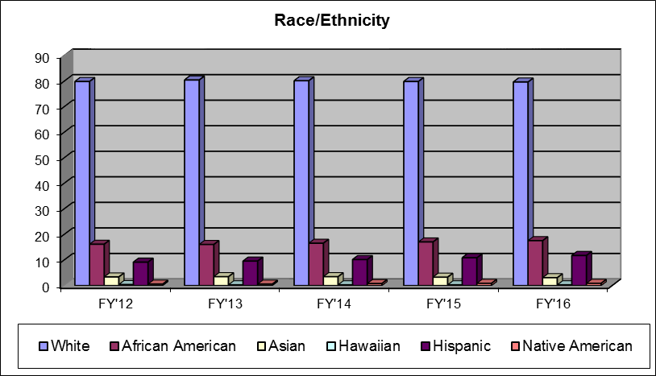



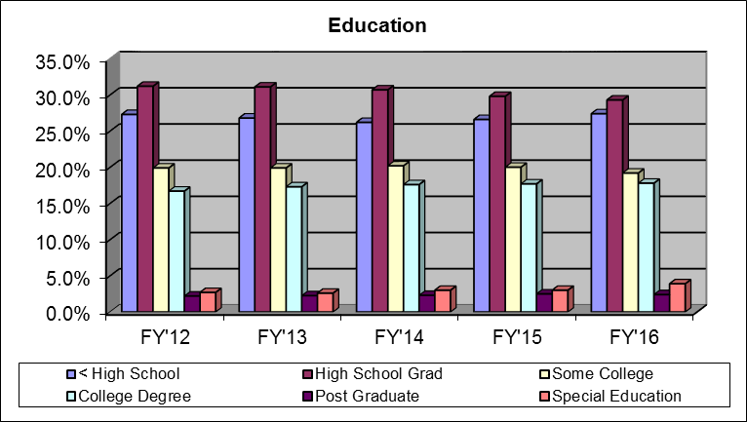



**Economic Impact Fact Sheet**

**Return on Investment (ROI) July 1, 2015 – June 30, 2016**

**Massachusetts Rehabilitation Commission – Vocational Rehabilitation Program**

Individuals with disabilities successfully placed into competitive employment:  **3,816**

Average hourly wage for employed consumers: **$13.18**

Average work hours per week for employed consumers: **26.8**

Total annual earnings for consumers placed into employment:  **$70,090,945**

Estimated public benefits savings from employed consumers:  **$28,620,000**

Projected annual Massachusetts income tax paid by employed consumers: **$2,348,557**

Projected annual Federal income tax paid by employed consumers: **$4,605,014**

Consumers placed into employment with medical insurance: **95.9%**

Return to society based on increase in lifetime earnings for

consumers placed into employment, FY2016*: **$915,514,332**

Return to society based on returns to government in the form

of increased taxes and reduced public assistance payments, FY2016**: **$326,969,404**

*\*Based on Commonwealth Corporation Study on ROI that $14 is returned to society based on increases in lifetime earnings for each $1 invested in the MRC Vocational Rehabilitation program.*

*\*\*Based on Commonwealth Corporation Study on ROI that $5 is returned to the government for each $1 invested in the MRC Vocational Rehabilitation program.*

**Massachusetts Rehabilitation Commission**

The Massachusetts Rehabilitation Commission (MRC) promotes equality, empowerment, and independence of individuals with disabilities. These goals are achieved through enhancing and encouraging personal choice and the right to succeed in the pursuit of independence and employment in the community.

The MRC provides comprehensive services to people with disabilities that maximize their quality of life and economic self-sufficiency in the community.

**TOP 10 JOBS AND OCCUPATIONAL CATEGORIES ON IPE, IN PLACEMENT, AND IN SUCCESSFUL EMPLOYMENT, SFY2016, WITH DEMAND FACTOR AND MEDIAN HOURLY WAGE FOR MASSACHUSETTS, 2016**

**TOP 10 JOBS**

**IPE**

|  |  |  |  |
| --- | --- | --- | --- |
| **SOC Code** | **Top 10 Jobs Written on IPEs** | **LQ\*** | **Median Wage** |
| 21-1093 | Social and Human Service Assistant | 1.89 | $15.02 |
| 41-2031 | Retail Sales | .97 | $11.42 |
| 21-1011 | Substance Abuse Counselor | 2.23 | $20.15 |
| 43-5081 | Stock and Order Clerks | .99 | $11.76 |
| 21-1099 | Community and Social Services Specialist | .55 | $18.47 |
| 31-1014 | Nursing Assistant | 1.09 | $14.31 |
| 15-1199 | Miscellaneous Computer Occupations | 1.03 | $44.09 |
| 43-9199 | Misc. Office & Administrative Support Workers | .52 | $23.22 |
| 43-9061 | Office Clerks, General | .87 | $17.22 |
| 41-9099 | Sales and Related Workers, All Other | .58 | $25.71 |
| **Total** | **Average** | **1.07** | **$20.14** |

**Placement**

|  |  |  |  |
| --- | --- | --- | --- |
| **SOC Code** | **Top 10 Jobs for Initial Placement** | **LQ\*** | **Median Wage** |
| 41-2031 | Retail Sales | .97 | $11.42 |
| 43-5081 | Stock and Order Clerks | .99 | $11.76 |
| 41-2011 | Cashiers | .83 | $10.81 |
| 41-9099 | Sales and Related Workers, All Other | .58 | $25.71 |
| 35-9099 | Misc. Food Preparation and Serving Workers | .56 | $17.81 |
| 37-2011 | Janitors and Cleaners | 1.01 | $15.73 |
| 31-1014 | Nursing Assistant | 1.09 | $14.31 |
| 43-4051 | Customer Service Representative | .93 | $18.86 |
| 35-2021 | Food Preparation | .82 | $11.62 |
| 21-1099 | Community and Social Services Specialist | .55 | $18.47 |
| **Total** | **Average** | **.83** | **$15.65** |

**Successful Employment**

|  |  |  |  |
| --- | --- | --- | --- |
| **SOC Code** | **Top 10 Jobs for Successful Employment Outcomes** | **LQ\*** | **Median Wage** |
| 41-2031 | Retail Sales | .97 | $11.42 |
| 43-5081 | Stock and Order Clerks | .99 | $11.76 |
| 41-9099 | Sales and Related Workers, All Other | .58 | $25.71 |
| 41-2011 | Cashiers | .83 | $10.81 |
| 35-9099 | Misc. Food Preparation and Serving Workers | .56 | $17.71 |
| 37-2011 | Janitors and Cleaners | 1.01 | $15.73 |
| 31-1014 | Nursing Assistant | 1.09 | $14.31 |
| 43-4051 | Customer Service Representative | .93 | $18.86 |
| 35-2021 | Food Preparation | .82 | $11.62 |
| 21-1099 | Community and Social Services Specialist | .55 | $18.47 |
| **Total** | **Average** | **.83** | **$15.65** |

**TOP 10 OCCUPATIONAL CATEGORIES**

**IPE**

|  |  |  |  |
| --- | --- | --- | --- |
| **SOC**  **Category** | **Top 10 Occupational Categories on IPEs** | **LQ\*** | **Median Wage** |
| 43-0000 | Office and Administrative Support | .92 | $19.29 |
| 21-0000 | Community and Social Services | 1.64 | $20.28 |
| 39-0000 | Personal Care and Service | 1.11 | $13.51 |
| 31-0000 | Healthcare Support | 1.09 | $15.17 |
| 41-0000 | Sales and Related | .90 | $14.14 |
| 27-0000 | Arts, Design, Entertainment, Sports & Media | 1.08 | $26.86 |
| 29-0000 | Healthcare Practitioners & Technical | 1.17 | $37.08 |
| 25-0000 | Education and Training | 1.11 | $28.60 |
| 35-0000 | Food Preparation and Related | 0.91 | $11.43 |
| 15-0000 | Computer and Mathematical | 1.39 | $44.80 |
| **Total** | **Average** | **1.13** | **$23.12** |

**Placement**

|  |  |  |  |
| --- | --- | --- | --- |
| **SOC**  **Category** | **Top 10 Occupational Categories for Initial Placement** | **LQ\*** | **Median Wage** |
| 43-0000 | Office and Administrative Support | .92 | $19.29 |
| 41-0000 | Sales and Related Occupations | .90 | $14.14 |
| 35-0000 | Food Preparation and Related | .91 | $11.43 |
| 53-0000 | Transportation and Material Moving | .75 | $15.87 |
| 21-0000 | Community and Social Services | 1.64 | $20.28 |
| 37-0000 | Building, Grounds Cleaning, & Maintenance | .97 | $16.08 |
| 39-0000 | Personal Care and Service | 1.11 | $13.51 |
| 31-0000 | Healthcare Support | 1.09 | $15.17 |
| 51-0000 | Production and Manufacturing | .69 | $17.54 |
| 25-0000 | Education and Training | 1.11 | $28.60 |
| **Total** | **Average** | **1.00** | **$17.19** |

**Successful Employment**

|  |  |  |  |
| --- | --- | --- | --- |
| **SOC Category** | **Top 10 Occupational Categories for Successful Employment Outcomes** | **LQ\*** | **Median Wage** |
| 41-0000 | Sales and Related | .90 | $14.14 |
| 43-0000 | Office and Administrative Support | .92 | $19.29 |
| 35-0000 | Food Preparation and Related | .91 | $11.43 |
| 53-0000 | Transportation and Material Moving | .75 | $15.87 |
| 21-0000 | Community and Social Services | 1.64 | $20.28 |
| 37-0000 | Building, Grounds Cleaning, & Maintenance | .97 | $16.08 |
| 39-0000 | Personal Care and Service | 1.11 | $13.51 |
| 31-0000 | Healthcare Support | 1.09 | $15.17 |
| 51-0000 | Production and Manufacturing | .69 | $17.54 |
| 25-0000 | Education and Training | 1.11 | $28.60 |
| **Total** | **Average** | **1.00** | **$17.19** |

**\*LQ= location quotient, measures extra demand in an area for a particular job category. 1= normal demand, 2= twice as much demand as other places, etc. Baseline is for Massachusetts compared to national average.**

**Source: MA EOLWD and US Bureau of Labor Statistics**