FY17 ECSE Grant Fund Code 262 – Final Financial Reports

Instructions for Submitting Final Financial Reports

Introduction:

All Grantees must submit a Final Financial Report at the close of the grant period for each individual grant they have received for the current fiscal year. One report is to be submitted for each individual grant to EEC within sixty days (60) of the close of the grant.

How to Complete the Final Financial Report Form:
Please log in to your online grant application to find the Final Financial Report button at the bottom of the home page.

To complete FY17 Final Financial Report, scroll down to bottom of page.
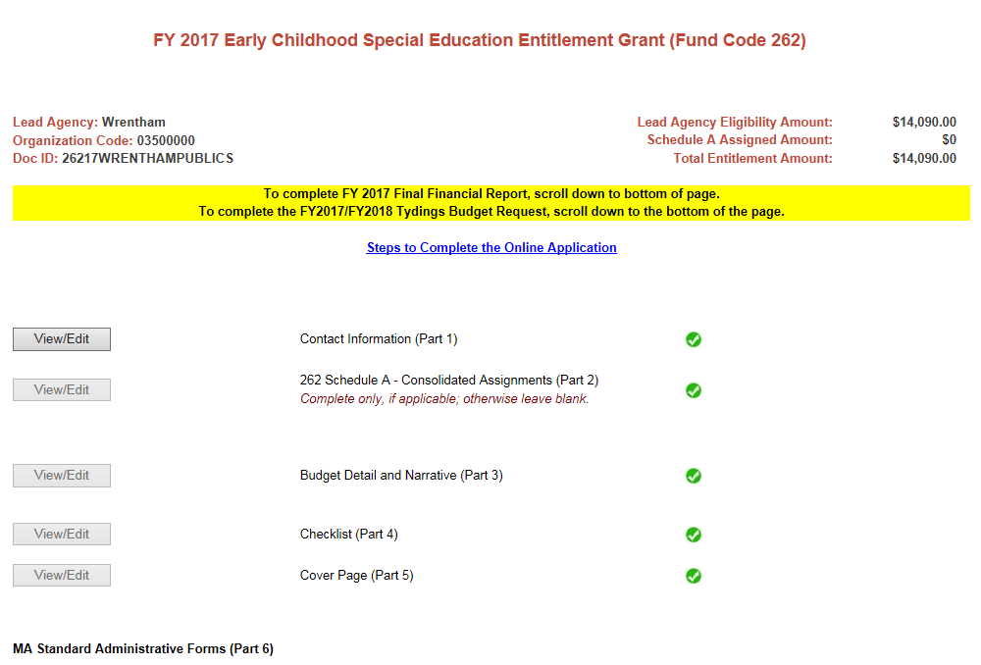

Click on the “Final Financial Report” located at the bottom of the Home Page:
Final Financial Report:
- 1. Complete the contact information section.
Fill in the Name, Title, Phone, and Email address of person completing this report.

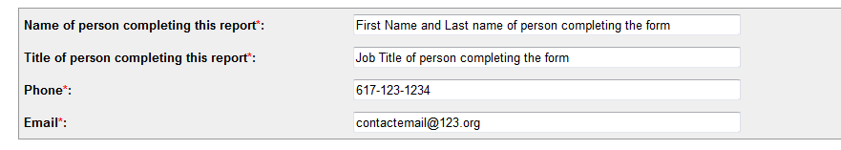

BUDGET INSTRUCTIONS:
Column A: Expenditure Category: Under the Expenditure Category, the 18 Line Items for Fund Code 262 are displayed.
Column B: Approved Budget: Pre--populated with the dollar amounts from the Total Grant Budget column for each Line Item where funds were assigned in the Approved FY17 262 Budget. The submission date for this budget is displayed above the budget section in this report.
Column C: Funds Expended: Enter the dollar and cents for the amount of 262 funds spent that corresponds with the appropriate line item in Column C.
The Grand Total for Funds Expended must not be greater than the Approved Budget Grand Total nor more than the total amount of FY17 262 payment received, plus any MTRS paid by EEC.
- Over-expenditures that fall at or below the 10% increase thresholds specified in EEC budget amendment procedures are also allowable when the filing the FFR.
- Increases in spending greater than 10% that exceed the allowable thresholds are considered unapproved expenses and will be subject to possible audit exceptions and/or require the return of any funds that were expended inappropriately.
Column D: Balance of Unexpended Funds - The balance of funds not spent (if applicable) will populate based on the amounts entered in Column C. The unexpended balance for each line item must not be a negative number (less than $0).
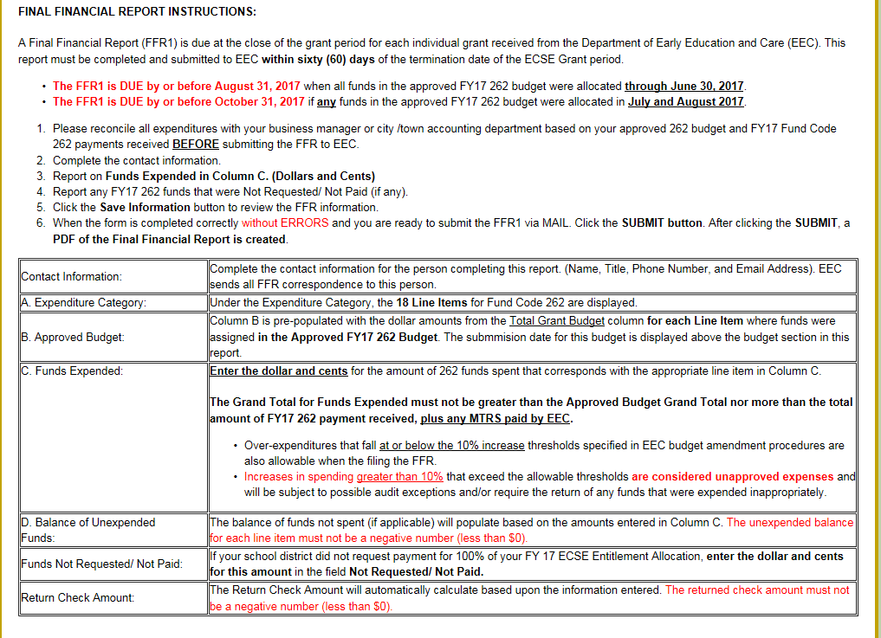

2. Report the Funds Expended in Column C.
- Fill in the grant funds expended based on the approved budget line item expenditures. Funds Expended must not exceed the dollar amount of funds paid plus MTRS.
Please save your information frequently using the save information button located at the bottom of the page.
This date is the latest submission of an approved budget or budget amendment.

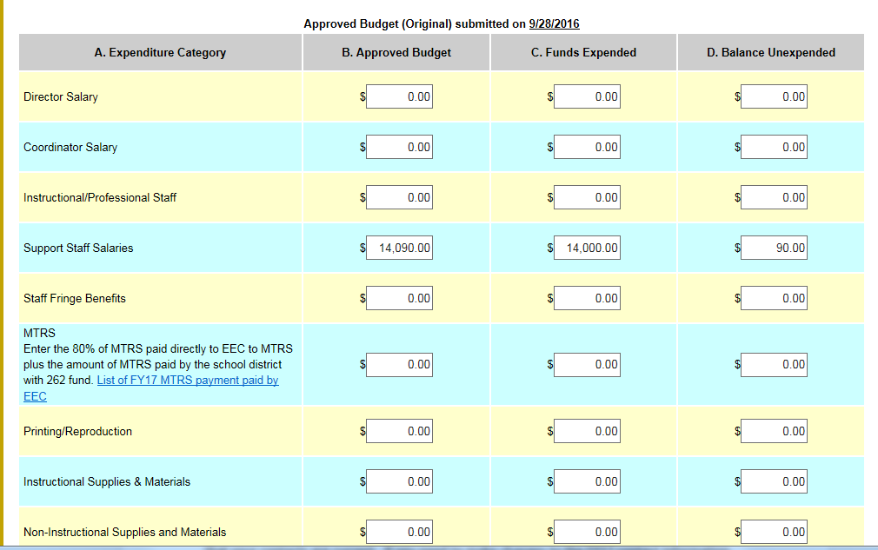

3. Report the amount of FY 2017 262 funds that were Not Requested/ Not Paid by EEC (if any).
If you were not paid 100% of your FY17 ECSE grant funds, the dollar amount of these unrequested funds should be entered in the Funds Not Requested/Not Paid box.
Return Check Amount: The return check amount will automatically calculate based upon the information entered. The unexpected balance must not be a negative number (less than $0.)
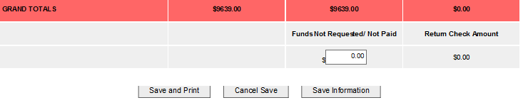

4. Click the Save and Print button when the form is completed and you are ready to submit the FFR via MAIL.
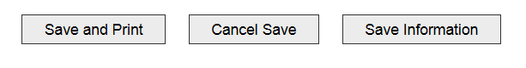
After clicking the Save and print button, A PDF of the Final Financial Report is created.

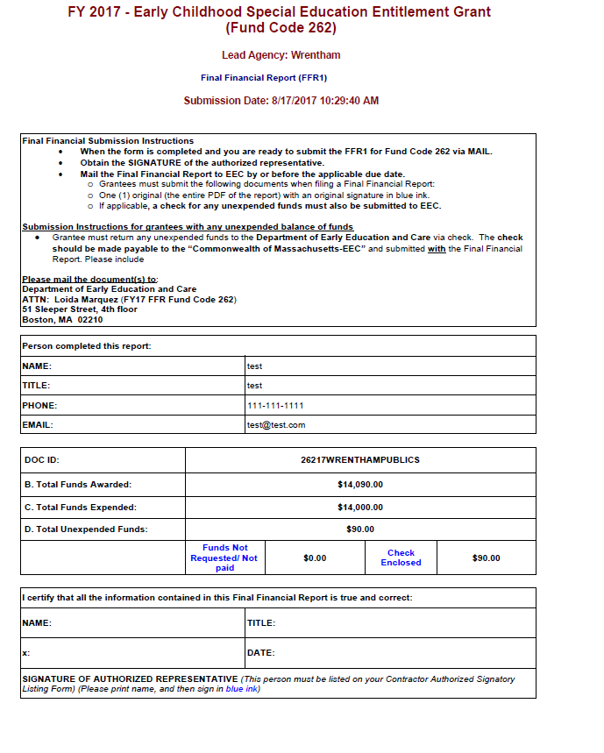
5. Obtain the SIGNATURE of the authorized representative.
- The printed Final Financial Report must be signed by an authorized signatory.
- Include an original signature (in blue ink) of the authorized representative.

Important: An unsigned Final Financial Report will NOT be approved and will have to be resubmitted to EEC.
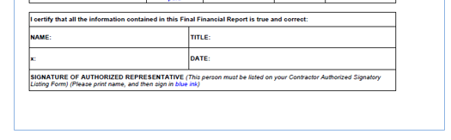

6. Mail the Final Financial Report to EEC.
Grantees must submit the following documents when filing a Final Financial Report:

- One original (the entire PDF of the report) with an original signature in blue ink.
- If applicable, a check for any unexpected funds.

Submission instructions for grantees with unexpended balance of funds.
- Grantees must return any unexpected funds to the Department of Early Education and Care via check. The check should be made payable to the “Commonwealth of Massachusetts-EEC” and submitted with the Final Financial Report.

Please mail the document(s) to:
Department of Early Education and Care
51 Sleeper Street, 4th Floor
Boston, MA 02210
Attention: Loida Marquez (262)

NOTE: Eligibility for FY17/FY18 Tydings:

ECSE Grantees that did not receive 100% of their FY17 ECSE funds or have returned unspent funds via check to EEC will be eligible to request and spend these funds through FY17/FY18 Tydings (Carry Over).
- After the successful submission and reconciliation of the FY17 Final Financial Report, EEC will notify a grantee via email of their eligibility for FY17/FY18 Tydings.

Failure to submit the Final Financial Report and check for unspent funds by the due date will delay access to the Tydings funding.

