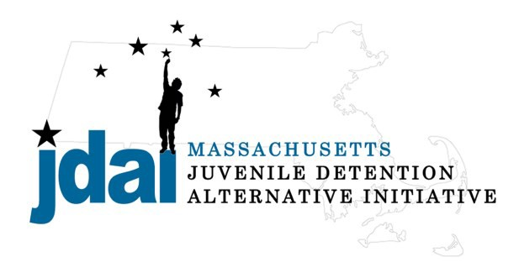Hampden County Bench Card: Alternatives to Secure Detention

An Alternative to Detention is a location or supervision that allows a juvenile with an open delinquency matter, including violation of probation, to remain out of hardware secure detention pending further court action.

Family/ Communit y Supervision:

- Straight Release– Personal Recognizance
- Release to an Alternative/Extended Family Member

Low Sup ervision:
Increasing Supervision

- Life Skills/ Afterschool: Bridging the Gap (Holyoke) 271 Appleton Street, Holyoke, MA 01040, 413-532-6312, Anthony Falvo
- Life Skills/ Afterschool: Bridging the Gap (Springfield) 170 Pearl Street, Springfield, MA 01101, 413-733-1518, Anthony Flavo

Medium Supervision:

- Release with Pre-Trial Probation Conditions
- Release with Electronic Monitoring/ GPS
- RFK Children’s Action Corps.: Detention Diversion Advocacy Project, 225 High Street, Holyoke, MA 01040, 413-437-7803 Rosa Santiago

Medium – High Supervision:

- DYS: Community Based Option (Placement to be Determined by DYS)
  - Western Region Reception Center (WRRC), 280 Tinkham Road, Springfield, MA 01129; 413-731-4970, Christopher J. Liberis
- DYS: Shelter Care Options (Placement to Be Determined by DYS)
  - Gandara Alternative Options 45 Lower Westfield Road, Holyoke, MA 01040, 413-561-1500, Mary Gustason (Males Only)
  - Grafton Girls, Key, Inc., 30 Institute Road, North Grafton, MA 01536, 508-839- 4648, Meghan Rondeau (Females Only)
- Substance Abuse : Statewide Information and Referral 866-705-2807
  - Detox & Stabilization: MYR, Community Health link, 26 Queen Street, Worcester, MA 01610, 508-860-1244, Melonie Amir
  - Detox & Stabilization: CASTLE, High Point Treatment Center, 30 Meadowbrook Road, Brockton, MA 02301, 508-638-6009, Kim Fischer

Additional placement or services options may be available if the youth is involved with a state agency.

JDAI Massachusetts Alternative to Detention Committee has gathered these resources from the Hampden JDAI Community. JDAI Massachusetts, and its affiliated partners, do not specifically endorse or recommend the services provided by the listed agencies and entities. Please send updates or corrections to jdai @stat e.ma.us . Updated: January 2016

