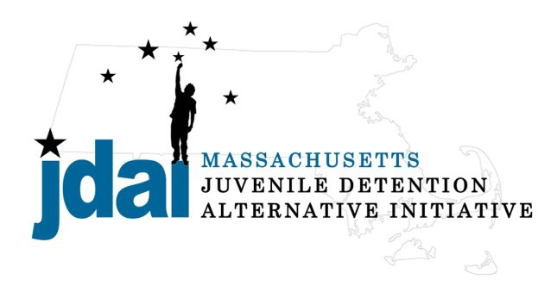Middlesex County Bench Card: Alternatives to Secure Detention

An Alternative to Detention is a location or supervision that allows a juvenile with an open delinquency matter, including violation of probation, to remain out of hardware secure detention pending further court action.

Family/ Communit y Supervision:

- Straight Release– Personal Recognizance
- Release to an Alternative/Extended Family Member

Low Sup ervision:

- Release with Section 58 Conditions
Increasing Supervision
- Life Skills/ Afterschool: Bridging the Gap (Cambridge) 402 Mass Avenue, Cambridge, MA 02139, 617-547-3400 ext 235, Amanda Chen (Interim Director)
- Life Skills/ Afterschool: Bridging the Gap (Lowell) 150 Appleton St., Lowell, MA, 978-458-4923 x 227, Tanya Cameron
- Day/ Evening Program: UTEC (Lowell) 34 Hurd Street, Lowell, MA 01852, 978- 856-3948, David Crump

Medium Supervision:

- Release with Pre-Trial Probation Conditions
- Release with Electronic Monitoring/ GPS

Medium – High Supervision:

- DYS: Shelter Care Options (Placement to Be Determined by DYS)
  - Lakeside, NFI, 629 Lowell Street, Peabody, MA 01960, 978-535-2366, Phyllis LaBranche (Males Only)
  - Carbone Hall, Eliot Human Services, 569 Salem End Road, Framingham, MA 01702, 508-532-7660, Marc Breau (Males Only)
  - Grafton Girls, Key, Inc., 30 Institute Road, North Grafton, MA 01536, 508-839- 4648, Meghan Rondeau (Females Only)
- Substance Abuse : Statewide Information and Referral 866-705-2807
  - Detox & Stabilization: MYR, Community Health link, 26 Queen Street, Worcester, MA 01610, 508-860-1244, Melonie Amir
  - Detox & Stabilization: CASTLE, High Point Treatment Center, 30 Meadowbrook Road, Brockton, MA 02301, 508-638-6009, Kim Fischer

** Juvenile Court Restorative Justice Diversion (JCRJD) may be an option for many youth, upon agreement with the Middlesex DA **
Additional placement or services options may be available if the youth is involved with a state agency.
JDAI Massachusetts Alternative to Detention Committee has gathered these resources from the Middlesex JDAI Community. JDAI Massachusetts, and its affiliated partners, do not specifically endorse or recommend the services provided by the listed agencies and entities. Please send updates or corrections to jdai @stat e.ma.us . Updated: January 2016

