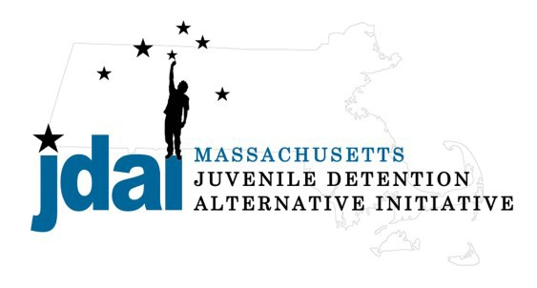Suffolk County Bench Card: Alternatives to Secure Detention
An Alternative to Detention is a location or supervision that allows a juvenile with an open delinquency matter, including violation of probation, to remain out of hardware secure detention pending further court action.

Family/ Commun ity Supervision :

- Straight Release– Personal Recognizance
- Release to an Alternative/Extended Family Member

Low Supervision :

- Life Skills/ Afterschool: Bridging the Gap (Boston), 650 Dudley St, Boston, MA 02125, 617-318-6916, Jovan Zuniga
- Structured Day/Evening Program: Youth Options Unlimited, 7 Palmer St, Roxbury, MA, 617-541-2600, Lorraine Trowers
Increasing Supervision
- Mentoring: Mission Safe, 1481 Tremont Street, Roxbury, MA 02120, 617-592-7608, Nikki Flionis
- Structured Day/Evening Program: Roca, Inc. (Boston) 845 Albany St, Boston, MA 02119, 617-442-3101 (Youth over 17 years of age), Shannon McAuliffe
- Structured Day/Evening Program: Roca, Inc. (Chelsea) 101 Park Street, Chelsea, MA, 617- 889-5210 (Youth over 17 years of age), John Fleming

Medium Supervision:

- Release with Pre-Trial Probation Conditions
- Release with Electronic Monitoring/GPS
- RFK Children’s Action Corps.: Detention Diversion Advocacy Project (Dorchester) 1452 Dorchester Ave, 4th Floor, Dorchester, MA 02122, 978-423-8410, Theresa Conti

Medium– High Supervision:

- DYS: Community Based Option (Placement to be Determined by DYS)
  - Metro Region Reception Center (MRRC), Judge Connelly Building, 450 Canterbury St., Roslindale, MA 02131, 617-474-8189, Paul Forbes
- DYS: Shelter Care Options (Placement to Be Determined by DYS)
  - Carbone Hall, Eliot Human Services, 569 Salem End Road, Framingham, MA 01702, 508-532-7660, Marc Breau (Males Only)
  - Grafton Girls, Key, Inc., 30 Institute Road, North Grafton, MA 01536, 508-839-4648, Meghan Rondeau (Females Only)
- Substance Abuse : Statewide Information and Referral 866-705-2807
  - Detox & Stabilization: MYR, Community Health link, 26 Queen Street, Worcester, MA 01610, 508-860-1244, Melonie Amir
  - Detox & Stabilization: CASTLE, High Point Treatment Center, 30 Meadowbrook Road, Brockton, MA 02301, 508-638-6009, Kim Fischer
Additional placement or services options may be available if the youth is involved with a state agency.

JDAI Massachusetts Alternative to Detention Committee has gathered these resources from the Suffolk JDAI Community. JDAI
Massachusetts, and its affiliated partners, do not specifically endorse or recommend the services provided by the listed agencies and entities.
Please send updates or corrections to jdai@state.ma.us. Updated: January 2016

