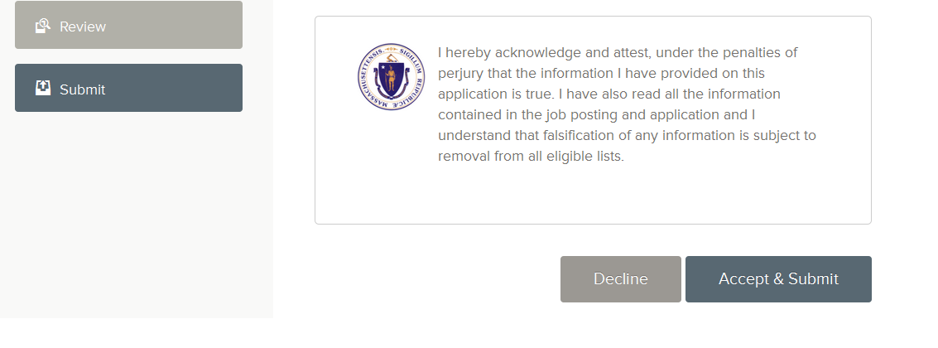

You must click “Accept & Submit” to submit your application and receive a confirmation email; otherwise, you have not submitted your application and won’t be able to pay, which will disqualify you for the exam.

You must hit “Click to Pay” to submit online payment, if you are not applying with a [Fee Waiver](http://www.mass.gov/anf/docs/hrd/cs/forms/cs-fee-waiver.rtf) – when you hit “Click to Pay”, it will open a new tab or new window, depending on your browser settings – you may need to disable pop-up blocker for the payment screen to open up

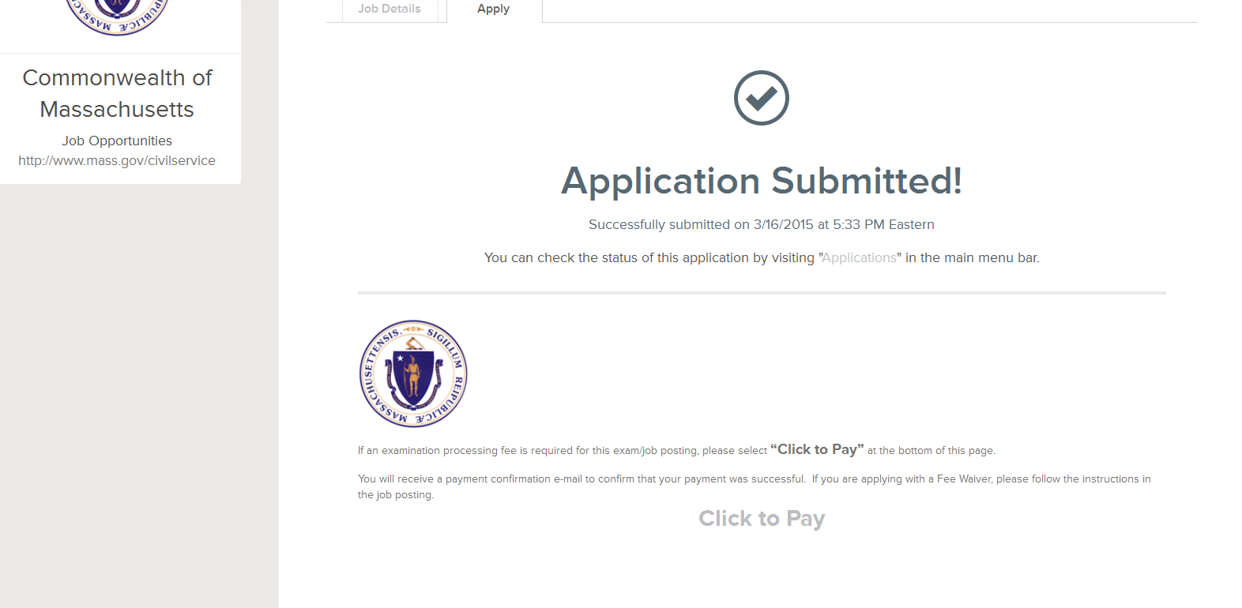

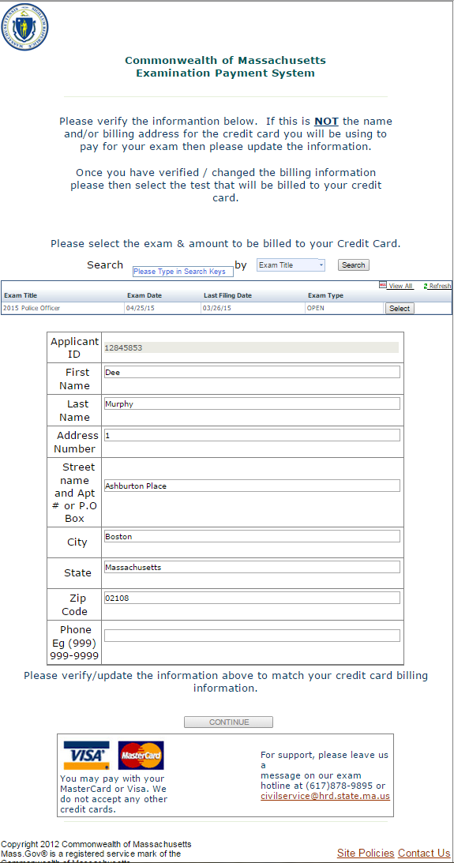

* Make sure you are entering the **Billing Address and Zip Code** of the card provided
* You should not use any punctuation in required fields
  + Last Name of O’Brien Jr. should be Obrien Jr
  + Address of 10 Lover’s St. should be 10 Lovers St
  + Punctuation in the Phone Number should not affect payment
    - 617-878-9700 http://solidwize.com/wp-content/uploads/2012/04/Green-Check-Mark.jpg
    - (617) 878-9700 http://solidwize.com/wp-content/uploads/2012/04/Green-Check-Mark.jpg
* Field too Long: If any field is long, please shorten your address
  + An address of 1001 Martin Luther King Jr. Blvd. should be shortened to 1001 Martin
  + A last name is Washington Smith should be shortened to Smith
* Only a five digit Zip Code should be used.
  + If a zip code is 12345-6789 shorten it to 12345
* If these changes have been made and you are still having issues please change your browser
  + The payment system will not work on Safari, Apple products, ever

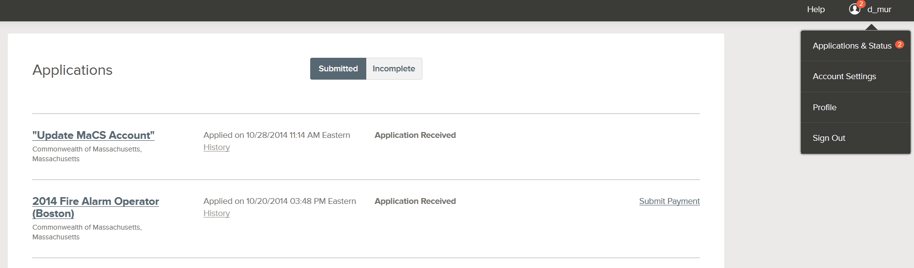



If you have an issue with the payment process and cannot complete it the first time, you can log back into your account and view your Applications (go to your Username in the right-hand corner and click the username – a list of options will drop-down, and then you can click on Applications). You’ll see on the right-hand side of the Applications page “Submit Payment.” That will allow you to go through the steps to pay for the exam. You will not be scheduled for an exam until you Submit Payment, OR until you submit a Fee Waiver form and proof. If you apply with a [Fee Waiver,](http://www.mass.gov/anf/docs/hrd/cs/forms/cs-fee-waiver.rtf) your application status will always remain ‘Submit Payment’ so do not be concerned, as long as you submitted the Fee Waiver form and proof.