The Commonwealth of Massachusetts
Executive Office of Health and Human Services
Department of Public Health
Bureau of Infectious Disease and Laboratory Sciences
305 South Street, Jamaica Plain, MA 02130

CHARLES D. BAKER
Governor
KARYN E. POLITO
Lieutenant Governor

MARYLOU SUDDERS
Secretary
MONICA BHAREL, MD, MPH Commissioner

Clinical Advisory
Zika Virus
UPDATED: August 3, 2017

Overview of Significant New Information and Changes in Guidance

Decreased Zika virus transmission
- Rates of Zika virus transmission have dropped dramatically in Central and South America and the Caribbean indicating the risk of exposure in those areas has decreased.
- There are currently 95 countries and territories where Zika virus has been documented; many of these are places where it has been circulating at low levels for decades (See CDC world map of areas with Zika).
- Evaluation and testing recommendations are now the same for all countries where Zika has been identified.
Testing recommendations and commercial laboratories
- Testing for Zika virus infection is readily available from multiple clinical and commercial laboratories.
- Routine testing of patients with a relatively low pre-test probability of infection will result in an increase in false-positive test results.
- Recent changes to the testing recommendations, including who should be tested and the specific testing algorithm to be used, are all designed to decrease the probability of a false-positive laboratory result.
  - Testing of asymptomatic pregnant women is no longer routinely recommended due to the difficulty in establishing specific timing of infection. Anti-Zika IgM antibody persists in some patients well past 12 weeks, making timing of infection uncertain. This is particularly true for patients who have spent weeks to months in an area with Zika or who have made multiple visits to those areas.
  - Testing of asymptomatic pregnant women can be considered using a shared decision-making approach to include a full discussion of the limitations of testing and potential risks and benefits.
  - Symptomatic patients should be tested simultaneously for Zika virus RNA by PCR on both serum and urine, and for anti-Zika virus IgM antibodies for 12 weeks after their symptom onset.
  - To reduce the chance of a single positive laboratory test representing a false positive, testing interpretation guidance has changed; positive results on multiple test or sample types increases the certainty that positive results are indicative of true exposure.
Infant Evaluation
- Testing of placental and fetal tissues has proven to be of relatively low utility and is recommended only in a few specific instances (see Infant Testing and Evaluation Recommendations).
- Infants born to mothers with possible Zika virus exposure during pregnancy must be carefully and comprehensively evaluated by physical exam, including standardized head measurements and a hearing screen. Based on an evaluation of the likelihood of maternal exposure to Zika virus, health care providers must have a low threshold for consideration of a head ultrasound and ophthalmologic exam as abnormalities may exist even in apparently healthy infants (see Infant Testing and Evaluation Recommendations).

- Zika Virus
Zika virus is a mosquito-borne flavivirus (in the same family as yellow fever, dengue and West Nile viruses) which has been identified in 95 countries and territories (See CDC world map of areas with Zika). The most significant concern associated with Zika virus remains the possibility of congenital infection. Data from the United States and its territories indicate that 5-6% of pregnancies associated with maternal Zika virus infection result in a possible Zika-related defect. The proportion is higher when maternal infection occurs during the first or early second trimester.
In addition to congenital infection, small proportions of patients have been diagnosed with Guillain-Barré syndrome, meningoencephalitis, or thrombocytopenia following Zika virus infection.
Between the end of 2015 and the end of 2016, epidemic levels of Zika virus transmission were occurring throughout Central and South America and the Caribbean. Surveillance during 2017 has indicated a dramatic decrease in transmission levels in all of those areas (Figure 1), likely due to development of immunity in large portions of the population as a result of previous exposure. While some cases of Zika are still being diagnosed in travelers returning to the United States, including Massachusetts (Figure 2), the risk of exposure to Zika virus is significantly reduced.
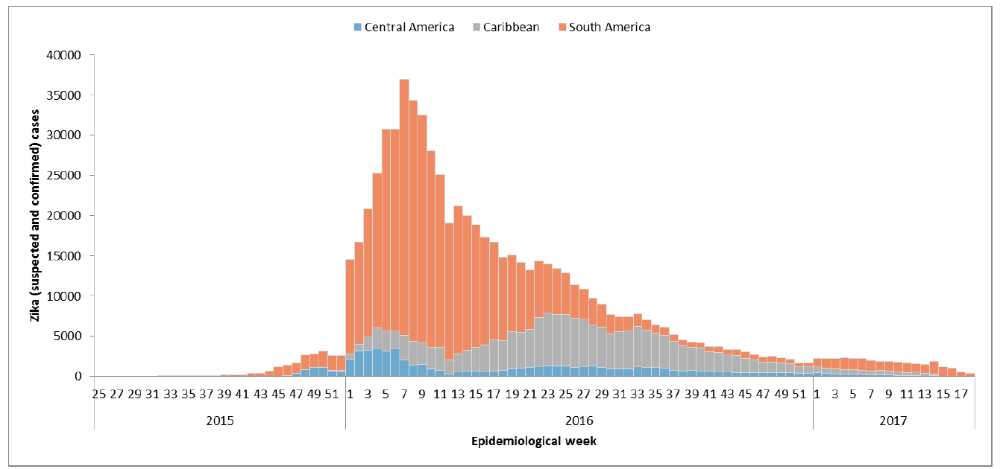
Figure 1: Number of Zika virus cases reported in South America (orange), Central America (blue) and the
Caribbean (gray) between 2015 and 2017 (PAHO:http://www.paho.org/hq/index.php?option=com_docman&task=doc_view&Itemid=270&gid=40222&lang=en)
.
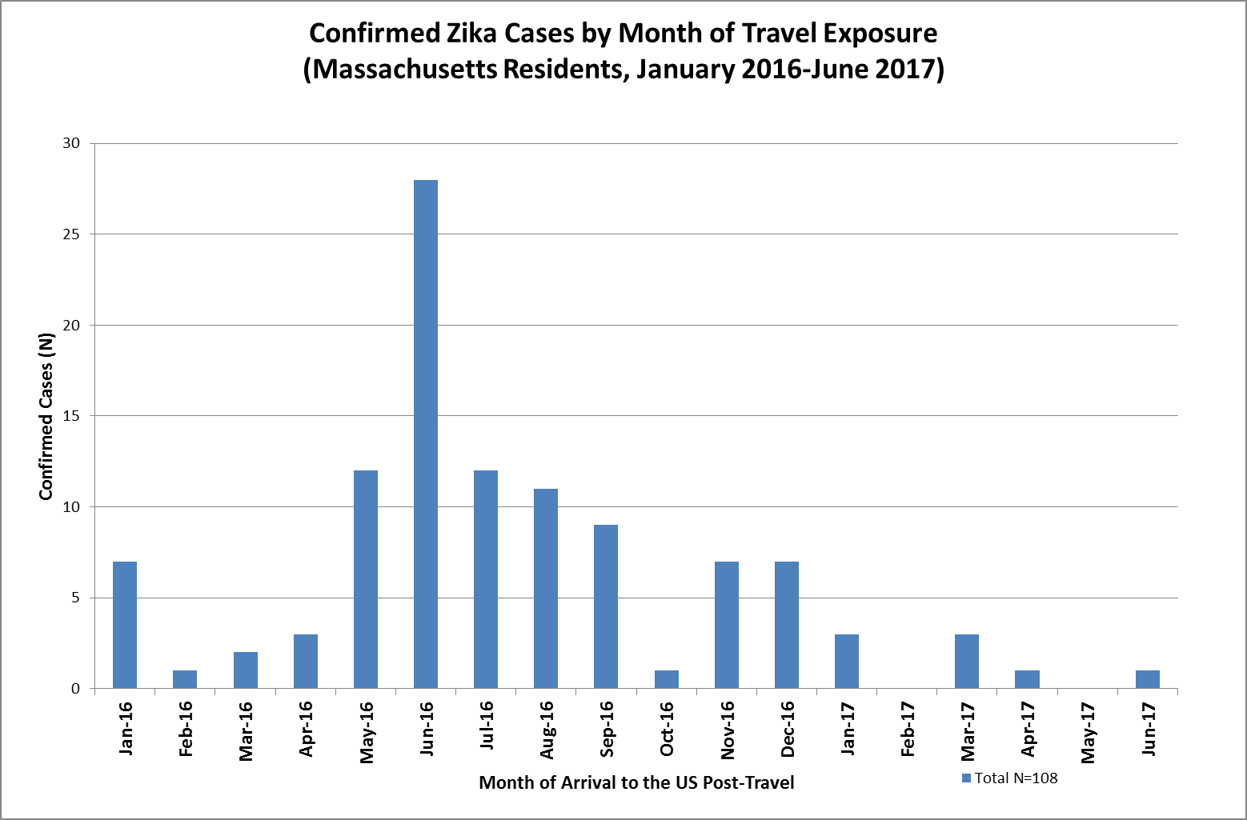

Figure 2: Number of Zika virus cases in Massachusetts residents with travel to locations with Zika virus by month of exposure

- Recommendation to Postpone Travel for Pregnant Women and their Partners, and Couples Planning Pregnancy
Despite the decreased risk of exposure to Zika virus, there are still opportunities for exposure while traveling. Currently, there is no vaccine and no prophylactic medications available to prevent Zika virus infection.
Recommendations About Travel:
- Pregnant women and women planning pregnancy are encouraged to postpone travel to areas with Zika virus transmission.
- Because sexual transmission is possible, the male sex partners of women who are pregnant or planning a pregnancy within six months, should also strongly consider postponing their travel.
When making a decision regarding travel, pregnant women and their partners should consider recent reports of Zika virus activity at their destination, likelihood of exposure to mosquitoes (based on time of year, scheduled activities, type of accommodations), duration of travel (longer stays may increase exposure risk) and expectation of adherence to mosquito bite prevention strategies.
Mosquito bite prevention strategies, recommended for all travelers to an area with transmission, include:
- wearing long-sleeved shirts and long pants;
- using U.S. Environmental Protection Agency (EPA)–registered insect repellents;
- using permethrin-treated clothing and gear; and
- staying and sleeping in screened-in or air-conditioned rooms.

When used as directed by the product label, insect repellents containing DEET, picaridin, and IR3535 are safe for pregnant women.

- Recommendations about Preventing Sexual Transmission, especially to Pregnant Women, and Delaying Conception for Individuals or Couples with Recent Travel to an Area with Zika Virus
Despite the decreased risk of exposure to Zika virus, sexual transmission from an infected partner is still possible and no therapeutic approach to reduce the possibility of congenital infection currently exists.
Preventing Sexual Transmission to Pregnant Women: individuals who reside in or have traveled to an area with Zika virus who have a pregnant partner should:
- abstain from sex; or
- consistently and correctly use condoms every time they have sex for the duration of the pregnancy, including vaginal, anal and oral sex and the sharing of sex toys.

Preventing Sexual Transmission and Delaying Conception for Non-Pregnant Couples:
- Women with possible Zika virus exposure should use condoms or abstain from sex AND delay conception for at least 8 weeks after start of symptoms or last possible exposure.
- Men with possible Zika virus exposure should use condoms or abstain from sex AND the couple should delay conception at least 6 months after start of symptoms or last possible exposure. (There is evidence of RNA persistence in semen up to 6 months after exposure but with less than 5% of men with detectable RNA at the end of 3 months).

Fact sheets on correct condom use are available from the U.S. Department of Health and Human Services and CDC at .

- Understanding Laboratory Testing for Zika Virus
Two types of laboratory tests are available to assess infection with Zika virus.
- RT-PCR: Detection of Zika virus RNA indicates the presence of the virus itself. PCR for Zika RNA can be done on serum, urine, cerebral spinal fluid, and amniotic fluid. Sample types and timing of collections for at-risk patients are detailed in the Diagnostic Testing Guidance algorithm.
Availability: This test is widely available commercially for most sample types and at the Massachusetts State Public Health Laboratory (MA SPHL). Check with your laboratory for testing availability and turn-around times. Information about specific assays being used can be found here.
Test Limitations: The duration of detectable viral RNA in serum and urine is highly variable. False positive results have been documented.
- Anti-Zika virus IgM antibodies: These may provide evidence of recent exposure in certain patients. Anti-Zika virus IgM antibodies reliably appear within 2 weeks following exposure and may persist for months. Serum samples with a positive or equivocal anti-Zika virus IgM result must be confirmed by testing serum for the presence of neutralizing antibodies using the plaque reduction neutralization test (PRNT). Sample types and timing of collections for at-risk patients are detailed in the Diagnostic Testing Guidance algorithm.
Availability: This test is widely available commercially for most sample types and at the MA SPHL. Check with your laboratory for testing availability and turn-around times. Information about specific assays being used can be found here.
Test Limitations: The duration of circulating IgM antibodies is variable and may persist well beyond 12 weeks making timing of infection uncertain. Cross-reactivity with dengue virus in individuals who have had previous exposure to dengue precludes identification of the currently infecting flavivirus. False positive results have been documented.
- Diagnostic Testing Guidance
Based on accumulated information about laboratory test performance, duration of antibody response, serologic cross-reaction and the increased risk of false-positive test results due to a decreased pre-test probability of infection, testing recommendations have changed significantly.
- Testing is available through MA SPHL for symptomatic pregnant women, fetal losses, fetuses or infants with birth defects consistent with Zika virus congenital infection and patients with rare manifestations of Zika (eg. Guillain-Barré syndrome, thrombocytopenia or meningoencephalitis), within 12 weeks of symptom onset.
- Laboratory testing for all other patients should be sent to commercial laboratories to take advantage of the improved access to commercially available testing. Samples that test positive at commercial labs should be forwarded to MA SPHL for confirmation.
- Routine testing for asymptomatic pregnant women with possible Zika virus exposure is no longer recommended. Testing should be considered as part of a complete discussion with the patient about the limitations of testing and the inherent risks and benefits. This testing is available through commercial laboratories.
- Asymptomatic pregnant women with ongoing possible Zika exposure through frequent travel or ongoing possible sexual exposure should be handled on a case by case basis. PCR testing, without IgM testing, up to 3 times during pregnancy can be considered.
- Information about infant testing is available in the Recommended Perinatal Testing and Evaluation of Infants Born to Mothers with Possible Zika Virus Exposure and Infants with Congenital Zika Virus Syndrome guidance document.

Discussion points helpful for engaging asymptomatic pregnant patients in a shared decision-making process for testing:

- Difficulty in assessing timing of exposure for asymptomatic patients, especially those who have spent weeks to months in an area with Zika
- Increased rate of false positives with application of laboratory testing in patients with a low risk of exposure
- Variable persistence of Zika virus RNA and IgM antibody potentially causing misleading test results
- Previous laboratory diagnosis of Zika virus suggestive of current immunity
- Previous exposure to dengue virus or yellow fever or Japanese encephalitis vaccine with the potential for cross reactivity
- Likelihood of patient’s exposure based on recent reports of Zika virus activity at the travel destination
- Likelihood of exposure to mosquitoes (based on time of year, scheduled activities, type of accommodations), duration of travel (longer stays may increase exposure risk) and adherence to mosquito bite prevention strategies.
- Likelihood of sexual exposure due to evidence of limited persistence in semen more than 3 months after exposure
- Patient’s ability to tolerate potential uncertainty either from not testing or from an inconclusive result
- Lack of a therapeutic approach to reduce the possibility of congenital infection

To discuss or request testing, please contact the MDPH Epidemiology Line at 617-983-6800, available 24/7. When contacting the MDPH, please have the following information available:
- Date of onset of disease symptoms;
- Date of specimen collection;
- Unusual immunological status of patient (e.g., immunosuppression);
- Travel history with dates (e.g., travel to area with Zika) (See CDC world map of areas with Zika);
- Vaccination history (e.g., vaccination against yellow fever, Japanese encephalitis);
- Previous laboratory confirmed Zika virus infection;
- Disease history (e.g., previous history of chikungunya or dengue fever); and
- Brief clinical summary including suspected diagnosis and approximate gestational age

Specimens approved for testing at the MA SPHL should be submitted using the MA SPHL clinical specimen submission form and should include the information provided above.
Specific information on specimen collection, storage and shipping is available at Specimen Collection, Storage and Shipment for Molecular, Serological and Tissue Testing for Zika Virus.

Testing Algorithm for Symptomatic Patients AND Asymptomatic Pregnant Patients for Whom Testing is Recommended After a Full Discussion of the Risks and Benefits of Testing and the Limitations Inherent in Laboratory Testing
(Adapted from Update: Interim Guidance for Health Care Providers Caring for Pregnant Women with Possible Zika Virus Exposure — United States (Including U.S. Territories), July 2017 | MMWR for application in Massachusetts)
Positive Zika virus PCR in EITHER serum or urine
Zika virus PCR (serum and urine)
AND Zika virus IgM serology (serum)
Plaque reduction
neutralization test (PRNT)
- MA State Public Health Laboratory: Symptomatic pregnant women and patients with rare manifestations
  - Call MDPH Epidemiology Program for testing approval prior to submission: 617-983-6800 available 24/7
- Commercial laboratories: All other patients
Zika virus PRNT<10
Zika virus PRNT ≥10 AND
Dengue virus PRNT ≥10
Zika virus PRNT ≥10 AND
Dengue virus PRNT <10
Negative Zika virus PCR AND negative Zika virus IgM
Negative Zika virus PCR AND nonnegative Zika virus IgM
Symptomatic¹ women with no previous laboratory-confirmed diagnosis of Zika virus infection
- who were pregnant during travel to or residence in an area with Zika,
- conceived during or within 8 weeks of their own travel to or residence in an area with Zika,
- conceived within 6 months of their male partner’s travel to or residence in an area with Zika, or
- had unprotected sexual contact while pregnant with a sex partner with travel to or residence in an area with Zika.
Asymptomatic women meeting any of the criteria above for whom testing is being pursued following a shared-decision making process to include a discussion of the issues listed on page 4
Patients with rare manifestations that may be associated with Zika virus including Guillain-Barré syndrome, thrombocytopenia, or evidence of neuroinvasive disease
Acute Zika virus infection
If either urine or serum is PCR positive but IgM is negative, consider resubmitting serum for IgM ≥ 2 weeks to reduce chances that initial result represents a false positive.
Zika virus infection; timing of infection cannot be determined
For pregnant women without Zika virus exposure before the current pregnancy, positive IgM represents recent Zika virus infection
Flavivirus infection; specific virus and timing of infection cannot
be determined
OR
For pregnant women without Zika virus exposure before the current pregnancy, positive IgM represents recent unspecified flavivirus infection
No evidence
of Zika virus infection
WHOM to test
Before testing, discuss testing limitations and potential risks for misinterpretation of test results
WHERE to test?
WHEN to test?
As soon as possible, through 12 weeks post-symptom onset
Or after last possible exposure for asymptomatic patients

WHICH tests?
INTERPRETATION
¹Symptomatic: two or more of the following symptoms - maculopapular rash, nonpurulent conjunctivitis, fever, myalgia/arthralgia or persistent, unusual headache with onset ≤14 days after last potential exposure OR prenatal ultrasound findings indicative of congenital Zika virus syndrome

- ADDITIONAL RESOURCES

CDC Zika virus web site: http://www.cdc.gov/zika/index.html

World Map of Areas with Zika virus

Caring for Pregnant Women and those of Reproductive Age
- UPDATE: Update: Interim Guidance for Health Care Providers Caring for Pregnant Women with Possible Zika Virus Exposure — United States (Including U.S. Territories), July 2017 | MMWR
- Webpage: Clinical Guidance for Healthcare Providers Caring for Pregnant Women and Women of Reproductive Age with Possible Zika Virus Exposure

Caring for Infants and Children
- Interim Guidelines for Healthcare Providers Caring for Infants and Children with Possible Zika Virus Infection – United States, February 2016 (Feb. 26, 2016)
- Interim Guidelines for the Evaluation and Testing of Infants with Possible Congenital Zika Virus Infection — United States 2016 (January 29, 2016)
- Webpage: Clinical Guidance for Healthcare Providers Caring for Infants and Children with Possible Zika Virus Infection

Preventing Sexual Transmission
- UPDATE: Update: Interim Guidance for Prevention of Sexual Transmission of Zika Virus — United States, July 2016 | MMWR (July 29, 2016)
- Webpage: Zika and Sexual Transmission
Guidance for U.S. Laboratories Testing for Zika Virus Infection (July 26, 2016)
Occupational Health and Safety for Healthcare Providers During Delivery
- Preventing Transmission of Zika Virus in Labor and Delivery Settings Through Implementation of Standard Precautions — United States, 2016 (March 25, 2016)

