APPENDIX E. State Health Assessment Stakeholder Wheel and List of Organizational Stakeholders including Commissioners, Advisories and Stakeholder Groups, Statewide Partnership Advisory Members, Organizational Key Informants and Focus Group Stakeholders

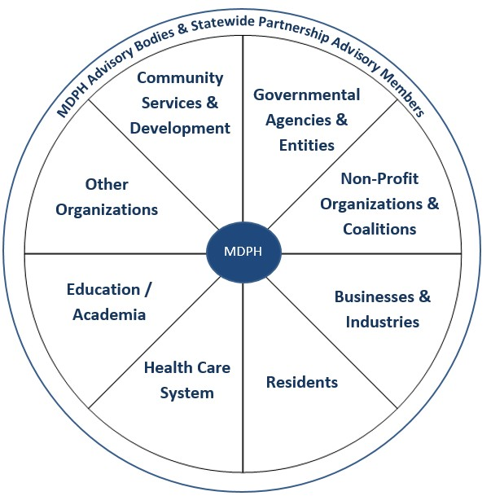

Sector | Key Stakeholders
Community Services & Development: Organizations Focused on Serving Communities | - ABCD, Inc.  - Boston Planning & Development Agency (BPDA)  - Citizens’ Housing and Planning Association  - Local Initiatives Support Coalition  - Project Bread  - WalkBoston
Governmental Agencies & Entities: State Government Offices and Departments | - Health Policy Commission  - MA Department of Elementary and Secondary Education  - MA Department of Higher Education  - MA Department of Mental Health  - MA Department of Transportation  - MA Executive Office of Elder Affairs
Non‐Profit Organizations & Coalitions: Non‐Profits Working in Public Health | - American Cancer Society  - American Heart Association  - DentaQuest  - Health Care for All  - Health Resources in Action (HRiA)  - MA Health Council  - MA Public Health Association  - National Institute for Children’s Health Quality

Sector | Key Stakeholders
Businesses & Industries: Associations Representing Industries and Special Interests | - American Association of Retired Persons (AARP)  - Associated Industries of Massachusetts (aim)  - Association for Behavioral Health (ABH)  - MA Association of Health Plans (MAHP)  - MA Association of Public Health Nurses (MAPHN)  - MA Coalition for Suicide Prevention  - MA Dental Society (MDS)  - MA Food Council  - MA Law Reform Institute  - MA League of Community Health Centers  - MA Prevent Injuries Now! Network (PINN)  - National Association for the Advancement of Colored People (NAACP)
Residents: Individuals, Consumers and Specific Populations | - Asian Women for Health  - Current substance users  - General public  - Homeless Youth  - Individual: College professor, urban school  - MA Alliance of Portuguese Speakers (MAPS)  - Nipmuc Tribe  - People with disabilities  - Police  - Recovery community  - Veterans

Sector | Key Stakeholders
Health Care System: Organizations and Individuals Involved with Health Care Delivery and Insurance | - Atrius Health  - Blue Cross Blue Shield Foundation  - Boston Medical Center  - Cambridge Health Alliance  - Compass Medical  - Conference of Boston Teaching Hospitals  - First Responders  - Health and Disability Partnership  - Hilltown Community Health Center  - HIV care providers  - MA Chapter American Academy of Pediatrics  - MA Medical Society  - Maternal and Child Health Practitioners  - Mental Health Providers  - Partners HealthCare  - Primary care providers  - Substance use treatment providers
Education/Academia: Educational Institutions and Organizations | - Boston University School of Public Health  - Brandeis University  - Harvard Catalyst  - Harvard School of Public Health  - Institute for New England Native American Studies at the University of Massachusetts, Boston  - MA Association of School Committees  - MA Association of School Superintendents  - MA Department of Higher Education  - Regis College  - UMass Amherst School of Public Health and Health Sciences  - Wellness In Schools Coalition
Other Organizations | - Council on Compulsive Gambling  - GE Foundation  - HomeBASE, a Red Sox Foundation and Massachusetts General Hospital Program  - MA Rural Council on Health

Sector | Key Stakeholders
MDPH Advisory Bodies: Existing Regularly Meeting Groups of Stakeholders | - 13 Largest Cities Forum  - Coalition for Local Public Health  - Health and Disability Partnership  - Health and Medical Coordinating Coalitions ‐ North Shore, South Shore, and Boston (HMCCs)  - Local State Advisory Committee  - MA Coalition for Suicide Prevention  - MA Commission on LGBTQ Youth  - MA Rural Council on Health (MARCH)  - Advisory Board to the Occupational Health Surveillance Program  - Prescription Monitoring Program Stakeholders  - Preventive Health and Health Services Block Grant Advisory  - State Technical Advisory Group  - Wellness In Schools Coalition

Sector | Key Stakeholders
Statewide Partnership Advisory: External Advisory Board Charged with Informing Content, Disseminating Information and Identifying Gaps | - ABCD, Inc.  - Alliance of MA YMCAs  - American Cancer Society  - American Heart Association  - American Lung Association  - Asian Women for Health  - Association for Behavioral Healthcare  - Atrius Health  - Boston University, School of Public Health  - Compass Medical  - Conference of Boston Teaching Hospitals’ Community Benefit Advisory Committee  - Harvard Catalyst  - Health Care for All  - Health Policy Commission  - Institute for New England Native American Studies at the University of Massachusetts, Boston  - John Snow Inc. (JSI)  - Lead and Environmental Health Association  - Local Initiatives Support Coalition  - MassAHEC Network / UMass Medical School  - MA Alliance of Portuguese Speakers (MAPS)  - MA Association of Public Health Nurses  - MA Chapter American Academy of Pediatrics  - MA Coalition for Occupational Safety & Health  - MA Dental Society  - MA Health Council  - MA League of Community Health Centers  - MA Medical Society  - MA Public Health Association  - National Institute for Children’s Health Quality  - New England AIDS Education and Training Center  - Partners for a Healthier Community  - Partners HealthCare – Community Health  - Regis College  - UMass Amherst, College of Nursing  - UMass Amherst, School of Public Health and Health Sciences  - WalkBoston  - Western MA Health Equity Network

Sector | Key Stakeholders
Focus Groups | - HomeBASE, a Red Sox Foundation and Massachusetts General Hospital Program  - HIV care providers  - Homeless Youth  - MA Integrated Prevention and Care Committee  - MA Rural Council on Health  - MCH Title V Block Grant Advisory  - Nipmuc Tribe  - Substance abuse services coalition members (Southeast, Cape Cod & Western Regions)

Sector | Key Stakeholders
Key Informants | - American Association of Retired Persons (AARP)  - Asian Women for Health  - Associated Industries of Massachusetts (aim)  - Brandeis University  - Cambridge Health Alliance  - Citizens’ Housing and Planning Association  - DentaQuest  - Massachusetts Department of Mental Health (DMH)  - DPH Council on Compulsive Gambling  - Executive Office of Elder Affairs  - GE Foundation  - Health Resources in Action (HRiA)  - HomeBASE, a Red Sox Foundation and Massachusetts General Hospital Program  - Individual/College Professor, Urban School  - MA Association of Health Plans  - MA Association of School Committees  - MA Association of School Superintendents  - MA Department of Elementary and Secondary Education  - MA Department of Higher Education  - MA Department of Transportation (MassDOT)  - MA Food Association  - MA Law Reform Institute  - MA Public Health Association  - MA Prevention Injury Network Now  - NAACP  - National Institute for Children’s Health Quality  - Partners for a Healthier Community  - Project Bread  - UMass Boston, Gerontology Institute  - WalkBoston

