How State Employees can Pledge to COMECC

Paper pledges
You will receive a COMECC Pledge Form .
  - Please fill out your name, Employee ID number, Dept ID, Region (I to V), Maildrop, your office phone number and/or email address.
  - Please choose the amount of payroll deduction per Pay Period.
  - Please choose the number of payroll deduction; Recurring donation or One-time donation
  - Please sign and write date.
  - Please select charities, which you wish your money to go.
Note: COMECC does accept check donations in addition to payroll deduction, and offer totally secure online credit card through www.comecc.net .
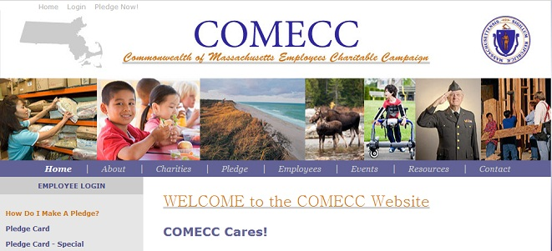

On-line pledges
COMECC Online Pledge is secure, quick and simple.
Usernames and passwords are Case Sensitive
Your Login is your First and Last name. However, there are no punctuations, hyphens, apostrophes spaces or multiple names. To ascertain your “first name” it is the first name on your payroll. Hyphenated names are one word without the hyphen. If there is a space between your name that is two words and only the first one is in your login. Any apostrophe is removed.
Your “last name” is the last name on your payroll. If your name is hyphenated or has a space between the names, it is the name AFTER the hyphen or space. (unless it is less than three letters and a space, von, del, dos, san OR St., St, Saint, Santa) Any punctuation and suffixes are removed including apostrophes, hyphens, commas, periods, etc.
For example : Jo-Ann Harkin Blake is JoannBlake (Case sensitive)
Whereas : Jo Ann Harkin-Blake would be JoBlake
Example: Sue Ann St. Croix is SueStCroix
Whereas: Sue-Ann Von Auster is SueAnnVonAuster
Your first time password is your last name exactly as it is written on your payroll, including both if you have two last names. This includes all spaces, hyphens, punctuation and suffixes.
Please email Tim Palmer with any login issues – tim.palmer@bostonabcd.org
NOTE: COMECC takes your privacy very seriously. We will not release your details unless you give us permission to do so. Whether you pledge online or using a paper pledge form you have the option of indicating if you want your contact details and the amount of your donation releasing to the charities you have chosen. No information about your pledge is released unless you give us permission on your pledge form.

