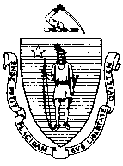
Massachusetts Department of Public Health
Bureau of Environmental Health
305 South Street
Jamaica Plain, MA 02130-3597
(617) 983-6712 (617) 983-6770 - Fax
Food Protection Program
Policies, Procedures and Guidelines
Issue: Carbonated Nonalcoholic Beverages Finished Product Testing No: BW-01

Massachusetts regulation 105 CMR 500.000: Good Manufacturing Practices for Food requires bottlers of carbonated nonalcoholic beverages to conduct analyses of their finished product.

For the purposes of this requirement, manufacturers are required to take finished product samples as frequently as necessary to ensure that all products meet the quality standards in 105 CMR 500.093. Samples must be taken prior to the introduction of any additives, colors, flavorings or other product enhancers. Samples may, however, be taken prior to, or immediately following, carbonation.

Routine tests results need not be submitted to the Department but shall be maintained at the manufacturing location.

