Commonwealth of Massachusetts

MassHealth
School-Based Medicaid Program

Instruction Guide
For
Statewide
Random Moment Time Study
(RMTS)

Revised July 2015
Replaces Guide Issued July 2010

SBMP-RMTS (Rev 07/15)

Table of Contents

Section Page

- Introduction 3
- Random Moment Time Study (RMTS) 4
- School-Based Medicaid Providers’ Responsibilities 6
- On-line Training for Time Study Participants 9
  - On-line Training Management Reports 10
- Time Study Participant Responsibilities and Instructions 12
  - Obtaining User ID and Password 13
  - Reset/Forgot Password 16
  - Failed Login 16
  - Notification and Recording of Moment 17
- Participation Requirements and Monitoring Compliance 24
  - RMTS Management Reports 25
- Technical Notes/System Requirements 27
- Appendix: Sample Reports and Designee Form 29
  - RMTS Management Reports 31

Summary of Changes from Prior Version

Please note: This manual has been through a full review and rewrite, so it should be reviewed in its entirety. This summary of changes is provided as a tool to direct special attention to certain areas of the most substantive changes, but it should not be considered as all-inclusive.

- Section II: Random Moment Time Study
- Section III: School-Based Medicaid Provider Responsibilities
    - Direct Service Practitioners
    - Administrative Only Staff
    - Uploading RMTS Participant Lists

Introduction

The Massachusetts School-Based Medicaid Program (formerly the Municipal Medicaid program) coordinates claims by School-Based Medicaid providers for partial federal reimbursement of qualifying direct health services provided to MassHealth members in schools (known as “Direct Service Claiming”). The School-Based Medicaid program also provides a means for schools to seek federal reimbursement for certain administrative expenditures for MassHealth children (known as “Administrative Activity Claiming”).

One component of both the Administrative Activity Claiming and the Direct Service Claiming is the completion of a Random Moment Time Study (RMTS). This guide provides step-by-step instructions for completing the RMTS. Included in this guide is information on the following.

- The RMTS process
- Provider responsibilities to participate in the RMTS
- Determining RMTS participants
- Obtaining and updating a User ID and password for participants
- Resetting forgotten passwords
- Entering data
- Understanding the RMTS deadlines
- Accessing reports for compliance monitoring
- Contacting the University of Massachusetts Medical School (UMMS) for systems help

Contact Information

University of Massachusetts Medical School (UMMS)
Center for Health Care Financing
School-Based Medicaid Program
333 South Street
Shrewsbury, Massachusetts 01545

schoolbasedclaiming@umassmed.edu

Phone: (800) 535-6741, option 1
Fax: (508) 856-7643

Random Moment Time Study (RMTS)

The Random Moment Time Study (RMTS) methodology quantifies the work of a statewide group of health professionals and support staff involved in the delivery of medical and health-related services provided through the School-Based Medicaid Program by sampling the work efforts of these individuals. The RMTS methodology requires employees to be polled at random moments, over a quarter of a calendar year, and calculates the results of the polling. This method provides a statistically valid means of determining which portion of the group’s time is spent performing activities that are reimbursable by Medicaid in the Direct Service Claiming (DSC) program or the Administrative Activity Claiming (AAC) program. The results of the RMTS are combined with provider-specific costs, which will be submitted in an annual cost report to determine provider reimbursement for Direct Service Claiming, and will be submitted as part of the quarterly Administrative Activity Claims. The RMTS process is designed to be as quick and unobtrusive to participants as possible.

The RMTS is completed online using the statewide RMTS system. A detailed description of this system is provided throughout this document.

The RMTS does not replace the requirement to document direct medical services provided to students.

An outline of the RMTS process follows below.

Step 1: Providers enter district-wide calendars and staff hours into the RMTS system on-line, prior to August 15 each year. Providers update calendars with any changes to the last day of school, prior to March 1 each year.

Step 2: Providers upload the list of eligible RMTS participants into the RMTS system 30 days prior to the start of the quarter.

Step 3: RMTS participants receive passwords from the RMTS system via email as needed.

Step 4: Participants and moment dates and times are randomly selected from the statewide pool through the RMTS system.

Step 5: Participants receive notification of moments from the RMTS system at the time of the moment.

Note: Please note the change required by Center for Medicare and Medicaid (CMS) that participants, all school district staff, and their designated billing agents/vendors are not allowed any advanced notification of moments. This includes a restriction on all RMTS reports so that future moments will not be available on any reports.

Step 6: Participants login to the RMTS system and respond to the questions within the five calendar-day grace period (120 hours).

Step 7: Participants will be contacted as needed by UMMS for clarification of answers.

Step 8: Participants receive follow-up email reminders from the RMTS system if data is not entered two, 24, 48, 72, and 96 hours after the moment. The participant’s supervisor and the district’s RMTS manager are copied on emails sent 72 and 96 hours after the moment.

Note: The schedule of which reminder email notifications include a copy to the supervisor and RMTS Manager for each school district is customizable by district. Please contact UMMS for additional information.

Step 9: After five calendar days (120 hours), the participant will not be able to complete or edit the moment.

Step 10: Quarterly statewide time study results are calculated by UMMS and distributed to providers for inclusion in the AAC claims. The Direct Service cost report will also include statewide time study results.

School-Based Medicaid Providers’ Responsibilities

Each provider is responsible for completing the following tasks to ensure that the RMTS process is successfully completed.

Step 1: Designate a time study contact and send that person’s name, phone number, fax number, and email to UMMS. Update this information as required. This information should be sent to UMMS via email to schoolbasedclaiming@umassmed.edu or fax to 508-856-7643. See Appendix for the School-Based Medicaid Program District Contact Designee Information form.

Step 2: In order to determine the eligible moments to be included in the RMTS, providers must enter their annual school district calendar and staff hours into the RMTS system prior to August 15. In addition, any updates to the calendar, specifically changes to the last day of school, must be made by March 1.

Step 3: Providers must identify the personnel who are eligible to participate in the time study.

For Direct Service Practitioners

- Include personnel who meet the credentialing qualifications outlined in the Direct Service Practitioners chart below and who will be reasonably expected as part of their current job duties to provide Medicaid-covered, IEP-related, direct medical services to students (Medicaid eligible and/or non-Medicaid eligible) in the quarter being requested (these staff should be designated as ‘Medical Yes’ on the RMTS participant list).
- Include personnel who meet the credentialing qualifications outlined in the Direct Service Practitioners chart and who will be reasonably expected as part of their current job duties to perform Medicaid-related administrative activities in the quarter being requested and will not provide Medicaid-covered IEP related medical services to students (these staff should be designated as ‘Medical No’ on the RMTS participant list).
- Include Medicaid Billing Personnel who will be reasonably expected as part of their current job duties to perform School-based Medicaid billing functions in the quarter being requested (these staff should be designated as ‘Medical Yes’ on the RMTS participant list).
- Staff whose salary costs are duplicative of costs reimbursed through the application of the Indirect Cost Rate must be excluded from the RMTS. (See School-Based Medicaid Bulletin 28, July 2015.)

Direct Service Practitioners (Providers must meet the provider qualifications and perform direct services)
- Speech/Language Therapist – Medicaid Definition (130 CMR 432.404(C) or 432.405)
- Speech/Language Assistant – Medicaid Definition (260 CMR 10.02)
- Occupational Therapist – Medicaid Definition (130 CMR 432.404(B) or 432.405)
- Occupational Therapy Assistant – Medicaid Definition (259 CMR 3.02 (1) through (3))
- Physical Therapist – Medicaid Definition (130 CMR 432.404 (A) or 432.405)
- Physical Therapy Assistant – Medicaid Definition (259 CMR 5.02 (1) through (3))
- Nurse Registered Nurse – Medicaid Definition (130 CMR 414.404 (A)
- Licensed Practical Nurse – Medicaid Definition (130 CMR 414.404 (A)
- Audiologist – Medicaid Definition (130 CMR 426.404)
- Audiologist Assistant – Medicaid Definition (260 CMR 10.02)
- Hearing Instrument Specialist - Medicaid Definition (130 CMR 416.404)
- Counselor – Medicaid Definition (130 CMR 429.424(E)(2))
- Psychologist 1 – Medicaid Definition (130 CMR 429.424.(B)(1) or 429.424(B)(2))
- Psychologist 2 – Medicaid Definition (130 CMR 429.424.(B)(1) or 429.424(B)(2))
- Social Worker 1 – Medicaid Definition (130 CMR 429.424 (C)(1) or 429.424 (C)(2))
- Social Worker 2 – Medicaid Definition (130 CMR 429.424 (C)(1) or 429.424 (C)(2))
- Personal Care Service Provider – Medicaid Definition (42 CFR 440.167)
- Medicaid Billing Personnel
- Psychiatrist – Medicaid Definition (130 CMR 429.424(A)(1) or 429.424(A)(2))

For Administrative Only Staff

- Include health personnel who do not meet the provider qualifications outlined in the Direct Service Practitioners chart below BUT who will be reasonably expected as part of their current job duties to provide Medicaid-covered, IEP-related, direct medical services to students (Medicaid eligible and/or non-Medicaid eligible) in the quarter being requested. (These staff should be designated as ‘Medical No’ on the RMTS participant list.)
- Include health personnel who do not meet the provider qualifications outlined in the Direct Service Practitioners chart BUT who will be reasonably expected as part of their current job duties to perform Medicaid-related administrative activities in the quarter being requested. (These staff should be designated as ‘Medical No’ on the RMTS participant list.)
- Include other personnel listed on the Administrative Only Staff chart who will be reasonably expected as part of their current job duties to perform Medicaid-related administrative activities in the quarter being requested. (These staff should be designated as ‘Medical No’ on the RMTS participant list.)
- Staff whose salary costs are duplicative of costs reimbursed through the application of the Indirect Cost Rate must be excluded from the RMTS. (See School-Based Medicaid Bulletin 28, July 2015.)

Administrative Only Staff
- Speech/Language Aide, Assistant
- Speech/Language Therapist
- Occupational Therapist
- Occupational Therapist Aide, Assistant
- Physical Therapist Aide, Assistant
- Physical Therapist
- Audiologist
- Audiologist Assistant or Aide
- School Psychologist
- Hearing Instrument Specialist
- School Psychologist Intern
- Case Manager
- Counselor
- School Adjustment Counselor
- School Guidance Counselor
- Nurse
- Nurse’s Aide
- Psychiatrist
- Psychologist
- Social Worker
- Personal Care Service Provider
- Direct Support Personnel
- Vision Specialist
- Physician

Administrative activities that are reimbursable under the School-Based Medicaid Program are described in detail in the School-Based Medicaid provider contract. These activities include the following.

Medicaid Outreach: Performing activities that inform eligible or potentially eligible individuals about Medicaid and how to access it;

Facilitating/Assisting in the MassHealth Application Process: Assisting individuals in applying for Medicaid;

Provider Networking/Program Planning/Interagency Coordination: Performing activities associated with the development of strategies to improve the coordination and delivery of Medicaid-covered services to school-age children, and when performing collaborative activities with other agencies regarding Medicaid-covered services;

Individual Care Planning, Monitoring, Coordination and Referral: Making referrals for, coordinating, and/or monitoring the delivery of Medicaid-covered services; and

Arrangement of Transportation and Translation Related to Medicaid Services: Assisting an individual to obtain Medicaid-covered transportation or translation services.

Related Materials
MassHealth School-Based Medicaid Bulletin 17 (April 2009)
School-Based Medicaid Provider Bulletin 28 (July 2015)

Step 4: Providers must prepare and upload the quarterly RMTS Participant List.

RMTS participant files must be uploaded approximately 20 days before the start of each quarter, even if you have no changes from the current quarter.

The ‘Quick Guide to Uploading RMTS Participants’ document is a helpful resource to extract and upload the RMTS participant lists for the RMTS Designee.

It is important to review the information for each participant on the list to ensure that it is accurate for the quarter being uploaded. By including a participant on the list, you are certifying that he/she has the qualifying credentials for the job description listed and is reasonably expected to provide/perform Medicaid-covered, IEP-related, direct medical services, Medicaid-related administrative activities, or School-Based Medicaid billing services for the quarter being requested.

On-line Training for Time Study Participants

On-line training is available for time study participants and at the School-Based Medicaid Program site at www.chcf.net/chcfweb/sbc/administration/user/userlogin.do.

‘MARMTS Training Updated’ provides both an overview of the RMTS process and a step-by-step guide to completing the RMTS online.

To access and review the module:

Step 1: After logging in, click “Online Training Materials” in the left navigation.

Step 2: Select ‘MA-RMTS Training: Updated’.

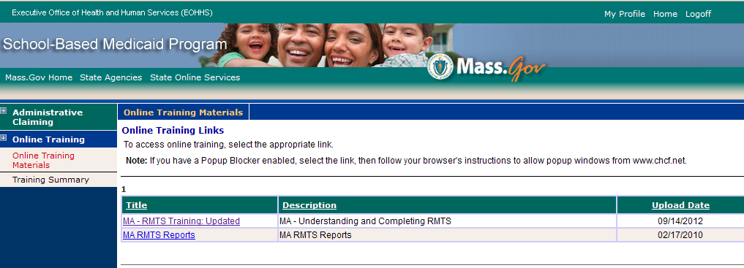

Step 3: Follow the instructions as presented in the self-guided module.

Step 4: Once the training module is completed or is closed prior to completion, the following screen will appear. Click on the button that indicates whether or not the RMTS training has been completed.

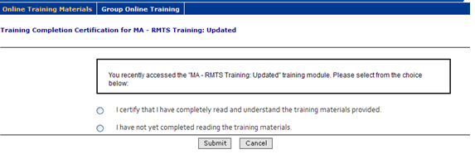
Step 5: Click ‘Submit’

On-line Training Management Reports

Training reports are available that indicate those participants who have accessed the training module.

1. Training Documents Viewed Report: This report lists all participants who have viewed the online training module. It includes the time study participant’s name, employee ID number, job type, job description, job code, email, module name, and the date and time that the module was accessed.

2. Training Documents Not Viewed Report: This report lists participants and training modules they have not reviewed. It includes the time study participant’s name, employee ID number, job type, job description, job code, email, and module name that was not accessed.

The following steps outline the process for accessing and using the summary reports.

Step 1: After logging into the RMTS system, click “Online Training” in the left navigation bar.

Step 2: Click “Training Summary” in the left navigation bar.

Step 3: Click on the name of the report to view or print.

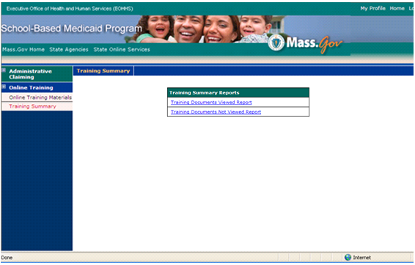

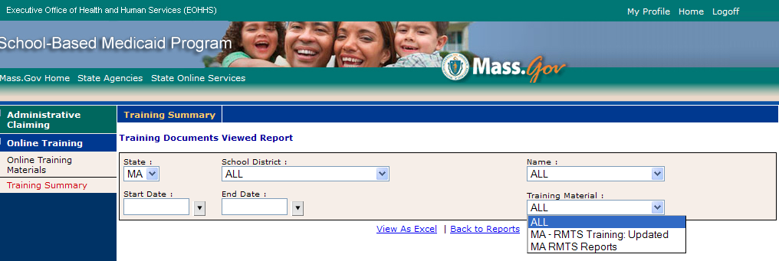

The “State” field will default to MA for Massachusetts. The “School District” field will display your school district name.

Step 1: In the “Name” field, either select an individual participant from the drop-down list or choose “All” to view data for all RMTS participants.

Step 2: Enter “Start Date” and “End Date.”

Step 3: The “Training Material” lists all online trainings.

Step 4: Click “View As Excel.”

Please refer to the Appendix for additional sample reports.

Time Study Participant Responsibilities and Instructions

The provider-specific lists of time study participants will be combined into two statewide pools. From these pools, participant moment(s) days and times will be randomly selected for completion. Each selected participant will receive a notification email at the time of his/her moment(s). The participant will answer four questions, and certify his/her responses. If the moment remains unanswered, reminder emails will be sent two hours, 24 hours, 48 hours, 72 hours and 96 hours after the selected moment. After five calendar days (120 hours), the participant will no longer be able to enter or edit data for the selected moment.

Note: Please note the change required by Centers for Medicare and Medicaid (CMS) that participants, all school district staff, and their designated billing agents/vendors are not allowed any advanced notification of moments. This includes a restriction on all RMTS reports so that future moments will not be available on any reports.

This section provides detailed instructions for the time study participant so they can successfully log in and complete the time study. Included is information on
- Obtaining User ID and password
- Reset/Forgot Password
- Entering and saving data
- Certifying data

Obtaining User ID and Password

Step 1: An email will be sent from schoolbasedclaiming@umassmed.edu with a User ID, a temporary password, and a link to the website. Note: Please save the email where you can retrieve it easily.

Sample Email Text

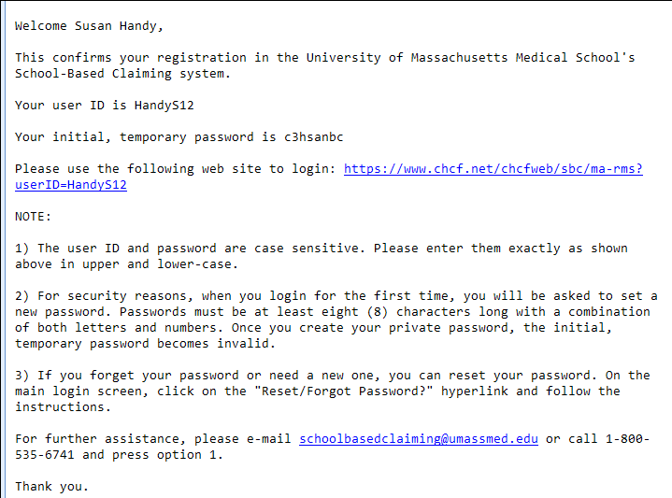

Step 2: Click on the link provided in the email notification www.chcf.net/chcfweb/sbc/ma-rms/.

Step 3: When clicking on the link, the designated User ID, composed of parts of the user’s last and first name, will prepopulate in the User ID field. Note: The User ID is only prepopulated when the website link is used. If the link was not used, the user must type in his/her User ID.

Step 4: Type in or copy and paste your temporary password. Click “Login.”

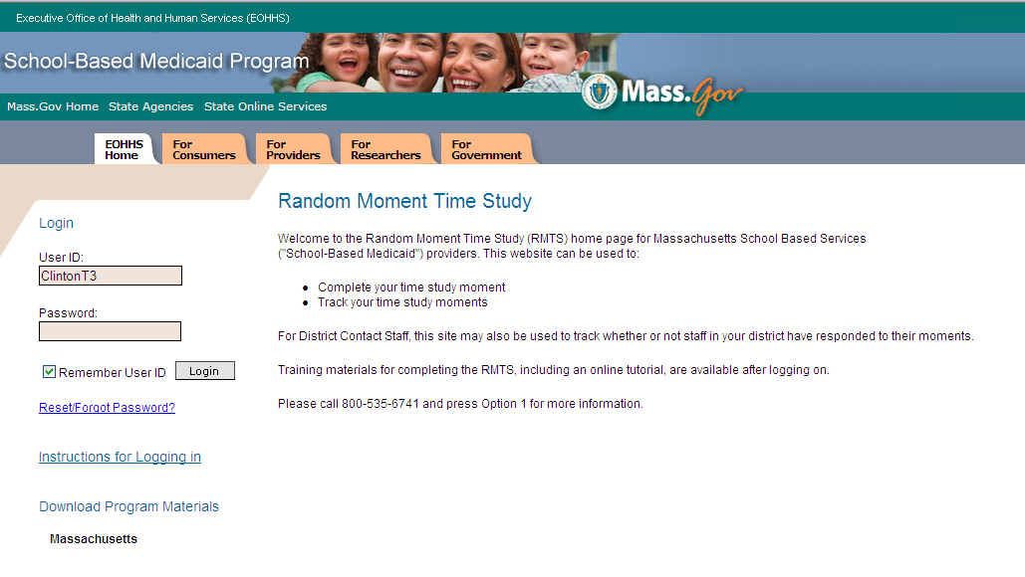

Step 5: Read the Non-UMMS User Data Access Agreement form and check the box ‘I accept the terms and conditions of this agreement.’

Create and enter a new password in the box to the right of “New Password.” Click “Clear” to clear the field and retype the password. Verify the password by entering it a second time in the box to the right of “Confirm Password.” Click “Save.”

- NOTE: Passwords must be a minimum of eight characters, must contain at least one uppercase, one lowercase, and one numerical value. In addition, you cannot repeat previously used passwords.

Passwords will expire every 90 days, at which time the system will prompt the user to create a new one when logging in.

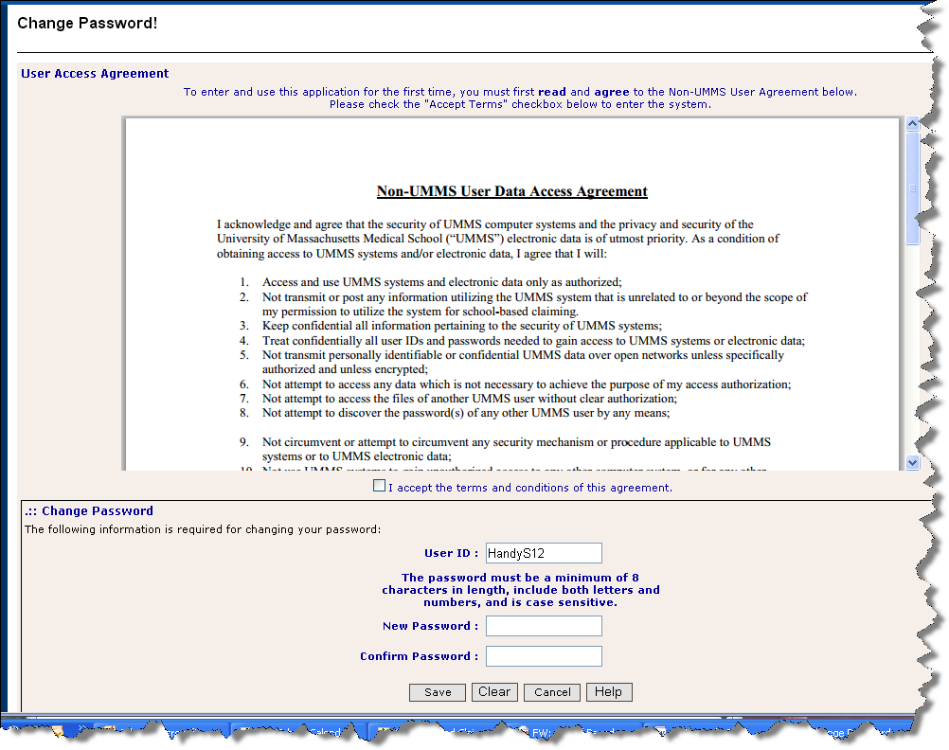

The time study page will then appear on the screen.

Reset/Forgot Password

If the participant has forgotten his/her password, he/she may reset their password using the login screen. To do this, see below.

Step 1: Click on the “Reset/Forgot Password?” link underneath the User ID and password section.

Step 2: Provide the User ID and the email address that the RMTS system has on record. (Note: If your email address has changed, email UMMS at schoolbasedclaiming@umassmed.edu or call (800) 535-6741, option 1, to update your information.)

Step 3: Click “Reset.”

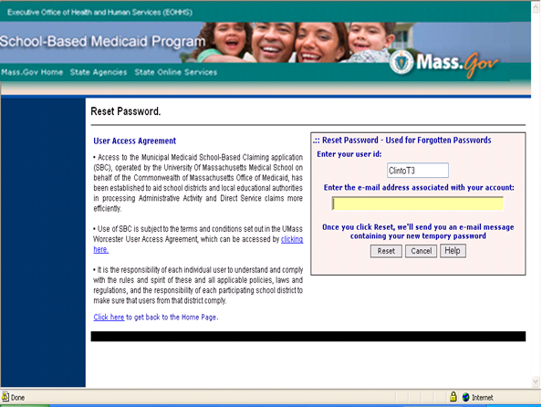
Must know User ID.
Enter email address. Click “Reset.”

A message stating that the password has been successfully reset will appear on the screen.
A system-generated email will be sent with the same User ID and a new temporary password.

Note: You must know your User ID to reset your password.

Failed Login

If an error was made when logging in, the system will display ‘Incorrect User ID or Password.’ The participant may try again to enter his/her User ID and password. After three failed attempts, the system will suspend the password. Email UMMS at schoolbasedclaiming@umassmed.edu or call (800) 535-6741, option 1, for assistance.

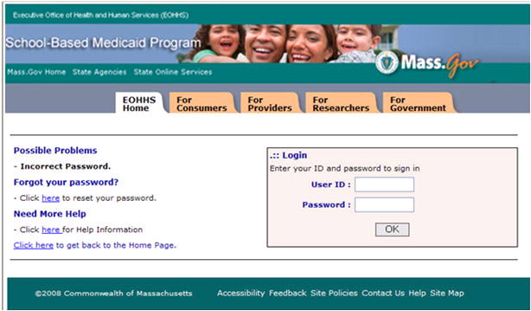

Notification and Recording of Moment

Step 1: The participant will receive an email from schoolbasedclaiming@umassmed.edu indicating the date and time of his/her moment. This email will be sent at the time of the moment.

Sample Email Text

^{Welcome Smith James,}

As indicated through prior emails, you have been selected to participate in the Massachusetts Random Moment Time Study for ABC School District.

If you have already completed your sample moment, thank you!

If you have not, it is essential that you now take the time to click on the link below and document your activity. This will ensure that your county receives the proper Medicaid reimbursement.

Your sample moment in time occurs at 03/02/2009 10:27 AM. Once your moment is 'active' you will have 120 hours to document your time.

https://www.chcf.net/chcfweb/sbc/ma-rms?userID=SmithJ

Note: Your User ID, SmithJ, will be pre-populated, but you will need your password to access your form. Click on the 'Forgot Password?' link on the site if you need to have your password reset.

If you have already completed your moment, you may verify or edit your entry by logging in, and clicking 'Prior Moments'.

Thank you for your time and dedication to this important revenue-generating program for your school district.
For further assistance, please email SchoolBasedClaiming@umassmed.edu or call 1-800-535-6741 and press option 1.

Step 2: The participant will log in and click on the link for the moment.

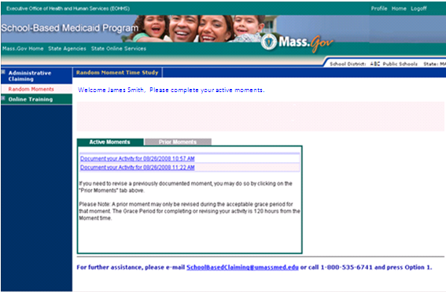

Step 3: The participant will click on “Answer the Question.”

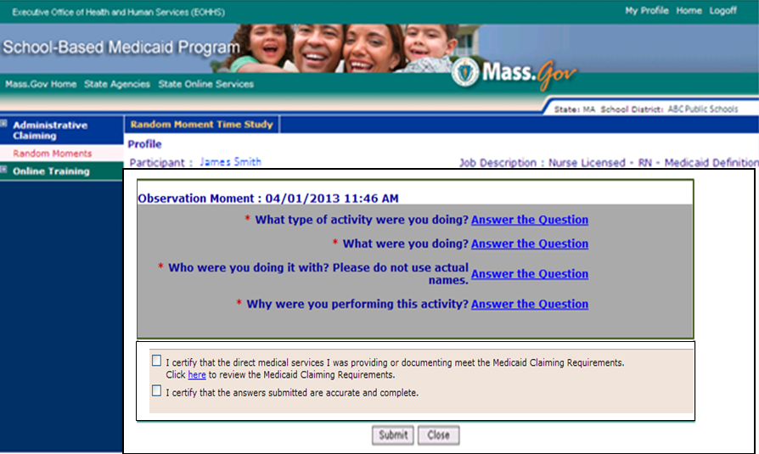

Step 4: The participant will click on the appropriate answer to each question or select “Other” to be able to free-type answers to the subsequent questions. Then click “Save.” Repeat this process for the remaining three questions.

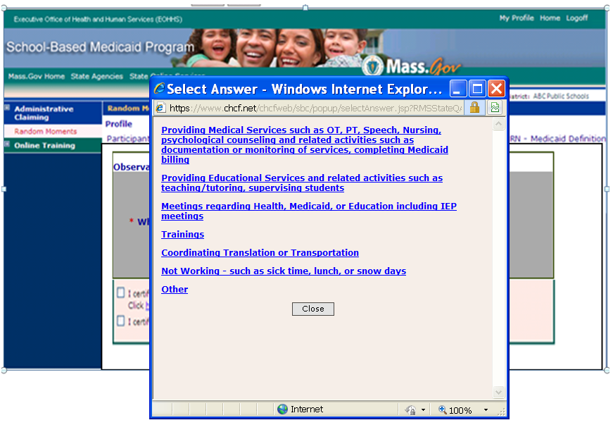

Step 5: Certifications and submission of moment responses: When all four questions have been completed, the responses will appear below each question. Below the questions and responses are two certification check boxes.

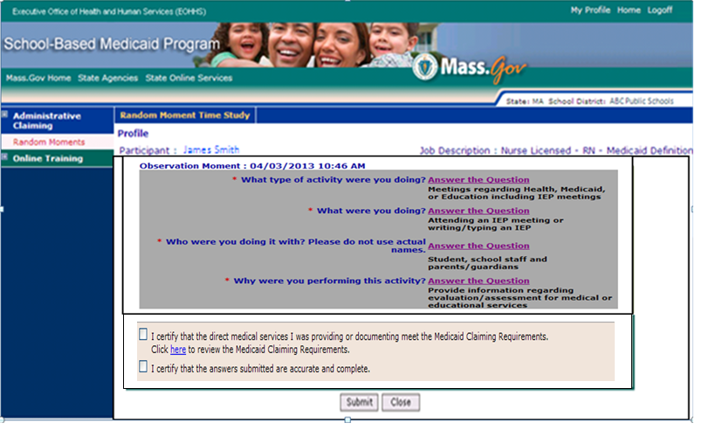

The first box states, ‘I certify that the direct medical services I was providing or documenting meet the Medicaid Claiming Requirements. Click ‘here’ to review the Medicaid Claiming Requirements.’ By checking the box, the participant is indicating three things.

1. He/she is a Medicaid-Defined provider with the required qualifications and supervision.
2. He/she was preparing for, providing, or documenting Medicaid-covered services such as OT, PT, SLT, Nursing, or Counseling.
3. The student has the service provided/documented in his/her IEP.

NOTE: It does not matter if the student is Medicaid-eligible or not.

If the requirements have been met, click the box next to ‘I certify that the direct medical services I was providing or documenting meet the Medicaid Claiming Requirements.’ Do not click the box if the services did not meet the Medicaid Claiming Requirements.

There is more detail in the first box for your information. To access this chart to view more detail about the certification requirements, you may click on the ‘here’ in the statement: Click ‘here’ to review the Medicaid Claiming Requirements.

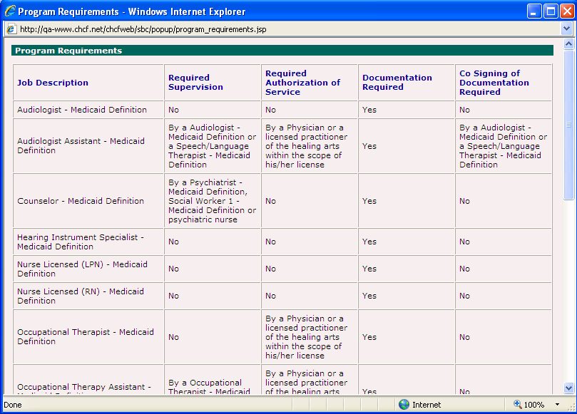

The second box to be checked asks the participant to confirm the accuracy of his/her responses.

Click the box, ‘certify that the answers submitted are accurate and complete.’ When the checkmark appears, click ‘Submit.’

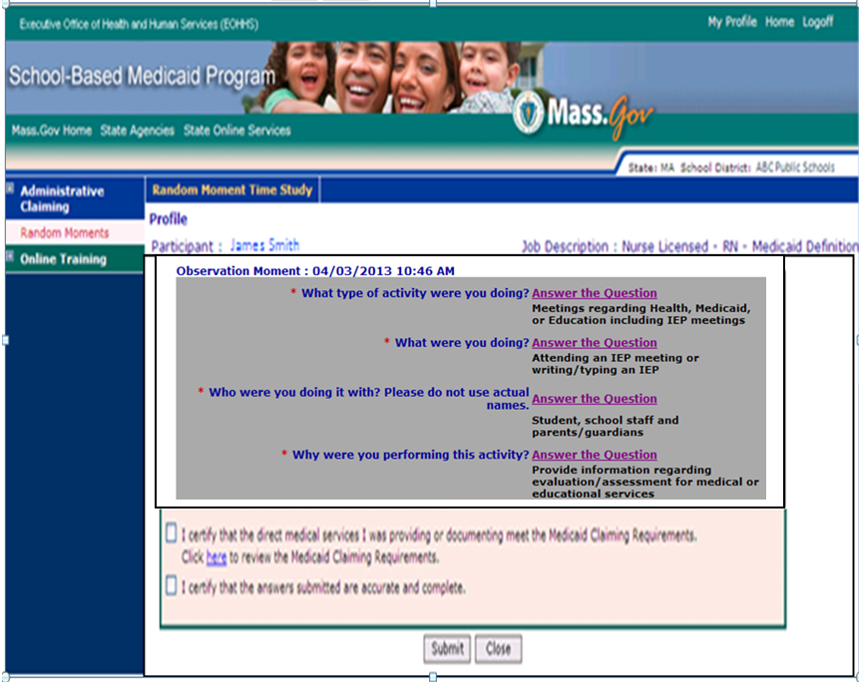

If the participant does not click the certification box, the following message will appear.

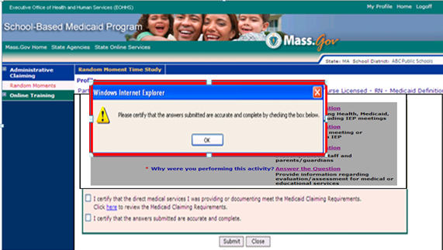

Step 6: To review or edit the response once it has been submitted, click on “Prior Moments,” then click on the date and time to review or edit. The participant will be returned to the screen displaying his/her answers.

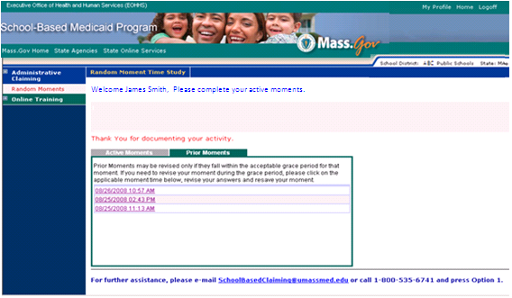

Step 7: If the grace period has not ended, the data may be changed by clicking ‘Answer the Question’ and selecting a different option. Then click the boxes at the bottom to certify answers.

NOTE: After the grace period has ended, the data may be viewed but not changed. A grace period is equal to five calendar days (120 hours).

Step 8: If the participant does not complete the moment, email reminders will be sent automatically from schoolbasedclaiming@umassmed.edu.

Sample Email Text

^{Welcome James Smith,}

Recently, you were selected to participate in the Random Moment Time Study for ABC School District, but our record indicates that you have not yet recorded your assigned moment.

Your participation is an important part of the Medicaid reimbursement for your district. Please complete your sample moment which occurred on 05/08/2009 02:55 PM before it expires.

Simply click on the link below and record your activity for the assigned time: http://www.chcf.net/chcfweb/sbc/ma-rms?userID=SmithJ.

^{Your UserID is SmithJ.}

Thank you for your attention and commitment to this important revenue-generating program for your school.

For further assistance, please email SchoolBasedClaiming@umassmed.edu or call 1-800-535-6741 and press option 1.

Participation Requirements and Monitoring Compliance

Participation is crucial to the accuracy of the RMTS results. A statewide compliance rate of 85% per RMTS pool per quarter has been set by CMS. If the statewide participation rate is not met, a statewide penalty will be applied. The penalty is that nonreimbursable time will be added to the time-study results for all non-responses. This will negatively impact federal reimbursement for both Administrative Activity Claiming (AAC) and Direct Service Claiming (DSC) statewide. Throughout the quarter, UMMS will monitor compliance across the state. However, the RMTS manager designee for each provider is also required to monitor compliance for his/her time-study participants.

Every provider whose response rate is lower than 85% in either RMTS pool in a given quarter will receive a notification letter. If the statewide response rate for either RMTS pool does not reach 85% in a given quarter, providers who received a notification letter within the last two years and whose response rate was lower than 85% in that quarter will be unable to claim reimbursement for that quarter. The Executive Office of Health and Human Services reserves the right to grant exceptions to this rule on claiming prohibitions for individual providers in instances of extreme unforeseen circumstances, such as a natural disaster, on a case-by-case basis.

A series of management reports are available to monitor participation. All reports are real-time and are accessible by each the RMTS manager designee. Sample reports have been provided in the appendix. Each report is described in detail below.

All moments have a status. This indicates where the moment is in the process. These statuses are displayed on multiple reports. The RMTS manager designee provider should closely monitor any participants with a status of “Incomplete” and follow up with such participants prior to the end of the grace period. Below are status terms used in the RMTS by UMMS.

Incomplete: The moment is in the future or the time study participant has not answered the questions and the grace period has not ended.

Incomplete Expired: The time study participant has not answered the questions and the grace period is over.

Manual Incomplete: The time study participant has answered the questions and a coder has not reviewed the answers.

Automapped: The time study participant has answered the questions and the system has assigned an activity code.

Pending 1, 2 & 3: The coder has reviewed the time study participant’s answers but needs additional information to code the response accurately.

First Approval: One coder has reviewed the time study participant’s answers and assigned an activity code to the moment and a second coder has not yet reviewed the assigned code.

Approved: The second coder has reviewed the time study participant’s answers and approved the activity code assigned by the first coder.

Not Paid Time: The time study participant has indicated that he/she was not scheduled to work at the time of his/her moment.

RMTS Management Reports

- RMTS Participant Moment by Date Report: This report lists all moments for the current date range within the quarter by the individual provider. It allows the RMTS manager designee to monitor the status of moments during a specified time and would be used to send reminders to time-study participants. It includes the time-study participant’s name, employee ID number, job description, job code, email, school district, school (if available), the date and time of the moment, the date and time of the end of the grace period, and the status of the moment.

- RMTS Incomplete Moments Report: This report lists details of moments the time-study participant has not completed. It allows RMTS manager designee to know which time-study participants have not answered the questions for their assigned moment so they can send additional reminders. It includes the time-study participant’s name, employee ID number, job description, job code, email, school district, school (if available), the date and time of the moment, the date and time of the end of the grace period, and the status of the moment.

- RMTS Participant Moments Completed Report: This report lists details of moments the time-study participant has completed. It allows RMTS manager designee time study coordinators to know which time-study participants have successfully answered the questions for their assigned moment in a timely fashion. It includes the time-study participant’s name, employee ID number, job description, job code, email, school district, school, if available, the date and time of the moment, the date and time of the end of the grace period, and the status of the moment.

- RMTS Compliance Report: This report shows details of how many moments each RMTS pool has during the quarter and how many are completed. It allows Time Study Coordinators to monitor in aggregate how many moments have occurred, how many are completed, and the percentage of completed moments to total quarterly moments. For each RMTS pool it includes total number of moments for quarter, number of moments occurred to date, number of moments completed to date, number of moments not completed and expired, number of moments not completed and not expired, and number of moments completed to date/total number of moments for quarter.

The following steps outline the process for accessing and using the management reports.

Step 1: Click on “Reports” in the left navigation bar.

Step 2: Click on the name of the report to view or print.

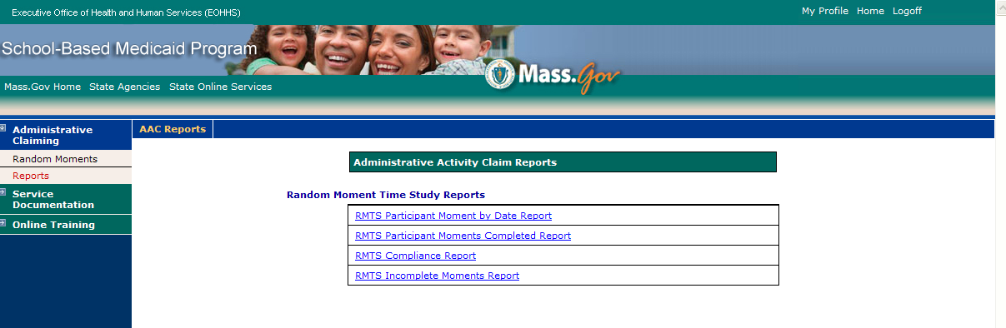

Step 3: Complete the fields below. Then click ‘View as Excel’. Note: The system defaults to the current quarter and year.

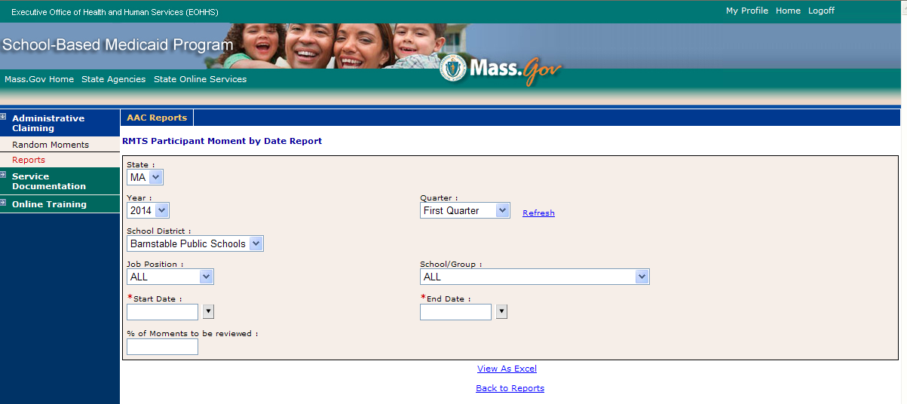

Technical Notes/System Requirements
Workstation Requirements

Operating Systems
Win 98 or higher
Macintosh

Web Browsers
Internet Explorer 5.0 – 11.0 with MS Windows XP, Windows 7, or Vista
Safari 3.0 or Higher
Mozilla Firefox 2.0 or Higher
Note: Internet Explorer web browser is not supported on Macintosh operating system. Safari should be used instead of IE.

Cookies
Workstations: Enable cookie in browser.
See “Instructions for Finding your Browser/Enabling Cookies”

Web Filters
Workstations should allow access to the following URL.
Production Secure connection: www.chcf.net/chcfweb/ and cbe-rmts.chcf-umms.org/

Email
Email should allow delivery from SchoolBasedClaiming@umassmed.edu in large quantities on a single day.

Instructions for Online Training Application
Flash Player is needed to run the Instructions for the online training program. The link www.adobe.com/software/flash/about/ has a connection to Player Download Center, which will walk you through the process of downloading the most recent version of Player. It takes about two minutes.
MP4 files can be opened with Windows Media Player and other multiformat media players, such as VLC, QuickTime.

System Administration Requirements

Cookies
System administrator: If there is a proxy server, set proxy NOT to cache the www.chcf.net domain.

Actual Website URL
www.chcf.net/chcfweb and cbe-rmts.chcf-umms.org/
Note: www.chcf.net cookies (sessions) are tied to the URL and IP address.

Routers
If SBC IP address needs to be explicitly defined on routers, SBC IP address is 146.189.217.25, 146.189.217.92
and 146.189.217.21

Email
Email servers should allow email delivery from SchoolBasedClaiming@umassmed.edu.

Email server IP – emails may be sent through the following mail gateways.

146.189.195.117
146.189.195.118
146.189.144.105
146.189.144.106
146.189.144.107
146.189.144.147
146.189.144.148
146.189.144.149

Web Filters

Allow access to the following URL.
Production Site Secure Connection: www.chcf.net/chcfweb/ and cbe-rmts.chcf-umms.org/.

Instructions for Finding Your Browser/Enabling Cookies
Internet Explorer
1. Choose Help > About Internet Explorer
2. Find out Internet Explorer version

Safari
1. Choose Help
2. Find out Safari version

Mozilla Firefox
1. Choose Help
2. Find out Mozilla version

Enabling Cookies
Internet Explorer 6 - 11
1. Choose Tools > Internet Options
2. Click the Privacy tab
3. Click the Default and choose Medium level
Internet Explorer 5
1. Choose Tools > Internet Options
2. Click the Security tab
3. Click Internet, then Default Level
4. Select Medium Level
Mozilla Firefox
1. Choose Tools > Options
2. Select Privacy
3. Click Accept cookies from sites

Download Internet Browser

Use the following websites to download a free copy of the latest browser.

Internet Explorer
www.microsoft.com/windows/ie/worldwide/ie6sp1downloads.asp

Apple’s Safari Browser
www.apple.com/safari/download/

Mozilla Firefox
www.mozilla.com/en-US/products/firefox

Appendix: Sample Reports and Designee Form

Time Study Designee Form

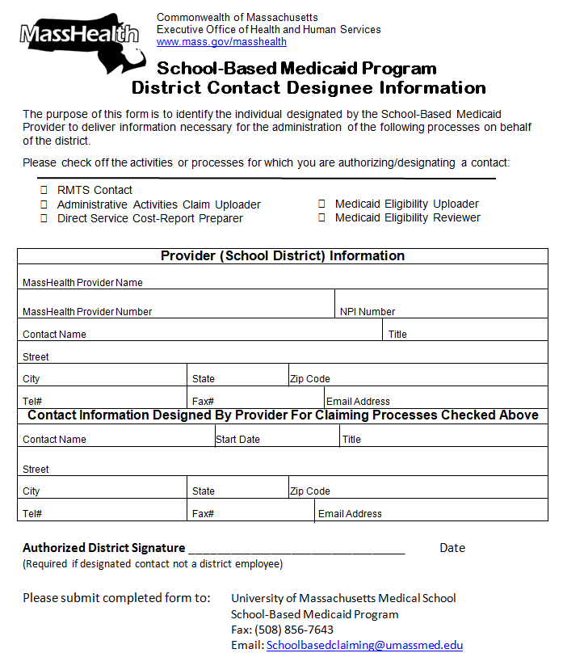

On-line Training Management Reports

These reports can be founded under the On-line Training tab, Training Summary.

Training Documents Viewed Report

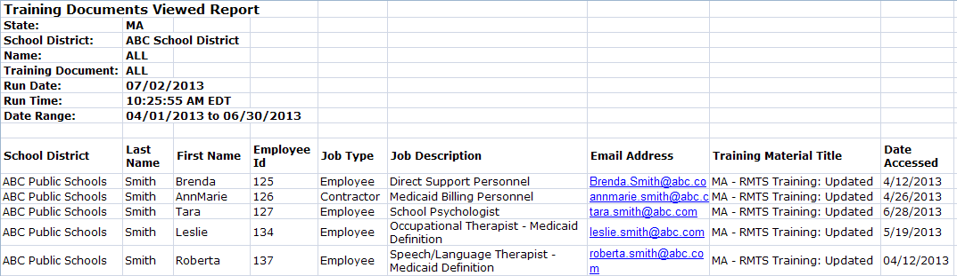

Training Documents Not Viewed Report

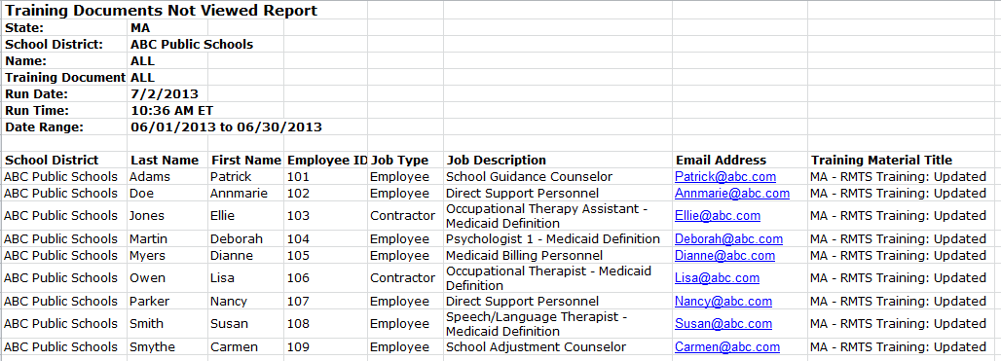

RMTS Management Reports

RMTS Incomplete Moments Report

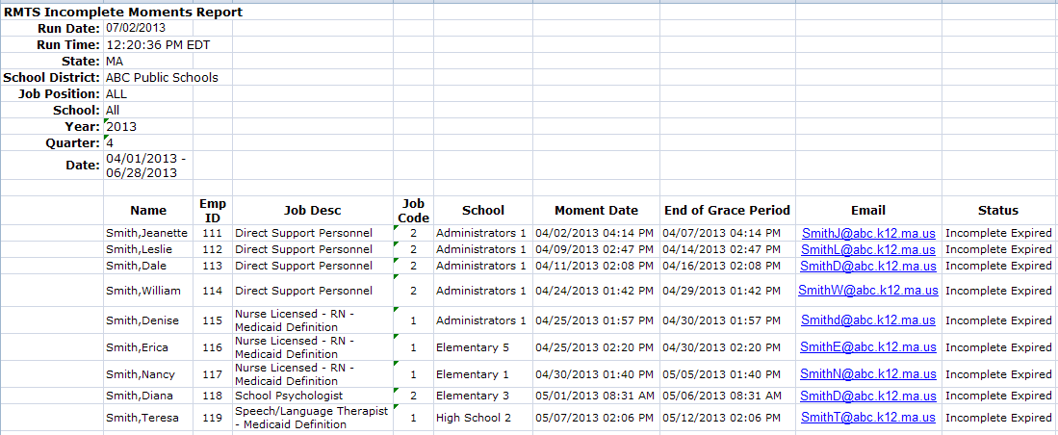

RMTS Participant Moments Completed Report

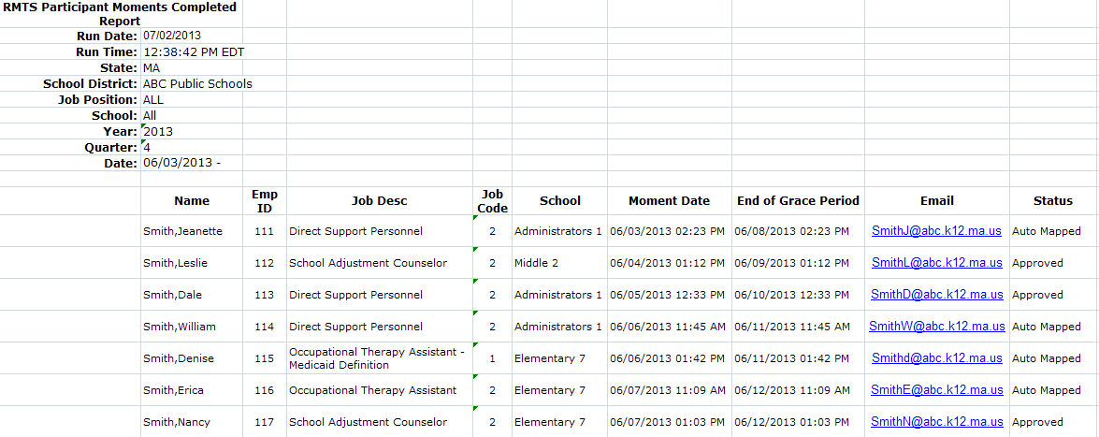

RMTS Compliance Report



