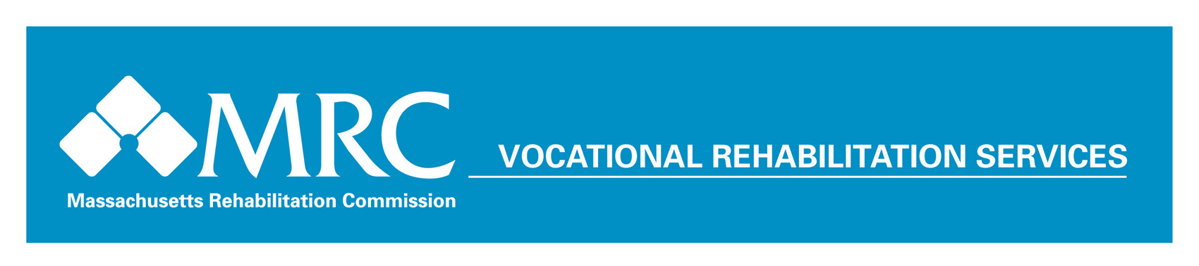
Economic Impact Fact Sheet
Return on Investment (ROI) July 1, 2016 – June 30, 2017
Massachusetts Rehabilitation Commission – Vocational Rehabilitation Program
Individuals with disabilities successfully placed into competitive employment: 3,973
Average hourly wage for employed consumers: $14.11
Average work hours per week for employed consumers: 26.74
Total annual earnings for consumers placed into employment: $77,948,960
Estimated public benefits savings from employed consumers: $29,797,500
Projected annual Massachusetts income tax paid by employed consumers: $2,688,741
Projected annual Federal income tax paid by employed consumers: $5,272,041
Consumers placed into employment with medical insurance: 96.6%
Return to society based on increase in lifetime earnings for
consumers placed into employment, FY2017*: $1,023,909,731

Return to society based on returns to government in the form
of increased taxes and reduced public assistance payments, FY2017**: $365,682,047

*Based on Commonwealth Corporation Study on ROI that $14 is returned to society based on increases in lifetime earnings for each $1 invested in the MRC Vocational Rehabilitation program.
**Based on Commonwealth Corporation Study on ROI that $5 is returned to the government for each $1 invested in the MRC Vocational Rehabilitation program.

Massachusetts Rehabilitation Commission

The Massachusetts Rehabilitation Commission (MRC) promotes equality, empowerment, and independence of individuals with disabilities. These goals are achieved through enhancing and encouraging personal choice and the right to succeed in the pursuit of independence and employment in the community.

The MRC provides comprehensive services to people with disabilities that maximize their quality of life and economic self-sufficiency in the community.

