CHAPTER 3
Environmental Health

Environmental Health
This chapter provides an overview of several environmental health issues in Massachusetts and related trends, disparities, and resources. It addresses the following environmental topic areas that affect the health of residents:

- Environmental Exposures
- Childhood Lead Exposure
- Climate and Health

- Environmental Justice Populations and Health
- Occupational Exposures and Disease

- Selected Resources, Programs, and Services
Chapter Data Highlights
- High rates of childhood lead exposure due to old housing stock with greatest risk among low-income and populations of color
- Temperatures rising due to climate change and expected to impact children, elderly, disabled, homeless, and low-income residents the most
- Poor health outcomes are more common in Environmental Justice populations
- Rates of mesothelioma are higher in Massachusetts than in the US

Overview
Environmental health risks can come from exposure to contaminants in air, water, soil, and food as well as workplace hazardous chemicals. MDPH reduces and prevents environmentally-related risks by tracking and evaluating potential exposure pathways and disease, and supports policies and programs to reduce exposure to environmental hazards and provide communities with healthier environments.
In Massachusetts, some populations are affected more than others by environmental exposures and associated health problems. These populations include:
- Younger or older individuals and those with pre-existing respiratory and cardiovascular diseases who may be more susceptible to health problems linked with environmental risk factors
- Individuals who live close to sources of environmental contamination
- Individuals who work with hazardous chemicals
- Individuals with higher exposures to air pollution and higher prevalence of social stressors (e.g., poverty, violence) may also be more susceptible to the health impacts of environmental contaminants.
Through collaborations with local health departments, community partners, and others, MDPH manages health and environmental information to identify opportunities for prevention and to reduce environmental exposures that can lead to health disparities and health inequities.

Environmental Exposures
Environmental exposure includes results from contact with physical, chemical, biological, and radiological substances. Many factors are important in determining whether environmental exposures can lead to health risks. These include:
- The amount of exposure
- Whether individuals are exposed through eating, drinking, breathing, or touching a substance
- Whether the type of substance can cause harm

Public Health Fish Advisories
Due to pollution, eating fish from Massachusetts streams, rivers, lakes, ponds, and some coastal waters may cause possible health risks. Developing fetuses, nursing infants, children less than 12 years of age, pregnant women, nursing mothers and women who may become pregnant are at highest risk.
The Massachusetts Department of Environmental Protection (MassDEP) collects and analyzes fish from fresh bodies of water annually and provides the data to MDPH for evaluation. MDPH reviews the samples for chemicals to provide guidance on safety for consumption.

Trends/Disparities
Since the early 1980s, MDPH has issued more than 200 waterbody-specific fish advisories. Most of the advisories resulted from elevated levels of mercury. Other chemicals detected include polychlorinated biphenyls (PCBs) and the pesticides dichlorodiphenyltrichloroethane (DDT) and chlordane.
MDPH has identified public health fish advisories by Environmental Justice (EJ) areas where Black, Asian and Hispanic populations and/or non-English speaking and/or low-income populations are more prevalent. Greater health risks from consuming contaminated fish occur more often in EJ areas because residents often depend on locally-caught fish as a regular part of their diet.
Many urban rivers have advisories that recommend limiting or refraining from all fish consumption from these sources. Areas safe for fishing (e.g., in more rural areas) may be difficult to get to for individuals with limited transportation options or income.

Ambient Air Quality
Exposure to ambient (or outdoor) air pollution has been linked to a wide range of cardiovascular and respiratory health problems. Higher, short-term exposure to air pollutants is associated with asthma attacks and increased hospital admissions. Long-term impacts of exposure to air pollutants include decreased lung function, increased sensitivity to asthma triggers, and increased susceptibility to infections, cardiovascular harm, and premature death. ,
Under the Clean Air Act, the US Environmental Protection Agency (EPA) sets National Ambient Air Quality Standards (NAAQS) for pollutants to limit concentrations in ambient air. Ozone is one important measure of air quality in Massachusetts. Ground–level ozone is a gas created when pollutants from cars and power plants react with each other in the presence of heat and sunlight. Ozone formation is weather dependent, and levels are typically higher during the summer.

Trends/Disparities
From 2005 to 2015, Massachusetts experienced a 21% decrease in ozone levels. Figure 3.1 shows the number of days in Massachusetts where ozone levels exceeded the 2008 ozone standard of 0.075 parts per million (ppm), from 2005 to 2015. (The NAAQS for ozone was revised to 0.070 ppm in December 2015.)
- The numbers of days when ambient ozone concentrations have exceeded the NAAQS has decreased in Massachusetts over time (131 days in 2005 and 7 days in 2015) (see Figure 3.1).
- Climate change models predict that by 2050, the increase in temperature will contribute up to seven parts per billion (ppb) of ozone pollution above summer daily averages.
- MDPH estimates an average 4.75% increase in emergency room visits in Massachusetts in 2050 compared to 2011 (approximately 2,150 additional visits) for a seven ppb increase in ozone.

Figure 3.1
Trends in Ozone, Massachusetts, 2005-2015

NOTE: OZONE DATA FOR DAYS OVER THE NAAQS ARE MEASURED BY AIR MONITORS. MONITORS ARE NOT PRESENT IN ALL COUNTIES. STATEWIDE AMBIENT OZONE CONCENTRATIONS HAVE DECREASED OVER TIME. ABOVE AVERAGE TEMPERATURES AND BELOW AVERAGE HUMIDITY IN 2012 CONTRIBUTED TO INCREASED NUMBER OF DAYS OBSERVED WHERE OZONE LEVELS EXCEED THE NAAQS. IN 2014, THERE WERE NO DAYS WHERE OZONE LEVELS WERE MORE THAN THE NAAQS IN COUNTIES WHERE MONITORS WERE PRESENT. THE TRENDLINE SHOULD NOT BE USED FOR ASSESSING NAAQS ATTAINMENT. METHODS FOR CALCULATING ANNUAL TRENDS CAN BE FOUND ON THE MA EPHT PORTAL.
The potential public health impact of ozone exposure is due to its role in making existing asthma worse, resulting in increased emergency department visits and hospitalizations.
- Massachusetts has one of the highest rates of asthma in the United States. The prevalence in 2015 was 10.2% versus a national prevalence of 9.2% for individuals reporting that they currently have asthma. The prevalence in Massachusetts children was 12.9% in 2015.
- Adults age 65 years and older have the second highest rate of hospitalization due to asthma.
- Black non-Hispanics and Hispanics consistently have had significantly higher age-adjusted rates of hospitalization due to asthma than White non-Hispanics.
- Children younger than five years of age have had the highest rates of emergency department visits, outpatient observation stays, and hospitalization due to asthma.
Exposure to air pollutants often varies geographically. The consequence of different exposures to sources of air pollutants is that health risks associated with environmental factors can be heightened for Black, Hispanic and Asian families with lower income levels as well as for children, the elderly, and people with pre-existing heart or lung diseases. For example:
- Power plants that emit gases like nitrogen oxide are typically located in lower income communities.
- Proximity to traffic and living in urban areas have been shown to contribute to both increased ozone exposure and asthma.
- Adults with asthma living near roads with heavy traffic are at increased risk for hospitalization for asthma attacks and lung cancer.
- Individuals who rely on open windows for cooling during summer months are at greater risk for adverse health impacts than those with air conditioning.
- People working or exercising outside breathe more deeply, resulting in ambient air pollutants penetrating deeper into the respiratory tract.

Recreational Water Quality
Swimming at Massachusetts beaches is one of the most popular and low-cost recreational activities in the Commonwealth. Swimming and beach-related activities can improve overall physical, mental, and social well-being. However, swimming in polluted water can lead to illnesses such as fever, gastrointestinal distress, skin problems, and ear, nose, throat irritation or infections. Good water quality is important for public health, especially for those most vulnerable, such as the young, sick, and elderly.
Testing recreational water quality is important to help reduce the number of swimming-associated illnesses. Massachusetts beaches are required to be tested for fecal indicator bacteria (FIB) and are closed if these levels exceed water quality standards. FIB levels and closures are required to be reported to MDPH.

Trends/Disparities
In 2016, 3% of freshwater and 3.5% of marine beach samples in Massachusetts exceeded FIB regulatory levels. Exceeding FIB standards is often associated with rainfall, reflecting the impact of land-based pollution (e.g., dog waste, bird droppings) and sewage. In 2016, FIB levels and/or unsafe conditions such as rip tides, shark sightings, and harmful algae blooms required the closing of beaches on 274 occasions. In 2016, the highest number of FIB exceedances at marine beaches occurred in three cities in the greater Boston metropolitan area: Boston, Lynn, and Quincy as shown in Figures 3.2 and 3.3.
In 2016, the number of freshwater beaches that exceeded the FIB standard varied among communities across the state with many communities having at least one beach that did not meet the standard. Overall, the highest number of FIB exceedances occurred in Brimfield, Templeton, and West Tisbury.
Figure 3.2
Number of Marine Fecal Indicator Bacteria (FIB) Exceedances, Massachusetts, 2016
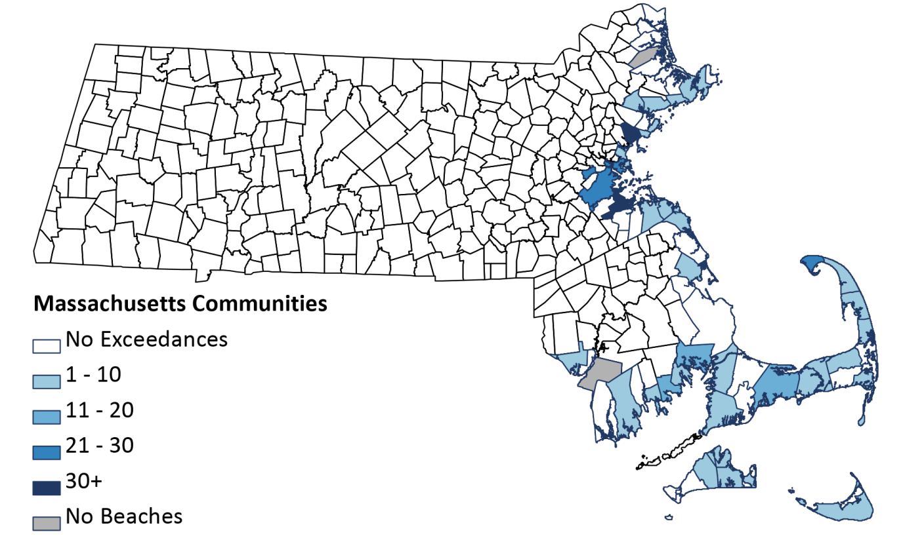

Figure 3.3
Number of Freshwater Fecal Indicator Bacteria (FIB)Exceedances, Massachusetts, 2016
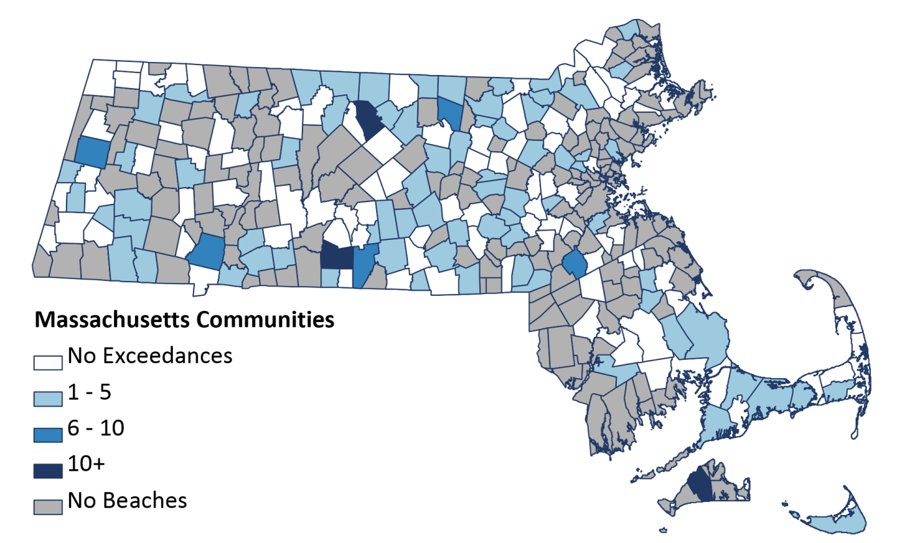

Public Drinking Water Quality
Approximately 93% of Massachusetts residents rely on public supplies for their drinking water. People can become exposed to contaminants in drinking water by drinking, eating foods prepared with water, breathing water droplets or chemicals released from the water while showering, and absorbing chemicals through the skin while bathing.
In Massachusetts, the MassDEP has statutory responsibility to oversee and implement federal and state Safe Drinking Water Act requirements. MDPH collaborates with MassDEP to assist communities in understanding the health risks associated with contaminants in drinking water. Health-based drinking water standards and guidelines exist for over 100 chemical, radiological, and biological substances.

Trends/Disparities
Massachusetts drinking water is generally considered high quality. However, a particular public water supply or private well may contain a contaminant(s) at a level above MassDEP’s standards or guidelines. Residents can obtain information on their particular drinking water source by visiting this linked website or by calling their local water department. Private well owners can obtain information on how to have their well water tested by visiting this website as well.

Childhood Lead Exposure
There is no safe level of exposure to lead and even relatively low levels of lead can cause severe and irreversible health effects, including damage to a child’s mental and physical development. , Numerous studies have documented correlations between childhood lead poisoning and future school performance, unemployment, crime, violence, and incarceration, making lead exposure an important social determinant of health. ,,,
While the Commonwealth has made substantial gains in mitigating the harmful effects of lead, lead exposure remains a significant health risk for children across the state. Massachusetts has the fourth oldest housing stock in the country: approximately 71% of the Commonwealth’s housing was built before 1978, the year lead was banned in residential paint. Children are most often exposed to lead through ingestion of dust or soil contaminated by loose or deteriorated lead paint, often on windows and exterior surfaces, or disturbed by unsafe renovations.
The Massachusetts Lead Law (see MGL c. 111, §§ 189A-199B and 105 CMR 460.000) is one of the nation’s most comprehensive for lead poisoning prevention by requiring the de-leading of any dwelling unit where a child under six years of age resides, regardless of a child’s blood lead level (BLL) or whether the property is owner-occupied. Massachusetts law requires that all children be tested for blood lead between nine and 12 months of age, again at two and three years of age, and also at age four in communities designated at high risk. MDPH’s Bureau of Environmental Health enforces the Commonwealth’s Lead Law and collects and analyzes data based on childhood blood lead screening and environmental housing records.

Trends/ Disparities
Blood lead levels have historically declined across the Commonwealth. Blood lead levels at or above the CDC reference value (of 5 µg/dl) among children nine months to 4 years of age show a continued decrease since 2011.
- In 2016, the Massachusetts prevalence of childhood blood lead levels at or above the CDC reference value (of 5 µg/dL) was 2%.
- Lead screening data from 2016 indicate that 3,500 children in Massachusetts may have blood lead levels ≥ 5 µg/dL. Of those 3,500 children, 651 had blood lead levels prompting immediate MDPH response, case management services ,(blood lead levels ≥ 10 µg/dL) and 57 children were identified having blood lead levels legally considered “lead poisoned” pursuant to current regulation (blood lead level of 25 µg/dL or greater).
In Massachusetts, the prevalence of blood lead screening among children nine months to four years of age has averaged 76% for the past six years as seen in Figure 3.4. Lead exposure impacts all areas of the Commonwealth, including rural and urban communities, but blood lead screening rates tend to be lower in some rural, central, and western areas of the state.
Figure 3.4
Massachusetts Blood Lead Screening Rate, Children Aged 9-47 months, 2003-2016

A wide geographic variation in childhood lead exposure exists across the state with some communities in western, central, and cape cod areas experiencing two or three times the state average prevalence of higher blood lead levels, as seen in Figure 3.5.
Data show a higher prevalence of childhood blood lead levels ≥ 5 $µ$g/dL in lower income communities and among Black, Asian non-Hispanic, and Hispanic children making lead exposure a critical health equity issue. In particular, Black non-Hispanic and American Indian populations are disproportionately impacted and have rates of high blood lead levels almost twice those of the White non-Hispanic population.
As seen in Figure 3.6, communities with a higher than average percentage of low- to moderate-income families have more than twice the percentage of blood lead levels at or above 5 µg/dL compared to communities with a lower percentage of low- to moderate-income families.
Figure 3.5
Massachusetts Prevalence of Confirmed Blood Lead Levels ≥ 5 µg/dL by Community,
among Children aged 9-47 months, 2016
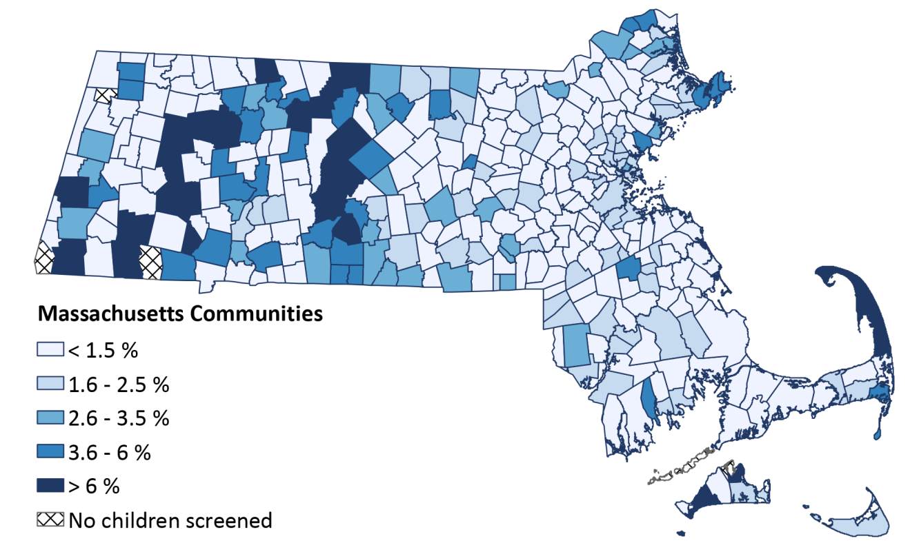

Figure 3.6
Massachusetts Community Prevalence of Childhood Blood Lead Levels ≥ 5 µg/dL by Percentage of Families with Low to Moderate Income, 2011-2015

SOURCE: MA CHILDHOOD LEAD POISONING PREVENTION PROGRAM AND US CENSUS BUREAU.
NOTES: 1. INCLUDES CONFIRMED BLOOD LEAD LEVELS (ONE VENOUS OR TWO CAPILLARY BLOOD SAMPLES ≥ 5 $µ$G/DL WITHIN 84 DAYS) AND A PROPORTION OF UNCONFIRMED TESTS BASED ON THE POSITIVE PREDICTIVE VALUE OF CAPILLARY TESTS ≥ 5 $µ$G/DL. 2. LOW TO MODERATE INCOME DEFINED AS LESS THAN 200% OF POVERTY USING POVERTY TO INCOME RATIO (PIR) FROM THE 2011-2015 AMERICAN COMMUNITY SURVEY OF THE US CENSUS BUREAU.

Climate and Health
Climate change is expected to adversely affect human health and welfare in Massachusetts due to increased heat, sea-level rise, increased intensity and frequency of rainfall, more intense storms, and degraded air and water quality.
Massachusetts is one of the first states in the country to recognize the importance of implementing strategies to mitigate and prepare for the potential impacts of climate change. Strategies intended to reduce the impact of climate can also address the need to reduce health disparities and increase community resilience. For example, emission control strategies to reduce greenhouse gas emissions required by Governor Baker’s 2016 Executive Order Establishing an Integrated Climate Change Strategy for the Commonwealth may also reduce health impacts associated with exposure to ozone pollution. Tracking emissions, climate, and health data can help document changes over time and place, monitor vulnerable populations, and evaluate the results of local climate-adaptation strategies.

Heat Stress
The Northeast region of the US is especially vulnerable to the impacts of extreme summer temperatures due to urbanization “heat islands”, low air conditioner prevalence, and substantial numbers of elderly residents. Heat stress increases the risk of a range of potential adverse health outcomes, including dehydration, heat cramps, heat exhaustion, and heat stroke/sunstroke and can cause adverse effects in people with existing chronic conditions, including cardiovascular disease, diabetes, and obesity.
Many adverse heat outcomes can be prevented through planning, preparation, and education. MDPH’s collaboration with local and state health departments and its role in emergency preparedness can help reduce health impacts during heat events by notifying the public of steps they can take to reduce exposure and by opening cooling centers.,,,,,

Trends/Disparities
Emergency department visits and hospitalization rates for heat stress in Massachusetts include all cases where heat stress was explicitly listed. However, heat stress may not be listed as the primary diagnosis for some heat-related hospitalizations such as increased hospital admissions for cardiovascular, kidney, and respiratory disorders.
- In 2012, there were 13.1 emergency department visits for heat stress per 100,000 population (95% confidence interval: 12.2-13.9 per 100,000 population) and 1.4 hospital admissions per 100,000 population (95% confidence interval: 1.2-1.7 per 100,000 population).
- As shown in Figure 3.7, it is estimated that the projected number of days with temperatures above 90 degrees fahrenheit across most of Massachusetts will double from 2020 to 2050.
- Some residents are more susceptible to heat impacts due to socioeconomic status, health, age, or geographic location. The most vulnerable groups are children, elderly living alone, persons with a disability, low-income residents, homeless individuals, and persons living in urban areas with higher exposures to heat.
- Communities of color, lower socioeconomic populations , and homeless populations are more likely to have limited adaptive capacity to address heat-related impacts. This may be due to various factors such as lack of access to emergency health care and cooling centers.
Figure 3.7
Projected Number of Days Over 90 Degrees Fahrenheit in Counties in Massachusetts, 2020 and 2050

SOURCE: NATIONAL ENVIRONMENTAL PUBLIC HEALTH TRACKING PORTAL; HIGH EMISSION SCENARIO

Environmental Justice Populations and Health
According to the Environmental Justice (EJ) Policy of the Massachusetts Executive Office of Energy and Environmental Affairs (EEA), environmental justice is based on the principle that all people have a right to be protected from environmental pollution and to live in and enjoy a clean and healthful environment regardless of race, ethnicity, income, national origin or English language proficiency.

Trends/Disparities
Minority and low-income populations are more likely to live in close proximity to contaminated and abandoned sites, regulated facilities, and sources of pollution. The Massachusetts EEA EJ Policy of 2002 was designed to build on federal environmental justice guidelines to reflect the needs and circumstances specific to Massachusetts. It targets EEA resources to service those high-minority/Hispanic ethnicity/low-income communities in Massachusetts where the residents are “most at risk of being unaware of or unable to participate in environmental, energy, or climate change decision-making.” These neighborhoods are defined as US Census block groups that meet one or more of the following criteria:
- The median annual household income is at or below 65% of the statewide median annual household income for Massachusetts.
- 25% or more of the residents are minority (US Census population of those who self-identify as Latino/Hispanic, Black/African-American, Asian, Indigenous people, or otherwise identify as non-White).
- 25% or more of the residents have English Isolation (US Census American Community Survey population of households where no adults speak English very well).
MDPH collaborates with EEA to identify existing health burdens among EJ populations. In 2017, EEA released a revised EJ Policy including the addition of four health criteria recommended by the MDPH Bureau of Environmental Health to identify Vulnerable Health EJ Populations: childhood asthma, low birth weight, childhood lead poisoning, and heart disease morbidity. Vulnerable Health EJ Populations are those that have evidence of higher than average rates of environmentally-related health outcomes, making them particularly vulnerable to adverse environmental exposures.
In comparing the prevalence of these health outcomes between EJ and non-EJ populations, the disparities are evident, as seen in Figure 3.8.
- While only 4% of non-EJ communities had a rate of childhood asthma emergency department (ED) visits greater than 110% of the state rate, 27% of EJ communities (those with at least one EJ block group), had a rate of asthma ED visits greater than 110% of the state rate (2009-2013).
- A high prevalence of children with elevated blood lead levels and an elevated rate of heart disease morbidity were both present in nearly double the proportion of EJ populations compared to non-EJ (42% v. 19% and 40% v. 22%, respectively).
- From 2010 to 2014, 49% of EJ block groups had a rate of low birth weight above 110% of the state rate, while 31% of non-EJ block groups had a rate of low birth weight above 110% of the state rate.

Occupational Exposures and Disease
Conditions in the workplace, including chemicals, may impact health. Workers may breathe in dust, fumes, and vapors or absorb them through the skin. Some of the chemicals can have short-lived acute health effects; other chemicals can have long-lasting health implications. Some chemical exposures can contribute to common chronic diseases, such as asthma, chronic obstructive pulmonary disease, lung and other cancers, and cardiovascular disease.
This section includes information about health outcomes associated with two chemicals that have long been recognized as workplace hazards that can have serious health effects: lead and asbestos.
Figure 3.8
Prevalence of Vulnerable Health Criteria in Massachusetts among Environmental Justice and non-Environmental Justice Populations, 2010-2014

NOTES: CHILDHOOD ASTHMA MEASURE DEFINED AS A FIVE-YEAR AVERAGE RATE OF EMERGENCY DEPARTMENT VISITS FOR CHILDHOOD ASTHMA GREATER THAN OR EQUAL TO 110% OF THE STATE RATE. LOW BIRTH WEIGHT MEASURE DEFINED AS A FIVE-YEAR AVERAGE RATE OF (FULL-TERM) LOW BIRTH WEIGHT ABOVE 110% OF THE STATE RATE. ELEVATED CHILDHOOD BLOOD LEAD MEASURE DEFINED AS A FIVE-YEAR AVERAGE PREVALENCE OF CONFIRMED ELEVATED BLOOD LEAD LEVELS (≥10µG/DL) GREATER THAN 110% OF THE STATE PREVALENCE. HEART DISEASE MORBIDITY MEASURE DEFINED AS A FIVE-YEAR AVERAGE AGE-ADJUSTED RATE OF HOSPITALIZATIONS FOR MYOCARDIAL INFARCTION GREATER THAN 110% OF THE STATE RATE. EJ POPULATIONS DEFINED AT THE BLOCK GROUP LEVEL FOR LOW BIRTH WEIGHT AND CHILDHOOD LEAD EXPOSURE MEASURES AND AT THE COMMUNITY LEVEL FOR CHILDHOOD ASTHMA AND HEART DISEASE MORBIDITY MEASURES. COMMUNITIES WITH AT LEAST ONE EJ BLOCK GROUP WERE DEFINED AS EJ COMMUNITIES.

Adult Lead Exposure
Lead can harm nearly every system in the body, even at levels previously thought to be safe. Exposure to lead in adults can cause anemia, nervous system dysfunction, high blood pressure, kidney damage, cognitive impairment, and adverse reproductive outcomes.,,,
The blood lead level (BLL) is the best biological indicator of recent lead exposure. Previously, a blood lead level of 25 micrograms per deciliter (µg/dL) or greater was considered by CDC as "elevated" for adults. This has recently been lowered to 5 µg/dL, the same as the CDC’s reference level for blood lead in children. Clinical laboratories in Massachusetts are required to report all adult blood lead test results electronically to the Massachusetts Occupational Lead Poisoning Registry in the Department of Labor Standards (DLS). Federal and state laws require employers to protect their employees from exposure to lead in the workplace. ,,,
Most adults with high BLL are exposed to lead at the workplace. Adults may also be exposed though other sources such as hobbies and at firing ranges. Lead on the job may be brought home and affect family members, including pregnant women and children less than six years of age who are at high risk.

Trends/Disparities
According to the Massachusetts Occupational Lead Poisoning Registry, from 2005 to 2014, for each of these years, on average, 154 adults were reported with blood lead levels ≥ 25 µg/dL.
- The prevalence of blood lead levels ≥ 25 µg/dL among adults in Massachusetts was significantly lower than that reported for the US in six of the last ten years (2005, 2007, 2008, 2010, 2012, and 2013).
- The prevalence of blood lead levels ≥ 25 µg/dL among adults both in Massachusetts and the nation has declined significantly since surveillance began in the early 1990s.

Figure 3.9
Prevalence of Elevated Blood Lead Levels (BLL ≥ 25 µg/dL) in Adults, by Year, US & Massachusetts, 2005 – 2014

SOURCES: NUMERATOR: MA: MA DEPARTMENT OF LABOR STANDARD'S OCCUPATIONAL LEAD POISONING REGISTRY, US: ADULT BLOOD LEAD EPIDEMIOLOGY SURVEILLANCE SYSTEM (ABLES). DENOMINATOR: ESTIMATES FOR THE NUMBER OF EMPLOYED ADULTS OBTAINED FROM THE GEOGRAPHIC PROGRAM (GP) AND LOCAL AREA UNEMPLOYMENT STATISTICS (LAUS), US BUREAU OF LABOR STATISTICS, AND US DEPARTMENT OF LABOR
NOTES: BASED ON MA RESIDENTS, AGED 16 AND OLDER; ANNUAL CRUDE RATE IS EXPRESSED PER 100,000 WORKERS. US RATES BASED ON THE NUMBER OF STATES REPORTING DATA TO NIOSH IN A GIVEN YEAR (AVERAGE # OF STATES REPORTING OVER THIS PERIOD WAS 39 STATES)

Other trends/disparities include:
- In Massachusetts, the largest numbers of workers with the highest blood lead levels (40 µg/dL) were employed in the construction industry, primarily as painters and de-leaders.
- Hispanic workers have been found to be over-represented among adults reported with elevated blood lead levels., From 2003-2009, the most recent time period for which data on ethnicity is available, Hispanic workers in Massachusetts accounted for 10% of cases with the highest blood lead levels (≥ 40 µg/dL), whereas Hispanic residents made up 6% of the Massachusetts workforce.
- Low-income residents, racial/ethnic minorities, and immigrants are often employed in more hazardous jobs with higher exposures to lead and other chemical, physical and psychosocial hazards.
- In addition to higher risks of being exposed to lead both at work and in the communities where they live, low-income, minority and immigrant workers may not have access to the resources, health and safety training, and benefits available through more secure employment and be unaware of their rights in the workplace. Poverty and economic insecurity contributes to these workers remaining in high-risk, low-paying jobs, increasing their risk for occupational injury and decreasing the likelihood that they will report these workplace hazards to their employers. Discrimination, or the fear of discrimination, among this population also deters them from speaking out about hazards in the workplace.,,,,

Asbestos-Related Disease
Exposure to asbestos most often occurs in occupational settings.,, Breathing in dust that contains asbestos can damage the lungs and other organs causing diseases such as mesothelioma, asbestosis, and lung cancer., Asbestos is the only well-established risk factor for mesothelioma, a usually fatal cancer of the lining of the lung and abdomen.

Trends/ Disparities
From 2005-2013, an average of 93 cases of mesothelioma was reported to MDPH each year, and the incidence rate of mesothelioma exceeded that for the nation for all but two years (2008 and 2011). There was a downward trend in the Massachusetts mesothelioma incidence rate over time, ranging from 19.4 cases per million in 2005 to 14.6 cases per million in 2013.
From 2005-2014, there was an average of 799 hospitalizations of individuals with a diagnosis of asbestosis each year, with a hospitalization rate that consistently exceeded the national rate. There has been a significant decline in hospitalizations from asbestosis in Massachusetts since 2007. Almost all of the individuals with mesothelioma or hospitalized with asbestosis were male and over 50 years of age.
In 2015, there were more than 23,000 registered asbestos removal projects in Massachusetts. Many of the workers potentially exposed to asbestos during abatement activities are foreign-born. A study of Cambodian asbestos abatement workers in Lowell found that they, like other recent arrivers, accepted jobs in hazardous industries, such as asbestos abatement, hazardous waste and other temporary employment. Discrimination and economic insecurity that make workers hesitant to speak up about workplace hazards may also contribute to disparities in occupational health risks.

Figure 3.10
Age-Standardized Rate of Hospitalizations from or with Asbestosis by Year, US & Massachusetts, 2005-2014
SOURCE: MA INPATIENT HOSPITAL DISCHARGE DATASET; NATIONAL CENTER FOR HEALTH STATISTICS' NATIONAL HOSPITAL DISCHARGE SURVEY (DISCONTINUED AFTER 2010); POPULATION ESTIMATES FROM US CENSUS
NOTE: RATES ARE AGE-ADJUSTED (STANDARDIZED) TO THE 2000 US STANDARD POPULATION AND EXPRESSED PER MILLION MA RESIDENTS 15 YEARS OR OLDER

Selected Resources, Programs, and Services
Following are selected resources, services and programs that support the topics discussed in this chapter.

Public Health Fish Advisories
- The MDPH fish advisory website provides guidance on the safe consumption of fish and information on fish advisories for specific waterbodies.
- Individuals can request testing of fish for contaminants in Massachusetts waterbodies.
Ambient Air Quality
- The MassDEP provides daily air quality and pollution forecasts to help Massachusetts’ residents understand current ambient air conditions and their health impacts.
Recreational Water Quality
- Local boards of health and the Massachusetts Department of Conservation and Recreation are required by law to regularly monitor beach water quality. The MDPH Beaches and Algae website provides daily updated information on fecal indicator bacteria levels and closures at marine beaches as well as historical test results.
Public Drinking Water Quality
- Consumer confidence reports (CCRs) are annual reports required by law and distributed to consumers by water suppliers. They contain information on the source of a community’s drinking water, the quality of the water, and compliance with state and federal drinking water regulations.
- Information on drinking water quality is available at MassDEP’s website (or through your local water department) and also at the Massachusetts Environmental Public Health Tracking (EPHT) website.
- The MassDEP Assistance Program for Lead in School Drinking Water provides financial and technical assistance to schools to test drinking water for the presence of lead and copper.
Childhood Lead Exposure
- Community Progress Report Initiative addresess the wide variation in blood lead screening and prevalence rates at the community level, MDPH developed a direct mailing tool for physician outreach that provides community-specific indicators of childhood lead screening and exposure, highlights areas of needed improvement, and encourages clinicians to screen all children and educate parents on available resources.
- Case Management and Primary Prevention services availble when a child is identified with a high blood lead level. MDPH provides services to the family including a code enforcement inspection of the property to identify and eliminate sources of exposure, culturally and linguistically appropriate family advocacy, clinical case management, and community health worker assistance.
- Primary Prevention Services available through the MDPH Childhood Lead Poisoning Prevention Program. Private lead inspectors obtain licenses and training on inspections and compliance activities for property owners.
- The Lead Law is designed to protect children from harmful exposures by requiring lead safe housing wherever a child under the age of six resides. Frequently, families are illegally steered away from apartments that may contain lead, a practice that disproportionately impacts lower-income families and can lead to homelessness. Fair housing laws prohibit owners from refusing to rent to families because they have young children.
- Regulations for Lead Poisoning Prevention and Control: The Childhood Lead Poisoning Prevention Program (CLPPP) has proposed amendments to lower the definition of lead poisoning to 10 µg/dL with mandatory code enforcement inspection and remediation of the child’s home, strengthen confirmatory screening with venous blood, and reduce the cost of de-leading by refining lead hazard criteria.
- Financial help for lead abatement is available through tax credits, grants, and loans to help with the cost of lead abatement and reduce housing discrimination. Detailed information is available on the MDPH Childhood Lead Poisoning Prevention Program (CLPPP) website.
Climate and Health
- The MDPH Bureau of Environmental Health (BEH) supports local health department and municipal efforts to develop adaptation plans to reduce health impacts from climate change. The EPHT has information on this work.
Environmental Justice Populations and Health
- Vulnerable Health Environmental Justice population identification can be used as a screening tool to evaluate existing health burdens and vulnerabilities among Environmental Justice populations.
Occupational Exposures and Disease
- The MDPH Occupational Health Surveillance Program collaborates with other agencies to ensure that adults exposed to lead have appropriate medical treatment and to promote workplace changes to reduce occupational exposures to lead.
- The Massachusetts Occupational Lead Poisoning Registry (OLPR):follows up with adults with higher blood lead levels, their health care providers, and employers to ensure adequate medical treatment and removal from exposure and to control exposures to protect others at risk, disseminates educational materials in multiple languages about adult and childhood lead poisoning, and coordinates with the Childhood Lead Poisoning Prevention Program to address potential cases of take home lead exposures.
- Massachusetts Department of Labor Standards oversees licensing and training of lead abatement workers.
- The Massachusetts Department of Labor Standards and the Massachusetts Department of Environmental Protection enforce laws requiring control of asbestos exposure during removal projects and the training and licensing of asbestos abatement supervisors and certification of workers.
- The MDPH Cancer Registry Program and the Occupational Health Surveillance Program are collaborating with the Centers for Disease Control and Prevention to analyze cancer registry data by industry and occupation for five states, including Massachusetts, in an effort to identify previously unrecognized settings in which workers and community members may be at risk of exposure to hazards such as asbestos which can lead to cancers such as mesothelioma and lung cancer.

References

US Department of Health and Human Services. Healthy People 2020. Available at: https://www.healthypeople.gov/2020/topics-objectives/topic/environmental-health. Accessed July 31, 2017.
US EPA (2017). Should I Be Concerned About Eating Fish and Shellfish? Last updated February 14, 2017. Available at: https://www.epa.gov/choose-fish-and-shellfish-wisely/should-i-be-concerned-about-eating-fish-and-shellfish.
Fann, N., Lamson, A. D., Anenberg, S. C., et al. Estimating the national public health burden associated with exposure to ambient PM2. 5 and ozone. Risk analysis. 2012; 32(1), 81-95.
Pope III CA, Burnett RT, Thun MJ, et al. Cardiopulmonary Mortality, and Long-term Exposure to Fine Particulate Air Pollution. JAMA. 2002; 287(9):1132–1141.
Jerrett, M., Burnett, R. T., Pope III, C. A., et al. Long-term ozone exposure and mortality. New England Journal of Medicine. 2009; 360(11), 1085-1095.
Tagaris, E., Liao, K. J., DeLucia, A. J., et al Potential impact of climate change on air pollution-related human health effects. Environmental Science & Technology. 2009; 43(13), 4979-4988.
Massachusetts Environmental Public Health Tracking. Available at: https://matracking.ehs.state.ma.us/Environmental-Data/Air-Quality/Air-Quality-FAQ.html#ozone Accessed October 16, 2016.
Faber, D. R., & Krieg, E. J. (2002). Unequal exposure to ecological hazards: environmental injustices in the Commonwealth of Massachusetts. Environmental Health Perspectives. 2002;110 (Suppl 2): 277-288.
American Academy of Pediatrics Committee on Environmental Health. Lead exposure in children: prevention, detection, and management. Pediatrics. 2005;116(4):1036–1046.
National Toxicology Program. Monograph on Health Effects of Low-Level Lead. Research Triangle Park, NC: National Institute of Environmental Health Sciences; 2012.
Lanphear BP, Hornung R, Khoury J, et al. Low-level environmental lead exposure and children’s intellectual function: an international pooled analysis. Environ Health Perspect. 2005;113(7):894–899.
Dietrich KN, Ris MD, Succop PA, Berger OG, Bornschein RL. Early exposure to lead and juvenile delinquency. Neurotoxicol Teratol. 2001;23(6):511–518.
Wright JP, Dietrich KN, Ris MD, et al. Association of prenatal and childhood blood lead concentrations with criminal arrests in early adulthood. PLoS Med. 2008;5(5):e101.
Reyes JW. Environmental policy as social policy? The impact of childhood lead exposure on crime. BE J Econ Anal Policy. 2007;7(1):1–41.
Duffy, P.B. and C. Tebaldi. Increasing prevalence of extreme summer temperatures in the US In: Climatic Change, vol 111, no. 2; 2012:pp. 487-495.
Massachusetts Climate Change Adaptation Report. 2011.
MDPH, Massachusetts Environmental Public Health Tracking Portal. Available at: https://matracking.ehs.state.ma.us/.
National Environmental Public Health Tracking Portal. Available at: https://ephtracking.cdc.gov/showIndicatorPages.action?selectedContentAreaAbbreviation=15&selectedIndicatorId=97&selectedMeasureId=.
Tagaris, E., Liao, K. J., DeLucia, A. J., et al. Potential impact of climate change on air pollution-related human health effects. 2009; 43(13), 4979-4988.
US EPA and CDC. Climate Change and Extreme Heat, What You Can Do to Prepare. Available at: https://www.epa.gov/sites/production/files/2016-10/documents/extreme-heat-guidebook.pdf.
USGCRP, 2016. The Impacts of Climate Change on Human Health in the United States: A Scientific Assessment. Crimmins, A., J. Balbus, J.L. Gamble, C.B. Beard, J.E. Bell, D. Dodgen, R.J. Eisen, N. Fann, M.D. Hawkins, S.C. Herring, L. Jantarasami, D.M. Mills, S. Saha, M.C. Sarofim, J. Trtanj, and L. Ziska, Eds. US Global Change Research Program, Washington, DC, 312 pp. Available at: http://dx.doi.org/10.7930/J0R49NQX.
Massachusetts Environmental Public Health Tracking Portal. Available at: https://matracking.ehs.state.ma.us/Health-Data/heat-stress-hospitalization.html.
Brulle RJ and Pellow DN. ENVIRONMENTAL JUSTICE: Human Health and Environmental Inequalities. Annual Review of Public Health. 2006;27(1):103-124.
OSHA Safety and Health Topics. Available at: lead https://www.osha.gov/SLTC/lead/healtheffects.html, Accessed July 14, 2017.
Schwartz, B S, Stewart WF, Bolla KI et al. Past adult lead exposure is associated with longitudinal decline in cognitive function.2000;55: 1144-1150.
Cullen MR, Robins JM, Eskenazi B. Adult inorganic lead intoxication: presentation of 31 new cases and a review of recent advances in the literature. 1983;62: 221-247.
Schwartz, BS, Hu, H. Adult lead exposure: time for change. Environmental health perspectives 2007;115: 451-454.
CDC National Notifiable Diseases Surveillance System. Lead, elevated blood levels, 2016. Case definition: 2015 Atlanta, GA: US Department of Health and Human Services, DCD; 2015. Available at: https://wwwn.cdc.gov/nndss/conditions/lead-elevated-blood-levels/case-definition/2016/. Accessed June 18, 2017
Code of Massachusetts Regulations Occupational lead poisoning registry 454 CMR 23.00.
Occupational Safety and Health Administration. Lead. Available at https://www.osha.gov/SLTC/lead/. Accessed June 25, 2017.
Environmental Protection Agency Lead-based paint poisoning prevention in certain residential structures 40 CFR. 745, Subpart E. Available at: https://www.epa.gov/lead/lead-renovation-repair-and-painting-program-rules. Accessed July 17, 2017.
Massachusetts CMR 454 CMR 25.00 Occupational safety and health for state workers.
Alarcon WA. 2015 Elevated Blood Lead Levels Among Employed Adults—United States, 1994-2013 MMWR Weekly Report October 23, 2015. Available at: https://www.cdc.gov/mmwr/preview/mmwrhtml/mm6254a4.htm. Accessed June 18, 2017.
Massachusetts 454 CMR 22 Deleading and lead-safe renovation regulations.
Barbosa F, Tanus-Santos JE, Gerlach RF, Parsons PJ. A critical review of biomarkers used for monitoring human exposure to lead: advantages, limitations and future needs. Environment Health Perspect 2005:113-1669-74.
Numerator: MA: The MA Department of Labor Standard’s Occupational Lead Poisoning Registry, US: The Adult Blood Lead Epidemiology Surveillance System (ABLES) Denominator: Estimates for the number of employed adults obtained from the Local Area Unemployment Statistics (LAUS) Program, Bureau of Labor Statistics, US Department of Labor.
Massachusetts Division of Occupational Safety. Lead at Work: Elevated blood lead levels in Massachusetts workers, 1996-2001. Available at: http://www.mass.gov/eohhs/docs/dph/occupational-health/lead-at-work.pdf Accessed June 25, 2017.
California Department of Public Health (2017): Blood Lead Levels in California Workers Data Reported to the California Occupational Blood Lead Registry, 2012–2014. Available at: https://archive.cdph.ca.gov/programs/olppp/Documents/CABLLReport2012-14.pdf Accessed July 13, 2017.
Mahaffey, Kathryn R., et al. "National estimates of blood lead levels: United States, 1976–1980: association with selected demographic and socioeconomic factors." New England Journal of Medicine 307.10 (1982): 573-579.
Rosenman KD, Health disparities in occupational exposures in Health Disparities in Respiratory Medicine, 2016. Gerald, Lynn B., Berry, Cristine (Eds.). Springer.
Krieger, Nancy. "Discrimination and health." Social epidemiology 1 (2000): 36-75.
Steege AL, Baron SL, Marsh SM, Menendez CC, Myers JR. Examining occupational health and safety disparities using national data: A cause for continuing concern. Am J Ind Med 57:527–538, 2014.
Landsbergis PA, Grzyacz JG, LaMontagne AD. Work organization, job insecurity and occupational health disparities. Am J Ind Med 57:495-515, 2014.
Stanbury M, Rosenman KD. Occupational health disparities: a state public health-based approach. Am J Ind Med 57:596–604, 2014.
Souza K, Steege AL, Baron SL. Surveillance of occupational health disparities: Challenges and opportunities. Am J Ind Med 53(2):84-94; 2010.
Krieger N, Chen JT, Waterman PD, Hartman C, Stoddard AM, Quinn MM, Sorenson G, Barbeau EM. The inverse hazard law: Blood pressure, sexual harassment, racial discrimination, workplace abuse and occupational exposures in US low-income black, white and Latino workers. Soc Science & Med 67(12):1970-1981;2008.
Oury TD., Sporn TA, Roggli, VL eds. Pathology of asbestos-associated diseases. Springer Science & Business Media, 2014.
Peto J, et al. Continuing increase in mesothelioma mortality in Britain. The Lancet 345.8949 (1995): 535-539
World Health Organization (WHO) International Programme on Chemical Safety: Asbestos Available at: http://www.who.int/ipcs/assessment/public_health/asbestos/en/ Accessed on July 14, 2017.
USDHHS, National Institute of Health, National Heart, Lung and Blood Institute. Available at: https://www.nhlbi.nih.gov/health/health-topics/topics/asb Accessed on July 14, 2017.
Becklake, Margaret R. Asbestos-Related Diseases of the Lung and Other Organs: Their Epidemiology and Implications for Clinical Practice 1, 2. American review of respiratory disease 1976;114:187-227.
MDPH. Occupational Health Surveillance Program and MA Cancer Registry, 2005-2013.
Friedman-Jimenez G. Achieving Environmental Justice: The Role of Occupational Health Fordham Urban Law Journal 21(3):605-631;1993.
Roelofs C. Latency attention deficit: Asbestos abatement workers need us to investigate. American Journal of Industrial Medicine 58.12 (2015): 1231-1234.
Krieger, Nancy. Discrimination and health. Social epidemiology 1 (2000): 36-75.
MA Inpatient Hospital Discharge Dataset and the National Hospital Discharge Survey. Population estimates from the US Census.
www.mass.gov/dph/fishadvisories.
www.mass.gov/eea/docs/dep/toxics/stypes/fishform.pdf.
Massachusetts Department of Environmental Protection. MassAir Online. Available at: http://public.dep.state.ma.us/MassAir/Pages/MapCurrent.aspx?ht=1&hi=101. Accessed October 16, 2017
MDPH, Beach Testing website. Available at: www.mass.gov/dph/beaches.
http://www.mass.gov/eea/agencies/massdep/water/drinking/overview-of-the-source-water-assessment-and-protection-pr.html.
https://matracking.ehs.state.ma.us/
Childhood Lead Screening Community Progress Reports. Available at: http://www.mass.gov/eohhs/researcher/community-health/environment-health/lead.
https://matracking.ehs.state.ma.us/

