Introduction

What is a State Health Assessment?
A State Health Assessment (SHA) uses a collaborative, systematic process to collect, analyze, and interpret a prioritized subset of available state-level data to provide context for the health of residents across Massachusetts and identifies the key assets--resources, programs, and services--that promote and protect the public’s health. The SHA process also includes many methods of data collection and a variety of data sources to help ensure diversity in perspectives outside of the health department. Accordingly, the Massachusetts Department of Public Health (MDPH) and partner organizations, agencies, and initiatives will use the SHA when conducting state-level health improvement planning. Individuals, organizations, and coalitions may also leverage the SHA as a source of data when applying for state, federal, and private funding to promote the well-being of residents across the Commonwealth.
Why Conduct a State Health Assessment?
The Massachusetts Department of Public Health and its partners will use this assessment to inform state health improvement planning.
It is also important to remain attuned to emerging health concerns of residents to ensure that state, regional, and local public health initiatives address public health needs. Towards this end, SHAs are conducted on a regular basis not only to assess the health of the population but also to ensure that state-level planning processes are responsive to the most current health needs identified in the assessment.

About Us: Massachusetts Department of Public Health
Public health in Massachusetts is a statewide commitment to ensure that all residents have the opportunity to experience the best health and well-being regardless of race, ethnicity, socioeconomic status, geographic location, or physical ability. This vision is supported by a strong public health infrastructure and health care delivery system. Using a wide variety of approaches including screenings, education, research, regulations, inspections, and the provision of funding to numerous local programs and interventions to promote health for all residents and vulnerable populations, MDPH works to prevent illness, injury, and premature death; ensure access to high quality health and health care services; respond quickly to emerging public health threats; and promote wellness and health equity for all 6.8 million residents of the Commonwealth.
Major Services Provided by the Massachusetts Department of Public Health
- Operating four public health hospitals, the State Laboratory Institute, and the State Office of Pharmacy Services
- Collecting, maintaining, and publishing vital records and health statistics
- Licensing, certifying, or accrediting hospitals, clinics, laboratories, and thousands of health professionals
- Interpreting and enforcing public health laws
- Providing outcome-driven, evidence-based programs to promote wellness, and prevent and control disease and disability through the management of state and federal resources
- Providing 24/7 coverage to detect, prevent, and resolve threats to the health of the public
- Preventing, protecting against, mitigating, responding to, and recovering from disasters
Massachusetts is a national leader in public health in many ways. The health of Massachusetts residents exceeds national averages in many areas and Massachusetts leads the country in providing health insurance coverage to our residents due to health care reforms.
The success of the Commonwealth’s efforts to promote public health would not be possible without the leadership and support of essential partners. These include the Public Health Council, the Massachusetts Legislature, other state and federal agencies, public health authorities representing 351 cities and towns, over 700 community-based service providers, MDPH commissions, learning institutes and thousands of dedicated public health professionals across the Commonwealth.
MDPH works to ensure quality public health services are provided consistently. The National Public Health Performance Standards identify ten essential public health services for public health systems and provide a foundation for quality and performance improvement efforts. These essential public health services include:
- Monitoring health status to identify and solve community health problems
- Diagnosing and investigating health problems and health hazards in the community
- Informing, educating, and empowering people about health issues
- Mobilizing community partnerships and action to identify and solve health problems
- Developing policies and plans that support individual and community health efforts
- Enforcing laws and regulations that protect health and ensure safety
- Linking people to needed personal health services and assuring the provision of health care when otherwise unavailable
- Assuring a competent workforce
- Evaluating effectiveness, accessibility, and quality of personal and population-based health services
- Researching for new insights and innovative solutions to health problems

Overview and History
Established in 1869, MDPH was the first state board of health in the United States. With over 3,000 employees, MDPH operates four public health hospitals and numerous divisions and regulatory bodies focused on a broad range of public health services including: Family-centered services to help children and prevent maternal and infant risks; cancer, heart disease, and other chronic disease prevention, injury prevention, and promotion of rural health; Environmental health including community sanitation and childhood lead poisoning prevention; Infectious disease control and prevention of vaccine-preventable diseases, and sexually transmitted diseases; the licensure of many health professionals and the promotion of access to safe and effective pharmaceuticals; and patient safety and the licensure and certification of health care facilities. Throughout its history, MDPH has been a pioneer in the development and implementation of public health programs and strategies.
The dedicated staff at MDPH work across fourteen locations throughout the Commonwealth. Their duties are diverse: nurses, doctors and other clinicians care for some of the state’s most vulnerable patients at MDPH’s four public health hospitals; epidemiologists and nurses monitor diseases and the risk factors that cause them, and investigate clusters of illness; inspectors protect the public by enforcing public health regulations and laws; administrators provide guidance to more than 700 community-based agencies that receive funding from MDPH; educators and outreach workers enroll clients in WIC and Early Intervention; and laboratorians work to identify strains of illness across the state. MDPH employees are located all across the Commonwealth to protect and improve the health of all residents.
MDPH has a history of tackling significant and challenging public health issues. Today, MDPH is leading the nation in its response to the current opioid epidemic. Access to prevention, intervention, treatment, and recovery support services for individuals, families, and communities affected by opioid use disorder across the Commonwealth is a key priority of the Baker-Polito Administration. Accordingly, MDPH is working in partnership with state, regional, and local leaders to build upon and advance statewide strategies to address the current opioid epidemic.

Governance

Massachusetts Department of Public Health

MDPH is led by the Commissioner of Public Health and supported by the Public Health Council. It is organized into seven bureaus: Community Health and Prevention, Environmental Health, Family Health and Nutrition, Health Care Safety and Quality, Health Health Professions Licensure, Infectious Disease and Laboratory Sciences, and Substance Addiction Services; four public health hospitals: Lemuel Shattuck Hospital, Pappas Rehabilitation Hospital for Children, Tewksbury Hospital, and Western Massachusetts Hospital; the State Office of Pharmacy Services; and six offices: Data Management and Outcomes Assessment, Population Health, Health Equity, Local and Regional Health, Preparedness and Emergency Management, Office of the General Counsel, and the Registry of Vital Records and

Statistics. Additionally, the following core functions are also integral supports across all bureaus: Communications, Constituent Services, Government Affairs, Operations, Performance Management and Quality Improvement,and Policy and Regulatory Affairs.
Massachusetts: A History of American Public Health “Firsts”
The following partial list of Massachusetts “firsts” reflects the scope and impact of public health in the state’s history:
- First use of smallpox inoculation pioneered
- First food purity legislation enacted
- First public clinics/federally qualified health center in the United States opened
- First state board of health to conduct broad health promotion programs
- First food and drug laboratory in the nation
- First school health law
- First childhood lead poisoning prevention program and universal screening for lead poisoning
- First to provide state funding for WIC
- First statewide registry for Amyotrophic Lateral Sclerosis (ALS)
- First universal newborn screening program to detect life-threatening but treatable conditions
- First requirement for health warnings on smokeless tobacco products
- First Sexual Assault Nurse Examiner (SANE) program that provides specially trained nurses to provide compassionate care in hospital emergency departments for adolescent and adult victims and Children’s Advocacy Centers for pediatric victims
- First public drug formulary that includes both generic and brand names
- First statewide pediatric palliative care program
- First public surveillance of work-related injuries and occupational illnesses
- First state to incorporate substance misuse prevention and management education for all medical, dental, physician assistant, and advanced practice nursing students
- First state to allow many existing disparate data to be linked together in order to study the opioid epidemic in support of pressing health policy development and more effective decision making.

Executive Office of Health and Human Services
The Executive Office of Health and Human Services (EOHHS) is the largest executive agency in Massachusetts state government, overseeing a $22 billion state budget, twelve agencies and 22,000 employees. MDPH is one of twelve agencies that sit within EOHHS.

Public Health Council
The Massachusetts Public Health Council (PHC) is a Governor-appointed board that advises the Massachusetts Commissioner of Public Health. The PHC has had an important role in public health since it was established by legislation in the nineteenth century. The PHC was reinvigorated in 2007 as part of Health Care Reform, has fifteen members, and is chaired by the Commissioner of Public Health. The Commissioner is responsible for the executive management of the Department and has the statutory authority to take certain actions during a public health emergency (M.G.L. c. 17 § 2A).

Massachusetts Department of Public Health State Health Priorities
Responsibilities of the Public Health Council
- Approving most MDPH regulations prior to promulgation
- Voting whether to approve Determination of Need (DoN) applications
- Advising MDPH on major policy decisions, at the discretion of the Commissioner
- Granting the Commissioner authority to take necessary actions to protect the public's health upon a declaration of a public health emergency by the Governor
EOHHS and MDPH have prioritized addressing substance use disorders, housing instability and homelessness, promoting mental health and well-being, and reducing chronic disease with a focus on cancer, heart disease, and diabetes. These priorities were identified because they are trending negatively, increasing morbidity, mortality, and health care costs; and are social determinants of health or can be addressed using a social determinant of health perspective.

The “MDPH House”
The “MDPH House” (Figure 1) represents the foundation on which the MDPH works to achieve its vision and mission. Core drivers of MDPH’s vision and mission include: a sharp focus on using data effectively, addressing the social determinants of health, and a firm commitment to eliminate health disparities. The MDPH House is built on the foundational principles of Everyday Excellence, Passion and Innovation, Inclusiveness and Collaboration. At the core, Everyday Excellence refers to a culture of continuous improvement and performance management where everyone can contribute to the mission of MDPH and make a difference in a unique way. Passion and Innovation include passion about MDPH’s work and an intense focus on performing at the highest levels. Success requires thinking outside the box in order to solve the most challenging public health issues. MDPH values strong subject matter expertise and developing and integrating creative solutions to complex policy issues as well as population health management strategies. Inclusiveness and Collaboration focusing on the values of clear communication and learning from each other by collaborating across bureaus and offices, sharing information and resources with each other and externally to the public, having people with diverse experiences and skills at the table, and considering other ideas with an open mind. Together, these principles lay a solid foundation to achieve MDPH’s mission and vision.

Figure 1
Massachusetts Department of Public Health “House”
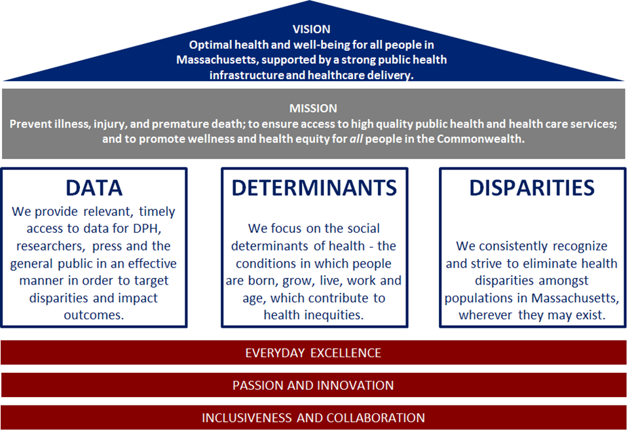

Framework Guiding the State Health Assessment Process
Development of the SHA is an iterative and collaborative process that has engaged organizations, agencies, and residents from all sectors across the state as well as staff within the MDPH. The following section provides an overview of the framework (Figure 2) that guided the development of the SHA and signals the next step in the journey of continuous quality improvement to public health in Massachusetts. The 2017 Massachusetts State Health Assessment (SHA) process framework is founded upon three main pillars of the MDPH House: Data, Determinants and Disparities. Following the six steps outlined ensures the inclusion of MDPH staff and external stakeholders with multiple points for input. This framework ensures that the result of the process—The 2017 Massachusetts State Health Assessment—will be able to inform improvement plans, policies, and practices. The framework is intended to be replicable every four to five years by MDPH. A more detailed description of the collaborative process of framing the SHA is described.
Figure 2
Massachusetts State Health Assessment Process
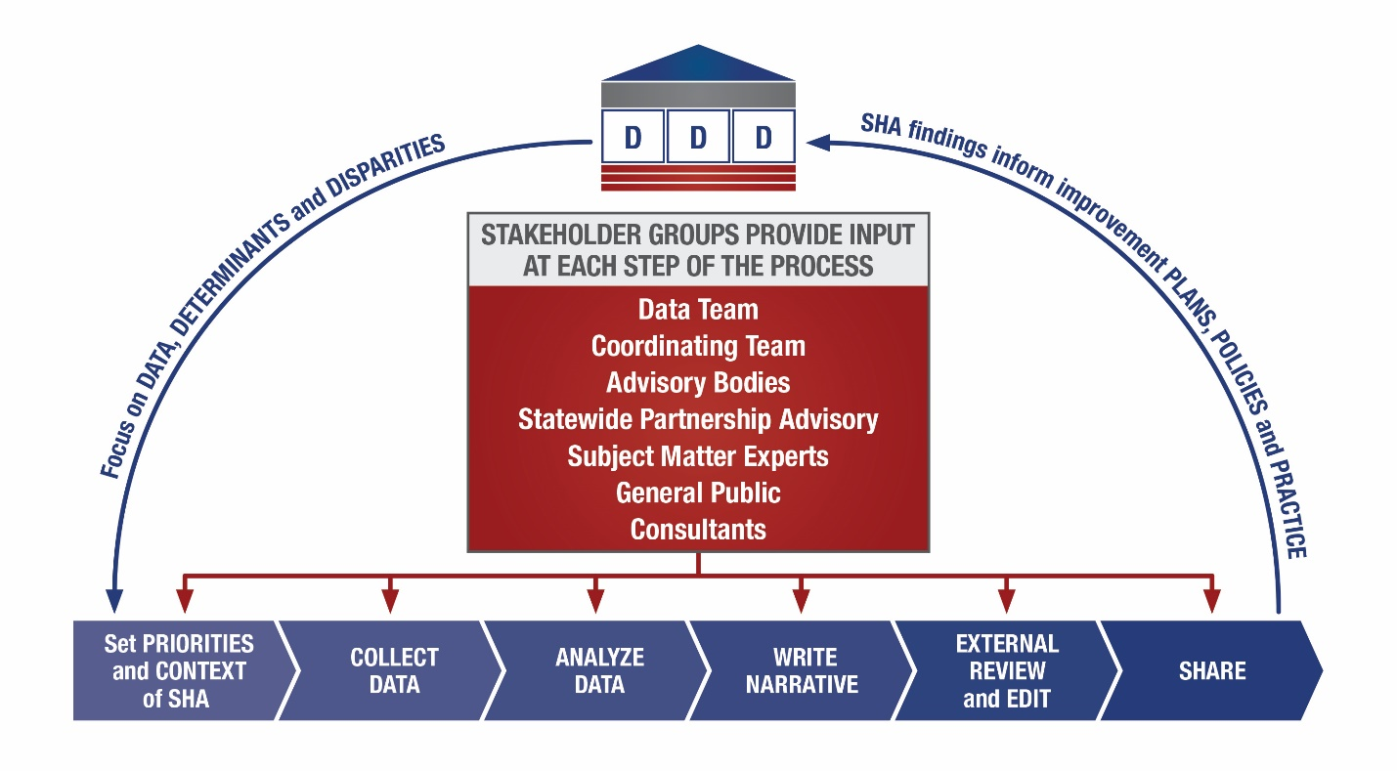

Health Equity and Social Determinants of Health
An individual’s health is influenced by many factors. Research shows that genetics and health care represent only a small fraction of what makes us healthy (see Figure 3). The majority of what contributes to our health is the social, economic, behavioral, and physical factors that we experience where we work, live, and play. In Massachusetts, we group these types of factors into six Determinants of Health: Built Environment, Education, Employment, Housing, Violence, and Social Environment (see Figure 4). Because many of these factors are driven by policies, institutions, and systems beyond an individual’s control, not all residents of the Commonwealth experience the same opportunities for good health. For example, some populations in Massachusetts experience inequitable living conditions and unequal treatment in many aspects of life such as job opportunities, sustainable wages, transportation options, quality education, discrimination-free workplaces, quality housing, affordable healthy foods, and social supports. Additionally, historical, institutional, and interpersonal racism have contributed substantially to these inequities, which can lead to poorer health outcomes. These unjust and unfair, socially-determined circumstances that lead to better opportunities for some populations and worse opportunities for others are defined as structural inequities.
Figure 3
What Makes Us Healthy?

SOURCE: ADAPTED FROM R TARLOV, A. (1999). PUBLIC POLICY FRAMEWORKS FOR IMPROVING POPULATION HEALTH. ANNALS OF THE NEW YORK ACADEMY OF SCIENCES. 896. 281-93.

Figure 4
Massachusetts’ Six Social Determinants of Health Categories
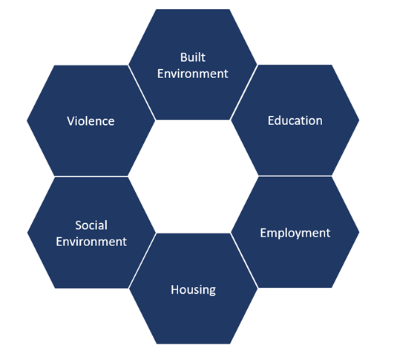
Structural inequities directly impact individuals’ quality of life and influence their health. Persons of certain races, education levels, geographic areas, genders, and income levels experience vastly different and often higher rates of chronic disease, violence, substance use, hospitalizations, and premature death when compared to the general population. These unjust and preventable differences in health outcomes are defined as health inequities.
The good news is that because most health inequities result from socially-determined structural inequities, change is possible. We can begin to improve health for a whole community when systems and structures, such as structural racism or gender bias, are acknowledged and explicitly addressed. By transforming inequitable policies, cultural norms, and structural barriers, we can move towards a Commonwealth where all people have the same opportunities to be healthy, regardless of race, ethnicity, income, ability, sexual orientation, gender identity, or age.
The following sections describe in more detail the six categories of health determinants as defined by the MDPH and the manner in which they impact the citizens of the Commonwealth.

Built Environment
The built environment includes the human-made elements of where we live, learn, work, travel, and play. It includes transportation systems, buildings, environmental exposures, streets, open spaces, infrastructure, and the systems that connect them. Built environment characteristics impact available resources and services across communities, as well as the environmental exposures individuals encounter. As a result it directly impacts individual risk behaviors (eg. tobacco use, physical activity, etc.), morbidity (eg. injury, hospitalizations, mental health, chronic diseases) as well as mortality (death).
Communities with more resources, services, and supportive policies often have a built environment that promotes health; however, some municipalities and neighborhoods were designed to include barriers maintaining racial or socioeconomic segregation. Segregation is "the physical separation of the races by enforced residence in certain areas that was designed to protect Whites from social interaction with Blacks." Although racially-explicit segregation is no longer legal, the US continues to be largely segregated by race because of historical patterns and current policies and practices, such as where public housing is located, lending patterns, and transportation options. This reinforces disparities in access to healthy foods, for example, communities of color generally have lower access to grocery stores and higher access to retailers that offer unhealthy items, such as fast food restaurants and liquor stores.,

Education
Education includes formal education in schools, educational activities in community groups or organizations, and informal education through interactions with people and institutions. It is one of the strongest predictors of lifetime health. The more education an individual has, the more likely they are to live longer and healthier lives.
Healthy children learn better, get better grades, and experience fewer behavioral problems. While in the education system, students often have access to resources that promote good health, such as physical activity breaks, school lunches, after-school programs and health-based resources such as screenings and management of chronic conditions. These programs have been shown to improve health outcomes, like childhood obesity, and mental health as well as school performance and learning outcomes. Unfortunately not all school systems have the resources to provide these vital programs. As students spend a significant portion of their day in school, schools also provide basic necessities such as shelter, sanitary facilities, food and water, and opportunities for socialization. All of these exposures while in school are directly associated with both better health and learning outcomes.
Even after leaving the education system, educational attainment continues to impact individuals’ health. Education is associated with better jobs, higher incomes, and economic stability. Education can also provide a greater sense of control over one’s life and stronger social networks, which again are linked to ability to engage in healthy behaviors and better overall health.
Unfortunately, educational attainment in Massachusetts is not equitable. Students from low-income communities and communities of color may face challenges in getting to school, differential public school resources, inequitable discipline practices, resources, and afterschool programming.

Employment
Employment provides income, benefits, and stability necessary for good health. Income, poverty, and unemployment are each profoundly linked with health. Income influences where people choose to live, to purchase healthy foods, to participate in physical and leisure activities, and to access health care and screening services. Having a job and job-related income provide individuals the opportunities to make healthy choices, engage in healthy behaviors, access necessary health care services, and enjoy a long life.
While being employed is important for economic stability, employment affects our health through more than economic drivers alone. Physical workspace, employer policies, and employee benefits all directly impact an individual’s health. The physical workplace can influence health through workplace hazards and unsafe working conditions which lead to injuries, illness, stress, and death. Long work hours and jobs with poor stability can negatively impact health by increasing stress, contributing to poor eating habits, leading to repetitive injuries, and limiting sleep and leisure time. Job benefits such as health insurance, sick and personal leave, child and elder services and wellness programs can impact the ability of both the worker and their family to achieve good health.
Unemployment is also associated with poor health, including increased stress, hypertension, heart disease, stroke, arthritis, substance use, and depression; and the unemployed population experiences higher mortality rates than the employed., The financial stresses connected with unemployment can lead to eviction, foreclosure, or homelessness, which have additional negative health consequences.
Underemployment is linked to chronic disease, lower positive self-concept, and depression. Workers with incomes below the poverty line are part of the working poor, who are more likely to have low-paying, unstable jobs, have health constraints, and lack health insurance.
Discriminatory hiring practices have limited the ability of people of color to secure employment. Those who have been arrested, have a conviction, felony or have been incarcerated are severely limited in their ability to find employment due to policies placing limitations on individuals who have interacted with the criminal justice system.
Housing
Housing is defined as the permanent or temporary dwelling unit that serves as a family’s or household’s residence. Housing has many characteristics, including stability, homelessness, quality, affordability, and many others. Housing is linked to certain health risk behaviors (tobacco and drug use), exposure to harmful elements (secondhand smoke, toxins, carbon monoxide, and asbestos), mental health, chronic conditions (obesity, cancers, infectious diseases, elevated lead levels, hypertension, allergies, etc.) as well as injuries and death.
Affordability is important, as people who spend more on housing have less to spend on education, transportation, health care, and food. Access to quality housing improves mental health and reduces stress. Unstable housing can lead to malnourishment in children, developmental disabilities, poor access to health care, use of illicit drugs, and negative mental health outcomes.
For those with housing, the location of a home also greatly impacts health and well-being, in part due to neighborhood conditions. Homes in neighborhoods that provide residents access to social and cultural opportunities, safe green spaces and parks, fresh and affordable produce, employment opportunities, and transportation, can promote health. Conversely, housing instability in a neighborhood can reduce the likelihood of forming strong local social support systems, which adversely impacts health. Housing near environmental hazards such as highly-trafficked roads and polluting industries can be more affordable but may lead to poor health outcomes.
Violence
Violence is the intentional use of physical force or power, threatened or actual, against a person or a community, likely to cause physical or psychological harm.,. A safer community is linked with better health outcomes. Violence influences the health of victims, their families, and the surrounding community. Violence can be self-directed (suicide or self-harm), interpersonal (directed towards individuals including family members, acquaintances or strangers, classmates, children, youths, and elders, and/or specific community members) or collective (resulting from social, political, and economic factors). Collective violence can occur on a large scale due to conflicts between groups or countries (such as war) but can also include other less explicit forms of violence (such as repression and neglect). Unequal access to power and resources (such as wealth), along with social inequality, can also lead to collective violence.
Suicide and self-harm are correlated with increased rates of injury, mental illness (PTSD, depression), substance use disorders, the experience of interpersonal violence or discrimination, and other hardships.
Interpersonal violence has been shown to have a significant negative impact on lifetime health outcomes. For example, experience of child abuse or neglect increases the likelihood of later involvement in the criminal justice system, poor academic performance, mental illness, and poor physical health, including heart disease, cancer, lung disease, alcoholism, drug use, depression, and smoking.
Other examples include intimate partner violence (IPV) and sexual violence (SV), which disproportionately affect women, transgender individuals and persons with disabilities. They can lead to death as well as injury and are associated with a number of adverse health outcomes such as sexually transmitted diseases, asthma, bladder and kidney infections, cardiovascular disease, circulatory conditions, central nervous system disorders, joint disease, and more. Victims of IPV and SV also face reproductive, psychological, and social consequences and may be more likely to engage in negative health behaviors such as high-risk sexual behavior, using harmful substances, unhealthy diet-related behaviors, and overuse of health services leading to increased health care costs., ,
Collective violence is linked to injury, death, depression, anxiety, suicidal behavior, substance abuse, and post-traumatic stress disorder. Unequal access to power, social inequality, and rapid changes in demographics have led to increased violence in communities of color and low socioeconomic status. Communities of color and low-income communities face low property values and poor housing conditions; resource-lacking educational systems and low levels of educational attainment; low-paying jobs and high unemployment rates; poor neighborhood conditions; and limited social capital. When such basic human needs are not being met, there is increased risk of income-generating crimes like burglary and robbery, stress, conflict, and substance use among residents, all of which ultimately increase the risk for violence.
But all types of violence do not impact all populations equally. Communities with lower socioeconomic status, communities of color, lesbian, gay, bisexual, transgender, and queer (LGBTQ) communities, people with disabilities, children, and the elderly are at increased risk for being impacted by or involved with all types of violence across the lifespan. Historical and present-day systems and policies have contributed to this inequity.

Social Environment
Who we are directly impacts how we interact with our community and society. Our race, gender identity, age, disability status, etc. influences the social environment that we experience. Our social environment impacts many mental and physical health outcomes, including: mental health, violence, risk behaviors (tobacco and drug use), physical health and well-being, and disease morbidity and mortality. We are influenced by the social environment on three levels: interpersonal, community, and society.
Across all three levels, systems of oppression such as structural racism and gender bias lead to social isolation, social exclusion, poor mental health, increased risk of violence, increased rates of poverty, higher hospitalizations, longer recovery times, and higher mortality rates for many conditions. Social isolation, social exclusion, racism, discrimination and poverty disproportionately affect low-income communities and communities of color and all negatively impact many aspects of health. Communities of color are more likely to have lower levels of resources and connectedness with other neighborhoods and higher levels of racial segregation. They also face more challenges when engaging in group action in neighborhoods to shift these conditions.
It is important to note that for individuals who belong to multiple disproportionately impacted populations, these adverse impacts are compounded. This concept is called intersectionality. It is only by looking at the additive impacts of each set of risks, that we can identify the most egregious inequities in the Commonwealth. For example, only when considering the intersection of age, race, and gender in Massachusetts, do we see patterns of increased risk of homicide for young Black men, increased risk of suicide for adult White men, and increased risk of dying during pregnancy for adult Black women.
Commitment to a just and equitable public health framework is essential for improving health at the individual, community, and society levels. In Massachusetts, individuals, institutions, and systems must work together to improve these determinants of health in order to create healthy communities for all residents of Massachusetts regardless of race, income, creed, gender identity, geography, sexual orientation, ability, or age.
Health inequities in Massachusetts are linked with socioeconomic status, race/ethnicity, gender, immigration status, geographic area, and other social determinants of health. Understanding how these factors impact individual’s life course and communities across the Commonwealth is important for identifying areas for intervention and tailoring public health and health care systems to meet the needs of Massachusetts’ residents.

Ensuring Stakeholder and Community Partnership
MDPH created a collaborative SHA process that involved coordination between MDPH leadership, data analysts, and programmatic staff, and their external partners, stakeholders, and community members that represented diverse populations and state health challenges. These partners, stakeholders, and community members included a statewide partnership advisory and MDPH’s existing commissions and advisory bodies that address public health issues such as ongoing identification and collection of health data and information, identification of health challenges, and evaluation of state assets and resources.

Key Working Groups and SHA Process Steps
In order to implement the SHA framework using its guiding principles, MDPH senior leadership established two key working groups -- a Coordinating Team and a Data Team -- to direct MDPH program staff and data analysts during the SHA process. These groups met regularly to coordinate the SHA process presented in Figure 2 above. The entire process consisted of the following six steps:
- Setting priorities and context of SHA health indicators (internal & external input)
- External data collection (Key Informant Interviews, Focus Groups, Advisory Bodies, etc.)
- Data analysis
- Writing the narrative (includes reviewing and incorporating edits)
- External review of final internal draft (and incorporation of edits)
- Distribution of the SHA to general public and community partners/stakeholders

Step One: Setting Priorities and Context of SHA Health Indicators
The MDPH Data Team convened Bureau leadership and key staff in May 2017 for a planning session to identify and prioritize the health indicators presented in the SHA. Bureau Directors were given ownership over specific chapters and organized teams of epidemiologists and Bureau subject matter experts to recommend an initial set of health indicators for possible inclusion in the Assessment. During the planning meeting, each Bureau worked in teams to refine their health indicator list under the guidance of facilitators, and chapter owners were identified. Each chapter owner then worked with the SHA Coordinating Team to finalize the indicator list. The process was designed to enable timely input from data experts from across MDPH and to ensure a comprehensive picture of the current health status of Massachusetts residents.
In order to carry out the prioritization process, a group of data analytic leaders and programmatic staff met regularly to coordinate the data analysis and associated narrative for the SHA. Bureaus were asked to provide an initial set of topics (high level headings), as well as health indicators/subtopics within each topic, to review and prioritize for possible inclusion in the SHA. The guidelines to consider when compiling the initial list were:
- What’s the compelling story for this indicator?
- Are there any notable trends or populations affected (e.g., age, gender, geography, race/ethnicity, time, etc.)
- Are there any notable disparities?
MDPH already measures and has collected data for most of the health indicators included. Some indicators were included because the scan and crosswalk describes the impact of these indicators on health even though MDPH does not collect the data (eg. certain environmental and mental health data).
During a data prioritization meeting organized by chapter, teams of epidemiologists, subject matter experts, and Bureau Directors reviewed the health indicator list, prioritized, and refined what to include in the SHA through three rounds of discussions. Below are the details on the three rounds to prioritize the indicators and what questions were used to guide the process. The process concluded with the Bureaus choosing the indicators that told the most compelling story.
Data Indicator Selection Process
Round 1: Choose Topics
- Do the topics in our list help tell a comprehensive story about the health status of Massachusetts residents?
- Do any topics overlap with other chapters?
- What topics are missing from this list?
  - Should anything be added?
  - What topics can be omitted from the SHA without losing the big picture of the chapter?
Round 2: Review Initial List of Health Indicators/Subtopics
- What indicators align best with the story of the topics selected for the chapter?
- Could the story be told with fewer indicators included? (And what is lost by dropping them?)
Final Round: Refine and Prioritize Health Indicators/Subtopics
- Vote for 1-2 indicators/subtopics per topic for inclusion in the SHA, then select top 5 “must have” indicators.

Steps Two and Three: External Data Collection and Data Analysis
The next two steps in the process consisted of obtaining and analyzing external, qualitative data through key informant interviews and focus groups and synthesizing community health and needs assessments from across the Commonwealth. Secondary data sources were compiled for the SHA and analyzed.

Key Informant Interviews
To enhance understanding of health priorities, trends, and concerns, 30 key informant interviews were conducted with community leaders across the Commonwealth. Key informants represented the following areas: education, transportation, nutritional assistance, housing, policy makers, minority serving populations, health care, oral health, mental health and philanthropy. Additionally, key informants represented the following communities disproportionately affected by health disparities: veterans, racial and ethnic minorities, children, and older adults. Interview topics focused on informants’ perspectives on current and emerging health concerns in Massachusetts, existing initiatives to address these health needs, and recommendations for improving the health of residents across the Commonwealth. The perspectives of key informants are included throughout the report to provide greater context to the health indicators presented.
Key informants described several health priorities for Massachusetts. The most frequently discussed were mental health, access to health care, addiction, elder health, and injury prevention. They also discussed the barriers to achieving health, including lack of funding, lack of awareness of the pressing health priorities, presence of stigma (specifically around mental health and addiction), lack of care coordination, and lack of health care services. Participants mentioned health insurance coverage and the multitude of programs and organizations in the Commonwealth as strengths supporting health. All six social determinants of health utilized in the Determination of Need Program were mentioned multiple times by nearly every key informant (housing, education, employment, violence/trauma, built environment, and social environment) but, of that list, the most common were housing, the built environment (specifically transportation), and employment.
Themes and illustrative quotes from the interviews are included throughout the SHA. Appendix A presents the interview guide used to facilitate the key informant interviews.

Focus Groups
Eleven targeted focus group discussions with a total of 129 individuals were conducted across the Commonwealth to identify community health concerns, priorities and barriers to good health. Populations represented in the focus groups included homeless youth, a tribal nation, HIV care providers, primary care providers, mental health providers, maternal and child health practitioners, rural health experts, and substance abuse service providers and users and/or persons in recovery representing cities and towns across the Commonwealth. Discussion topics included residents’ community health concerns; existing community assets, services, and initiatives; recommendations to address community health priorities; and residents’ vision for the future. Focus group participants’ perspectives are included throughout the SHA to enhance understanding of the context affecting the health of residents and to provide insight into the health status of populations experiencing health disparities. As a result of the focus groups, a few additional themes were added, including information about community health workers, rural health and local public health.
Appendix B presents the discussion guide used to facilitate focus groups.

MDPH Commissions, Advisories, and Stakeholder Groups
One MDPH commission, fourteen advisory bodies, and one stakeholder group included the SHA on their meeting agendas during this process. This provided MDPH an opportunity to present an overview of the SHA process, engage community stakeholders in discussion, and to obtain feedback that informed the development of the SHA. These commissions, advisories, and stakeholder groups convene regularly. Individual representatives provide insight, input, and feedback on matters related to a broad range of public health topics which made them ideal for inclusion in the development of the SHA. Figure 5 describes the primary sectors represented in the SHA process. These groups were consulted in the development of this assessment and vary in their purpose and expertise including HIV/AIDS, disabilities, rural health, emergency preparedness, occupational health, suicide prevention, the LGBTQ community, youth, local public health, school wellness, public health, and prescription monitoring. (See Appendix C for a full list and description of Commissions, Advisory Bodies, and Stakeholder Groups.)

Crosswalk of Community Health Assessments and Community Health Needs Assessments
To further understand health priorities across the state, a scan of municipal and health system Community Health Assessments (CHA) and Community Health Needs Assessments (CHNA) was conducted. All assessments which had been authored within the past five years (a total of 42) were included in this scan. These assessments describe the prominent community health issues, barriers to health, barriers to health care, health disparities, priority populations, strategies, strengths, weaknesses and resources for 339 municipalities representing 99% of the Commonwealth’s population. Data was collected from these documents and a crosswalk was created for analysis.
Figure 5
Primary Sectors Engaged in the State Health Assessment
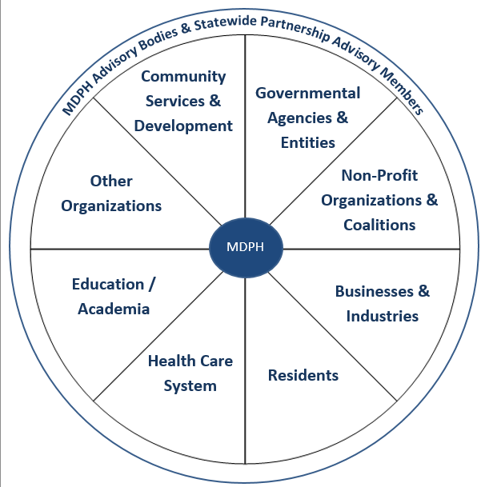

The top ten health priorities identified in the scan of community health and needs assessment were: mental health; alcohol and substance use; chronic disease (including obesity, diabetes, heart disease, asthma, etc.); cancer; lack of physical activity; poor nutrition; tobacco use; reproductive health (including maternal, prenatal and infant health); sexual health (including sexually transmitted infections and teen pregnancy); and public safety (including crime, violence and motor vehicle accidents). The top ten barriers to health or health care were: cost of care or insurance; transportation; lack of affordable housing; health literacy issues; insurance coverage; lack of services or providers; general access to care; lack of cultural humility; language barriers; and access to healthy food. The top four disparities were based on geography, race, economic status, and age. The top four priority populations were the elderly, youth, poor, and immigrant communities. The scan and crosswalk confirmed the topical areas that the SHA addresses. (See Appendix D for summary of the methods and analysis.)

Steps Four, Five, and Six: Writing, External Review, and Distribution of the SHA
The final three steps in the process include writing the analysis from steps one and two and circulating the draft SHA to statewide external stakeholders and to the public. Following this review, the SHA was made available through distribution of the the link to local health departments and on the MDPH website. This section describes in detail MDPH’s strategy to engage partners and obtain external feedback on the SHA.

Statewide Partnership Advisory
Effective and accountable public health leadership and practice requires a comprehensive health assessment that authentically engages a range of partners. The SHA Statewide Partnership Advisory (MA-SHA-SPA) and MDPH worked in collaboration to create the State Health Assessment. The MA-SHA-SPA is an external group of advisors who are concerned about health and represent a variety of sectors across the Commonwealth. Members were identified as representing a variety of statewide perspectives and were available during the time period. (See Appendix E for a full list of MA-SHA-SPA Partners and the organizations they represent.) The MA-SHA-SPA was charged with ensuring transparency and accountability to community stakeholders in the assessment process. Advisory members participated in the assessment planning process, providing recommendations on the health topics, health indicators, and referred the department to data and data sources included in the assessment. Additionally, the MA-SHA-SPA members provided feedback on the assessment and facilitated connections with other key informants and this group will continue to expand.
Sectors Represented on the Statewide Partnership Advisory Board
Businesses/Industry
Education/Academia
Health Care System
Residents
Non-Profit Organizations & Coalitions
Health Care System

General Public Feedback on Massachusetts State Health Assessment
In September 2017, a draft of the preliminary findings for the SHA was made publicly available for a two-week public review and feedback period. What’s more, an email which included links to the draft report and a survey was sent to all MDPH staff, key informants, focus group participants, each related advisory body and all statewide partnership advisory members. Feedback was incorporated into the report where possible and additional recommendations and next steps will be addressed when the state health improvement plan work begins.

Achieving and Maintaining National Public Health Accreditation Status
The MDPH has applied for national public health accreditation through the Public Health Accreditaton Board (PHAB). In order to achieve and maintain accreditation, a state health department must complete a rigorous, multi-faceted peer-reviewed state health assessment process. After achieving accreditation, PHAB also requires annual reports and reapplication for reaccreditation every five years. PHAB’s main goal is to advance quality and performance within public health departments in order to ensure the value and accountability to the communities they serve.
The completion and regular updating of the SHA represents an important foundation for obtaining and maintaining national public health accreditation status. For example, the MDPH State Health Improvement Plan, Strategic Plan, and Workforce Development Plan incorporates strategies, partners’ recommendation and staff training modules to address the health priorities, disparate health outcomes, and utilization of community assets identified in this SHA. Consequently, the value and accountability to Massachusetts residents from pursuing accreditation begins with and continuously relies upon successful completion and regular updating of the SHA.
In addition to state health departments, PHAB also recognizes local and tribal health departments with accreditation. To date, one regional public health system, the Worcester Division of Public Health/Central Massachusetts Regional Public Health Alliance has been accredited by PHAB, and three other local public health departments are in the process of pursuing accreditation from PHAB.
Appendices Related to this Chapter
- Key Informant Interview Guide
- Focus Group Discussion Guide
- Advisory Bodies & Descriptions
- Scan and Analysis of Community Health and Community Needs Assessments
- Statewide Partnership Advisory Board Partners and Organizations, Commissions, Advisory Bodies, and Stakeholder Groups Engaged for the State Health Assessment

References

Centers for Disease Control and Prevention. National Public Health Performance Standards: The Public Health System and the 10 Essential Public Health Services. Available at: https://www.cdc.gov/nphpsp/essentialservices.html Accessed June 17, 2017.
Massachusetts Executive Office of Health and Human Services. MDPH Organizational Chart. Available at: http://www.mass.gov/eohhs/docs/dph/commissioner/org-chart.pdf Accessed June 18, 2017.
Tarlov AR. Public policy frameworks for improving population health. Ann N Y Acad Sci. 1999;896:281-93.
Roof, K. & Oleru, N. (2008) Public Health: Seattle and King County’s Push for the Built Environment Journal;Journal of Environmental Health. 71(1) 24-27.
Williams DR, Collins C. (2001.) “Racial Residential Segregation: A Fundamental Cause of Racial Disparities in Health.” Volume: 116 issue: 5, page(s): 404-416 DOI: https://doi.org/10.1093/phr/116.5.404.
Schindler S. Architectural Exclusion: Discrimination and Segregation Through Physical Design of the Built Environment. Yale Law Journal. 2015; 124 (6). http://www.yalelawjournal.org/article/architectural-exclusion.
Braveman PA, Cubbin C, Egerter S, Williams DR, Pamuk E. Socioeconomic disparities in health in the United States: What the patterns tell us. American Journal of Public Health. 2010; 100: S186-S196.
Braveman PA, Cubbin C, Egerter S, Williams DR, Pamuk E. Socioeconomic disparities in health in the United States: What the patterns tell us. American Journal of Public Health. 2010; 100: S186-S196.
How does Employment--or Unemployment--Affect Health? (2013). Health Policy Snapshot Public Health and Prevention. Robert Wood Johnson Foundation. Retrieved from: http://www.rwjf.org/content/dam/farm/reports/issue_briefs/2013/rwjf403360.
Henkel D. Unemployment and substance use: a review of the literature (1990-2010). Current Drug Abuse Reviews. 2011 Mar;4(1):4-27.
Friedland DS, Price RH. Underemployment: Consequences for the Health and Well-Being of Workers. American Journal of Community Psychology. 2003; 32, 1 /2, 33-45. http://sites.lsa.umich.edu/ricprice/wp-content/uploads/sites/381/2016/04/Friedland-Price-2003-Underemployment-Consequences.pdf.
Kim M. Problems Facing the Working Poor. Department of Labor Studies and Employment Relations. 1999. https://www.dol.gov/oasam/programs/history/herman/reports/futurework/conference/workingpoor/workingpoor_toc.htm.
Shaw M. Housing and Public Health." Annu Rev Public Health, 25: 397-418, 2004.
Pratt GC, Vadali ML, Kvale DL, Ellickson KM. Traffic, Air Pollution, Minority and Socio-Economic Status: Addressing Inequities in Exposure and Risk. Caulfield B, ed. International Journal of Environmental Research and Public Health. 2015;12(5):5355-5372. doi:10.3390/ijerph120505355.
Preventing Violence and Reducing Injury. Prevention Institute web site. https://www.preventioninstitute.org/focus-areas/preventing-violence-and-reducing-injury/preventing-violence-and-reducing-injury. Accessed June 1, 2017.
School-Based Violence Prevention. Centers for Disease Control and Prevention web site. http://www.cdc.gov/policy/hst/hi5/violenceprevention/index.html. Updated June 22, 2017. Accessed June 25, 2017.
World Health Organization. World report on violence and health: Summary. 2002. http://www.who.int/violence_injury_prevention/violence/world_report/en/summary_en.pdf.
Corso PS, Mercy JA, Simon TR, Finkelstein EA, Miller TR. Medical costs and productivity losses due to interpersonal and selfdirected violence in the United States. Am J Prev Med. 2007;32(6):474-482.
Bellis MA, Hughes K, Leckenby N, Hardcastle KA, Perkins C, Lowey H.Measuring mortality and the burden of adult disease associated with adverse childhood experiences in England: a national survey. J Public Health (Oxf). 2015 Sep;37(3):445-54.
Smokowski PR, Kopasz KH. Bullying in school: An overview of types, effects, family characteristics, and intervention strategies. Children & Schools. 2005;27:101–109.
Hobson-Prater T, Leech T. The Significance of Race for Neighborhood Social Cohesion: Perceived Difficulty of Collective Action in Majority Black Neighborhoods. J. Sociol. Soc. Welfare. 2012;XXXIX(1): 89-109.
Centers for Disease Control and Prevention. CDC health disparities and inequalities report: United States, 2013. Morbidity and Mortality Weekly Report. 2013: 62(3); 1-187. Available at: https://www.cdc.gov/mmwr/pdf/other/su6203.pdf. Accessed July 2, 2017.

