CHAPTER 7
Health Systems and Health Care Access

Health Systems and Health Care Access
This chapter provides an overview of Health Systems and Health Care Access in the Commonwealth of Massachusetts and related trends and disparities. It provides information on health care access and delivery and the Department’s responsibility to regulate the health care system to ensure quality health care. The chapter includes the following topic areas:

Health Care Access and Utilization

Health Care Quality

Local and Regional Public Health

Oral Health

Mental Health

Health Care Workforce

Public Health and Health Care Systems Preparedness

Selected Resources, Services, and Programs

Overview
Massachusetts has long been recognized as a national leader in providing health care for its citizens. The focus includes continuously improving capacity and capabilities to allow Massachusetts public health and health care systems to prevent, protect against, quickly respond to, and recover from a variety of emergencies. People who cannot access health care are more likely to have poor overall health and chronic conditions. Accessing services such as preventive care, primary care, dental and mental health care, and emergency care without delay is necessary to a person’s overall health.
The overall trends in health care in Massachusetts are among the most positive in the nation:
- Massachusetts has the fewest uninsured residents in the nation. Only four percent were uninsured due to legislation enacted in 2006 to provide improved access to health care coverage in the Commonwealth.
- Only 7.5% of Massachusetts adults say they do not have a “usual place” of medical care compared to a national rate of 17.3%.
- Additionally, Massachusetts ranks first in the number of primary care physicians per 100,000 residents.
Although metrics like health insurance and the availability of providers and facilities are important for assessing access to care, it is vital to consider barriers to health care that disproportionately affect vulnerable populations. These barriers, for some residents of the Commonwealth, may lead to unmet health care needs, delays in receiving care, financial burden, and preventable hospitalizations.
Assessing and improving the quality of health systems is important for improving population health. A key Commonwealth goal is a health system that provides quality care that is safe, effective, timely, equitable, and patient-centered. This means working to reduce and prevent adverse events and ensuring timely and accessible evidence-based care for all in the right place and at the right amount.
Another important element to the health system is the expansion of Accountable Care Organizations (ACOs). The ACO program is a major component in the state’s five-year innovative 1115 Medicaid waiver that brings in significant new federal investment to restructure the current health care delivery system for MassHealth’s 1.9 million members. The waiver provides $1.8 billion in new federal investments, referred to as Delivery System Reform Incentive Payments (DSRIP), to support the transition of health care providers providing value-based care. The current fee-for-service system leads to gaps in care and inefficiencies and the ACOs selected demonstrate a strong commitment to improving care for the members they serve and will be held to high standards for quality and access of care.
Since December 2016, six ACOs have been participating in the MassHealth ACO Pilot program covering approximately 160,000 members and have already demonstrated early successes. For example, one ACO is connecting members with home and community-based services to avoid costly hospitalizations wherever possible, and to bring primary care services to members in their homes. MassHealth anticipates that the positive results demonstrated by the Pilot ACO program will continue with the full implementation and investments under the restructured ACO program.
MDPH ensures compliance by:
- Licensing health care facilities such as hospitals, nursing homes, clinics, rest homes, adult day health programs, and community health centers
- Licensing health care professionals such as physicians, nurses, community health workers, and pharmacists
- Monitoring and supporting health providers’ efforts to meet national standards for Culturally and Linguistically Appropriate Services (CLAS)
- Systematically collecting a variety of data including adverse events, such as falls, deep pressure ulcers, and cardiac events to assess safety, and aid informed decision-making and quality improvement
In addition, MDPH also is responsible for public health coordinating, preparedness and emergency management. MDPH collaborates with stakeholders to ensure that all public health and health care partners, as well as local community members, have the knowledge, plans, and tools to prepare for, respond to, and recover from threats to public health such as:
- Acts of bioterrorism
- Outbreaks of infectious disease
- Other large-scale public health emergencies or mass casualty incidents
Culturally and Linguistically Appropriate Services (CLAS) Standards

The Massachusetts Department of Public Health (MDPH) Office of Health Equity (OHE) implemented its CLAS initiative in three phases. CLAS I (2005-2010) developed strategies and tools for adoption of CLAS Standards in Massachusetts. CLAS II (2010-2013) focused on implementation and piloting of CLAS efforts and tools both across the agency and throughout its network of contracted service providers. CLAS III (2013-2015) focused on the sustainability and ongoing assessment of CLAS efforts.

Ongoing CLAS Implementation
To identify gaps and priorities across all bureaus, MDPH completed CLAS internal assessments in 2008, 2011. Findings and recommendations were presented to department leadership, and follow-up meetings were held in 2014 with individual bureaus, which informed improvements to the assessment tool and process. As a result, a new internal assessment was developed and implemented in 2016, which includes individual workplans and one-on-one technical assistance follow-up for each program. Future internal assessments will be done annually.

Since 2007, MDPH has required that contracted vendors of direct services complete a self-assessment as part of their annual workplans. The self-assessment guides vendors to detail how they plan to work on a CLAS-specific goal during the following 1-year contract period. Contract managers are trained to provide ongoing monitoring and support of vendors’ CLAS-implementation efforts as part of annual site visits and performance reviews.

Throughout CLAS I, II, and III, OHE convened an advisory board, with staff from all bureaus, who met regularly to ensure that the initiative met its objectives. Staff also worked in subcommittees to develop, pilot, promote and evaluate the CLAS-related trainings, materials, policies, and protocols MDPH developed. The committee also informed the initiative’s strategic sustainability plan, which called for the seamless integration of CLAS into all MDPH work.

CLAS Training and Technical Assistance

OHE developed CLAS trainings and presentations for internal and external audiences—department staff, contracted vendors, community groups, sister agencies, fellow Offices of Minority Health in other states. In-person trainings for MDPH contract managers and vendors are offered several times a year, and webinars are offered upon request. Interested individuals can contact CLAS@state.ma.us for information on CLAS trainings. Technical assistance requests are made by MDPH staff, vendors, and other stakeholders, via email or telephone and fulfilled by OHE in a timely manner.

CLAS Dissemination Tools

The Massachusetts Office of Health Equity developed Making CLAS Happen: Six Areas for Action, a manual to help organizations operationalize the CLAS Standards. It is organized into six chapters covering the 15 CLAS Standards:
- Foster cultural competence
- Build community partnerships
- Collect and share diversity data
- Benchmark: plan and evaluate
- Reflect and respect diversity
- Ensure language access

Each chapter includes hands-on tools, resource lists, and case studies from public health and social service providers. The manual has been printed and disseminated and continues to be used across the state and the country. It was updated in 2013 to reflect the enhancement of the CLAS Standards, and can be downloaded by chapter from the MDPH CLAS website, which serves as an accessible repository for the dissemination of all MDPH-produced, CLAS-related materials.

Health Care Access and Utilization

Health Care Access
This section discusses the issues surrounding health care access. Access to health care is an important determinant of health. Health problems, including acute and chronic conditions, can be prevented or treated by health care professionals. Key components of health care access include health insurance coverage, provider availability, provider linguistic and cultural humility and sensitivity, and quality of care.

Trends/Disparities
Although Massachusetts is a national leader in the number of health care facilities and health care providers, there are still some barriers that prevent individuals from accessing timely and adequate health care:
- Lack of health insurance
- Lack of transportation
- Lack of language interpreters
- Lack of knowledge to navigate the health care system
- Lack of childcare
- Lack of culturally competent care
- High cost of care
- Distrust of health providers and the health care system
Barriers in access to health care can lead to delayed health care utilization, less preventive services, financial hardship, and rising health care costs, primarily through increased and preventable urgent care visits and hospitalizations. In Massachusetts, specific racial/ethnic populations, those that are low income, and residents of rural areas, disproportionately experience barriers in receiving timely care. Access to basic health care may vary by race, ethnicity, socioeconomic status, age, sex, gender identity, sexual orientation, ability and geographic location.
The trends in the availability of basic health care across the Commonwealth are positive, both in terms of the geographic distribution of facilities and services and the total numbers of facilities and services.
The table below illustrates the distribution of health care facilities by county. Though the numbers vary widely between counties, they are proportionate to the population size of their respective areas.
Figure 7.1: Number of Health Care Facilities, By County, Massachusetts, June 2017
County  (Population) | Facility Type
 | Nursing Home | Rest Home | Adult Day Health | Acute Hospital | Non-acute Hospital | Clinic | Dialysis Centers | Total
Barnstable (214,276) | 18 | 3 | 4 | 2 | 2 | 38 | 2 | 69
Berkshire  (126,903) | 15 | 0 | 3 | 2 | 0 | 23 | 3 | 46
Bristol  (558,324) | 39 | 5 | 19 | 5 | 5 | 60 | 7 | 140
Dukes  (17,246) | 1 | 0 | 0 | 1 | 0 | 3 | 1 | 6
Essex  (779,018) | 50 | 8 | 20 | 9 | 6 | 118 | 9 | 220
Franklin  (70,382) | 5 | 1 | 1 | 1 | 0 | 10 | 1 | 19
Hampden  (468,467) | 31 | 3 | 11 | 6 | 4 | 77 | 9 | 141
Hampshire  (161,816) | 6 | 3 | 2 | 1 | 0 | 15 | 1 | 28
Middlesex  (1,589,774) | 84 | 11 | 35 | 15 | 6 | 145 | 14 | 310
Nantucket  (11,008) | 1 | 0 | 0 | 1 | 0 | 2 | 1 | 5
Norfolk  (697,181) | 46 | 5 | 14 | 4 | 8 | 74 | 12 | 163
Plymouth  (513,565) | 32 | 5 | 12 | 4 | 3 | 58 | 5 | 119
Suffolk  (784,230) | 31 | 7 | 30 | 15 | 8 | 98 | 10 | 199
Worcester  (819589) | 55 | 17 | 16 | 9 | 5 | 106 | 9 | 217
Total  (6,811,779) | 414 | 68 | 167 | 75 | 47 | 827 | 84 | 1682

As shown in in the Figure 7.2, acute care hospitals with an emergency department and acute hospitals with no emergency department are concentrated in the Boston metropolitan area.
Figure 7.2
Massachusetts Acute Care Hospitals and Satellite Emergency Facilities
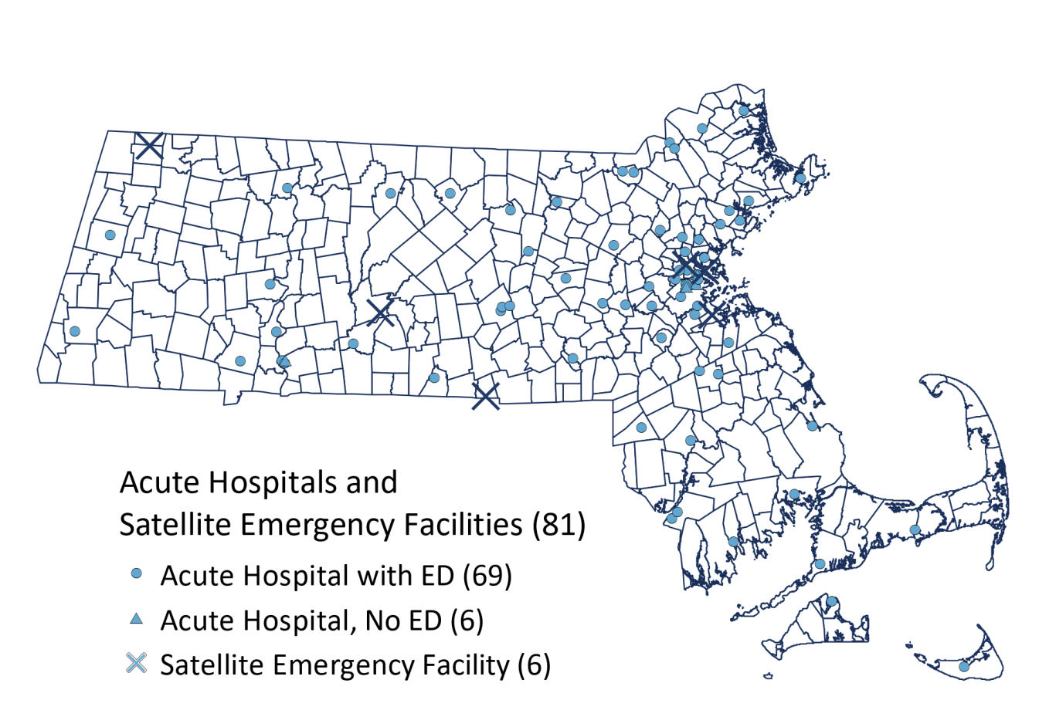
X

Massachusetts was home to the first community health center in the nation. Now in 314 locations and growing, Massachusetts community health centers provide high quality medical, dental, vision, pharmacy, behavioral health, addiction services and other community-based services to 998,000 residents regardless of their insurance status or ability to pay. Health centers work to eliminate the increased risk of serious illness, chronic disease, and mortality experienced among the state’s many ethnic and racial groups by hiring multilingual and multicultural staff at every level of their organizations; deploying community health workers to help patients navigate the complex health system; and assisting residents in enrolling—and staying enrolled—in critical health care coverage.
In 2016, community health center data shows:
- 4.7 million visits a year
- Services accessed by individuals in 96% of Massachusetts cities and towns
- Almost 24% of the state’s health center patients were women of child-bearing age (15-44)
- 23% were children under 18
- 11% of patients were older adults age 65 or older
- 89% of patients fell below 200% of the federal poverty level
- 44% were insured through MassHealth
- 31% had subsidized and unsubsidized commercial coverage
- 10% were Medicare beneficiaries
- Nearly 14% of patients remained uninsured
- 42% were non-English speaking
Community health centers address disparities identified in this and other chapters by providing locally-accessible, comprehensive, and patient-centered care. The result is that high-need patients in Massachusetts receive primary care and are less reliant on expensive emergency and hospital care. Community health centers are accessible in all areas of the state.
In 2009, the first ever data reporting platform for community health centers, DRVS™ (Data Reporting and Visualization System) was established. The platform measures and monitors health center performance on key clinical, operational, and financial metrics. DRVS is also providing support to several MDPH initiatives including the Massachusetts immunization information system (MIIS), the web-based immunization registry, Mass in Motion - - a community-based approach to promoting healthy eating and active living - - and the Bureau of Infectious Disease and Laboratory Sciences’ Office of Integrated Surveillance and Informatics Services which collect data on 80 reportable diseases.
Community health centers are dedicated to integrating addiction care into the primary care they deliver and were the first health care providers in Massachusetts to endorse Governor Baker’s core competencies for preventing and managing prescription drug misuse.
Currently, 86 percent of Massachusetts community health centers have achieved official patient-centered medical home (PCMH) recognition through an accredited organization, including the National Committee for Quality Assurance (NCQA) and the Joint Commission on Accreditation of Health Care Organizations. The Massachusetts Health Policy Commission, in collaboration with the NCQA, developed the PCMH PRIME Certification program which certifies Massachusetts-based federally qualified health centers for their integration of behavioral health either through formal agreements, co-location, or provider integration and emphasizes the importance of integrating behavioral health into patients’ primary care. As of July 2017, 28 percent of federally-funded health centers have achieved PRIME status, with an additional 20% on the path to certification.

Medical Use of Marijuana Program
In 2012, MDPH established the Medical Use of Marijuana Program to implement the registration of non-profit organizations that cultivate and dispense marijuana for medical use and the registration of physicians, patients, personal caregivers, and dispensary agents. Massachusetts legalized marijuana for recreational use in 2016.
MDPH oversees regulatory enforcement of registered marijuana dispensaries (RMD), patient support services delivery, and processing of RMD applications. Figure 7.3 illustrates the locations of RMDs across the state.
Additionally, it is also MDPH’s responsibility to regulate the evaluation and labelling of marijuana for medical use. To accomplish this, MDPH uses an analytical testing protocol based upon standards published annually by the United States Pharmacopoeia (USP) Convention.
In July 2017, a new law was enacted which established the Cannabis Control Commission. As part of the new law, the Medical Use of Marijuana Program will be moved from MDPH to the newly created Commission by December 2018. The Commissioner’s Office, Office of General Counsel and the Bureau of Health Care Safety and Quality’s Medical Use of Marijuana Program staff are committed to helping ensure this transition is seamless.
Figure 7.3
Massachusetts Registered Marijuana Dispensaries with a Certificate of Registration, March 2017
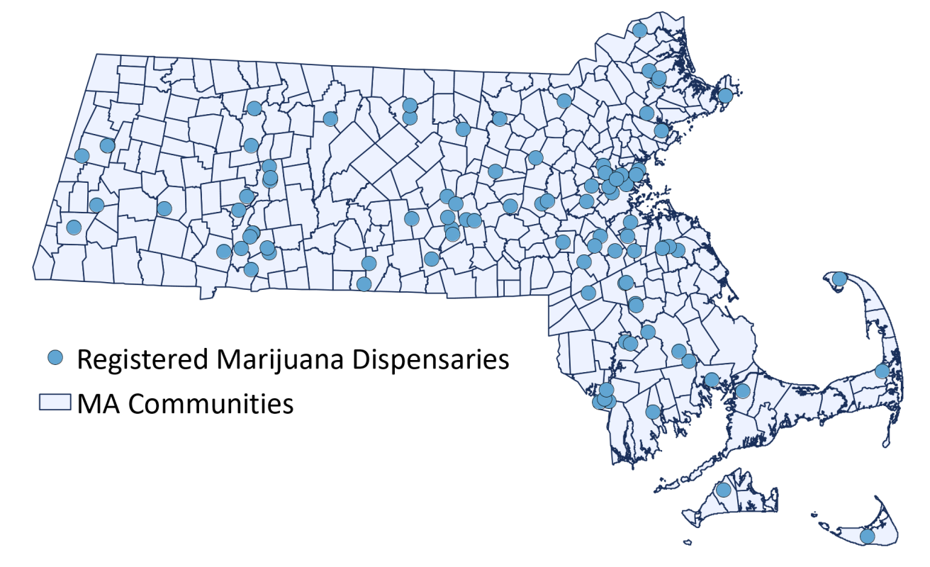

Hospitalizations
Hospitalizations provide a lens into the health of residents across the Commonwealth. Many hospitalizations for acute illnesses and chronic conditions can be prevented through preventive health care in outpatient settings. Decreasing preventable hospitalizations can reduce health care costs.

Inpatient Discharges by EOHHS Region
In Fiscal Year 2015, more than one-third (37.1%) of inpatient discharges across the Commonwealth occurred in Metro Boston. Northeastern (17.6%) and Western (12.1%) Massachusetts EOHHS regions together comprised nearly 30% of inpatient discharges across the state. From 2009 to 2015, inpatient discharges increased 65.2% in Metro Boston and 3% in the South Coast. Over this same time period, the Metro South (37.2%), Metro West (35.6%), and Cape and Islands (25.3%) experienced the greatest percent decrease in inpatient discharges.

Inpatient Discharges by Age
Nearly half (48%) of all inpatient discharges in 2012 were among persons 20 to 64 years of age and approximately one-third (37%) of inpatient discharges were among persons 65 years of age or older.
Figure 7.4
Inpatient Discharges by Age, Massachusetts, Fiscal Year 2012

SOURCE: CHIA, ACUTE CARE HOSPITALIZATION TRENDS IN MASSACHUSETTS

Observational Stay Discharges by Region
From Hospital Fiscal Years 2009 to 2013, observational stay discharges across Massachusetts increased by 25.7%. Over this period, the Cape and Islands (89.1%), Southcoast (54%), and Metro South (51.4%) regions experienced the greatest increase in observational stay discharges.
The Metro Boston (23.7%) and Northeastern Massachusetts (19.5%) regions each represented nearly one in five observational discharges across the Commonwealth in hospital fiscal year 2013.

Emergency Department Utilization
Emergency department utilization is an indicator of the health of a community and the identification of conditions that could be prevented by appropriate health care delivered in primary care settings., Decreasing potentially preventable emergency department visits may reduce health care costs.

Leading Causes of Emergency Department Discharges
Emergency department discharge includes emergency department visits that do not result in hospital admission. In 2012, conditions of the abdomen and pelvis and respiratory system and chest were among the leading causes of emergency department visits across Massachusetts, comprising 5% and 4.4% of total emergency department discharges respectively.

Emergency Department Visits by EOHHS Region
From Hospital Fiscal Years 2009 to 2015, emergency department discharges increased by 28.9%. Over this period, the Metro Boston region (60.8%) experienced the greatest increase in emergency department discharges. This increase was also high in Central Massachusetts (32.6%), Northeast Massachusetts (29.9%), the Cape and Islands (24.9%), and Southcoast (24.4%). This increase in emergency department discharges reflects trends following health care reform in Massachusetts and the implementation of the Affordable Care Act.,

Emergency Department Discharges by Age
In 2012, approximately two-thirds (65%) of emergency department discharges in Massachusetts were among persons 20 to 64 years of age. One in five (23%) emergency department discharges was among individuals from birth to 19 years of age.
Figure 7.5
Emergency Department Discharges, by Age, Massachusetts, Fiscal Year 2012

SOURCE: CHIA, ACUTE CARE HOSPITALIZATION TRENDS IN MASSACHUSETTS

Emergency Department Discharges by Payer Type
Patients with private health insurance (33%) and Medicaid (31%) each represented one-third of emergency department discharges in Massachusetts in 2012. Nearly one in five (18%) patients discharged from emergency departments across the Commonwealth had Medicare coverage in 2012.
Figure 7.6
Emergency Department Discharges, by Payer, Massachusetts, Fiscal Year 2012

SOURCE: CHIA, ACUTE CARE HOSPITALIZATION TRENDS IN MASSACHUSETTS

Health Care Quality
This section discusses trends and disparities relating to health care quality from the perspective of two key MDPH responsibilities specifically related to safety of care and timeliness of care and a few examples.

Safety: Trends/Disparities

Falls and Pressure Ulcers in Health Care Settings
MDPH uses an adverse event identification and reporting framework developed by the National Quality Forum (NQF) to identify trends and disparities to confront health care safety issues. This framework translates a set of adverse events into measurable, evidence-based outcomes called Serious Reportable Events (SRE). Falls and pressure ulcers (bed sores) are two of the SREs that MDPH and reports annually. MDPH also monitors and evaluates the quality of cardiac care delivered in Massachusetts by collecting patient-specific outcome data from all hospitals that perform certain cardiac procedures.
- From 2011 to 2015, the number of serious injuries or deaths after a fall increased 52.2%. (203 falls in 2011 vs. 309 falls in 2013)
- The number of pressure ulcers in acute care settings tripled from 2011 to 2015 (64 ulcers vs. 228 ulcers, respectively). During this period, the sharpest increase in falls and pressure ulcers in acute care settings occurred from 2012 to 2013.
Figure 7.7
Number of Falls with Serious Injury and Pressure Ulcers in Acute Care Hospitals, Massachusetts, 2011-2015

Much of these increases were the result of the adoption of new, more expansive NQF definitions in 2012 and MDPH will continue to monitor. Figure 7.7 shows the trends in Massachusetts in these safety categories in acute care hospitals identified through the NQF framework.

Cardiac Surgery and Coronary Intervention
Massachusetts hospitals that perform coronary artery bypass graft (CABG) and percutaneous coronary intervention (PCI) procedures are required to report patient-specific outcome data to MDPH on an annual basis. Risk-standardized, 30-day mortality is one of several indicators used to assess safety and quality of care.
In Fiscal Year 2014, Massachusetts had 7,546 hospital admissions in which at least one cardiac surgery was performed. Of these admissions, 3,063 (40.6%) involved bypass surgery. Of these admissions, 48 (1.6%) patients died within 30 days of surgery.
In Fiscal Year 2014, Massachusetts had 12,439 admissions in which at least one PCI (heart attack) procedure was performed. Of these admissions, 40 patients died within 30 days of surgery, which equates to 0.4%.
No adverse trends or disparities have been identified in CABG measure of safety, but MDPH’s data collection process will allow it to quickly identify adverse trends and disparities that may arise.

Timeliness: Trends/Disparities
The timeliness of receiving health care is critically important in sudden events, especially strokes. In Figure 7.8, the trend indicates increased improvement in receiving emergency care within three hours.

Figure 7.8
Percent of All Stroke Patients who Arrived in Emergency Department within 3 hours,
Massachusetts, 2008-2016

Local and Regional Public Health
A decentralized system of 351 local public health authorities (local boards of health and local health departments) plays an important role in the Massachusetts public health system. The Commonwealth has the highest number of local health departments in the country.
These local public health authorities work in partnership with MDPH and others to deliver a core set of services. Local public health authorities are charged with a broad set of responsibilities for enforcement of state sanitary, environmental, housing, and health codes, including:
- Protection of the food supply through inspections of restaurants and other food establishments
- Inspections and permitting of septic systems, landfills, and other solid waste facilities
- Health care and disease control, including timely reporting and response to communicable diseases, occupational health and safety violations, food poisoning, and rabies
- Inspections of pools, beaches, camps, motels, and mobile home parks
- Enforcement of state lead poisoning regulations and sanitary codes in housing
- Enforcing tobacco laws
- Developing, testing, and building awareness of emergency preparedness plans for a wide range of hazards

Trends/Disparities
Local public health services are primarily funded by local property tax revenues and fees. Inadequate funding for local public health is a key contributor to disparities in the delivery of core public health services across communities in the Commonwealth. Unlike many other states, Massachusetts does not provide base funding to local public health authorities for core public health services. Inadequate local public health funding is a key contributor to disparities in the availability of core public health services at the local level in Massachusetts.
Within the past decade, public health advocates have promoted voluntary accreditation as a means to advance state, local, and tribal health departments beyond a minimum set of services and standards. A principal component of accreditation through the national Public Health Accreditation Board (PHAB) is the demonstrated capacity to deliver the ten essential public health services. At this higher level of service delivery, there are also disparities among Massachusetts local public health authorities. Large communities are typically better equipped than small ones to provide at least some of the essential public health services. These disparities can be attributed to inadequate funding and limited staffing.
The MDPH approach to addressing inequities in core public health service delivery builds on the strengths of the local public health system. Some initiatives are particularly promising in addressing disparities in the provision of core services and the ten essential services. These initiatives include 1) technical assistance for public health accreditation, 2) supporting the formation of public health districts or other shared service arrangements, and 3) providing funding for municipalities to lead public health program and policy initiatives for tobacco control, wellness, addiction, and emergency preparedness. The trend over the past several years has been towards stronger relationships between MDPH and local public health authorities and more robust support for the important role of local health authorities in the Massachusetts public health system.
Nearly one-third of Massachusetts communities are part of a public health district or other cross-jurisdictional sharing agreement (see Figure 7.9). Serving about 20% of the population, these formal arrangements not only have demonstrated value in ensuring the delivery of core services but also enhance local capacity to provide some of the ten essential services. With their strong tradition of local autonomy, some Massachusetts cities and towns have been less receptive than others to public health collaboration across jurisdictional boundaries. The following efforts are among those in which Massachusetts has been working to advance cross-jurisdictional sharing:
- MDPH has been a participant in the Massachusetts Public Health Regionalization Project since its inception over a decade ago. Comprised of a diverse set of public health leaders, the project is dedicated to “strengthen[ing] the Massachusetts public health system by creating a sustainable, regional system for equitable delivery of local public health services across the Commonwealth”.
- In 2009, MDPH obtained funding from the US Centers for Disease Control and Prevention to support five new cross-jurisdictional sharing arrangements through the Public Health District Incentive Grant Program.
- The Special Commission on Local and Regional Public Health, convened in June 2017, is charged with assessing the effectiveness and efficiency of the local public health system and making recommendations for improvement.
Figure 7.9
Public Health Districts and Communities in Shared Services Arrangements, 2017
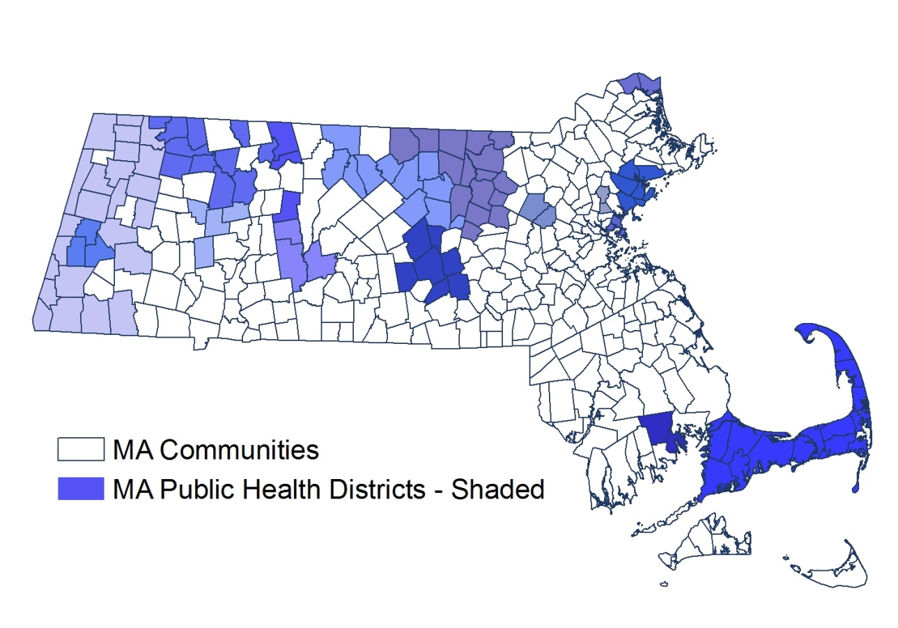

Oral Health
A healthy mouth is essential to overall health. Poor oral health can affect nutrition, learning, growth and development, self-esteem, quality of life, employability, and systemic health. When oral health is compromised, it can lead to increased risk for diseases such as cardiovascular disease or stroke. Oral disease has been linked to complications in pregnancy and childbirth and to respiratory, gastrointestinal, rheumatologic, and cardiovascular disease. Emerging evidence suggests a two-way relationship between diabetes and periodontitis, with diabetes increasing the risk for periodontitis, and periodontal inflammation negatively affecting glycemic control. Individuals with diabetes who receive periodontal intervention may lower their medical costs. Dental caries, or tooth decay, is the most common chronic disease among children and adolescents. Nationally, more than 51 million school hours are lost each year due to oral health issues.
There are notable racial/ethnic disparities in oral health care utilization for children, adults, and pregnant women. Insurance status is often a barrier to accessing oral health care, along with lack of adequate transportation to attend an appointment. Improving access to oral health services and preventive measures, such as community water fluoridation, is important to preventing and treating oral diseases. Basic knowledge about oral health and its importance to overall health could lead to improved health outcomes across the life course.

Trends/Disparities

Dental Care Utilization
Experts locate the root causes of disparities in oral health outcomes in structural factors: the geographic dispersion of oral health care systems, uneven access to linguistically and culturally appropriate oral health care services, and differences in health care coverage according to income, to name just a few sources of inequity. There are clear racial/ethnic disparities in dental visit rates among all age groups in Massachusetts.

Children and Adolescents
Results from the Youth Risk Behavior Surveillance System in 2015 show that nearly 9 out of 10 middle and high school students in Massachusetts reported seeing a dentist in the past year. For Massachusetts high school students only 78% of Black non-Hispanic students and 82.1% of Hispanic students reported a dental visit, compared to 84.4% Asian non-Hispanics and 93.2% White non-Hispanic.

Adults
Among Massachusetts adults, Behavioral Risk Factor Surveillance System data suggests that the percentage reporting a dental visit in the past year decreased between 2010 and 2014, but still remains higher than the national average.
- In 2014, 74.7% of Massachusetts adults reported a dental visit in the past year. A greater proportion of White non-Hispanic (76.4%) and Asian non-Hispanic (74.9%) adults reported a dental visit in the past year compared with Black non-Hispanic (65.6%) and Hispanic (68.1%) adults.
- The percentage of adults who reported a dental visit in the past year increases with household income. Only 59.4% of adults making $25,000 had a visit compared to 86% of adults making $75,000 or more. Those with higher levels of education are also more likely to have had a dental visit in the past year (<high school: 59.7%; high school 67.7%; some college: 74.6%; college or more: 84.3%).

Pregnant Women
In Massachusetts between 2013 and 2014, the Pregnancy Risk Assessment and Monitoring System suggests that 71.7% of women had their teeth cleaned in the year before pregnancy and only 62.2% of women had their teeth cleaned during pregnancy. As shown in Figure 7.10, there are several disparities in dental visits among women:
- Among pregnant women, between 2013 and 2014 a greater percentage of White non-Hispanic women reported a dental visit in the past year (78.4%) and during pregnancy (67.3%) compared to other racial/ethnic groups. Black non-Hispanic women had the lowest prevalence of dental visits in the past year (57%) and during pregnancy (49.2%).
- Between 2013 and 2014, a lower percentage of those who were living at or below 100% of the federal poverty level reported having their teeth cleaned before (57%) or during (50%) pregnancy compared to those above 100% of the federal poverty level (78% and 67%, respectively).

Figure 7.10
Percent of Pregnant Women who Had Their Teeth Cleaned, by Race/Ethnicity, 2013

Older Adults
Regardless of age, individuals with special health care needs often do not receive needed oral health care due to a lack of dental providers with expertise to treat them. Massachusetts is unique in that it has six specialized dental clinics operated by Tufts Dental Facilities to serve individuals with intellectual and/or developmental disabilities. In Fiscal Year 2016, Tufts Dental Facilities served 7,068 patients during more than 24,000 visits.
- In 2014, 15.6% of Massachusetts adults had six or more teeth missing.
- In 2009, 60% of residents in long-term care facilities had some natural teeth. Of these, 59% had untreated decay and 7% had urgent dental needs.

Insurance Status
Health insurance is an important determinant of access to dental oral health care. According to the Centers for Medicare and Medicaid Services (CMS), in Fiscal Year 2015 there were 668,111 individuals under the age of 21 enrolled in MassHealth for at least 90 continuous days and of those only 55.1% received any dental oral health care.¹⁶ The proportion of dental providers who accept MassHealth insurance remains low. Approximately 45% of dentists reported treating patients with MassHealth insurance. Only 28% of those dentists reported that patients on MassHealth insurance made up more than half of their patient population.

Water Fluoridation
Community water fluoridation has been shown to prevent up to 25% of tooth decay in children and adults. Fluoride is a naturally occurring element in many water supplies in trace amounts. In public water supply systems the fluoride level is adjusted to an optimal level to improve oral health in children. Fluoride is safe, odorless, colorless, and tasteless. More than 3.9 million people in Massachusetts receive the health and economic benefits of fluoridation. As of February 2017 more cities and towns in the eastern and central regions of Massachusetts are fluoridated, with few or no cities and towns in western Massachusetts and the cape cod region being fluoridated.
Figure 7.11
Fluoridated Towns and Cities, Massachusetts, 2017
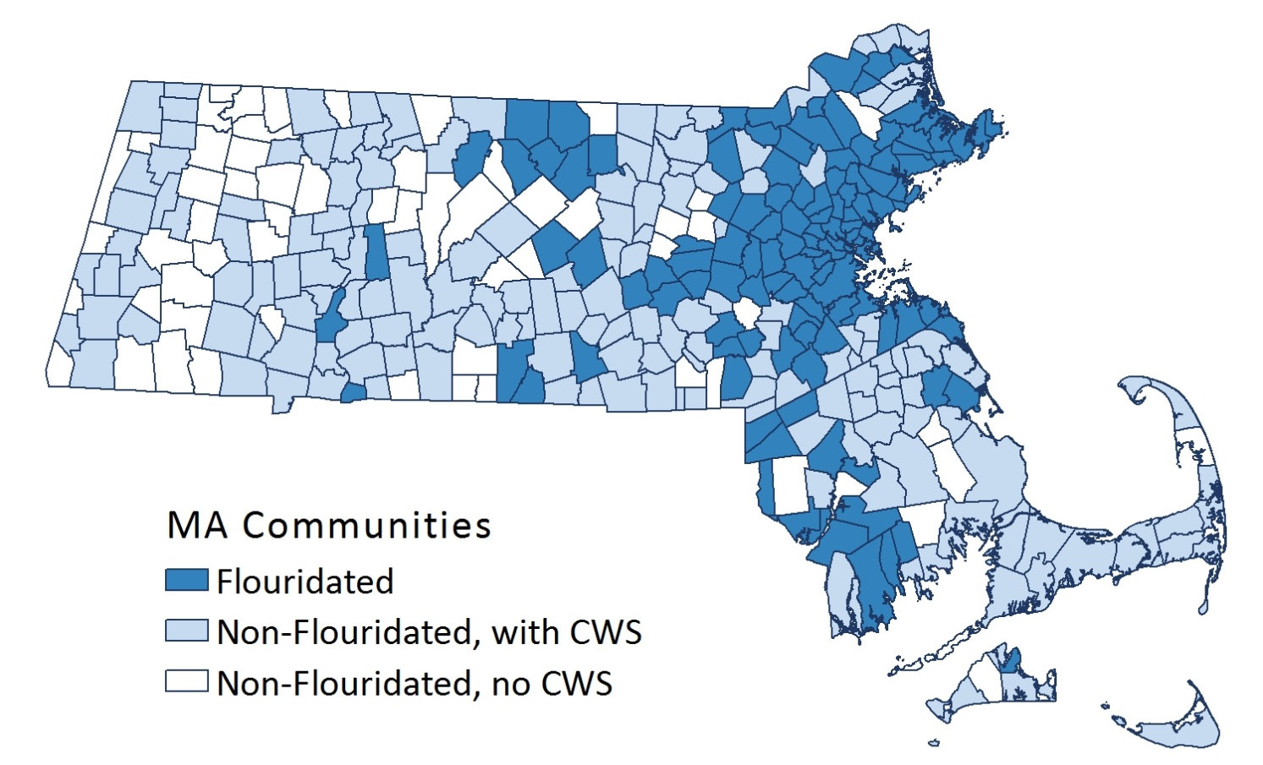

Mental Health
Approximately one out of seven White non-Hispanics, one out of eight Black non-Hispanics, and one out of six Latinos living in Massachusetts reported experiencing a mental health disorder in the last year. Looking at specifics of mental health, Latinos have higher rates of depression and poor self-reported mental health compared to White non-Hispanic, patterns that are not seen in the overall US population. As Massachusetts struggles to address the opioid crisis, one of MDPH’s goals is to improve coordination between substance use disorder and mental health issues. Additonal mental health information can be found in Chapters 5, 6, and 8.

Trends/Disparities

Utilization
Among those with mental illness, Latinos were less likely to receive any mental health care in the last year in Massachusetts, with disparities similar to the rest of the US.

Older Adults
As the number of elderly rises, nearly one in five will suffer from, one or more mental health and/or substance use conditions. One clear trend is the growing risk of avoidable arrest and incarceration. In Massachusetts, approximately 25% of state correctional inmates and up to 50% of county jail and house of correction detainees and inmates receive mental health services. At MCI Framingham, a correctional facility for female offenders, up to 70% of the women awaiting trial or serving sentences receive mental health services.
Disparities also exist in access to mental health services. Emergency Service Programs (ESPs) are community-based, recovery-oriented services which offer behavioral health crisis assessment, intervention, and stabilization services. Currently, only children and adults who receive MassHealth benefits receive coverage for ESP services.

Health Care Workforce
This section describes the health care workforce in Massachusetts in regards to:
- Physicians
- Nurses
- Pharmacists
- Emergency Medical Technicians
- Community Health Workers
- Mental Health Professionals
- Dental workers
Overall, licensure totals indicate a large availability of health-related professionals in the Commonwealth. These health professionals contribute to increasing access to health care in Massachusetts by creating an infrastructure of regulated, skilled workers. While the overall health care workforce trends are generally positive, disparities have been found and are described below.

Trends/Disparities
In summary, Massachusetts health professions licensure totals over the past five years increased 24.7% from Fiscal Year 2011 (193,775 licensees) to Fiscal Year 2015 (241,579 licensees). The number of licensees increased for most health-related professions, with the exception of nursing home administrators and emergency medical services (certified EMTs). Figure 7.12 is an example of the continuing positive trend in attracting health care professionals across all spectrums of the workforce.
Figure 7.12
Trends in the Growth of Total Number of MDPH Licensees, Fiscal Years 2011-2015
 | FY2011 | FY2012 | FY2013 | FY2014 | FY2015 | Δ 11-15 | Δ %
Board of Certification of Community Health Workers * | 0 | 0 | 0 | 0 | 0 | 0 | N/A
Board of Registration in Dentistry | 18,191 | 18,230 | 18,349 | 18,827 | 24,113 | 5,922 | 33%
Board of Registration of Genetic Counselors | 146 | 165 | 170 | 190 | 196 | 50 | 34%
Board of Registration in Naturopathy ** | 0 | 0 | 0 | 0 | 0 | 0 | N/A
Board of Registration of Nursing Home Administrators | 995 | 970 | 1,016 | 986 | 996 | 1 | 0%
Board of Registration in Nursing | 141,934 | 143,756 | 142,555 | 143,638 | 157,225 | 15,291 | 11%
Board of Registration of Perfusionists | 103 | 104 | 114 | 110 | 121 | 18 | 17%
Board of Registration in Pharmacy | 25,902 | 27,158 | 28,673 | 29,721 | 29,935 | 4,033 | 16%
Board of Registration of Physician Assistants | 2,199 | 2,437 | 2,479 | 2,808 | 2,906 | 707 | 32%
Board of Respiratory Care | 2,000 | 1,926 | 2,990 | 2,838 | 3,064 | 1,064 | 53%
Office of Emergency Medical Services (Certified EMTs) | 23,905 | 23,547 | 24,077 | 23,588 | 23,023 | -882 | -4%
Total | 193,775 | 218,293 | 220,423 | 222,706 | 241,579 | 47,804 | 25%
NOTE: *THE BOARD OF CERTIFICATION OF COMMUNITY HEALTH WORKERS WAS ESTABLISHED BY CHAPTER 322 OF THE ACTS OF 2010, WITH AN EFFECTIVE DATE OF JANUARY 1, 2012 AS A RESULT OF STATE HEALTH CARE REFORM AND IS INTENDED TO HELP INTEGRATE COMMUNITY HEALTH WORKERS INTO THE HEALTH CARE AND PUBLIC HEALTH SYSTEMS IN ORDER TO PROMOTE HEALTH EQUITY, COST CONTAINMENT, AND MANAGEMENT AND PREVENTION OF CHRONIC DISEASE. THE BOARD WILL ESTABLISH STANDARDS FOR THE EDUCATION AND TRAINING OF COMMUNITY HEALTH WORKERS AND COMMUNITY HEALTH WORKER TRAINERS, STANDARDS FOR THE EDUCATION AND TRAINING PROGRAM CURRICULA FOR COMMUNITY HEALTH WORKERS, AND REQUIREMENTS FOR COMMUNITY HEALTH WORKER CERTIFICATION AND RENEWAL OF CERTIFICATION. THE BOARD HAS DRAFTED REGULATIONS, CONDUCTED PUBLIC HEARINGS, AND ARE IN THE FINAL REVIEW STAGES FOR SUBMISSION FOR PROMULGATION.
NOTE: **THE BOARD OF REGISTRATION IN NATUROPATHY WAS ESTABLISHED BY MASS GENERAL CHAPTER 112, SECTIONS 266 THROUGH 274 WITH AN EFFECTIVE DATE OF SEPTEMBER 1, 2017. THE BOARD OF REGISTRATION IN NATUROPATHY IS CHARGED WITH EVALUATING THE QUALIFICATIONS OF APPLICANTS FOR LICENSURE AND GRANTING LICENSES TO THOSE WHO QUALIFY AND ESTABLISHING RULES AND REGULATIONS TO ENSURE THE INTEGRITY AND COMPETENCE OF LICENSEES.
NOTE: Δ=CHANGE
Figure 7.13
Trends in the Growth of Total Number of Division of Professional Licensure Licensees,
Fiscal Years (FY) 2011-2015
 | FY2011 | FY2012 | FY2013 | FY2014 | FY2015 | Δ FY 11-15  # | Δ %
Board of Allied Health Professions | 20,845 | 21,415 | 22,022 | 22,650 | 23,746 | 2,901 | 14%
Board of Registration of Chiropractors | 2,114 | 2,140 | 2,145 | 2,124 | 2,115 | 1 | 0%
Board of Registration of Dietitians and Nutritionists | 2,277 | 2,330 | 2,422 | 2,441 | 2,462 | 185 | 8%
Board of Registration of Dispensing Opticians | 1,597 | 1,602 | 1,590 | 1,585 | 1,537 | -60 | -4%
Board of Certification of Health Officers | 108 | 108 | 106 | 105 | 103 | -5 | -5%
Board of Registration of Hearing Instrument Specialists | 161 | 178 | 168 | 490 | 187 | 26 | 16%
Board of Registration of Massage Therapy | 9,322 | 9,621 | 9,785 | 9,887 | 9,799 | 477 | 5%
Board of Registration in Optometry | 1,541 | 1,546 | 1,554 | 1,542 | 1,559 | 18 | 1%
Board of Registration in Podiatry | 551 | 551 | 550 | 541 | 541 | -10 | -2%
Board of Registration of Social Workers | 21,603 | 22,827 | 22,461 | 23,791 | 23,702 | 2,099 | 10%
Board of Registration for Speech-Language Pathology and Audiology | 6,116 | 6,046 | 6,571 | 6,558 | 7,041 | 925 | 15%
Board of Registration in Veterinary Medicine | 2,863 | 2,953 | 2,968 | 2,994 | 2,869 | 6 | 0%
Total | 69,098 | 71,317 | 72,342 | 74,708 | 75,661 | 6,563 | 9%
SOURCE: OFFICE OF CONSUMER AFFAIRS AND BUSINESS REGULATION; NOTE: Δ=CHANGE

Physicians
In another positive trend, the physician to population ratio in Massachusetts rose from 387 per 100,000 in 2007 to 413 per 100,000 in 2014, the highest physician to population ratio in the nation. In 2014, the number of licensed physicians in Massachusetts totaled 27,845. Although the proportion of male physicians (60%) exceeded that for female physicians (40%), the percentage of female physicians in Massachusetts is the highest ratio of any state in the nation.
However, the distribution of physicians across the state is unbalanced as shown in the Figure 7.14. The density of physicians is generally high in eastern portions of the state, particularly areas surrounding the Boston metropolitan area. The density of physicians is much lower in western portions of the state, with many municipalities having very few or even no practicing physicians.
A similar trend is seen with primary care providers. Although Massachusetts has the highest physician to population ratio in the country, differences in availability of providers in rural and urban areas may contribute to disparities in access to care, and poorer health outcomes.

Figure 7.14
Ratio of Population to Physicians, Massachusetts, 2014
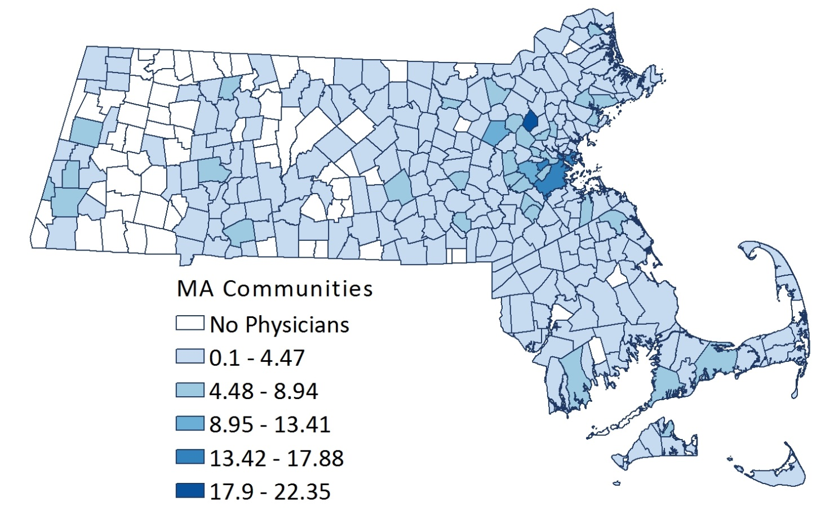

The trend in Massachusetts related to the number of primary care physicians is also positive. In 2014, 5,661 active Massachusetts physicians were categorized as primary care physician—20% of all physicians. Because primary care physicians are more likely to accept new patients and MassHealth insurance, these providers are critical for addressing disparities in the availability of health care.

Figure 7.15
Demographic and Practice Characteristics of Physicians, Primary Care Physicians (PCP) vs. Non-Primary Care Physicians (Non-PCP), Massachusetts, 2014

SOURCE: BOARD OF REGISTRATION IN MEDICINE
The Health Resources and Services Administration (HRSA) uses a primary care physician to population ratio of 1:3,500 or greater as one criterion to define primary care health professional shortage areas (HPSAs). As shown in Figure 7.16, towns and cities with more favorable physician to population ratios were more prevalent in the Boston and Metro West regions, and cities and towns with no physicians were more prevalent in the western and central portions of the state. Massachusetts has four geographic areas that are designated as primary care health professional shortage areas (HPSAs). Figure 7.16 illustrates geographic gaps in the distribution of primary care physicians.

Figure 7.16
Ratio of Primary Care Physicians to Population, Massachusetts, 2014
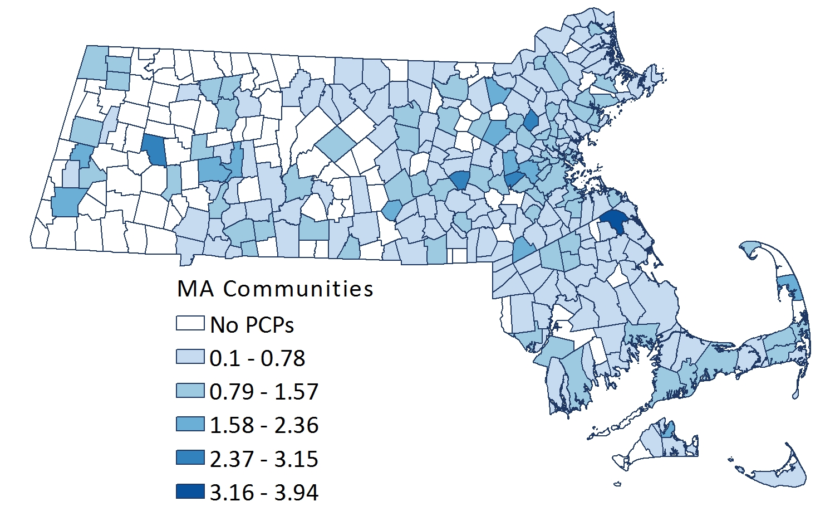
SOURCE: BORIM

Nurses
In 2014, Massachusetts had 123,862 registered nurses, 1,861 RNs per 100,000.
In 2014, there were 11,325 active registered nurses authorized to engage in advanced practice nursing. Approximately 78% of advanced practice registered nurses are nurse practitioners; 11% are nurse anesthetists; 8% are clinical nurse specialists; and 5% are nurse midwives. This represents a larger ratio of advanced practice registered nurses relative to the population than other states.
However, the distribution of nurses across the state is unbalanced as shown in Figure 7.17. The Boston, Metro West, and Northeast regions of the state have a higher ratio of registered nurses to the population, while cities and towns with a lower registered nurse density are located in the western and central regions of Massachusetts.
As shown in Figure 7.18, while the large RN population in Massachusetts may be a positive development, the RNs population may not sufficiently meet the needs of the non-English speaking populations which it serves.
Figure 7.17
Ratio of Registered Nurses to Population, Massachusetts, 2014

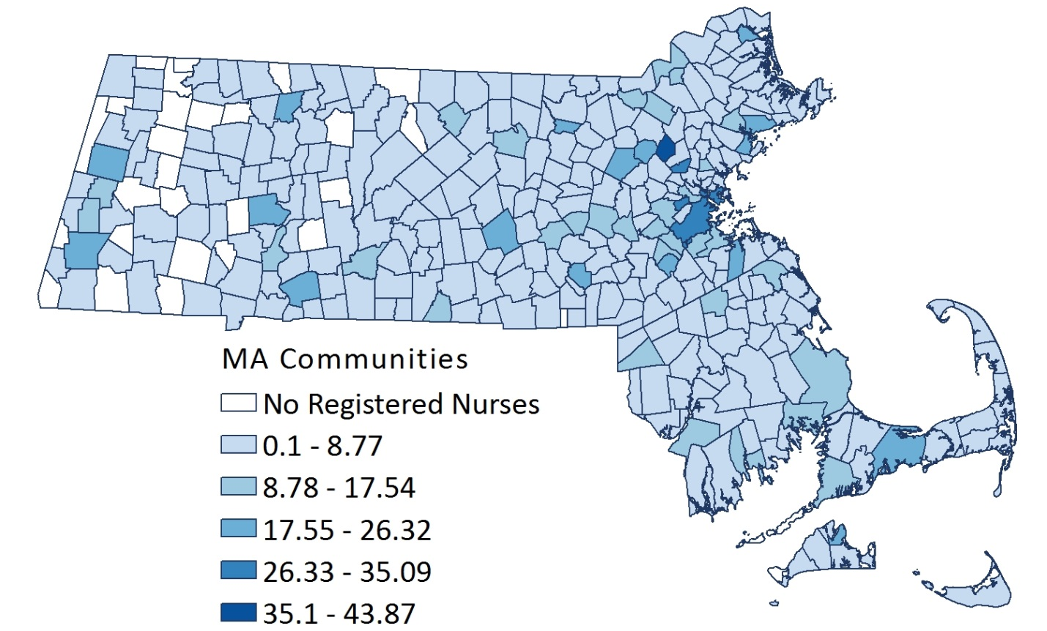

Figure 7.18
Comparison of Registered Nurse Language Fluency to Massachusetts Residents Primary Language,
Massachusetts, 2010-2014

Pharmacists
The pharmacist workforce survey and the Massachusetts Health Professions Data Series indicate that in 2014, Massachusetts had 11,177 licensed pharmacists or 168 pharmacists per 100,000 in population.
As shown in in the Figure 7.19, the distribution of pharmacists across the state is unbalanced. The density of pharmacists is higher in the eastern region of the state, particularly in the greater Boston area. The western and central regions of the state had a lower ratio of pharmacists to population.

Figure 7.19
Ratio of Pharmacists to Population, Massachusetts, 2014
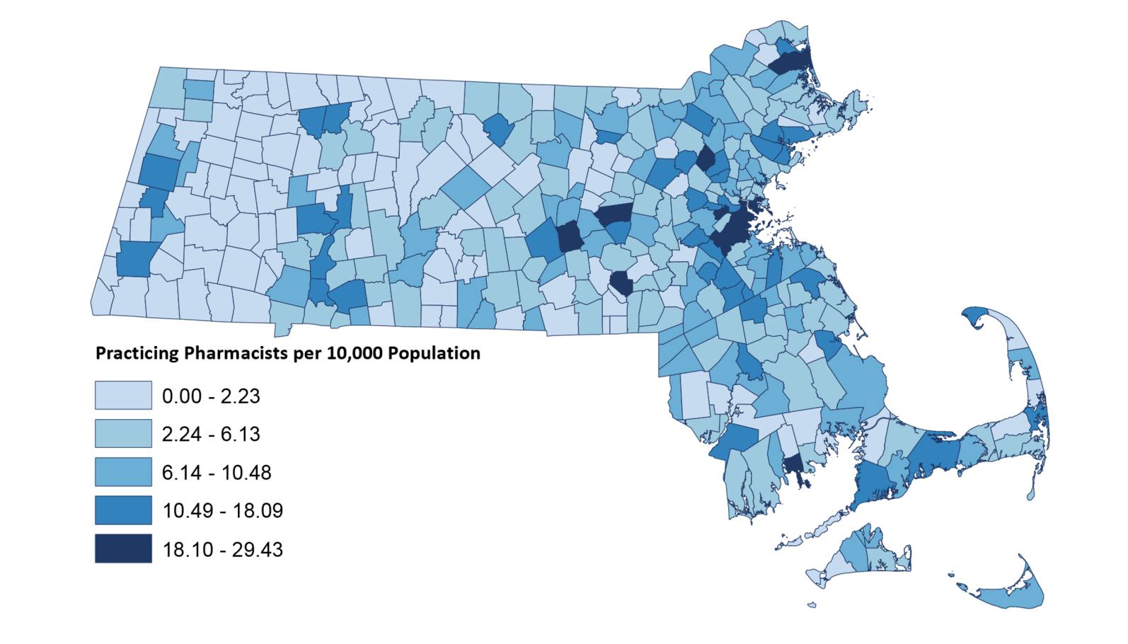

Emergency Medical Technicians
Emergency Medical Technicians (EMT) provide out-of-hospital emergency medical care and transportation for critical and emergent patients who access the emergency medical services (EMS) system. EMTs have the basic knowledge and skills necessary to stabilize and safely transport patients ranging from non-emergency and routine medical transports to life threatening emergencies. Emergency Medical Technicians function as part of a comprehensive EMS response system, under medical oversight.
In 2013, Massachusetts adopted the National Registry of EMTs (NREMT) certification standards which improved the quality of EMT training, while also streamlining the certification and recertification process. In 2017, more than 23,300 certified EMTs, including those with Basic, Advanced EMT, and Paramedic level certification, delivered community level emergency medical services to residents across the Commonwealth. In 2017, Massachusetts had 343.4 EMTs per 100,000 population, a 2.3% decline from 2011.
An increase in training requirements and low compensation contribute to a high rate of turnover among EMTs relative to other health care professions.

Community Health Workers
Community health workers (CHWs) are an essential public health workforce for reaching people in communities who experience the largest burden of health inequities. Community health workers (CHWs) are defined in Massachusetts as public health workers who apply their unique understanding of the experience, language, and/or culture of the populations they serve to carry out one or more of the following roles:
- Providing culturally appropriate health education, information, and outreach in community-based settings, such as homes, schools, clinics, shelters, local businesses, and community centers
- Bridging or culturally mediating between individuals, communities, and health and human services, including actively building individual and community capacity
- Assisting people to access the services they need
- Providing direct services, such as informal counseling, social support, care coordination, and health screenings
- Advocating for individual and community needs
The shared life experiences of CHWs make them uniquely positioned to develop trusting relationships with populations most at risk for poor health outcomes. 58% of CHWs identify as non-White, with 29% identifying as Hispanic, and 19% as Black non-Hispanic. 81% of CHWs are female. CHWs also provide culturally sensitive care. Through the variety of languages spoken, CHWs increase access to care for traditionally language-isolated patients.(Figure 7.20)

Figure 7.20
Languages Spoken among English Speaking Community Health Workers, Massachusetts, 2016

According to Figure 7.21 CHWs serve a variety of populations most at-risk for poor health outcomes due to their social and economic situations. Individuals experiencing housing instability comprise the most commonly served population. Also among the top five populations served are older adults, immigrants/refugees, and high utilizers of health care. CHWs also help people to managing some of the most prevalent chronic conditions including diabetes, hypertension, substance misuse, and behavioral health.

Figure 7.21
Top Populations Served by Massachusetts Community Health Workers in 2016

NOTE: OTHER SPECIAL POPULATiONS INCLUDES NON-ENGLISH SPEAKING POPULATION/IMMIGRANTS, DOMESTIC VIOLENCE SURVIVORS, AND CANCER PATIENTS
By developing trusting peer relationships with patients, CHWs connect people to community services, provide culturally sensitive care coordination for chronic disease management, and referral to preventive services. CHWs on care teams both improve outcomes and reduce costs, notably in terms of urgent care use and hospitalizations. This is especially relevant given that the top populations they serve in Massachusetts are among the highest cost, most at-risk patient groups.

Mental Health Workforce
It is well established that there is a continuing national shortage of qualified behavioral health professionals., The Office of Consumer Affairs and Business Regulation, Board of Allied Mental Health and Human Services Professions oversee licensing of applied behavior analysts, mental health counselors, educational psychologists, marriage and family therapists as well as rehabilitation counselors. Figure 7.22 depicts the number of licensees for Fiscal Year 2015.

Figure 7.22
Total Number of Allied Mental Health and Human Services Licensees, Massachusetts, Fiscal Year 2015
Profession | FY2015
Applied Behavior Analyst | 46
Mental Health Counselor | 5,974
Educational Psychologist | 380
Marriage and Family Therapist | 729
Rehabilitation Counselor | 327
Fiscal Year Total | 7,474

SOURCE: OFFICE OF CONSUMER AFFAIRS AND BUSINESS REGULATION, BOARD OF ALLIED MENTAL HEALTH AND HUMAN SERVICES PROFESSIONS

Dental Workforce
Massachusetts is facing shortages in the geographic distribution of its dental workforce. Dentists, dental hygienist, and public health dental hygienists make up the majority of this workforce which is well represented in the eastern part of the state. Many areas in western and central Massachusetts, however, have few or no dental providers.
Health Professional Shortage Areas (HPSAs) are designations made by the Health Resources and Services Administration (HRSA) that indicate health care provider shortages in primary care, dental health, and mental health. As shown in the Fgure 7.23, Massachusetts currently has seven geographic dental health professionals shortage areas located in the following areas: Dukes County, Nantucket County, Lower Outer Cape, Mid-Cape, Upper Cape, the Hilltowns, and South Berkshire.
Finally, individuals with special health care needs often do not receive needed oral health care due to a lack of dental providers with expertise to treat them. Massachusetts is unique in that it has six specialized dental clinics operated by Tufts Dental Facilities. These facilities serve individuals with intellectual or developmental disabilities. In Fiscal Year 2016, Tufts Dental Facilities served 7,068 patients during more than 24,000 visits.

Figure 7.23
Dental Health Professional Shortage Areas (HPSA), 2017
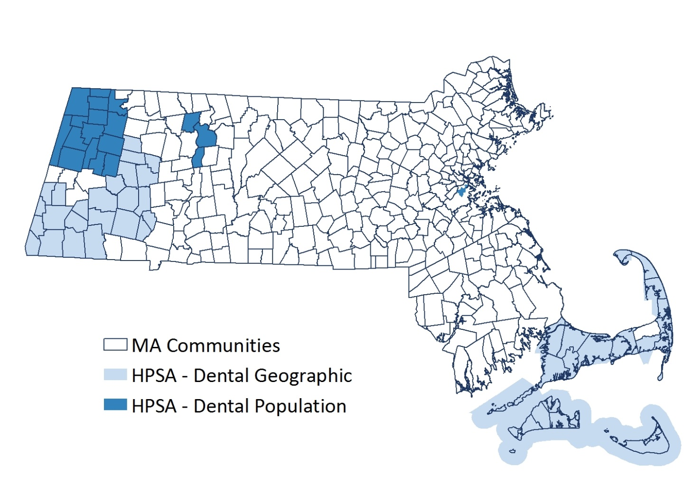
SOURCE : HRSA, DATA WAREHOUSE, SHAPE FILE
NOTE: MAP CURRENT AS OF 8-23-2017

Public Health & Health Care Systems Preparedness
This section discusses public health and health care system preparedness and the network of stakeholders who ensure that public health plans are implemented during emergencies of all types. Local public health has long been involved in public health preparedness for their communities. However, in the wake of post 9/11 events, the 2009 H1N1 pandemic and other novel health threats, public health authorities have been compelled to focus on the need for increased preparedness.
MDPH works to expand the ability to prepare for, respond to, recover from and mitigate the impacts of disasters, infectious disease, terrorism and mass casualty emergencies by:
- Acting as the partnering agency for State Emergency Support Function 8 (public health and medical) during an activation at the state emergency operations center
- Sharing situational awareness with more than 45,700 active users of Listservs which including a wide range of health care
- Reaching more than 9,300 active users of the Health and Homeland Alert Network (HHAN), an alert and notification system to share information about urgent public health and public safety incidents with public information officers, federal, state, territorial, tribal and local public health practitioners, clinicians, and public health laboratories
- Serving as the grantee for the Centers for Disease Control & Prevention (CDC) and the Office of the Assistant Secretary for Preparedness and Response (ASPR) emergency preparedness funding enabling MDPH to financially support regional coordination
- Offering technical support for preparedness including planning, exercises, and trainings for local public health and health care systems partners
- Encouraging the use of Functional Assessments to assist local communities in their planning efforts to integrate considerations for individuals with disabilities and others with access and functional needs into local emergency plans, programs, services and activities.
To ensure integrated planning and capacity-building across five core disciplines—acute care hospitals, community health centers and ambulatory care organizations, emergency medical services, local public health, and long term care—MDPH has created six regional Health and Medical Coordinating Coalitions (HMCCs). Each HMCC conducts cross-disciplinary capabilities-based planning to advance regional health and medical capacity across all phases of the disaster cycle, and the HMCC also ensures 24/7 availability to support information sharing and resource coordination in the event of an emergency within the HMCC Region.
MDPH recognizes that training and exercises are integral to federal, state, and local preparedness efforts. Trainings provide baseline knowledge in terms of duties, roles, and responsibilities as well as current topic-specific information for practitioners. Exercises - - whether discussion or operationally-based - - are designed to engage team members and get them working together to manage the response to a simulated incident and assess plans, policies, and procedures prior to an actual event.
Based on this imperative, MDPH has created a Multi Year Training and Exercise Plan (MYTEP) that serves as the roadmap for MDPH to move towards meeting its emergency preparedness priorities. MDPH has implemented a coordinated all-hazard strategy that combines enhanced planning, innovative training, and realistic exercises to strengthen Massachusetts’ resiliency in preparing for, responding to and recovering from health security incidents and emergencies.

Selected Resources, Services, and Programs
Following are selected resources, services, and programs that support the topics discussed in this chapter.

Workforce Development
- The Massachusetts Loan Repayment Program (MLRP) recruits health professionals working in areas with health profession shortages by providing loan repayment for professionals who agree to commit to practice in eligible health care organizations.
- The J-1 visa waiver program allows international medical graduates to practice in the United States under an educational exchange program for up to seven years in areas that serve the medically underserved populations.
- The MDPH Prescription Monitoring Program collects information on Schedule II through V controlled substances dispensed through a prescription.
- The Local Public Health Institute (Boston University School of Public Health) creates, implements, and sustains workforce development training for local public health and other local health system partners.
- The Collaborative Drug Therapy management (CDTM) is a multidisciplinary process for selecting appropriate drug therapies, educating and monitoring patients, and assessing outcomes of therapy.
- The MDPH supports the Community Health Worker (CHW) work force through technical assistance, certification and funding.
  - MDPH is one of the biggest funders of CHWs in Massachusetts, supporting the ability of CHWs to address chronic disease, environmental health, substance use, maternal health, violence and injury prevention, and HIV/AIDS.
  - The MDPH Office of Community Health Workers supports CHW program development, through technical assistance and best practice guidance on recruitment and hiring, supervision, training, and program evaluation, as well as policy guidance on workforce development and sustainable financing.
  - One of the first professional CHW boards in the nation, the Massachusetts Board of Certification of Community Health Workers provides voluntary certification for CHWs based upon a core set of competencies, and also approves core CHW training programs.
- Founded in 2000, the Massachusetts Association of Community Health Workers (MACHW) is a statewide professional organization which strengthens the professional identity of CHWs, fosters leadership among CHWs, and promotes the integration of CHWs into the health care, public health and human service workforce.
- Training is available through a variety of experienced organizations which specializes in core competency training and professional development opportunities for community health workers. Examples of established CHW training programs in MA include the Community Health Education Center (Lowell), Community Health Education Center (Boston), Center for Health Impact’s Outreach Worker Training Institute (OWTI), Holyoke Community College, Western Massachusetts Public Health Training Center, and the Massachusetts Department of Public Health’s Patient Navigator Hybrid Training.

Health Care Safety
MDPH monitors the safety of care provided in licensed health care facilities by investigating consumer complaints and conducting on-site surveys to ensure adherence to federal and state requirements.
Licensure regulations that specify the requirements for a hospital to become a designated Primary Stroke Services (PSS), include:
- Stroke protocols for patient assessment and care
- Continuous education of the public about warning signs and symptoms of stroke
- Emergency diagnostic and therapeutic services available 24/7/365 to patients presenting with symptoms of acute stroke
- An alternate point of entry plan for ambulances that requires the transport of patients presenting with symptoms of acute stroke to the nearest designated Primary Stroke Services hospital

Local and Regional Public Health
- The MDPH Office of Local and Regional Health provides funding and leadership to strengthen the capacity of local Boards of Health to meet their legal responsibilities to protect the health of their communities and supports external partners in strengthening local public health capacity and building a skilled local public health workforce by supporting:
  - The Local Public Health Institute at the Boston University School of Public Health) which creates, implement, and sustain workforce development training for local public health and other local health system partners
  - Legal technical assistance to local boards of health through the Massachusetts Association of Health Boards
- The Coalition for Local Public Health (CLPH), represents the five statewide public health organizations: Massachusetts Health Officers Association, Massachusetts Association of Public Health Nurses, Massachusetts Environmental Health Association, Massachusetts Public Health Association, and Massachusetts Association of Health Boards. The goal of the coalition to advocate for, promote, and strengthen the Massachusetts local public health system.

Medical Marijuana
- The MDPH Medical Use of Marijuana program provides processing and approval of applications for medical marijuana dispensaries.
- The MDPH Bureau of Environmental Health provides testing of medical marijuana products for safety.

Community Health Workers (CHW)
- The MDPH supports the CHW work force in a variety of ways – both through technical assistance, certification and funding.
  - MDPH is one of the biggest funders of CHWs in Massachusetts, supporting CHWs to address chronic disease, environmental health, substance use, maternal health, violence and injury prevention, and HIV/AIDS.
  - The MDPH Office of Community Health Workers supports CHW program development, through technical assistance and best practice guidance on recruitment and hiring, supervision, training, and program evaluation, as well as policy guidance on workforce development and sustainable financing.
  - One of the first professional CHW boards in the nation, the Massachusetts Board of Certification of Community Health Workers provides voluntary certification for CHWs based upon a core set of competencies, and also approves core CHW training programs.
- Founded in 2000, the Massachusetts Association of Community Health Workers (MACHW) is the statewide professional organization that strengthens the professional identity of CHWs, fosters leadership among CHWs, and promotes the integration of CHWs into the health care, public health and human services workforce.
- Training is available through a variety of experienced organizations that specializes in core competency training and professional development opportunities for community health workers. Examples of established CHW training programs in MA include: Community Health Education Center (Lowell), Community Health Education Center (Boston), Center for Health Impact’s Outreach Worker Training Institute (OWTI), Holyoke Community College, Western Massachusetts Public Health Training Center, and the Massachusetts Department of Public Health’s Patient Navigator Hybrid Training.

Mental Health
- The primary responsibility of mental health facilities in Massachusetts is the Department of Mental Health.
- The primary responsibility of licensing mental health providers is the Office of Consumer Affairs and Business Regulation, Board of Allied Mental Health and Human Services Professions.
- Other organizations like National Alliance on Mental Illness (NAMI) partner in a variety of ways to improve mental health including:
  - Collaborating with the Municipal Police Training Committee (MPTC) and the Department of Mental Health (DMH) to develop and launch a new mental health curriculum for all municipal police recruits
    - Partnering with the Somerville and Cambridge Police Departments to develop a Regional Crisis Intervention Training and Technical Assistance Center
    - Developing of local collaborations between police departments, behavioral health providers, and other stakeholders
    - Establishing of a Statewide Advisory Group on Criminal Justice Diversion
    - Developing a Cross-System Information Sharing Project with the Cambridge Police Department, the Department of Mental Health (DMH) and Harvard Law School

Oral Health
- The Perinatal and Infant Oral Health Quality Improvement grant program to expand the integration of quality oral health care into perinatal and infant primary care delivery systems statewide.
- The MDPH Oral Health Equity Project focuses on increasing childhood utilization of oral health services (up to age 14) in Worcester and Holyoke, two cities known for disparate oral health outcomes. The project is focused on engaging Black and Hispanic families through outreach and education.
- The MDPH Office of Oral Health operates school-based sealant programs where dental hygienists provide health screenings, oral health education, dental sealants and fluoride, and referrals for follow-up dental care screening, cleanings and recommended coating to adult teeth to prevent cavities while in public schools.

Public Health and Health Care System Preparedness
- MA Responds is an online registration system for public health, health care, and emergency response volunteers. Currently, 45 Medical Reserve Corps utilize this system to validate credentials, coordinate, and activate more than 8,000 volunteers.
- MDPH uses WebEOC, a web-based communications platform to support situational awareness during an emergency incident. The system allows for active communication of facility status and incident status among multiple organizations.
- MDPH provides funding to the DelValle Institute for emergency preparedness to provide interactive, all-hazards education focused on reducing the public health and safety impact of emergencies and disasters.
- Massachusetts Virtual Epidemiologic Network (MAVEN) is a web-based disease surveillance and case management system that allows MDPH and local health to capture and transfer appropriate public health, laboratory, and clinical data efficiently and securely over the internet in real-time. This is particularly helpful during outbreaks of communicable diseases and foodborne illness.
- MDPH provides funding for the Local Public Health Institute to create, implement, and sustain workforce development activities for local public health and other public health system partners.
- Each year MDPH sponsors a statewide campaign for Emergency Preparedness Month to encourage Massachusetts residents, families and communities to make plans and prepare for public health and medical emergencies, threats and disasters.

References

Kaiser Family Foundation estimates based on the Census Bureau's March 2014, March 2015, and March 2016 Current Population Survey (CPS: Annual Social and Economic Supplements).
Black LI, Schiller JS. State variation in health care service utilization: United States, 2014. NCHS data brief, no 245. Hyattsville, MD: National Center for Health Statistics. May 2016.
Kaiser Family Foundation. Available at: http://www.kff.org/disparities-policy/issue-brief/beyond-health-care-the-role-of-social-determinants-in-promoting-health-and-health-equity/. Accessed July 20, 2017.
CDC, Healthy People 2020. Available at: https://www.healthypeople.gov/2020/topics-objectives/topic/Access-to-Health-Services#2. Accessed July 20, 2017.
Institute for Clinical and Economic Review. Community Health Workers: A Review of Program Evolution, Evidence of Effectiveness and Value, and Status of Workforce Development in New England. The New England Comparative Effectiveness Advisory Council. Boston, Massachusetts: July, 2013.
Massachusetts Department of Public Health; Bureau of Health Statistics, Research, and Evaluation; Division of Research and Epidemiology. Racial and Ethnic Health Disparities by EOHHS Regions in Massachusetts, 2007. Available at: http:// www.mass.gov/eohhs/docs/dph/research-epi/disparity-report.pdf. Accessed July 20, 2017.
Moy E, Chang E, Barrett M. Potentially preventable hospitalizations – United States, 2001-2009. Morbidity and Mortality Weekly Report. 2013; 62(3): 139-143. Available at: https://www.cdc.gov/mmwr/preview/mmwrhtml/su6203a23.htm Accessed July 7, 2017.
Moy E, Chang E, Barrett M. Potentially preventable hospitalizations – United States, 2001-2009. Morbidity and Mortality Weekly Report. 2013; 62(3): 139-143. Available at: https://www.cdc.gov/mmwr/preview/mmwrhtml/su6203a23.htm. Accessed July 7, 2017.
Nyweide DJ, Anthony DL, Bynum JPW. Continuity of care and the risk of preventable hospitalization in older adults. JAMA Internal Medicine. 2013; 173(20)1879-1885.
Johnson PJ, Ghildayal N, Ward AC, Westgard BC, Boland LL, Hokanson JS. Disparities in potentially avoidable emergency department (ED) care: ED visits for ambulatory care sensitive conditions. Medical Care. 2012; 50(12): 1020-1028.
Galarraga JE, Pines JM. Costs of ED episodes of care in the United States." The American Journal of Emergency Medicine. 2016; 34(3): 357-365.
Smulowitz PB, Lipton R, Wharam JF et al., Emergency department utilization after the implementation of Massachusetts health reform. Annals of Emergency Medicine. 2011; 58(3): 225-234.e1.
Taubman SL, Allen HL, Wright BJ, et al. Medicaid increases emergency department use: Evidence from Oregon’s health insurance experiment. Science. 2014; 343(6168): 263-268.
The definition for falls was broadened to include those that resulted in serious injury or death while previously the definition had included only those where disability or death occurred.
Adult Coronary Artery Bypass Graft Surgery in the Commonwealth of Massachusetts, Fiscal Year 14 Report. Available at: http://www.massdac.org/wp-content/uploads/CABG-FY2014.pdf. Accessed on July 9, 2017.
Grieb, J, Clark, M, Regional Public Health Emergency Preparedness: The Experience of Massachusetts Region 4b, Public Health Rep. 2008 Jul-Aug; 123(4): 450–460.
Nelson, R. G. (2008). Periodontal disease and diabetes. Oral diseases, 14(3), 204-205.
Preshaw, P. M., Alba, A. L., Herrera, D., Jepsen, S., Konstantinidis, A., Makrilakis, K., & Taylor, R. (2012). Periodontitis and diabetes: a two-way relationship. Diabetologia, 55(1), 21-31.
Nasseh, K., Vujicic, M., & Glick, M. (2017). The relationship between periodontal interventions and healthcare costs and utilization. Evidence from an integrated dental, medical, and pharmacy commercial claims database. Health economics, 26(4), 519-527.
Jackson, S. L., Vann Jr, W. F., Kotch, J. B., Pahel, B. T., & Lee, J. Y. (2011). Impact of poor oral health on children's school attendance and performance. American Journal of Public Health, 101(10), 1900-1906.
MDPH, Youth Risk Behavioral Surveillance System, 2015.
MDPH, Behavioral Risk Factor Surveillance System, 2014.
MDPH, Pregnancy Risk Assessment and Monitoring System, 2013-2015.
MDPH, Massachusetts Statewide Oral Health Assessment of Seniors, 2009.
CDC, Community Water Fluoridation. Available at: https://www.cdc.gov/fluoridation/index.html. Accessed August 9, 2017.
The Massachusetts Health Policy Forum, Issues Brief: The Time is Now: Tackling Racial and Ethnic Disparities in Mental and Behavioral Health Services in Massachusetts, 2014.
Ibid
NAMI, Expanding Our Vision: Efforts to Decriminalize Addiction Must Include Mental Health. Available at: http://namimass.org/wp-content/uploads/AdvocacyDayPaper_singlepages_2FINAL.pdf. Accessed August 6, 2017.
MDPH, Data Brief: Health Professions Data Series – Physicians 2014. Available at: http://www.mass.gov/eohhs/docs/dph/com-health/primary-care/massachusetts-health-professions-data-series-physicians-2014.pdf. Accessed August 6, 2017.
Halpern, M. T. (2010). Adequacy of the Supply and Factors Influencing Potential Shortages Among Emergency Medical Technicians and Emergency Medicine Physicians Project Leads Statement of Problem. Available at: https://sites.duke.edu/ihss/files/2011/12/Halpern_ResearchBrief.pdf. Accessed July 17, 2017.
MDPH, BCHAP, Office of Community Health Workers, Available at: http://www.mass.gov/eohhs/gov/departments/dph/programs/community-health/prevention-and-wellness/comm-health-wkrs/chw-definitions.html. Accessed August 6, 2017.
MDPH, CHW Workforce Surveillance Survey, 2016.
Ibid
Ibid
Institute for Clinical and Economic Review. Community Health Workers: A Review of Program Evolution, Evidence of Effectiveness and Value, and Status of Workforce Development in New England. The New England Comparative Effectiveness Advisory Council. Boston, Massachusetts: July, 2013.
The Annapolis Coalition on Behavioral Workforce Development, An Action Plan for Behavioral Workforce Development. Available at: http://annapoliscoalition.org/wp-content/uploads/2013/11/action-plan-full-report.pdf. Accessed August 6, 2017.
Blue Cross Blue Shield of Massachusetts Foundation. Accessing Children’s Mental Health Services in Massachusetts. Workforce Capacity Assessment, October 2009. Available at: https://bluecrossmafoundation.org/sites/default/files/091029CBHReportForWeb.pdf. Accessed August 6, 2017.
NAMI, Expanding Our Vision: Efforts to Decriminalize Addiction Must Include Mental Health. Available at: http://namimass.org/wp-content/uploads/AdvocacyDayPaper_singlepages_2FINAL.pdf. Accessed August 6, 2017.

