An example of a dime-sized stool sample in a collection bottle showing the limit for the stool size.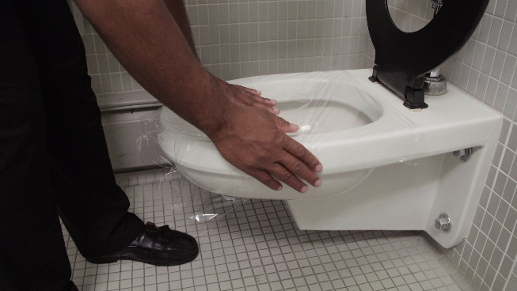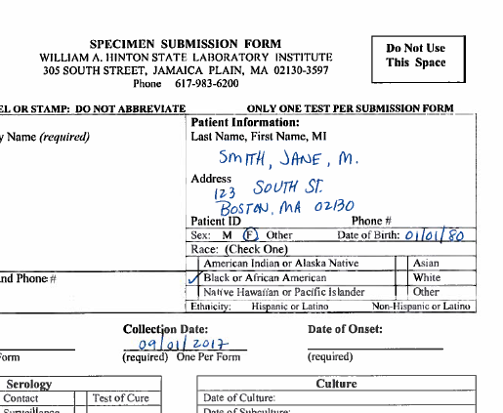

**How to Collect   
a Stool Sample**

When a foodborne illness outbreak is identified, the Massachusetts Department of Public Health works with local health departments and food establishments to find the source of the contaminated food or drink to prevent additional people from getting sick. As part of the outbreak investigation, the local health department visits the site that may be the source of the outbreak to interview employees and guide them through the process of collecting stool samples. The sample will be tested for foodborne pathogens to identify what may have caused the outbreak. If your test result is positive, you may be required to submit more stool samples to ensure you are healthy before you return to work.

Following the 4 steps in these instructions will guide you in collecting a useful stool sample for the laboratory and prevent the spread of foodborne illness.

**Step 1 – Fill out the Form**

* **Print your name, date of birth and address very clearly on the form included in the canister. Include the date when you collected the sample.**
* **If you have any symptoms, indicate the date when they began.**
* **Print your name and date of birth on the label of the sample bottle.**
* **Make sure your name and other information is the same on the form and the sample bottle.**

**Step 2 – Prep**

* **Wash your hands thoroughly before you start.**
* **Lift the toilet seat and place plastic wrap around the brim of the toilet. Use tape to secure the plastic wrap in place if necessary.**
* **Place the toilet seat down and make a small dip in the plastic for the stool to collect. Then poop onto the plastic wrap.**

**Step 3 – Collection**

* **Use the spoon in the sample bottle to collect a piece of stool no larger than a dime and place it in the bottle.**
* **Close the lid tightly.**
* **Place the sample bottle in the canister, along with the completed form.**
* **Wash your hands again thoroughly.**

**Step 4 – Return the Sample**

* **Return the canister to your facility manager or designated point person as soon as possible.**

**Tips to ensure your sample will be accepted for testing:**

* Make sure your name and date of birth are written the same on the canister label and the paperwork.
* Don’t provide too much sample or wait too long to submit your sample.
* If you are taking antibiotics, you cannot submit a sample until 48 hours after your last dose.

*If you have any questions, please contact your local health department.*