Accommodation Rate Expenditure Report

Accommodation Rate Expenditure Report – Input screen
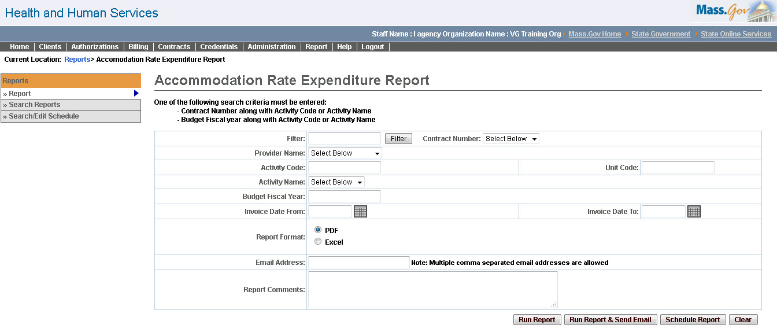

Accommodation Rate Expenditure Report – Output screen
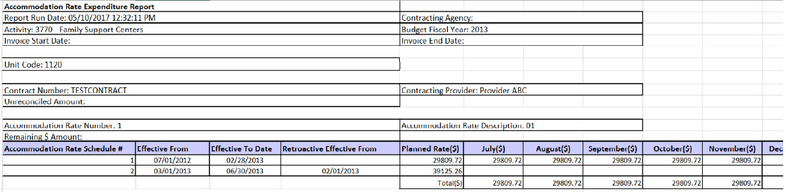
Report Description
Provides a snapshot of the expenditure per contract, per accommodation rate, per accommodation rate schedule thus making the data readily available to the users.

Report Benefit
Allows the user to view the expenditures for each of the months per unit code per AR Rate Schedule.

Required Parameters
- Contract Number
- Activity Code or Activity Name
- Report Format
OR
- Budget Fiscal year
- Activity Code or Activity Name
- Report Format

Scheduling
Yes

Agency Roles
AR Accounting Payment Manager, AR Payment Reviewer

Provider Roles
AR Billing, AR Review

Operation Roles
N/A
This information is provided by the Virtual Gateway within Health and Human Services.

