Activity PRC Details by Service Code

Activity PRC Details by Service Code – Input screen
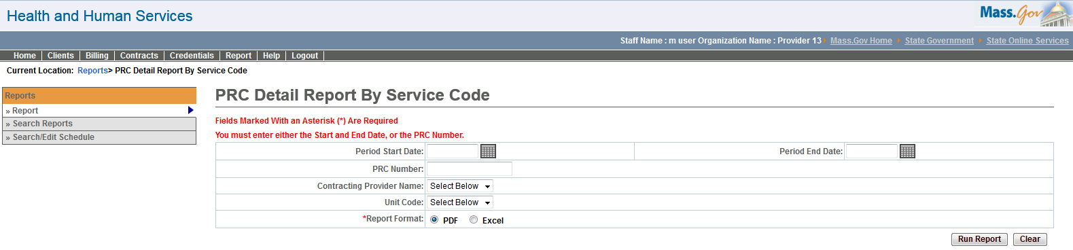

Activity PRC Details by Service Code – Output screen
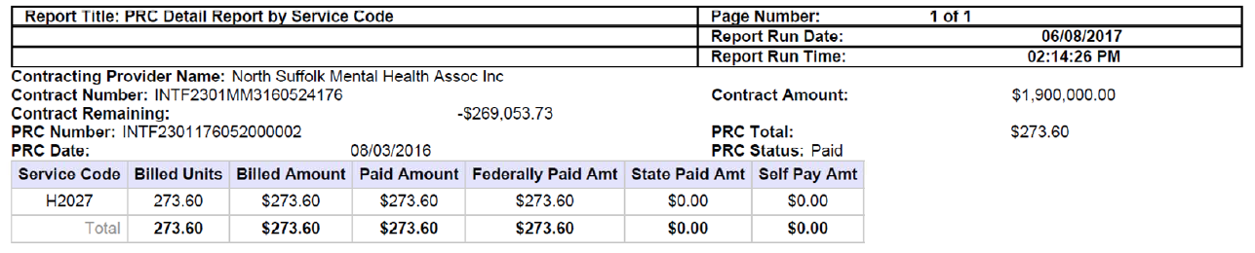

Report Description
Provides payment information per service code.

Report Benefit
This report will help the user to retrieve state, federal and self-paid amounts for each service code within a payment file. The user can select a date range within which all payment files would be retrieved, or specify an individual payment file.

Required Parameters

Period Start Date

Period End Date

Report Format

OR

PRC Number

Report Format

Scheduling
No

Agency Roles
UR Reports DI

Provider Roles
Contract and Payment Reviewer

Operation Roles
N/A
This information is provided by the Virtual Gateway within Health and Human Services.

