Activity PRC Details by Sub-Activity

Activity PRC Details by Sub-Activity – Input screen
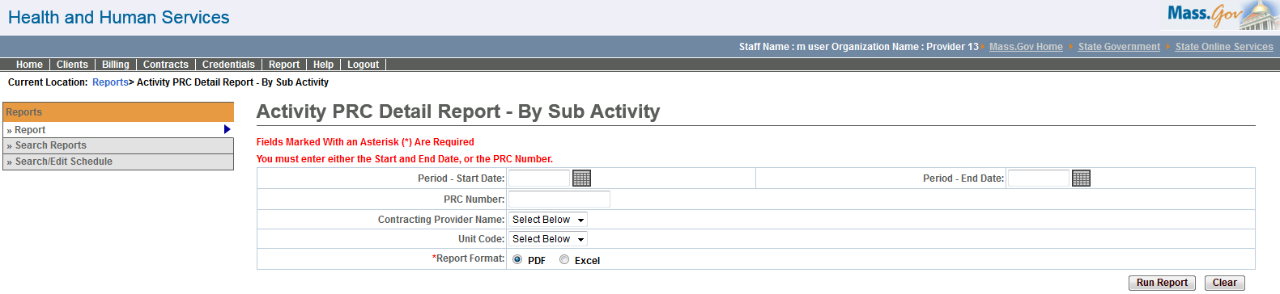

Activity PRC Details by Sub-Activity – Output screen
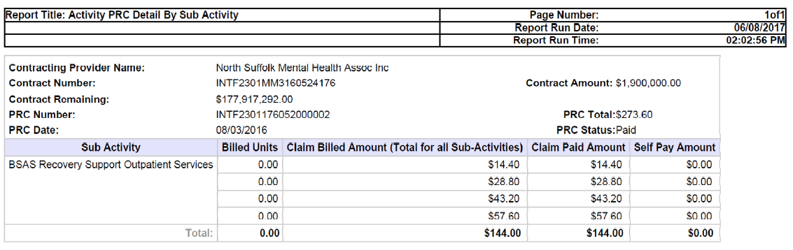
Report Description
Provides payment information per sub-activity.

Report Benefit
This report will help the user to retrieve the paid amount corresponding to all services for a sub-activity. The user can select a date range within which all payment files would be retrieved, or specify an individual payment file.

Required Parameters

1. Period Start Date

2. Period End Date

3. Report Format

OR

1. PRC Number

2. Report Format

Scheduling
No

Agency Roles

CR Report

Provider Roles
Contract and Payment Reviewer, CR Authorize, CR Billing, CR Review

Operation Roles
VG Support
This information is provided by the Virtual Gateway within Health and Human Services.

