CIES Budgeting Report

CIES Budgeting Report – Input screen
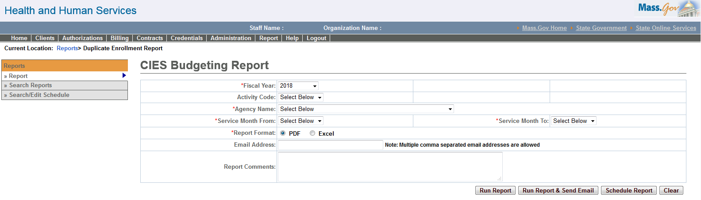

CIES Budgeting Report – Output screen
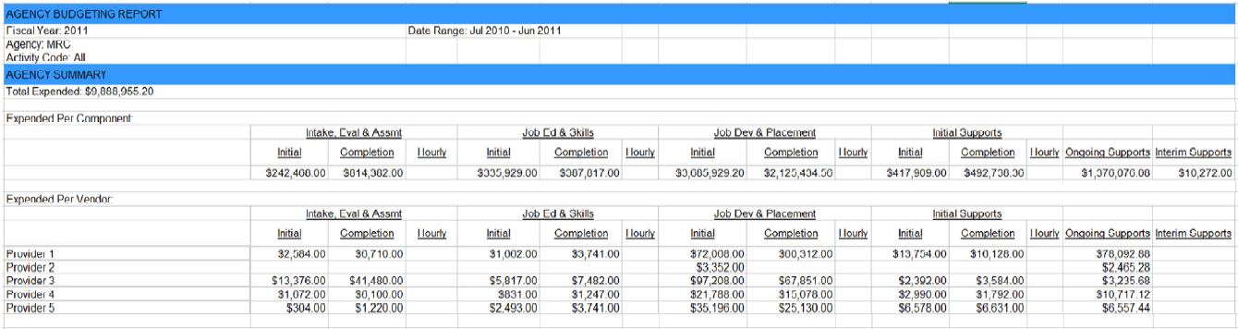
Report Description
CIES Budgeting report provides a summary of the amount paid for services per component per service and per provider per service for the CIES activities. These are grouped per service code.

Report Benefit
Allows the user to view the total amounts spent across each service per Vendor for the CIES activities.

Required Parameters

1. Fiscal Year

2. Agency Name

3. Service Month From

4. Service Month To

5. Report Format

Scheduling
Yes

Agency Roles
UR Reports

Provider Roles
NA

Operation Roles
NA
This information is provided by the Virtual Gateway within Health and Human Services.

