Client Enrollment Status Report (DI)

Client Enrollment Status Report (DI) - Input screen
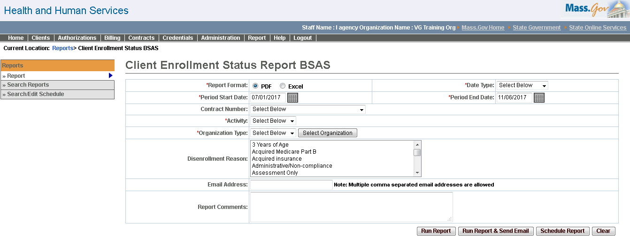
Client Enrollment Status Report (DI) - Output screen
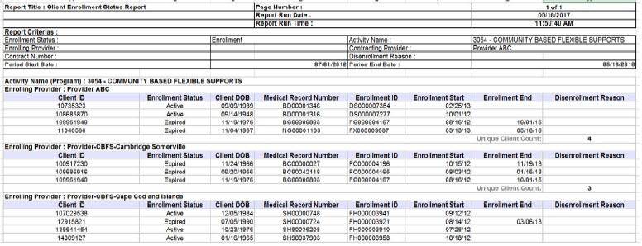
Report Description

Lists clients enrolled within a specified timeframe and may be used to confirm enrollments, identify clients who have not received services, and/or to assess capacity usage

Report Benefit
Provides a list of clients enrolled within some specified timeframe. This version of the report without client identification information is to be used by BSAS agency users.

Required Parameters

Report Format

Date Type

Period Start Date

Period End Date

Activity

Organization Type

Scheduling
Yes

Agency Roles
UR Reports, Quality Assurance Manager

Provider Roles
N/A

Operation Roles
VG Support

This information is provided by the Virtual Gateway within Health and Human Services.

