Client Enrollment Status Report

Client Enrollment Status Report – Input screen
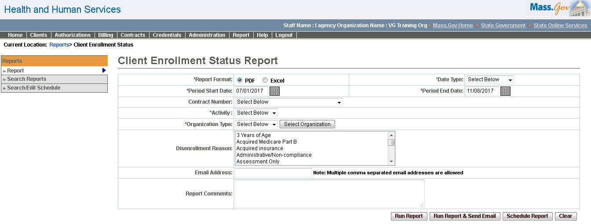

Client Enrollment Status Report – Output
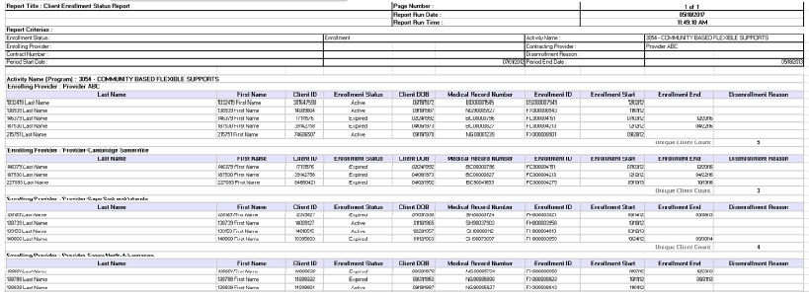
Report Description
Lists clients enrolled within a specified timeframe and may be used to confirm enrollments, identify clients who have not received services, and/or to assess capacity usage.

Report Benefit
Provides a list of clients enrolled within some specified timeframe. Can be used to identify clients that have been enrolled that have not received services, to confirm enrollments, to identify clients that have disenrolled and referred to another program (activity) and to assess organization capacity usage.

Required Parameters
- Report Format
- Date Type
- Period Start Date
- Period End Date
- Activity
- Organization Type

Scheduling
Yes

Agency Roles
UR Reports, Quality Assurance Manager

Provider Roles
Client Data Manager, Client Data Reviewer, UR Billing Centralized, UR Billing Decentralized, UR Release, UR Authorize, UR Review, ESM Manager

Operation Roles
N/A

This information is provided by the Virtual Gateway within Health and Human Services.

