Client Utilization Report

Client Utilization Report – Input screen
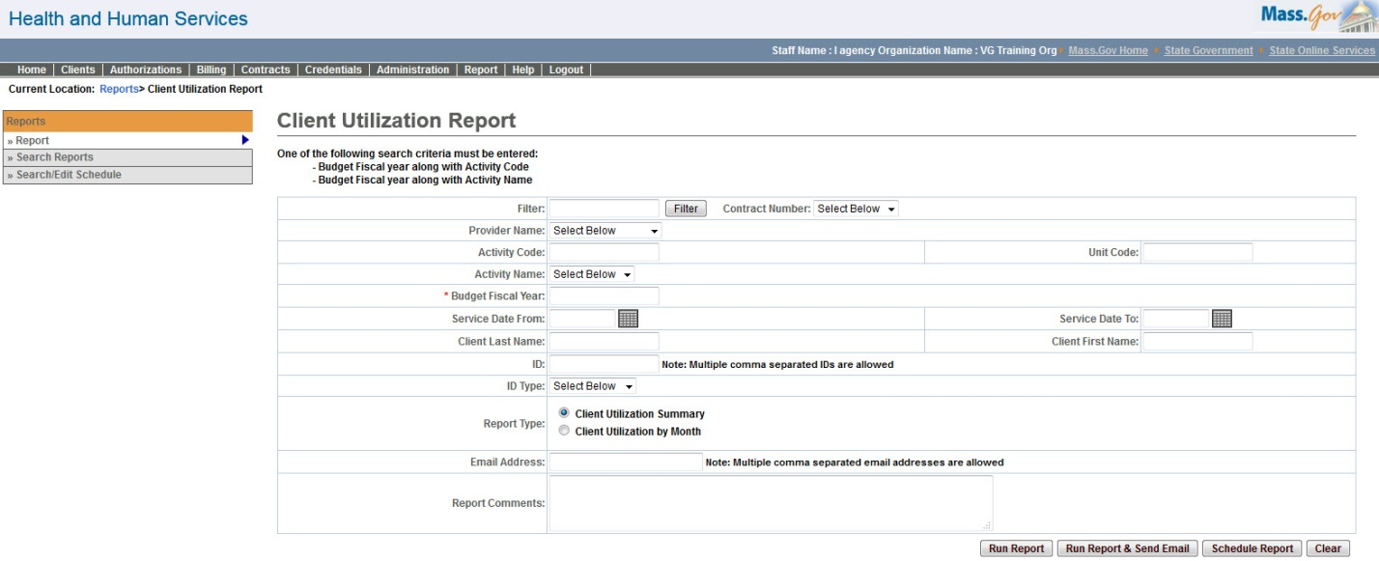

Client Utilization Report – Output screen
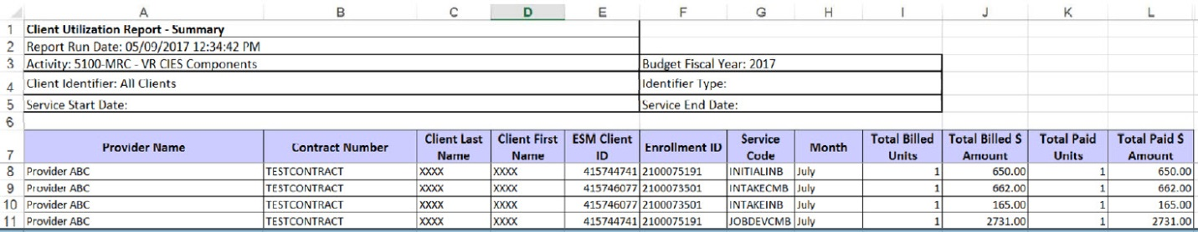
Report Description
Client Utilization report provide a snapshot of the data per provider, per activity, per service code, per client or contract, thus making the data readily available to the users.

Report Benefit
Allows the user to view billed v/s paid service units & amounts per client.

Required Parameters

Budget Fiscal year

Activity Code or Activity Name

Report Type

Scheduling
Yes

Agency Roles
UR Reports

Provider Roles
AR Billing, AR Review, AR Billing, CR Review, UR Billing Centralized, UR Billing Decentralized, UR Review

Operation Roles
N/A
This information is provided by the Virtual Gateway within Health and Human Services.

