Commodity Based Payment Request Report

Commodity Based Payment Request Report – Input screen
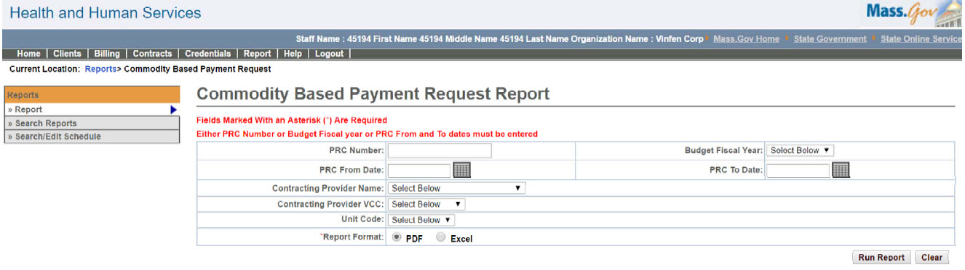

Commodity Based Payment Request Report – Output screen
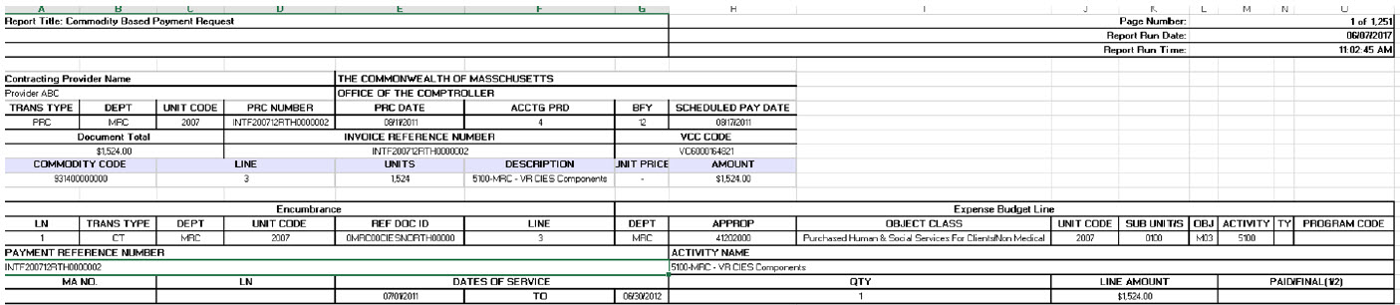
Report Description
N/A

Report Benefit
N/A

Required Parameters

1. PRC Number

2. Report Format

OR

1. Budget Fiscal Year

2. Report Format

OR

1. PRC From Date

2. PRC To Date

3. Report Format

Scheduling
No

Agency Roles

CR Reports, UR Reports

Provider Roles
CR Authorize, CR Review, CR Billing, UR Release, UR Authorize, UR Review, UR Billing Centralized, UR Billing Decentralized

Operation Roles
VG Support
This information is provided by the Virtual Gateway within Health and Human Services.

