Contract Utilization Report

Contract Utilization Report - Input screen
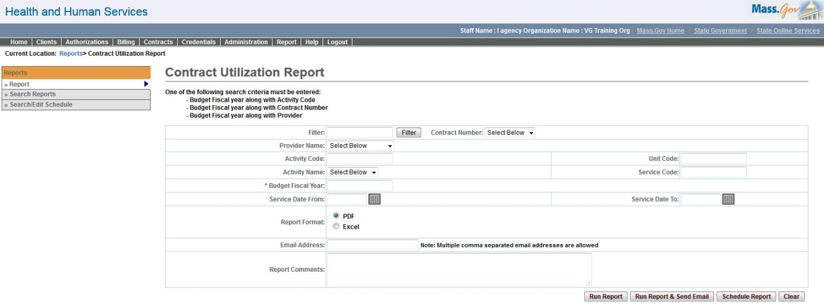

Contract Utilization Report - Output screen
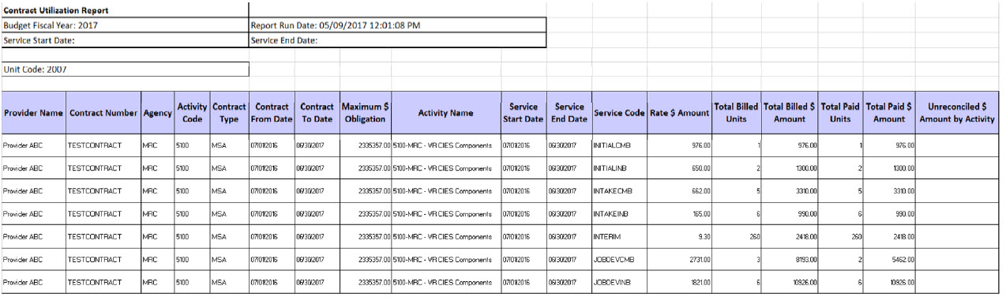
Report Description
Contract Utilization Report provides a snapshot of the data per provider, per activity, per service code, per client or contract, thus making the data readily available to the users.

Report Benefit
Allows the user to view billed v/s paid service units & amounts per contract. It also displays the unreconciled amounts for a contract.

Required Parameters

Budget Fiscal year

Activity Code or Contract Number or Provider

Report Format

Scheduling
Yes

Agency Roles
Contract Manager, Contract Reviewer

Provider Roles
Contract and Payment Reviewer

Operation Roles
N/A
This information is provided by the Virtual Gateway within Health and Human Services.

