Cost Reimbursement Budget

Cost Reimbursement Budget – Input screen
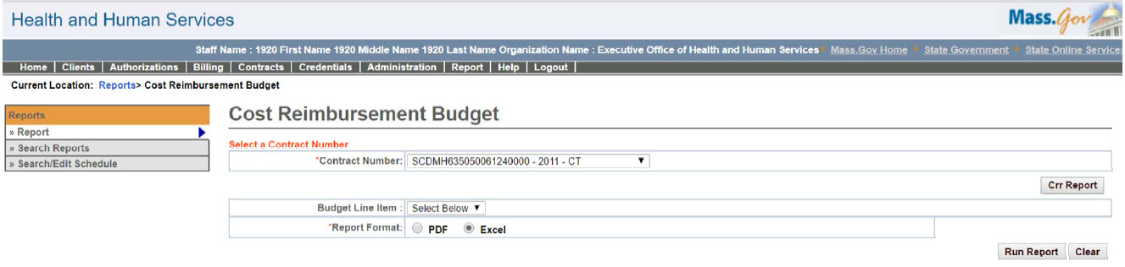

Cost Reimbursement Budget – Output screen
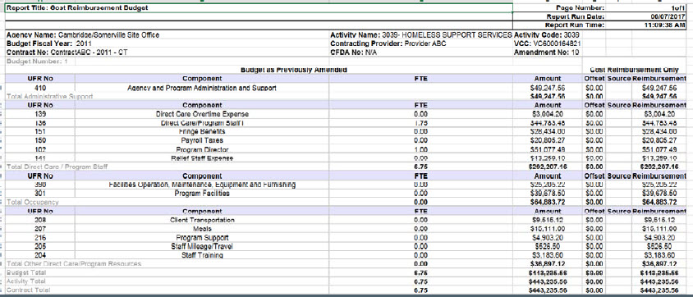
Report Description
Provides cost reimbursement line item budget details.

Report Benefit
Allows the user to retrieve information for each line item budget on a Cost contract. This report will provide cumulative billing information on a cost contract with respect to each line item budget.

Required Parameters
- Contract Number
- Report Format

Scheduling
No

Agency Roles
CR Reports

Provider Roles
CR Authorize, CR Review, CR Billing

Operation Roles
N/A
This information is provided by the Virtual Gateway within Health and Human Services.

