Cost Reimbursement Expenditure Analysis

Cost Reimbursement Expenditure Analysis – Input screen
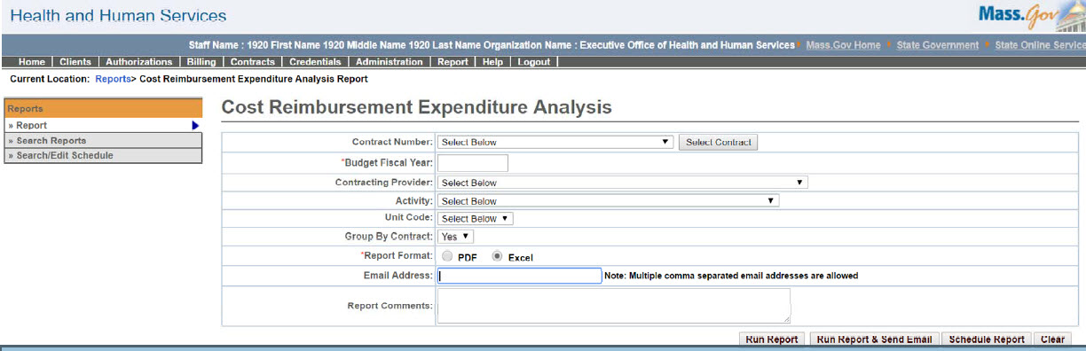

Cost Reimbursement Expenditure Analysis – Output screen
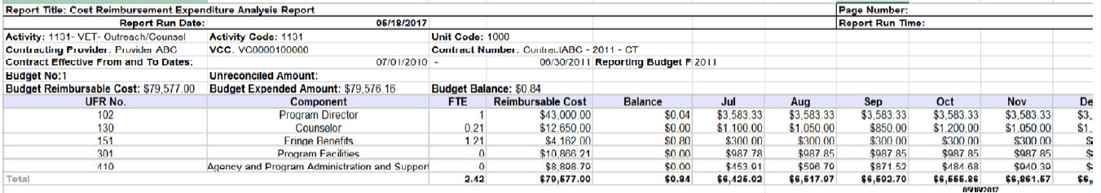
Report Description
Provides a fiscal year view to billing against UFR components for a specific contract.

Report Benefit
This report provides a detailed month-by-month expenditure analysis for each UFR component on a cost contract.

Required Parameters
- Budget Fiscal Year
- Report Format

Scheduling
Yes

Agency Roles
CR Reports

Provider Roles
CR Authorize, CR Review, CR Billing

Operation Roles
N/A
This information is provided by the Virtual Gateway within Health and Human Services.

