Cost Reimbursement Invoice

Cost Reimbursement Invoice – Input screen
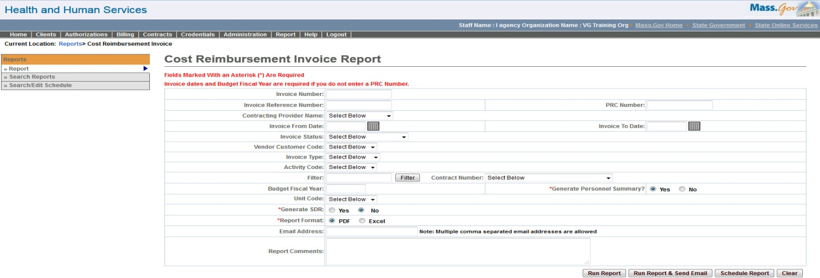

Cost Reimbursement Invoice – Output screen
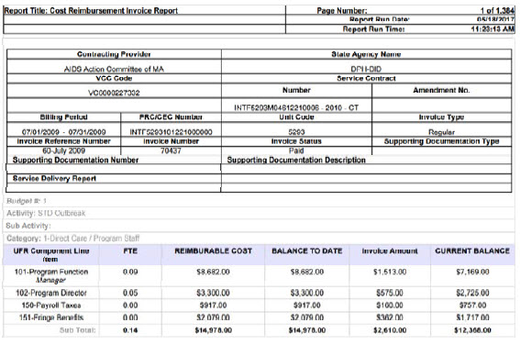
Report Description
Provides the ability to print hard copies of CR invoices.

Report Benefit
Allows the user to view the CR invoice details.

Required Parameters

Invoice From Date

Invoice To Date

Budget Fiscal Year

Generate Personnel Summary

Generate SD

Report Format

OR

PRC Number

Generate Personnel Summary

Generate SDR

Report Format

Scheduling
Yes

Agency Roles
CR Reports

Provider Roles
CR Authorize, CR Review, CR Billing

Operation Roles
N/A
This information is provided by the Virtual Gateway within Health and Human Services.

