HIPAA Claim Status Report

HIPAA Claim Status Report – Input screen
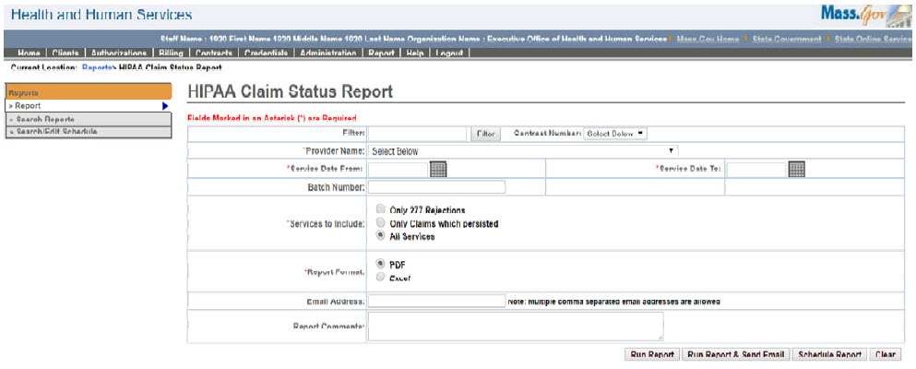

HIPAA Claim Status Report – Output screen
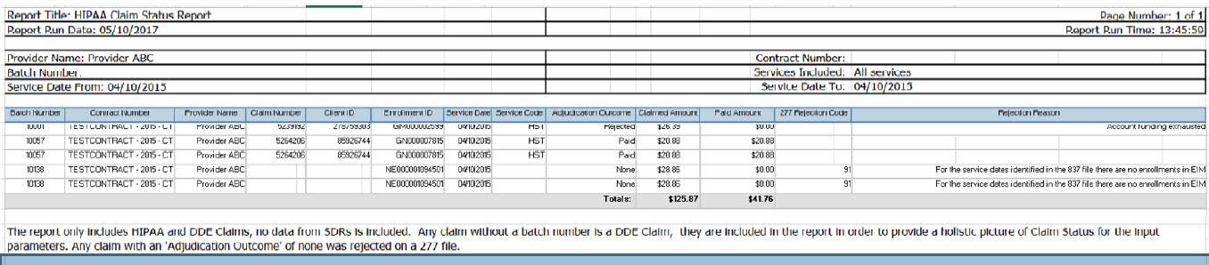
Report Description
Lists all the HIPAA services, their status, adjudication amounts and also the rejection reasons (in case of rejections).

Report Benefit
Allows the user to retrieve data for HIPAA claims submitted per provider as well as for a specific time frame. It also helps to analyze reasons for rejections.

Required Parameters

Provider Name

Service Date From

Service Date To

Services to Include

Report Format

Scheduling
Yes

Agency Roles

HIPAA Claim Manager, HIPAA Claim Reviewer

Provider Roles

Business Configuration Specialist, UR Reports DI

Operation Roles
N/A
This information is provided by the Virtual Gateway within Health and Human Services.

