Ledger Report

Ledger Report – Input screen
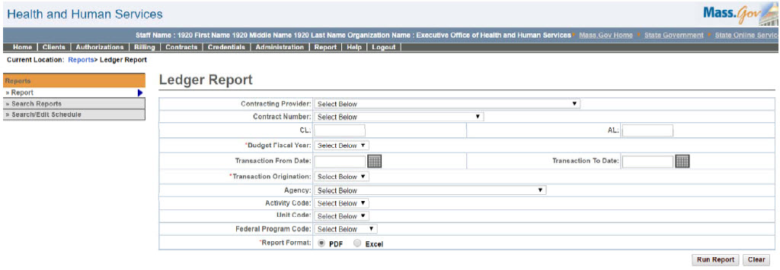

Ledger Report – Output screen
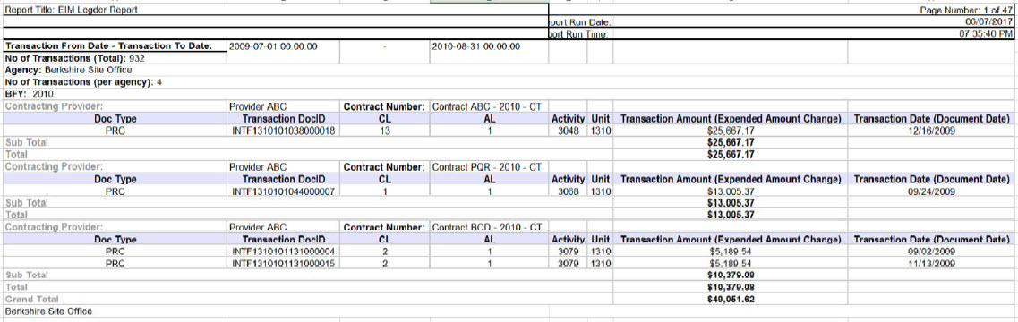
Report Description
Lists all the payments (PRC/CEC) that have been ledgered into the system.

Report Benefit
Allows the user to view all the payment information i.e. PRCs/CECs that have been made outside of EIM/ESM.

Required Parameters

Budget Fiscal Year

Transaction Origination

Report Format

Scheduling
No

Agency Roles

NA

Provider Roles

Batch Interface Manager

Operation Roles
N/A
This information is provided by the Virtual Gateway within Health and Human Services.

