Payment Detail by Client Report (DI)

Payment Detail by Client Report (DI) – Input screen
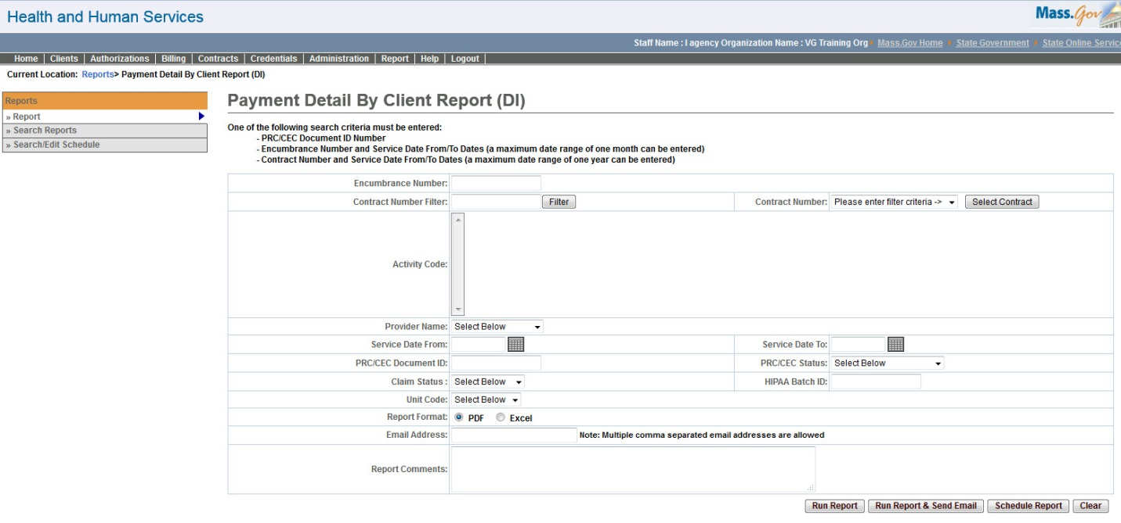

Payment Detail by Client Report (DI) – Output screen
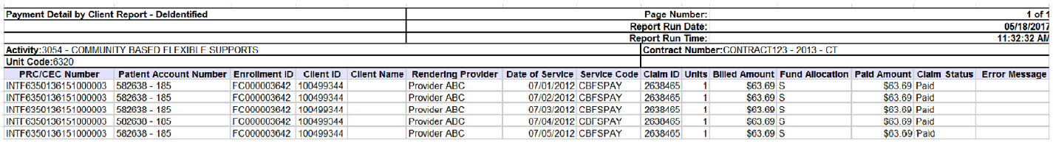
Report Description
Provides the list of clients that have been paid through a single Payment file along with their Billed/Paid amounts (without the client PII information).

Report Benefit
This report allows a user to retrieve payment information per client (without client PII data) based on either of the criteria's:
- Each Payment file
- Master contract and service dates
- Vendor contract number and service dates
Hence the user can retrieve billed and paid amounts for each client (without client PII data) based on the above mentioned criteria's.

Required Parameters
- PRC/CEC Document ID Number
OR
- Encumbrance Number
- Service Date From/To Dates (a maximum date range of one month can be entered)
OR
- Contract Number
- Service Date From/To Dates (a maximum date range of one year can be entered)

Scheduling
Yes

Agency Roles
UR Reports (DI)

Provider Roles

NA

Operation Roles
N/A
This information is provided by the Virtual Gateway within Health and Human Services.

